1. 导出采购单详情数据

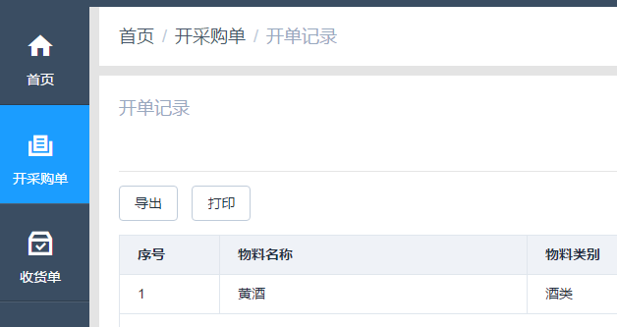

接口地址：/pms/purchase/order/show/export

接口参数：purchaseId

1. 导出收货单详情数据(包含根据采购单收货和直接新增收货单)

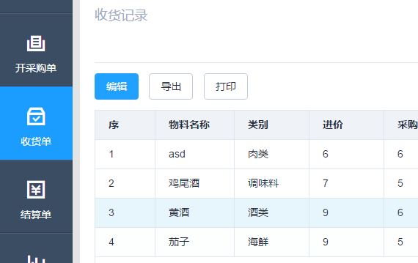

接口地址：/pms/receipt/order/detail/export

接口参数：receiptId

1. 导出未收货收货单数据

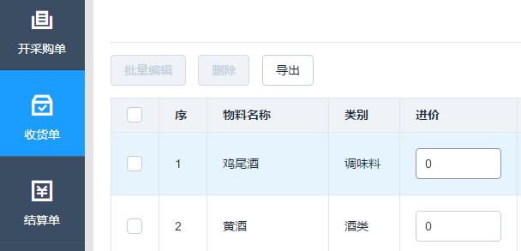

接口地址：/pms/receipt/order/export

接口参数："purchaseId":"be75f538ebc044939185ff109357657d"

1. 导出供应商/采购员结算数据

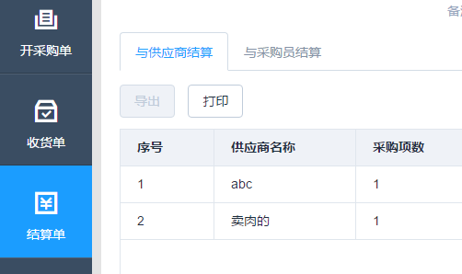

接口地址：/pms/settlement/order/show/export

接口参数："receiptId":"e41814bcc33f46fe8697054602fdd6fa",

"settlementStatus":"",

"settlementReceiver":"1"/”0”

1. 导出供应商/采购员结算详情数据

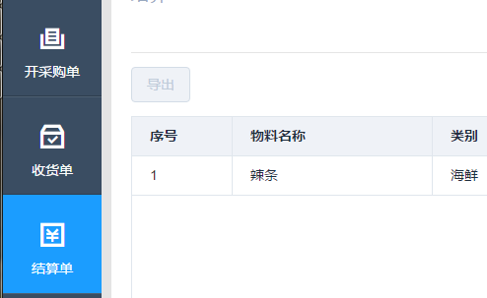

接口地址：/pms/settlement/order/detail/export

接口参数："receiptId":"1b67616d2e1f411b849fcaf77240e6ff",

"id":"80479acc62fa45d2869292d43ed2acf1",

"settlementReceiver":"1"/”0”

1. 导出供应商数据

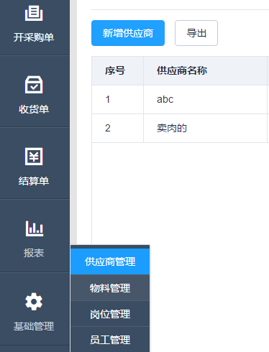

接口地址：/pms/management/supplier/export

接口参数："filter":"",

"pageNo":1,

"pageSize":10

1. 导出物料数据

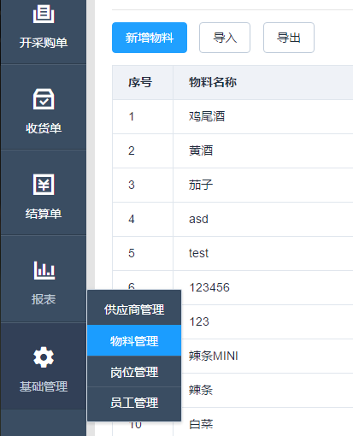

接口地址：/pms/management/material/export

接口参数："pageNo":1,

"pageSize":10,

"filter":"",

"pmsMaterialTypeId":""

1. 导出结算单报表数据

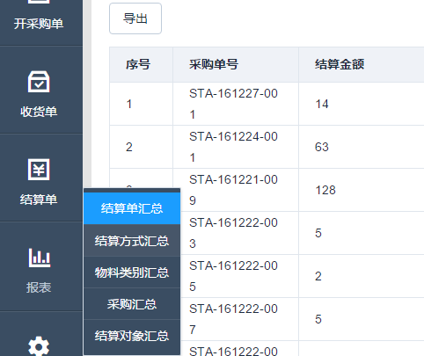

接口地址：/pms/report/settle/order/export

接口参数："filter":"",

"pageNo":1,

"pageSize":10,

"startTime":"",

"endTime":"

1. 导出结算单详情报表数据

接口地址：/pms/report/settle/order/detail/export

接口参数："receiptId":"a008661d161447db874ee3c0666760cf"

1. 导出结算支付方式报表数据

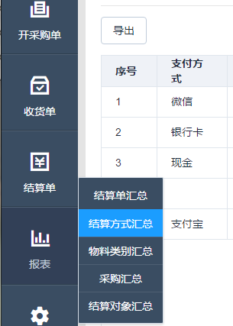

接口地址：/pms/report/pay/type/export

接口参数："filter":"",

"pageNo":1,

"pageSize":10,

"startTime":"",

"endTime":"

1. 导出结算支付方式详情报表数据

接口地址：/pms/report/pay/type/detail/export

接口参数："pageNo":1,

"pageSize":10,

"filter":"微信"

1. 导出物料类别报表数据

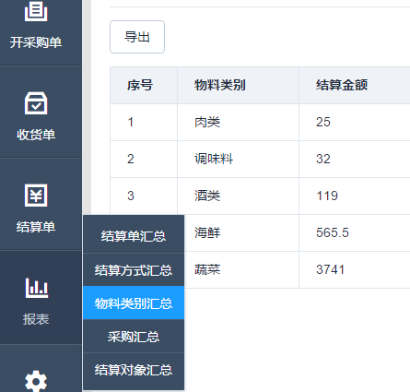

接口地址：/pms/report/material/type/export

接口参数："filter":"",

"pageNo":1,

"pageSize":10,

"startTime":"",

"endTime":"

1. 导出物料类别详情报表数据

接口地址：/pms/report/material/type/detail/export

接口参数："pageNo":1,

"pageSize":10,

"materialTypeId":"df59794122754d629777ec03339d5b13"

1. 导出采购单报表数据

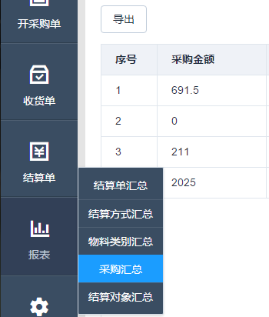

接口地址：/pms/report/purchase/export

接口参数："filter":"",

"pageNo":1,

"pageSize":10,

"startTime":"",

"endTime":"

1. 导出采购单详情报表数据

接口地址：/pms/report/purchase/detail/export

接口参数："pageNo":1,

"pageSize":10,

"purchaserId":"0"

1. 导出结算单报表数据

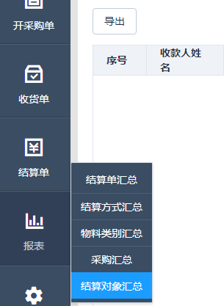

接口地址：/pms/report/settlement/export

接口参数："filter":"",

"pageNo":1,

"pageSize":10,

"startTime":"",

"endTime":"

1. 导出结算单详情报表数据

接口地址：/pms/report/settlement/detail/export

接口参数：接口没出 参数暂定