Contract Triage
End-to-End Testing Guide — for Testers
A Playwright walkthrough that creates a contract in the console, watches the agent triage it live, confirms the outcome, and observes the run in Langfuse.
Version 1.0 · Northgate Systems Ltd (internal)

1. What this test proves
This end-to-end (E2E) test exercises the whole Contract Triage product in one pass — the same journey a legal reviewer takes, driven by a real browser and a real LLM. A single run proves that every layer is wired together correctly:
- Console — opens with the queues already warm (the ten seeded contracts).
- New Contract form — captures the intake facts and an attached PDF, then submits.
- Loading state — the submit button shows the “Triaging…” spinner while the agent runs.
- Agent — the Microsoft Agent Framework graph classifies the paper, runs the policy gates, and reaches a disposition via real gpt-4o calls.
- Hydration — the new contract appears in the queue it was triaged to (Signed / Review / Inbox), and its detail view shows the outcome, journey, and reasoning.
- Observability — the run shows up as a span tree — workflow, agent invocation, and each chat call with prompts, token counts, latency and cost.
Because triage is a live model call, the outcome is not fixed: the same NDA may be signed on one run and escalated on another. The test adapts — it reads the disposition from the API response and follows the contract to whichever queue it lands in. A pass means the pipeline works, not that a specific verdict was reached.
2. Prerequisites
Tool | Version | Why
Docker | running | Langfuse trace stack (7 containers)
Python + uv | 3.12 | FastAPI backend + agent
Node.js | ≥ 20 (22 tested) | Next.js console + Playwright
OpenAI API key | gpt-4o access | the agent is LLM-first; no key = no triage

The OpenAI key is the one hard requirement. Without it the triage nodes raise LLMUnavailableError and Langfuse shows no chat spans. Put it in app/agent/.env (git-ignored):
OPENAI_API_KEY=sk-...
OPENAI_CHAT_MODEL=gpt-4o
3. The stack under test
The test drives an already-running stack. These are the moving parts and where they listen:
Service | URL | Role
Review console (Next.js) | http://localhost:3000 | what the test clicks
Triage API (FastAPI) | http://localhost:8000 | persist + run the agent
Langfuse | http://localhost:3001 | trace ingest + UI
MinIO (contract PDFs) | http://localhost:9092 | stores the uploaded PDF
MinIO / Postgres / ClickHouse / Redis | (internal) | Langfuse backing stores

The repo ships an Aspire AppHost (host/apphost.mts) that starts all of this with one command (aspire run). If your Aspire CLI build does not support the TypeScript AppHost (it may report “Unrecognized app host type”), use the framework-free harness in the e2e/ folder instead — it reproduces exactly the same containers, ports and Langfuse keys. The rest of this guide uses that harness.
4. One-time setup
- Install the backend (Python) dependencies:
cd app/agent
uv venv --python 3.12 && source .venv/bin/activate
uv pip install -e . --prerelease=allow
cd ../..
- Install the frontend dependencies (Node ≥ 20):
cd app/frontend && npm install && cd ../..
- Install Playwright and its browser:
cd e2e && npm install && npx playwright install chromium && cd ..
- Add your OpenAI key to app/agent/.env (see section 2).
5. Bring the stack up
5.1 Start Langfuse + the object stores (Docker)
cd e2e
docker compose -f docker-compose.langfuse.yml up -d
Wait ~60–90s on first run while Langfuse migrates its databases and provisions the Contract Triage project headlessly. It is ready when http://localhost:3001 returns the sign-in page.
5.2 Start the API and the console
From the e2e/ folder, in two terminals:
bash run-api.sh # FastAPI on :8000, traces → Langfuse
bash run-frontend.sh # Next.js console on :3000
run-api.sh sources stack.env, which points the agent's OpenTelemetry exporter at Langfuse over HTTP (Langfuse does not accept gRPC). On boot the API seeds ten example contracts and eagerly triages them, so the queues are warm — this is the first batch of traces you will see in Langfuse. Confirm all three are up:
curl -s localhost:8000/api/health # {"status":"ok"}
curl -s -o /dev/null -w "%{http_code}\n" localhost:3000
curl -s -o /dev/null -w "%{http_code}\n" localhost:3001
6. Run the end-to-end test
cd e2e
npm test
A headless Chromium runs the walkthrough below and writes a screenshot for each stage to e2e/artifacts/screenshots/. Expected console output:
Running 1 test using 1 worker
➡ Triaged CR-2026-0XX → end_state=signed_desk_edits → queue=signed (Signed — desk edits)
✓ 1 … create a contract, triage it, and see where it lands
1 passed
Stage 1 — the console loads with warm queues
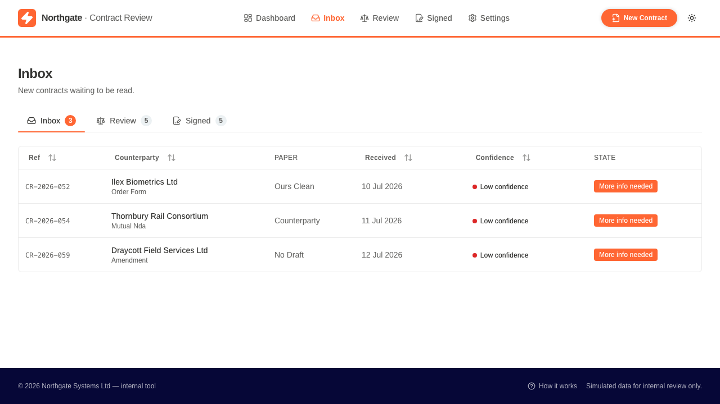
The Inbox on load. Counts (Inbox / Review / Signed) come from the ten seeded contracts.
Stage 2 — fill the New Contract form and attach the PDF
The test clicks New Contract, fills the intake facts (counterparty, what arrived, the sender's ask, sector) and attaches e2e/fixtures/sample-contract.pdf — a mutual NDA from “Meridian Freight Solutions Ltd”.
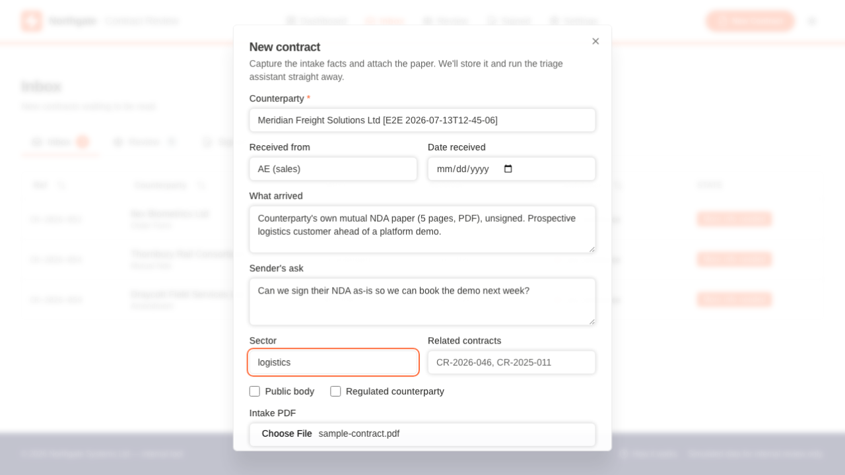
The intake form, completed, with the sample PDF attached.
Stage 3 — submit; the “Triaging…” loading state
On submit the button flips to a spinner labelled “Triaging…” and stays there while the agent runs synchronously. This is the loading state the test captures.
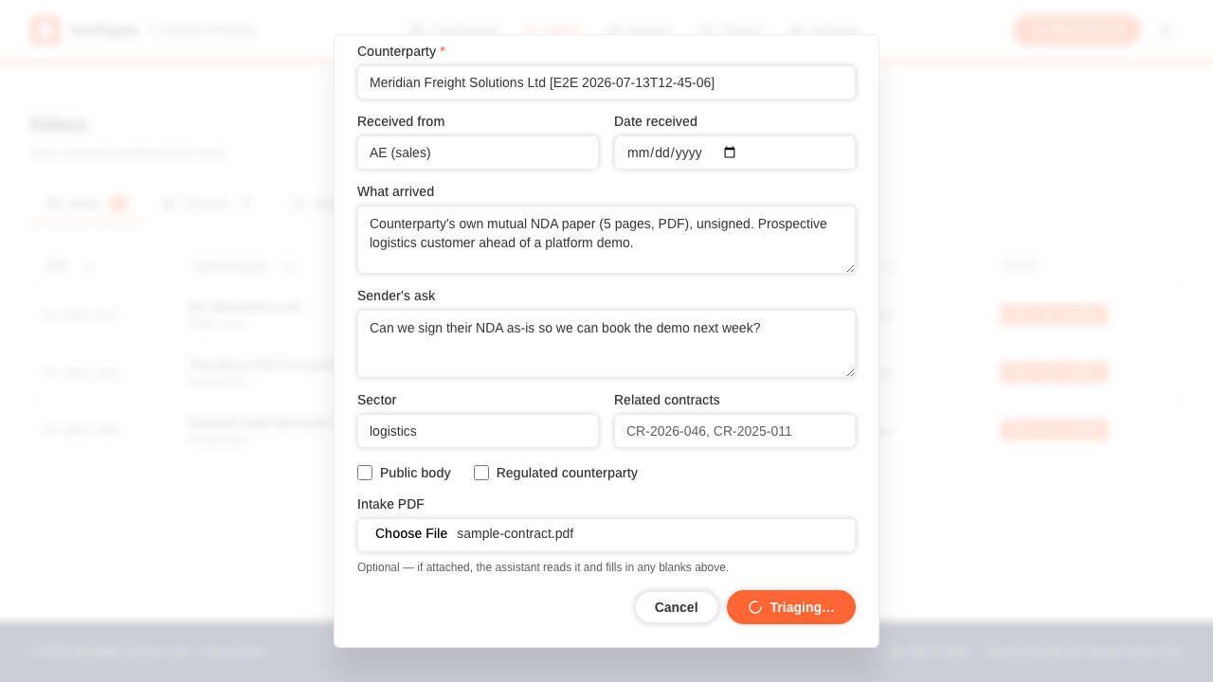
The form mid-run: “Triaging…” while the agent classifies and gates the contract.
Stage 4 — the page hydrates into the right queue
When the agent finishes, the dialog closes and the new contract appears in the queue matching its disposition. In this run it was escalated, landing in Review; on other runs it signs and lands in Signed.
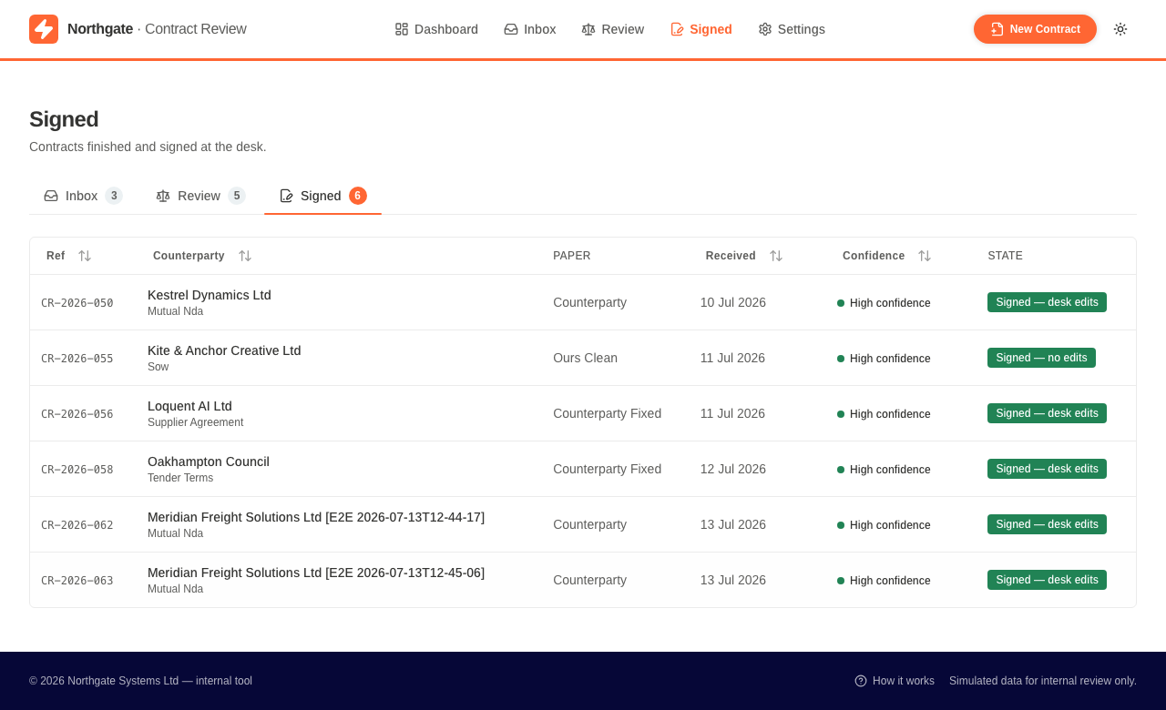
The triaged contract, newly arrived in its queue with the disposition badge.
Stage 5 — the detail view: outcome, journey and reasoning
Opening the row shows the full triage result: the journey strip (Arrived → Reviewed → Checked → Signed/Escalated), the model's plain-English explanation, the recommended action, and — on the Decision tab — the outcome badge.
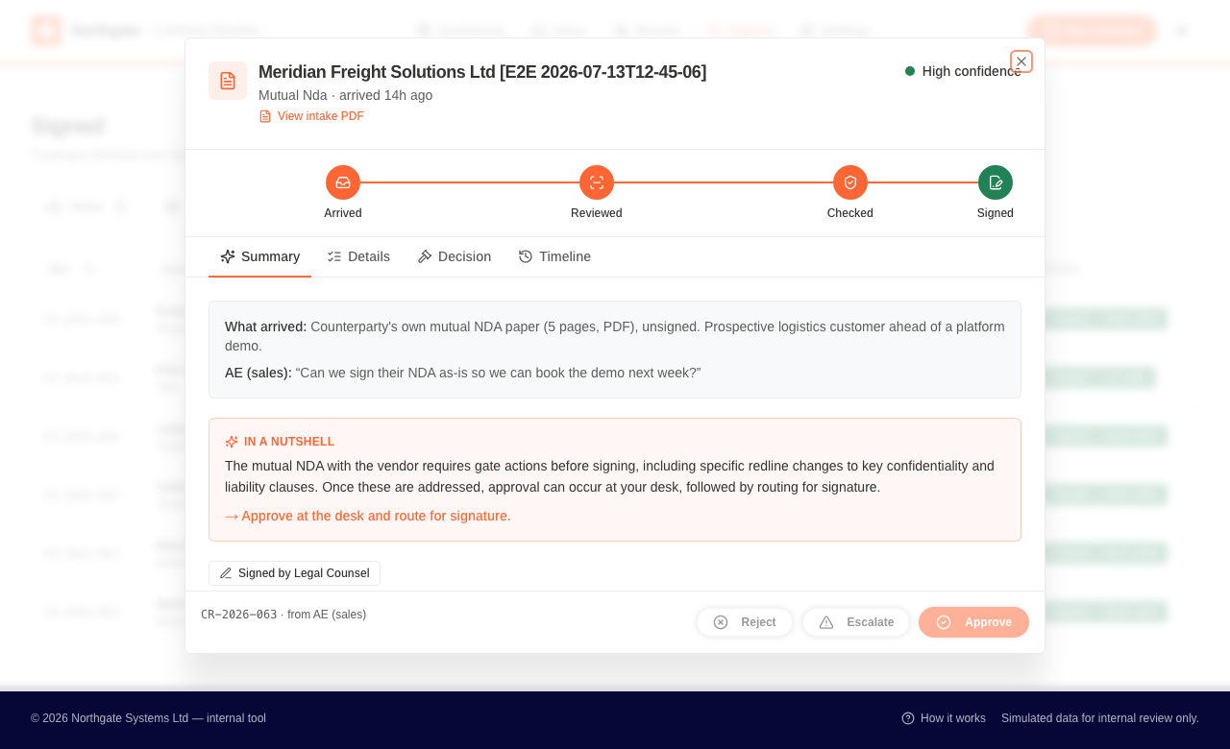
Detail view, Summary tab: the journey and the model's “in a nutshell” reasoning.
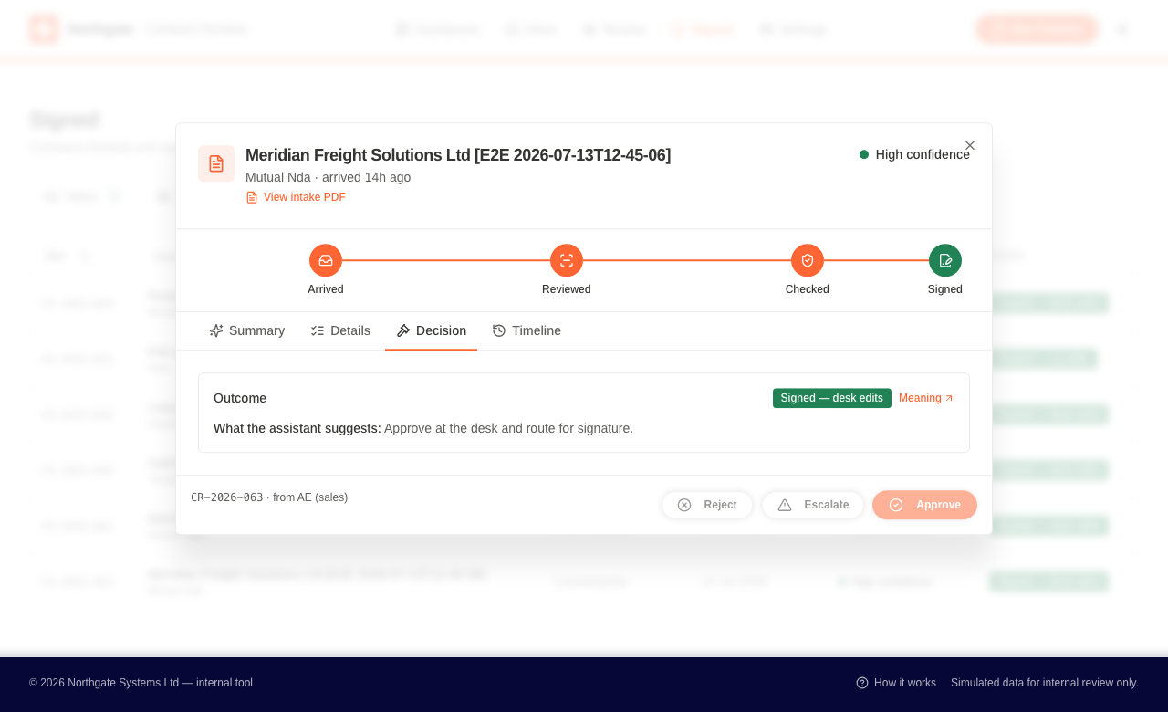
Detail view, Decision tab: the outcome and what the assistant recommends.
7. Observe the run in Langfuse
Every triage run is traced. To see the run the test just created:
- Open http://localhost:3001 and sign in:
email: admin@northgate.local
password: langfuse-admin
- Open the Contract Triage project → Tracing. Filter Trace Name to triage_contract.
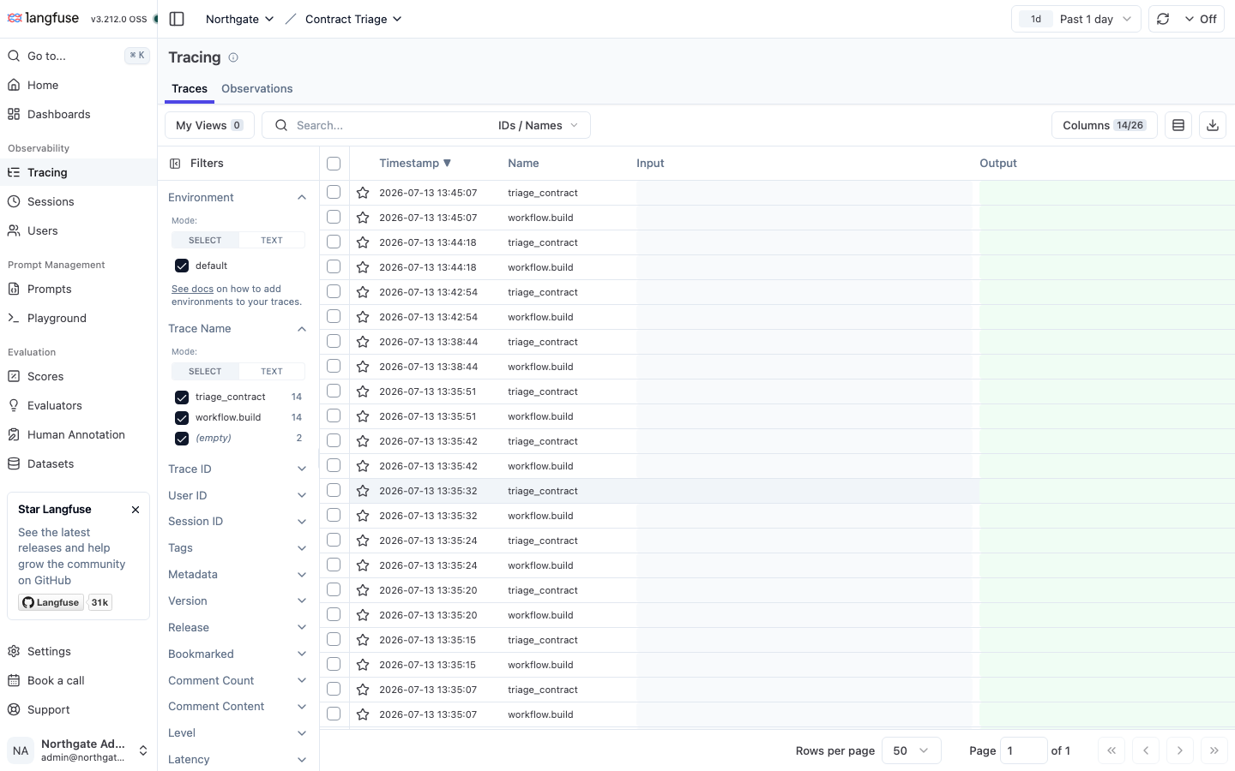
The Tracing list: one triage_contract (and one workflow.build) trace per run.
- Open the most recent triage_contract trace to see its span tree.
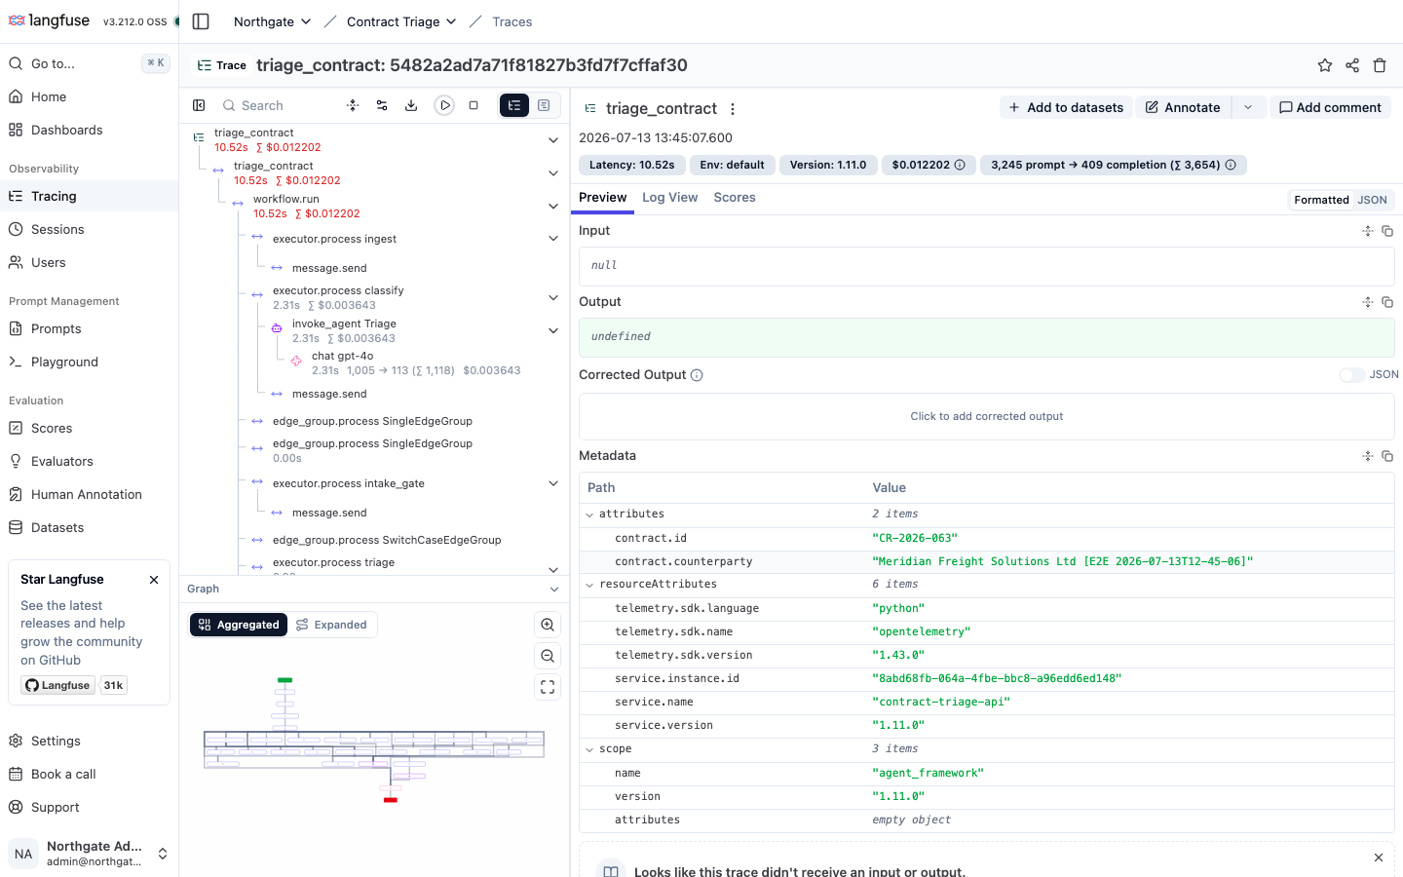
The span tree: workflow.run → classify → invoke_agent Triage → chat gpt-4o, with token counts, latency and cost. The metadata pins the trace to the contract id the test created.
The trace's metadata (contract.id, contract.counterparty) matches the CR-2026-0XX the test created and printed — that is your end-to-end link from a click in the browser to a costed LLM span in the observability stack.
8. What a pass looks like
- npm test reports “1 passed”.
- Six stage screenshots exist under e2e/artifacts/screenshots/ (01–06).
- e2e/artifacts/outcome.json records the created id, end_state and queue.
- A new triage_contract trace appears in Langfuse with a chat gpt-4o span carrying a token count and cost.
Reference from the authoring run: contract CR-2026-063 → signed_desk_edits → signed (Signed — desk edits).
9. Two defects found (and fixed) while authoring this test
Running the console against the live API — rather than its offline fixtures — surfaced two real bugs. Both are fixed in the frontend:
9.1 Live queues rendered empty
The backend labels a contract's queue with its disposition vocabulary (approved / quarantined / pending), but the console filters on inbox / signed / review. The initial load trusted the API's value verbatim, so every queue matched nothing and showed empty — the console only looked populated in offline/fixture mode. Fix: derive the queue from end_state at the API boundary (src/lib/api.ts), the same rule create/triage/resolve already used.
9.2 Duplicated confidence badge
The detail modal rendered the confidence ScoreBadge twice (a copy-paste duplicate), so the header read “Medium confidence · Medium confidence”. Fix: remove the duplicate line in src/components/contract-detail-modal.tsx.
10. Troubleshooting
Symptom | Cause & fix
Queues empty / rows missing | Frontend fix in §9.1 not applied, or the API returned nothing — check localhost:8000/api/contracts.
“LLMUnavailableError” in the API log | OPENAI_API_KEY missing/invalid in app/agent/.env.
No traces in Langfuse | API not started via run-api.sh (missing OTEL env), or Langfuse still migrating. Give it 90s and retry.
ModuleNotFoundError …otlp.proto.grpc | Set OTEL_EXPORTER_OTLP_PROTOCOL=http/protobuf (already in stack.env) — Langfuse is HTTP-only.
Test times out waiting for a row | Triage can take 30–60s; the config allows for it. Confirm the API is reachable from the browser.
Next.js won't start (engine error) | Node < 20. Use nvm: nvm use 22. run-frontend.sh does this automatically if a newer Node is installed.

11. The e2e/ harness — file map
Path | Purpose
docker-compose.langfuse.yml | Langfuse stack + object stores (mirrors host/apphost.mts)
stack.env | OTEL → Langfuse + object-store env for the API
run-api.sh / run-frontend.sh | launch the API and the console against the stack
playwright.config.ts | Playwright config (base URL, timeouts, artifacts)
tests/contract-triage.e2e.spec.ts | the end-to-end walkthrough
fixtures/sample-contract.pdf | the intake PDF the test uploads
tools/capture-langfuse.mjs | logs into Langfuse and screenshots a trace
artifacts/screenshots/ | per-stage screenshots (also embedded in this guide)

