PORTFOLIO CASE STUDY
Retail Sales &
Operations Analytics
A retail analytics case study built from raw transaction data into SQL reporting views and a three-page Power BI dashboard.

PROJECT FRAME
Dataset UCI Online Retail Dataset
Records analyzed 541,909 transaction rows
Period Dec 2010 to Dec 2011
Tools SQL Server, SSMS, Power BI
Focus Sales, product, customer, cancellation, and data quality analysis

Prepared as a project case study, not a tool report.

Why this project was built
I built this project to practice a realistic analytics workflow: start with raw retail transactions, prepare the data in SQL Server, and use the cleaned reporting views as the source for a Power BI dashboard.
The goal was not to create charts directly from a spreadsheet. The goal was to make the reporting logic clear enough to validate, explain, and reuse.
The project was structured around six questions:
1. How is revenue performing over time?
2. Which products contribute the most revenue?
3. Which products sell the most units?
4. Which customers generate the highest value?
5. Which countries dominate sales and cancellation impact?
6. What data quality issues should be visible before trusting the dashboard?
Understanding the raw data
The dataset contains online retail transactions with invoice numbers, product codes, product descriptions, quantities, invoice dates, unit prices, customer IDs, and countries.
I treated the dataset as raw operational data, not as a clean reporting table. That decision mattered because the data included cancelled invoices, missing customer IDs, missing product descriptions, negative or zero quantities, and service-related records such as postage or manual charges.
Data quality findings
Raw data rows 541,909
Missing Customer ID 135,080
Missing Description 1,454
Negative or zero quantity 10,624
Cancelled invoices 9,288
Valid sales rows 530,100
These checks helped define which records should be used for the main sales dashboard and which records should be monitored separately.

Preparing the reporting layer in SQL
The raw CSV file was imported into SQL Server and prepared through a set of SQL views. I used this approach so that each step had a clear role: raw data, cleaned data, valid sales data, and dashboard-ready analysis.
WORKFLOW
Raw CSV file → SQL Server raw table → Data quality checks → Cleaning view → Valid sales view → Analysis views → Power BI dashboard
SQL views used in the project
vw_retail_clean Cleaned raw fields, converted invoice dates and unit prices, calculated revenue, and flagged cancelled invoices.
vw_retail_valid_sales Filtered the records used for the main sales dashboard by excluding cancelled or invalid transactions.
vw_executive_kpi Prepared the core KPI metrics for revenue, orders, customers, quantity sold, and average order value.
vw_monthly_sales Prepared monthly revenue, order count, and quantity sold.
vw_product_performance_clean Analyzed product performance while excluding postage, manual charges, discounts, and other service-related records.
vw_customer_performance Summarized customer-level revenue, orders, and quantity purchased.
vw_country_performance Summarized revenue, orders, customers, quantity sold, and average order value by country.
vw_cancellation_analysis Measured cancellation impact by month and country.
vw_data_quality_summary Summarized the main raw data quality issues for reporting transparency.
Data decisions that shaped the analysis
Cancelled invoices were separated from the main sales dashboard and analyzed on a dedicated cancellation page.
Invalid quantities, invalid prices, invalid dates, and missing product descriptions were excluded from the valid sales view.
Missing CustomerID values were kept visible because they affect the reliability of customer-level analysis.
Postage, manual charges, discounts, and service-related codes were excluded from product performance ranking.
December 2011 was interpreted carefully because the dataset only contains part of that month.

Dashboard page 1: Executive overview
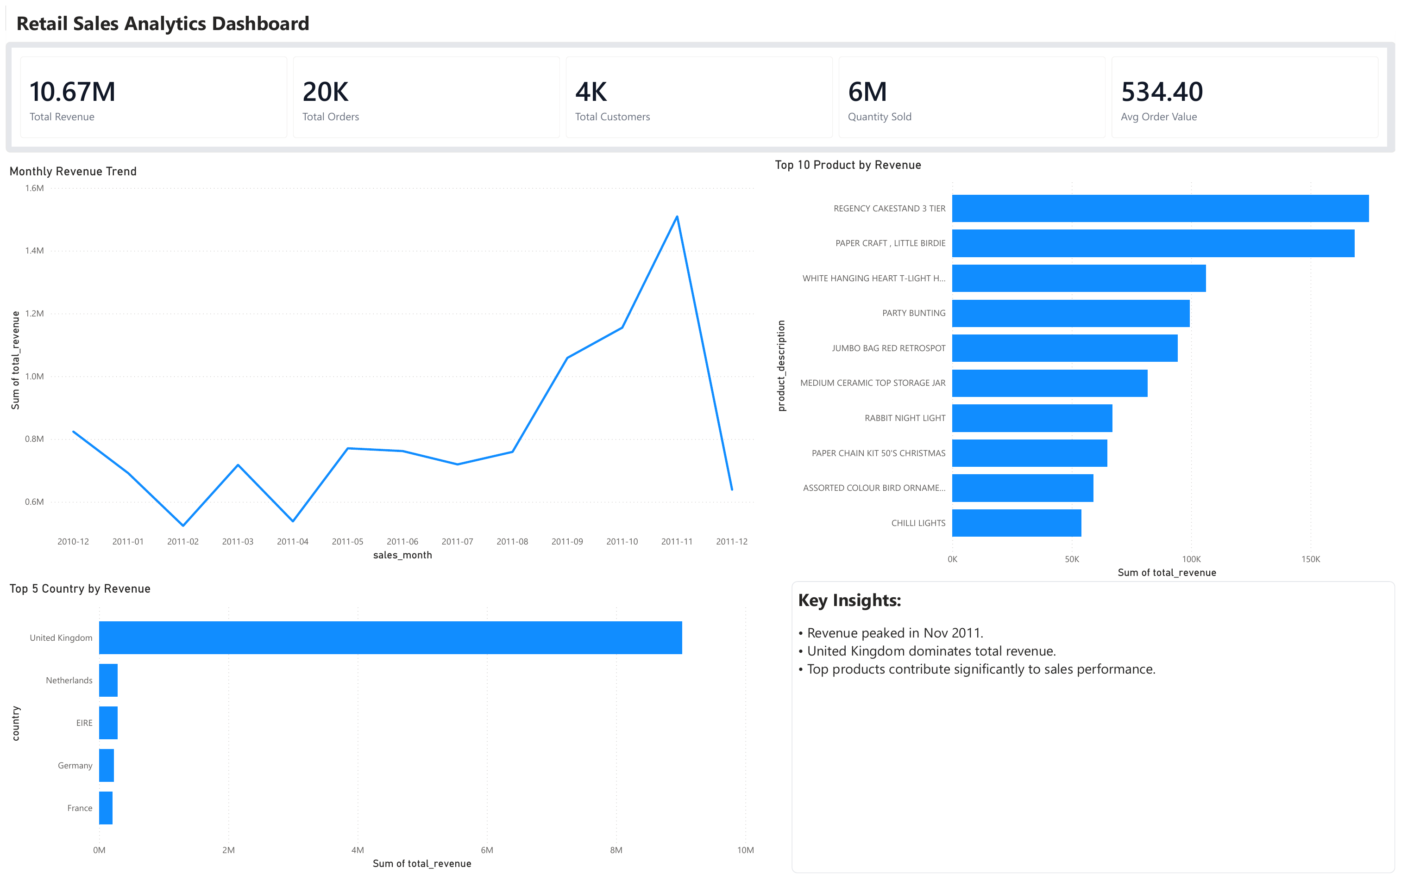
Executive Overview page. The page summarizes revenue, orders, customers, monthly revenue trend, top products, top countries, and key insights.
This page was built for fast business scanning. It answers what happened, where revenue came from, and which areas deserve attention.
Key result. Total revenue reached 10,666,684.54 across 19,960 valid orders. Revenue peaked in November 2011, and the United Kingdom dominated total revenue.

Dashboard page 2: Customer and product analysis
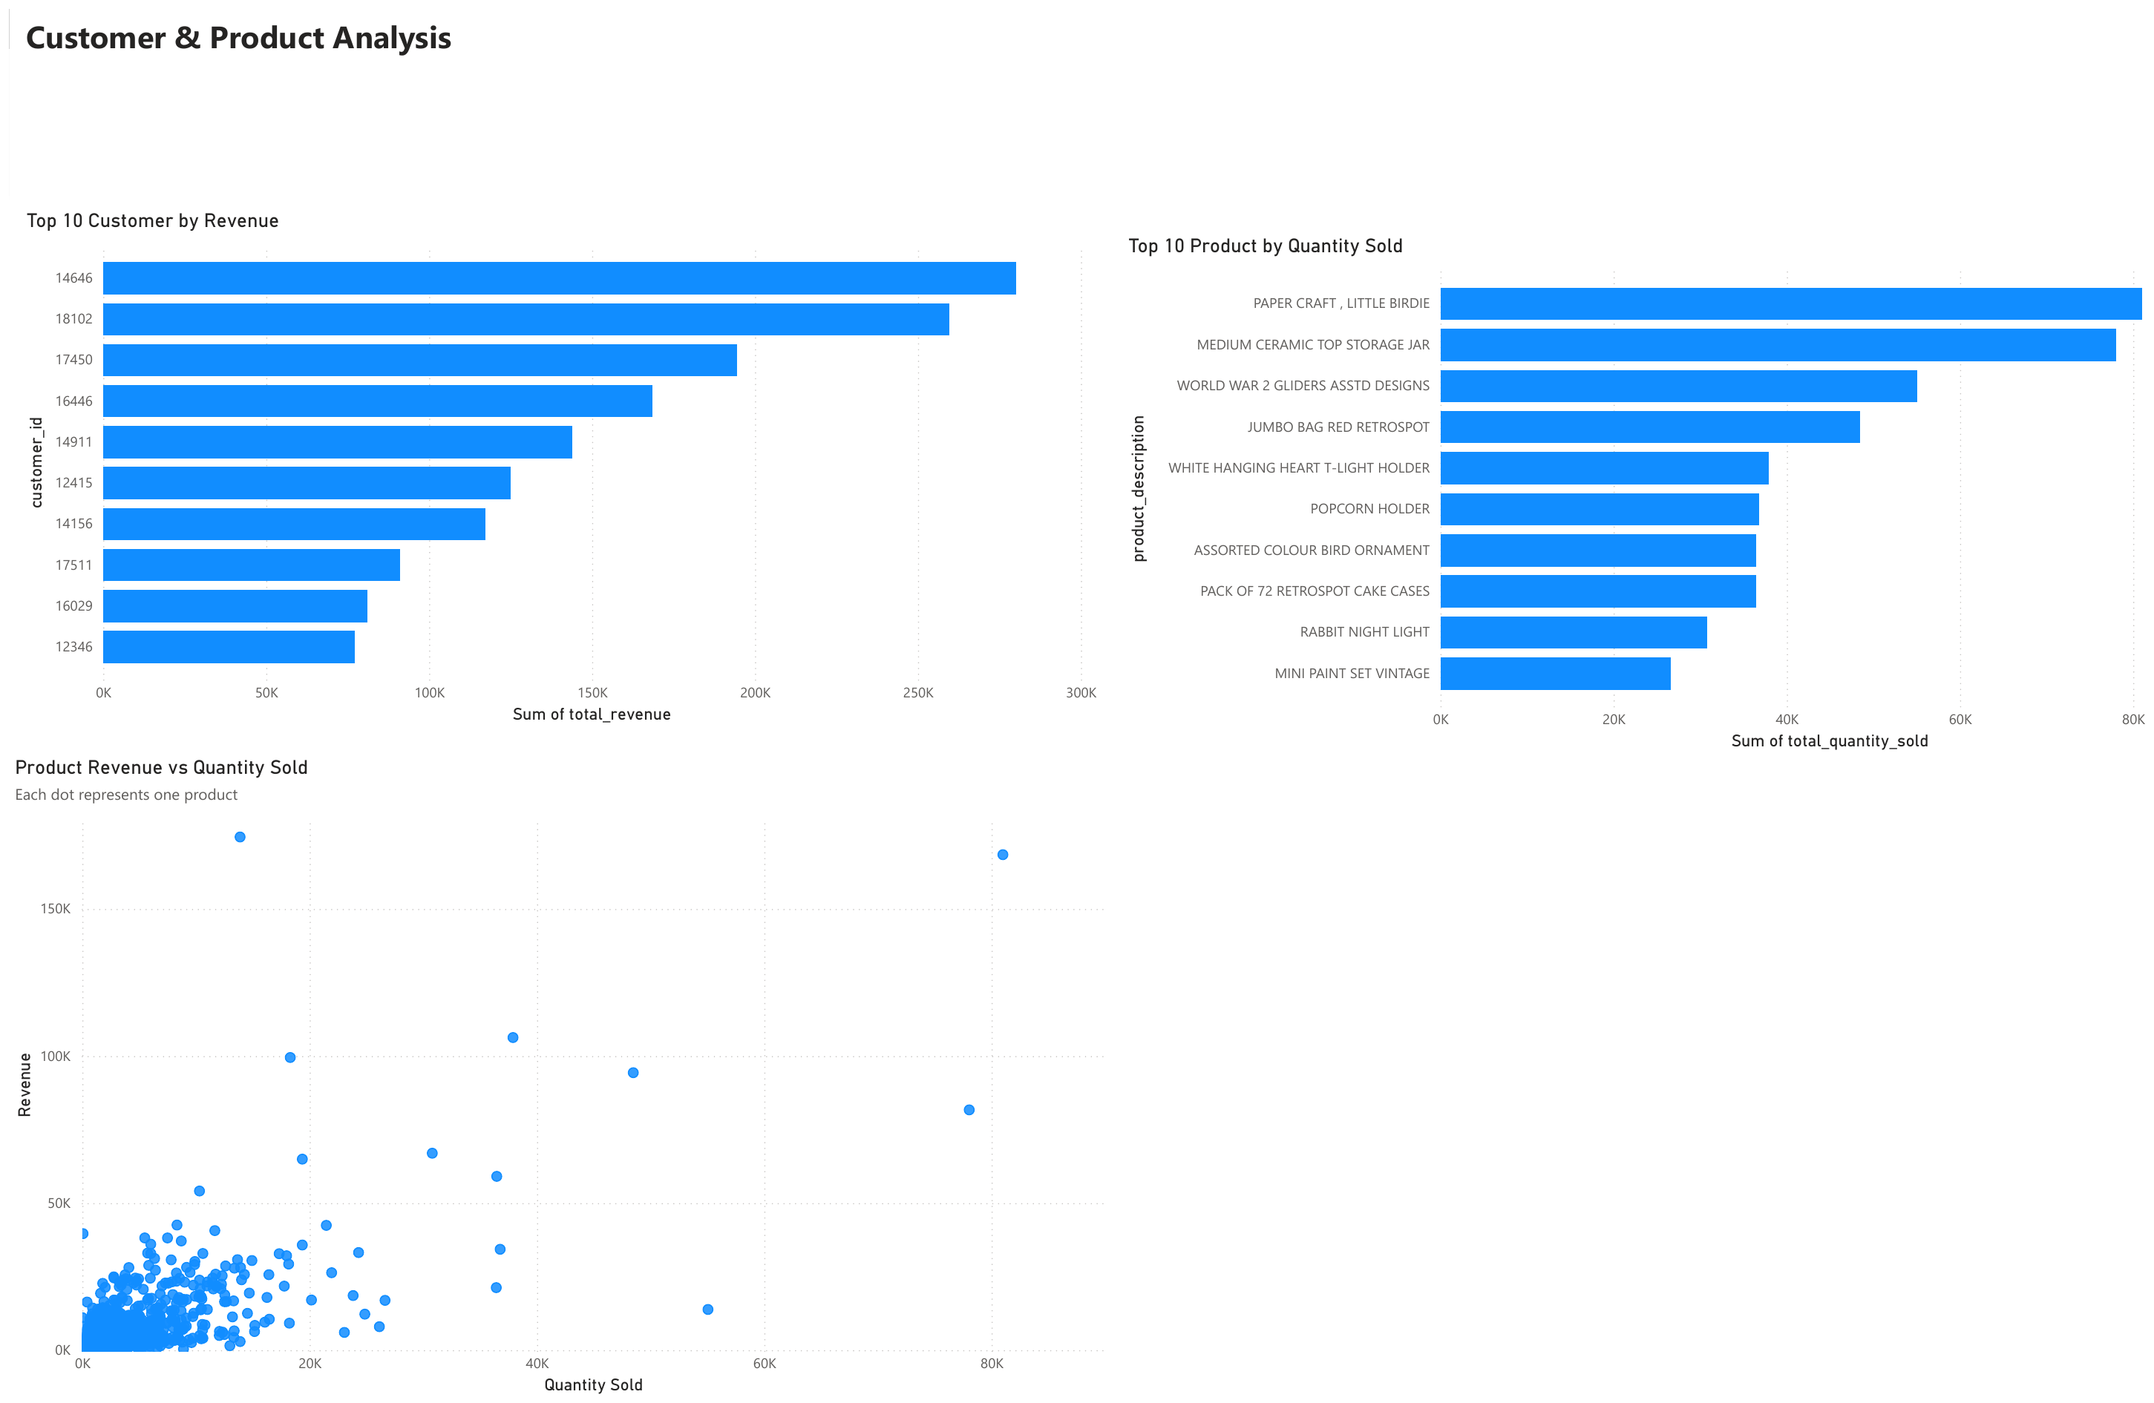
Customer & Product Analysis page. The page compares high-value customers, top products by quantity sold, and the relationship between product quantity and revenue.
This page separates quantity from value. A product can sell in high volume but contribute less revenue, while another product can sell less often and still create higher revenue.
Key result. CustomerID 14646 from the Netherlands generated the highest customer revenue. This shows why customer-level analysis can reveal details that country-level totals do not show.

Dashboard page 3: Cancellation and data quality
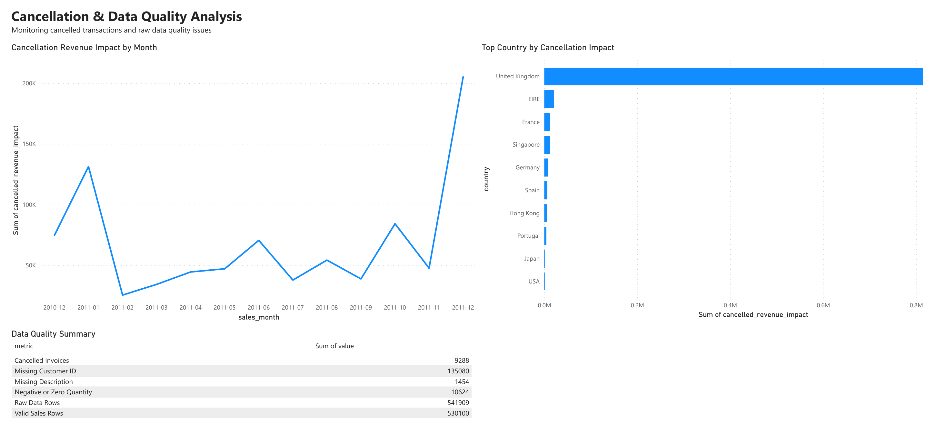
Cancellation & Data Quality page. The page separates cancellation impact and raw data issues from valid sales performance.
This page was included to keep the dashboard honest. It shows that reporting quality depends not only on visual design, but also on how cancelled transactions and incomplete fields are handled.
Key result. Cancellation impact was heavily concentrated in the United Kingdom. That is expected because the UK also dominates sales volume, but it still needs to be monitored when interpreting monthly performance.

What the analysis found
Revenue timing. Revenue peaked in November 2011, showing strong late-year sales performance. December 2011 should be interpreted carefully because the dataset only contains part of that month.
Market concentration. The United Kingdom contributed the largest share of total revenue and was the dominant market in the dataset.
Product behavior. The highest-revenue products were not always the highest-quantity products. Product performance needed both revenue and quantity views.
Customer value. The highest-revenue customer came from the Netherlands, even though the United Kingdom dominated total sales.
Cancellation risk. Cancellation impact was concentrated in the United Kingdom, so cancellation trends should be monitored alongside revenue trends.
Data completeness. Missing CustomerID values limited the depth of customer-level analysis and reduced visibility into repeat behavior and retention opportunities.
Business interpretation
The analysis shows that sales performance should not be judged from volume alone. Some products sell in high quantity but do not create the same level of revenue contribution as other products.
The cancellation analysis also shows why valid sales and cancelled transactions should be separated before interpreting monthly performance. Without that separation, revenue trends can be harder to trust.
The data quality summary adds context to the dashboard. Missing customer identifiers do not stop the project, but they do limit how far customer-level conclusions can go.

Recommendations and project scope
Monitor revenue together with cancellation impact so sales performance is not overestimated.
Prioritize high-revenue products for inventory planning, stock availability, and promotion decisions.
Track high-value customers separately for retention and account management.
Investigate cancellation spikes by month and country.
Improve CustomerID completeness to support deeper customer-level analysis.
Keep service charges such as postage and manual charges separate from product performance reporting.
Scope and limitations
The dataset does not include clean product categories, so product analysis was based on product descriptions and stock codes.
Some transactions have missing CustomerID values, which limits customer-level analysis.
The dataset only includes part of December 2011, so that month should not be compared directly with full months.
Profit and margin analysis could not be performed because product cost data was not available.
The dashboard focuses on historical analysis and does not include forecasting.
Project outputs
Power BI dashboard with three pages: Executive Overview, Customer & Product Analysis, and Cancellation & Data Quality.
SQL scripts prepared for data cleaning views, analysis views, and data quality checks.
Clean dashboard screenshots and this written case study explaining the workflow, data decisions, findings, and recommendations.

