LNA Folder explanation

LNA Folder introduction
LNA Folder includes three contents.
- doc
- setups
- src

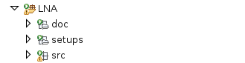

“doc” directory
“doc” directory includes only this document. This document explains LNA Folder contents and how to integrate LNA Folder to other device program.

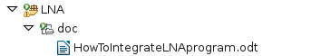

“setup” directory

“setup” directory includes 5 directories and some “.dbd” files. All of them are used for setting for LNA testing.

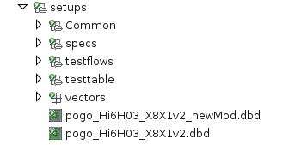

“.dbd” files
“.dbd” file is a pin configuration.
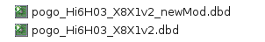

It can define Pin Name, Pogo pin number and the number of sites. This file can control Sites and Pins whether Disable or Enable.

“Common” directory
“Common” directory includes “groups.spec”.
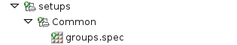

“groups.spec” defines group name and which group includes which pins. By using group name, users can handle pin definition in specification file, test method and so on easily.

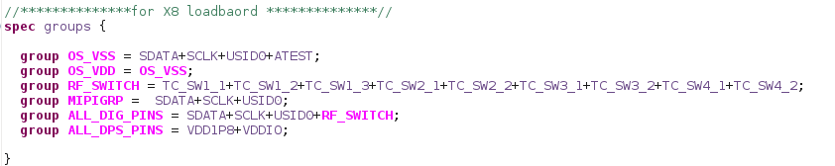

By importing this specification file, User can use this group name at another specification .

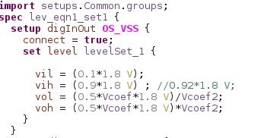

“specs” directory
“specs” directory manages specification files. And it includes 6 directories and 1 file as the followings,

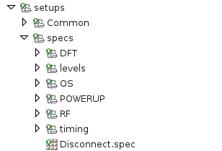

1. “levels” and “timing” directories.
  - Each specification files at “levels” directory defines Digital pin’s driver/comparator voltage settings and DPS voltage/clamp current value setting.

  - Each specification files at “timing” directory defines Digital pin’s tester period , equation and wave table.

2. The others directories.
  - All of specification at the others directories import a specification file from “levels” and “timing” directories respectively. And these specification files are used at Device testing.

3. “Disconnect.spec” specification file.
  - This specification file is called when DUT needs to be disconnected. All Digital and DPS pins will be disconnected.

“testflows” directory
SmarTest8 standard test flow structure are the following,
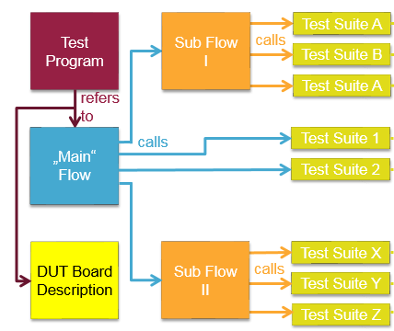

There is one Main Flow and it calls several Sub Flow. Then , several Sub Flows include some of test suites.

“testflow” directories include more than 10 test flow files as the following,
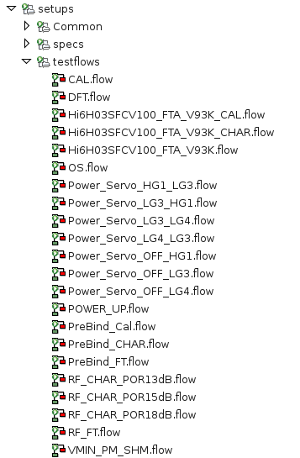

1. Main Flow
  - Hi6H03SFCV100_FTA_V93K_CAL.flow
  - Hi6H03SFCV100_FTA_V93K_CHAR.flow
  - Hi6H03SFCV100_FTA_V93K.flow

2. Sub Flow
  - CAL.flow
  - DFT.flow
  - OS.flow
  - Power_Servo_xxxxxxx.flow
  - POWER_UP.flow
  - RF_CHAR_xxxxxx.flow
  - RF_FT.flow
  - VMIN_PM_SHM.flow

There is one Main Flow and it calls several Sub Flow. Then , several Sub Flows include

“testatble” directory
“testtable” directory includes Master and Sub testtables. Test method of test program calls Master test table, and Master test table calls some of Sub testtables.
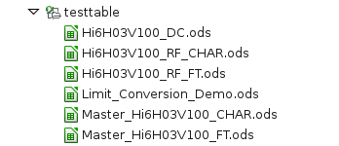

1. Master testtable
  - Master_Hi6H03V100_CHAR.ods
  - Master_Hi6H03V100_FT.ods

2. Sub testtable
  - Hi6H03V100_DC.ods
  - Hi6H03V100_RF_CHAR.ods
  - Hi6H03V100_RF_FT.ods

“vectors” directory
“vectors” directory contains vectors which will be used at testing. User needs to call these vectors in specification file and/or test method when vectors need to be executed.

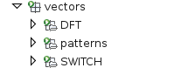

“src” directory
“src” directory contains 6 directories and each of them includes test methods.
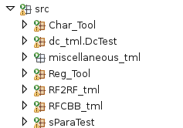

“Char_Tool” directory
The category of test methods at “Char_Tool” are for evaluating DUT characteristic. It contains Pin Margin method (PM.java) and Shmoo method (SHM.java). These test methods are not DUT specific, user can use them in another program by setting all parameter values at test flow.

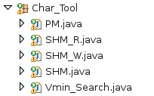

“dc_tml” directory
The category of test methods at “dc_tml” are for testing DC parameters. DPS current measurement (CommonCurrent.java) and Digital pin’s Open Short (Continuity.java) & Leakage current measurement (Leakage.java) are contained.

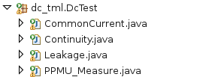

“miscellaneous_tml” directory
The category of test methods at “miscellaneous_tml” are for controlling Utility Lines and Utility Power Supply.

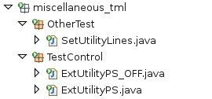

“Reg_Tool” directory
The category of test methods at “Reg_Tool” are for setting Register. Mainly these test methods control POR of Hi6H03 DUT. They contain test methods which are initializing POR data, dynamically creating POR patterns and reading register values.

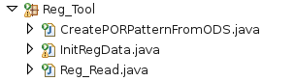

“RF2RF_tml” directory
The category of test methods at “RF2RF_tml” are for testing RF parameters. These test methods target DUT are for the type of “RFin-To-RFout”. “RF2RF_BURST_TEST.java” is used for Hi6H03 RF testing, then this method can test “Gain” ,”IIP2” ,”IIP3” ,“3rd harmonic” and “P1dB” at one java file.

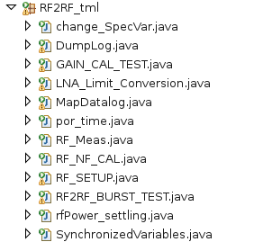

“RFCBB_tml” directory
The category of test methods at “RFCBB_tml” are Common Building Block of RF testing. These test methods are used for handling Calibration value and Class of DSP. Since this is Common Building Block , User can use Class in another device testing without any modifications.

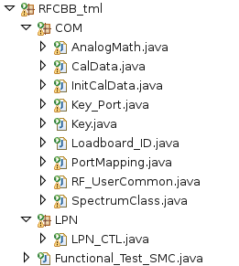

“sParaTest” directory
The category of test methods at “sPataTest” are for testing S-patameter. User can use these methods for checking S-parameter in other device testing with a little modification.

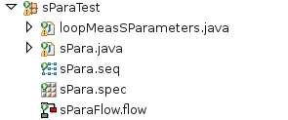

How to integrate LNA TestIP to another device projects
Process to integrate LNA TestIP to another SMT8 projects is the same as that way shown in MIPI folder.

