MIPI Folder explanation

MIPI Folder introduction
MIPI Folder includes three contents.
- doc
- setups
- src
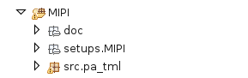

“doc” directory
“doc” directory includes this document and two “.ods” files. Two “.ods” files will be used in explanation at the topic of “How to integrate MIPI Folder to another device projects”.

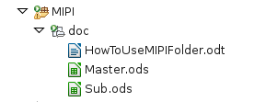

“setup” directory

“setup” directory includes “MIPI” protocol definition file(mipi.prot), “MIPI” spec file(specPA_MIPI.spec) and “MIPI” transaction sequence definition file(transSeq_MIPI.trseq).
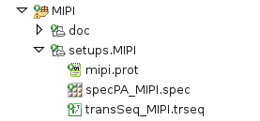

mipi.prot file

This is MIPI protocol definition file(.prot). This file can define the implementation of the protocol signal roles and the transaction. User needs to modify this file if Sequences, the number of bits and/or protocol are changed.

signalRole of “mipi.prot” file

signalRole pin name are used at “mipi.prot” temporally. signalRole pin names are “DATA” and “CLK”. Their name will be connected to “.dbd” file via protocolInterface of Specification file(.spec) and Test method(.java).
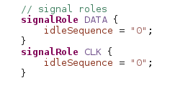

“WRITE” sequence of “mipi.prot” file

When “WRITE” of “MIPI” transaction sequence is called at Test Method, Pattern will be created automatically according to three input parameters which are “USID”, “AddrIn” and “DataIn”.

The following is the pattern sequence of “WRITE” at “mipi.prot”,

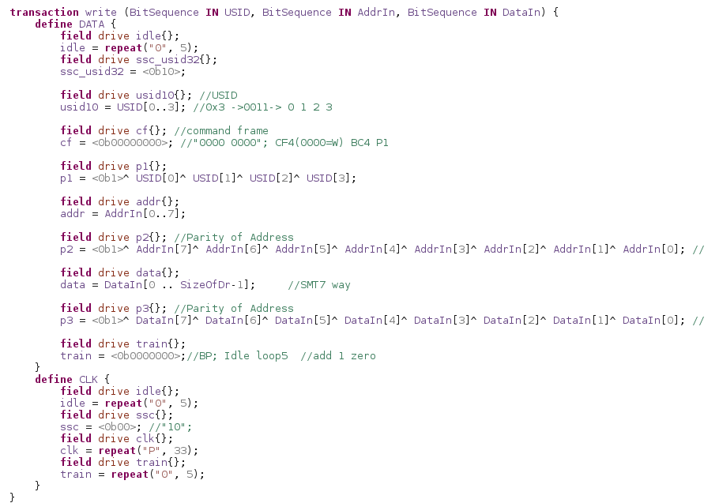

Each “field” from above picture can define three things,
    - Whether to use Driver (“drive”) or Receiver (“receive”)
    - How many vectors are inserted
    - State character which is inserted to vectors

WRITE PATTERN sequence of “DATA” pin
- Drive “0” for first 5 vectors [idle]
- Drive “1”, then set “0” to 2 vectors sequentially [ssc_usid32]
- Drive 4 vectors according to Input parameter of “USID” [usid10]
- Drive “0” for 8 vectors [cf]
- Drive 1 vector according to Input parameter of “USID” [p1]
- Drive 8 vectors according to Input parameter of “AddrIn” [addr]
- Drive 1 vectors according to Input parameter of “AddrIn” [p2]
- Drive 8 vectors according to Input parameter of “DataIn” [data]
- Drive 1 vectors according to Input parameter of “DataIn” [p3]
- Drive “0” for 7 vectors [train]

WRITE PATTERN sequence of “CLK” pin
- Drive “0” for 5 vectors [idle]
- Drive “0” for 2 vectors [ssc]
- Drive “P” for 33 vectors [clk]
- Drive “0” for 5 vectors [train]

“READ” sequence of “mipi.prot” file

When “READ” of “MIPI” transaction sequence is called at Test Method, Pattern will be created automatically according to two input parameters which are “USID” and “AddrIn”, and output “DataOut” value.

The following is the pattern sequence of “READ” at “mipi.prot”
READ PATTERN sequence of “DATA” pin
- Drive “0” for first 5 vectors [idle]
- Drive “1”, then set “0” to 2 vectors sequentially [ssc_usid32]
- Drive 4 vectors according to Input parameter of “USID” [usid10]
- Drive “0” for 2 vectors, then “1” for 1 vector,
next “0” for 5 vectors [cf]
- Drive 1 vector according to Input parameter of “USID” [p1]
- Drive 8 vectors according to Input parameter of “AddrIn” [addr]
- Drive 1 vectors according to Input parameter of “AddrIn” [p2]
- Drive “0” for 1 vector [bp]
- Read 8 vectors according to DUT output [data]
- Drive “0” for 7 vectors [train]

READ PATTERN sequence of “CLK” pin
- Drive “0” for 5 vectors [idle]
- Drive “0” for 2 vectors [ssc]
- Drive “P” for 33 vectors [clk]
- Drive “0” for 5 vectors [train]

specPA_MIPI.spec

This specification file defines “protocolInterface” which is used at “mipi.prot” file and connect these defined pins to “.dbd” file’s defined pins.
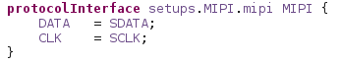

transSeq_MIPI.trseq

This transaction definition file defines transaction sequence and structure. These defined transactions can be called and used from test method.

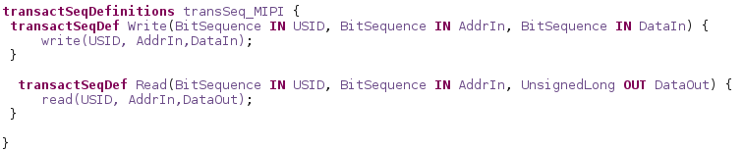

“src” directory

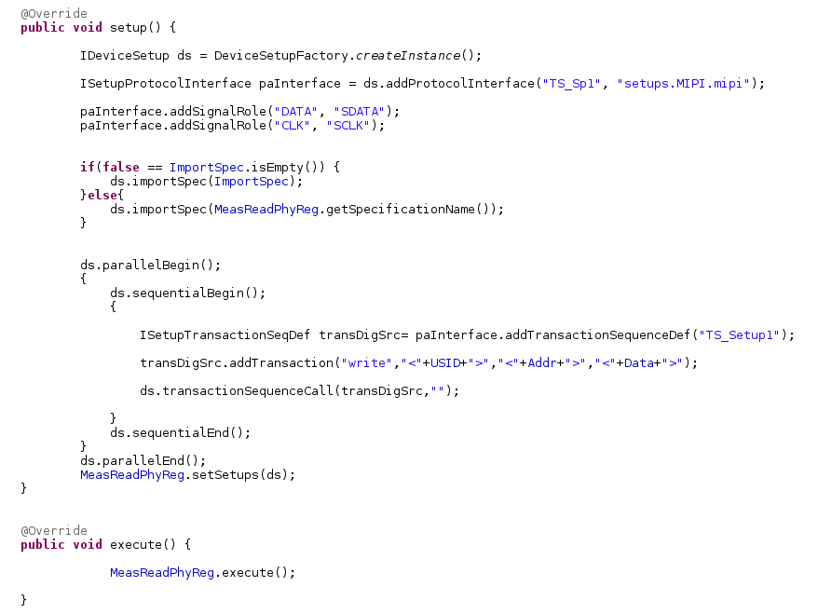
“src” directory includes two test methods. One is for “MIPI_WRITE.java” and the other is for “MIPI_READ.java”. This topic doesn’t explain both of them, but explains key point of how to create “MIPI” pattern in Test Method.

MIPI Write Case Test Method

1.
2.
3.
4.
5.
6.

      - Declares “Protocol Interface”
  - “TS_Setup1” is Transaction Sequencer Name. User can define it any name.
  - “setups.MIPI.mipi” is Protocol definition file(.prot) name and path. User must specify correct name and path.

      - Associates signal name to SignalRole of MIPI Protocol definition file
  - “DATA” & “CLK” are defined at MIPI Protocol definition file(.prot).
  - “SDATA” & “SCLK” are defined at “.dbd” file and need to associate them to MIPI Protocol definition here.

      - Declares “Transaction Sequence” and associates it with “Protocol Interface”
  - Needs to call name same with Transaction Sequencer Name.

      - Defines transaction
  - “write” is used for writing MIPI data to DUT.
  - “USID” is defined with String
  - “Addr” is defined with String
  - “Data” is defined with String

      - Call Transaction Sequence
  - After calling this transaction sequence, DSAPI will create Transaction Sequence Definition file(.trseq) automatically.

      - Execute
  - Execute Pattern and Write Data to DUT according to setting pattern

MIPI Read Case Test Method
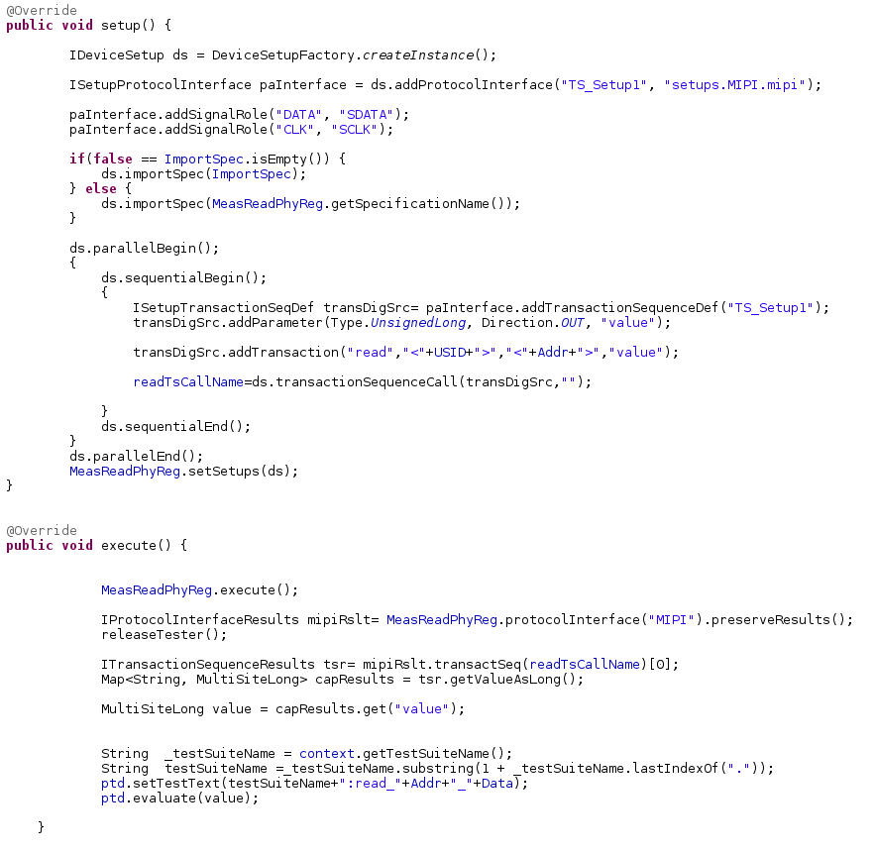
1.
2.
3.
4.

            - Creates “value” parameter at Transaction Sequential Definition file
  - This “value” parameter will be used for Reading data of DUT output.

            - Defines transaction
  - “read” is used for writing MIPI data to DUT.
  - “USID” is defined with String
  - “Addr” is defined with String
  - “value” is defined same with the added parameter name at Transaction Sequential Definition file(.trseq).

            - Retrieves data of DUT output
  - “MIPI” is protocol interface name(.prot) which is defined at Specification file

            - Evaluates data results of DUT output

How to integrate MIPI TestIP to another device projects

This topic explains how to integrate MIPI Folder by using new project whose name is “DEMO”. The target of this topic is to execute “MIPI_READ_TEST” and “MIPI_WRITE_TEST” without any errors. So, several tasks are not necessary for integrating “MIPI” folder to your desired folder.

Then, you become to understand points which files need to be modified in the case to integrate MIPI Folder to your desired project after this topic done.

Creates “DEMO” device project

An order for creating “DEMO” device project is the following,

- Right Click on “Package Explorer”
- Left Click “New” => “SmarTest Project”

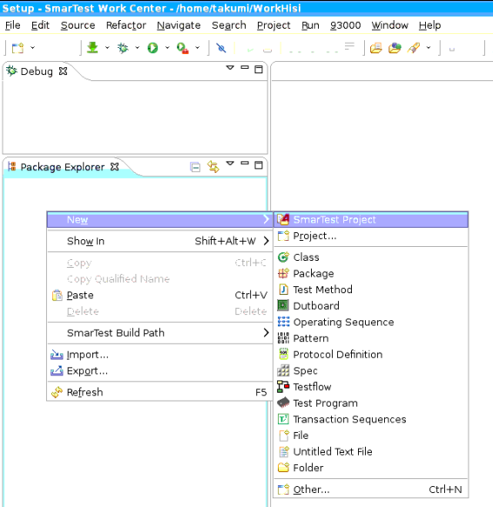

Then, the following’s Pop-up window will be appeared.

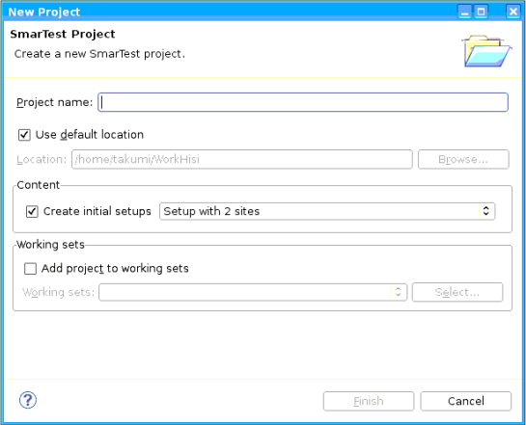

- Specifies “DEMO” to “Project name” column
- Unchecks “Use default location” and Specifies the program path which you want

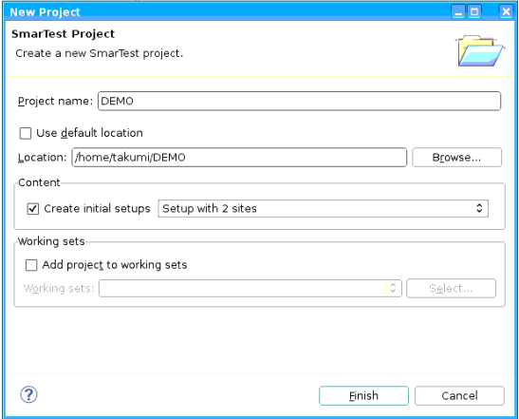

After that, “DEMO” device project will be created as the following.

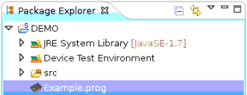

Copy “MIPI” folder and Paste it in a desired device project

Please copy & paste “MIPI” folder from another folder or projects to a desired device project from one of the three following ways,

- GUI Base on SmarTest 8’s Package Explorer
- GUI base on Dolphin file manager
- CUI base on Konsole

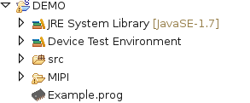

NOTE)
If you chose a way of “GUI Base on SmarTest 8’s Package Explorer”, please skip a next task. Because the next task has already done.

Set “MIPI” folder as “Source Folder”

We need to set “MIPI” folder as “Source Folder” in order to use setup, spec files and test methods from “MIPI” folder,

- Right Click on “MIPI” folder
- Left Click “Build Path” => “Use as Source Folder”

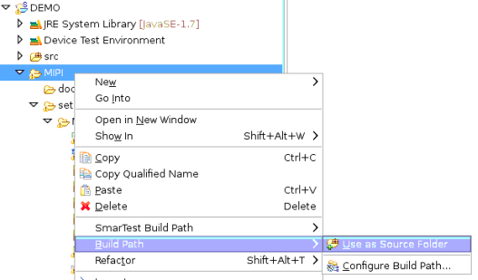

Removing Error description

After copying & pasting and setting “MIPI” folder as Source Folder, you see Error description in the following files,

- specPA_MIPI.spec
- ssi_base.spec

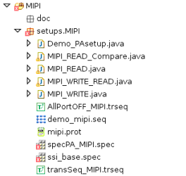

This is caused by that “SCLK” and “SDATA” signal names are not defined in “src/common/ExampleBoard.dbd” file. You can avoid this error by newly adding “SCLK” & “SDATA” information to “src/common/ExampleBoard.dbd”.
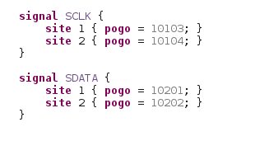

NOTE)
Above’s pogo channels may cause Run Time Error therefore please check whether your model file includes these channels. If they are not included, please change pogo channels or modify model file.

Spec File definition

“SCLK” & “SDATA” channel’s Level and Timing information hasn’t been defined. This topic adds both of their information to “src/exampleTests/ExampleSpec.spec”. Here, Level & Timing spec setting are defined according to Hi6H03 program’s setting.

2.5.1. Level Definition
Adds the following descriptions to “src/exampleTests/ExampleSpec.spec”.

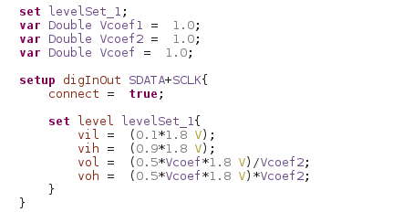

2.5.2. Timing Definition
Adds the following descriptions to “src/exampleTests/ExampleSpec.spec”.
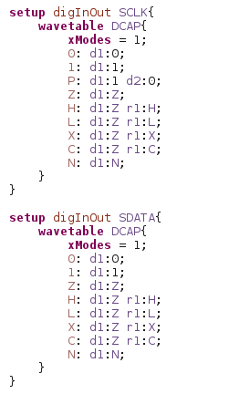
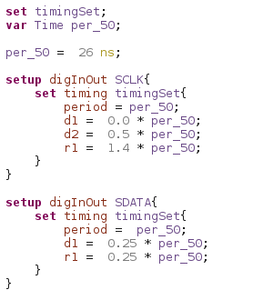

2.5.3. Digital Capture definition
Adds the following descriptions to “src/exampleTests/ExampleSpec.spec”.
This description is necessary to use Digital Capture on MIPI Read.
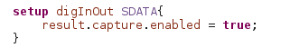

2.5.4. MIPI protocol definition
Adds the following descriptions to “src/exampleTests/ExampleSpec.spec”.
This description is necessary to call MIPI protocol.
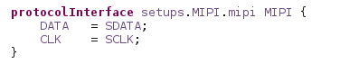

Test flow definition

“DEMO” device project has two test flows. One is “src/common/ExamplePreBind.flow” and the other is “src/common/ExampleMain.flow”. We modify both of them for applying “MIPI” test methods.

2.6.1. ExamplePreBind.flow modification
“MIPI” test methods need to get several parameters from test table. Therefore,
we need to use “TestTableReader” method and specify which test table will be used. Please modify “src/common/ExamplePreBind.flow” as the following,

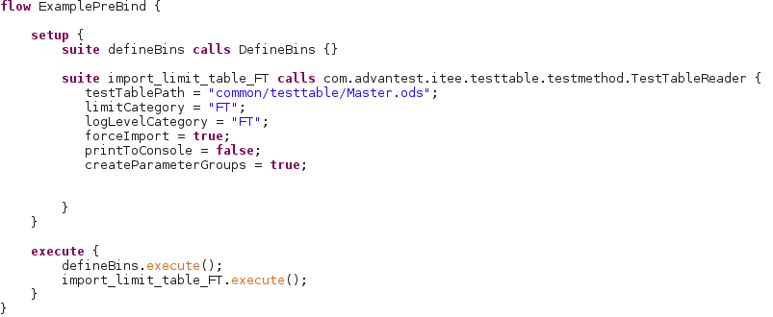

2.6.2. ExampleMain.flow modification
“MIPI_WRITE” and “MIPI_READ” test method can be called from “src.pa_tml.”. Please modify “src/common/ExampleMain.flow” as the following,

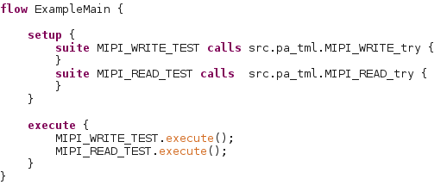

Test Table definition

In order to use “MIPI_WRITE” and “MIPI_READ” test methods, we need to use Test Table and get several parameters from it. Since we specified the test table name and path in the test flow definition, we set the test table there.

- Creates new folder whose name is “testtable” on “src/common/”

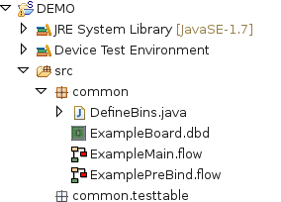

- Copies “Master.ods” and “Sub.ods” at “MIPI/doc”

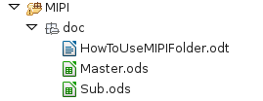

- Pastes “Master.ods” and “Sub.ods” to “src/common/testtable”

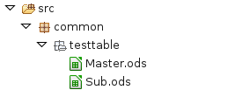

Executes test program

Check whether there are any Run Time Error during execution. Please execute test program.
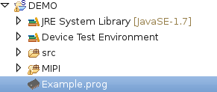

If Run Time Error doesn’t occur, Integrating MIPI Folder is success.

Points of integrating MIPI Folder to your desired project

      - “SCLK” and “SDATA” pin name are defined in “.dbd” file.

      - Level and Timing definition are defined well in Spec file.

      - Digital Capture setting is enabled in Spec file.
If disabled or not describe anything about Digital Capture, it causes Run Time Error on MIPI_READ test.

      - MIPI protocol definition is defined in Spec file.

      - Spec file name and path is filled out well in “Profile” sheets of Test Table.

      - “Addr”, “Data” and “USID” are filled out well in “Profile” sheets of Test Table.

NOTE)
Parameters name like “ImportSpec” of “Profile” sheet at Test table are case-sensitive. If your test method can’t read “ImportSpec” from Test table, please check whether both of Parameter name is perfectly matched.

Test Method
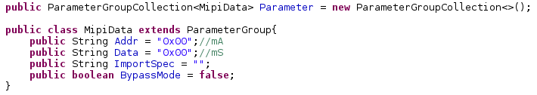
Parameters name of “Profile” sheet at Test Table
