Supplementary material
qPCRtools: a cross-platform desktop application for reproducible qPCR analysis without programming
Xiang Li^{1,2,*} Huichuan Huang^{1,2,*}
1 State Key Laboratory for Conservation and Utilization of Bio-Resources in Yunnan, Yunnan Agricultural University, Kunming, China
2 Key Laboratory for Agro-Biodiversity and Pest Control of Ministry of Education, Yunnan Agricultural University, Kunming, China
* Corresponding authors: lixiang117423@gmail.com (X.L.), absklhhc@gmail.com (H.H.)
Present address (X.L.): Yazhouwan National Laboratory, Sanya, Hainan, China

Contents
- Figure S1 — Analysis output on the bundled example data (standard curves and $ΔΔC_{t}$ expression).
- Figure S2 — Agreement between the application and an independent base-R reference.
- Table S1 — Numerical agreement summary across all methods. Panel (a): expression and curve quantities. Panel (b): raw and Holm-adjusted $P$ values.
- Table S2 — $P$-value sensitivity to the analysis scale.
- Table S3 — Reproducible re-analysis of the published qPCR examples.

Analysis output on the bundled example data
Figure S1 shows the two analyses discussed in the main text, produced from the application’s numerical output by the plotting script shipped in the repository (code/validation/plot_examples.py, matplotlib), which gives finer control over the layout than the in-interface figure export. The per-group means, standard deviations and $P$-values were independently reproduced without the application or the R package by code/validation/ check_example_stats.R.
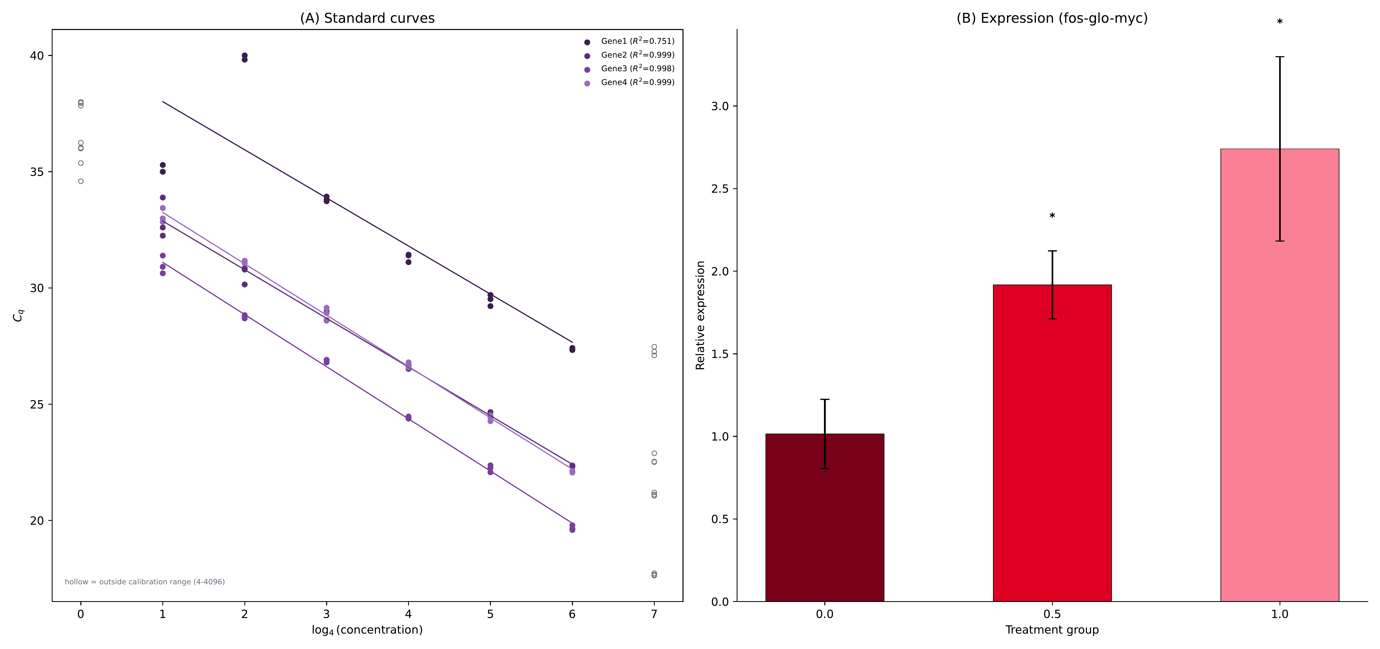
Figure S1. Analysis output on real data. (A) Standard curves for four genes over a four-fold dilution series, with fitted regressions and $R^{2}$. The abscissa is $\log_{4}$ concentration (dilution steps), matching the regression. Hollow symbols mark wells outside the calibrated range (4–4096). Gene1 has $R^{2}=0.75$ and is unsuitable for quantification; the other three have $R^{2}>0.99$. (B) Relative expression of fos-glo-myc across treatment groups ($ΔΔC_{t}$ method, calibrated to the control group), with Holm-adjusted significance labels and individual biological replicates. Reproduced from figures/fig2_results_v2.pdf.

Reproducible re-analysis of published qPCR data
The two real example plates distributed with the 2022 qPCRtools paper were processed independently in the graphical interface. The four-gene dilution series was used to demonstrate curve fitting and quality-control rejection. The separate treatment plate contains six genes, two groups, four biological replicates and two technical replicates; its design table supplies the published gene-specific efficiencies. Because those efficiencies are not all equal to the reference gene, the efficiency-corrected standard-curve expression path was selected. The treatment data and dilution series are separate published examples and are not described as one biological experiment.

Validation against an independent base-R reference
The application and an independent base-R implementation were run on the same input files for all three quantification methods. The reference was computed directly from the raw $C_{q}$ tables and did not call the R package. Every resulting quantity was compared pairwise (Figure S2, Table S1).
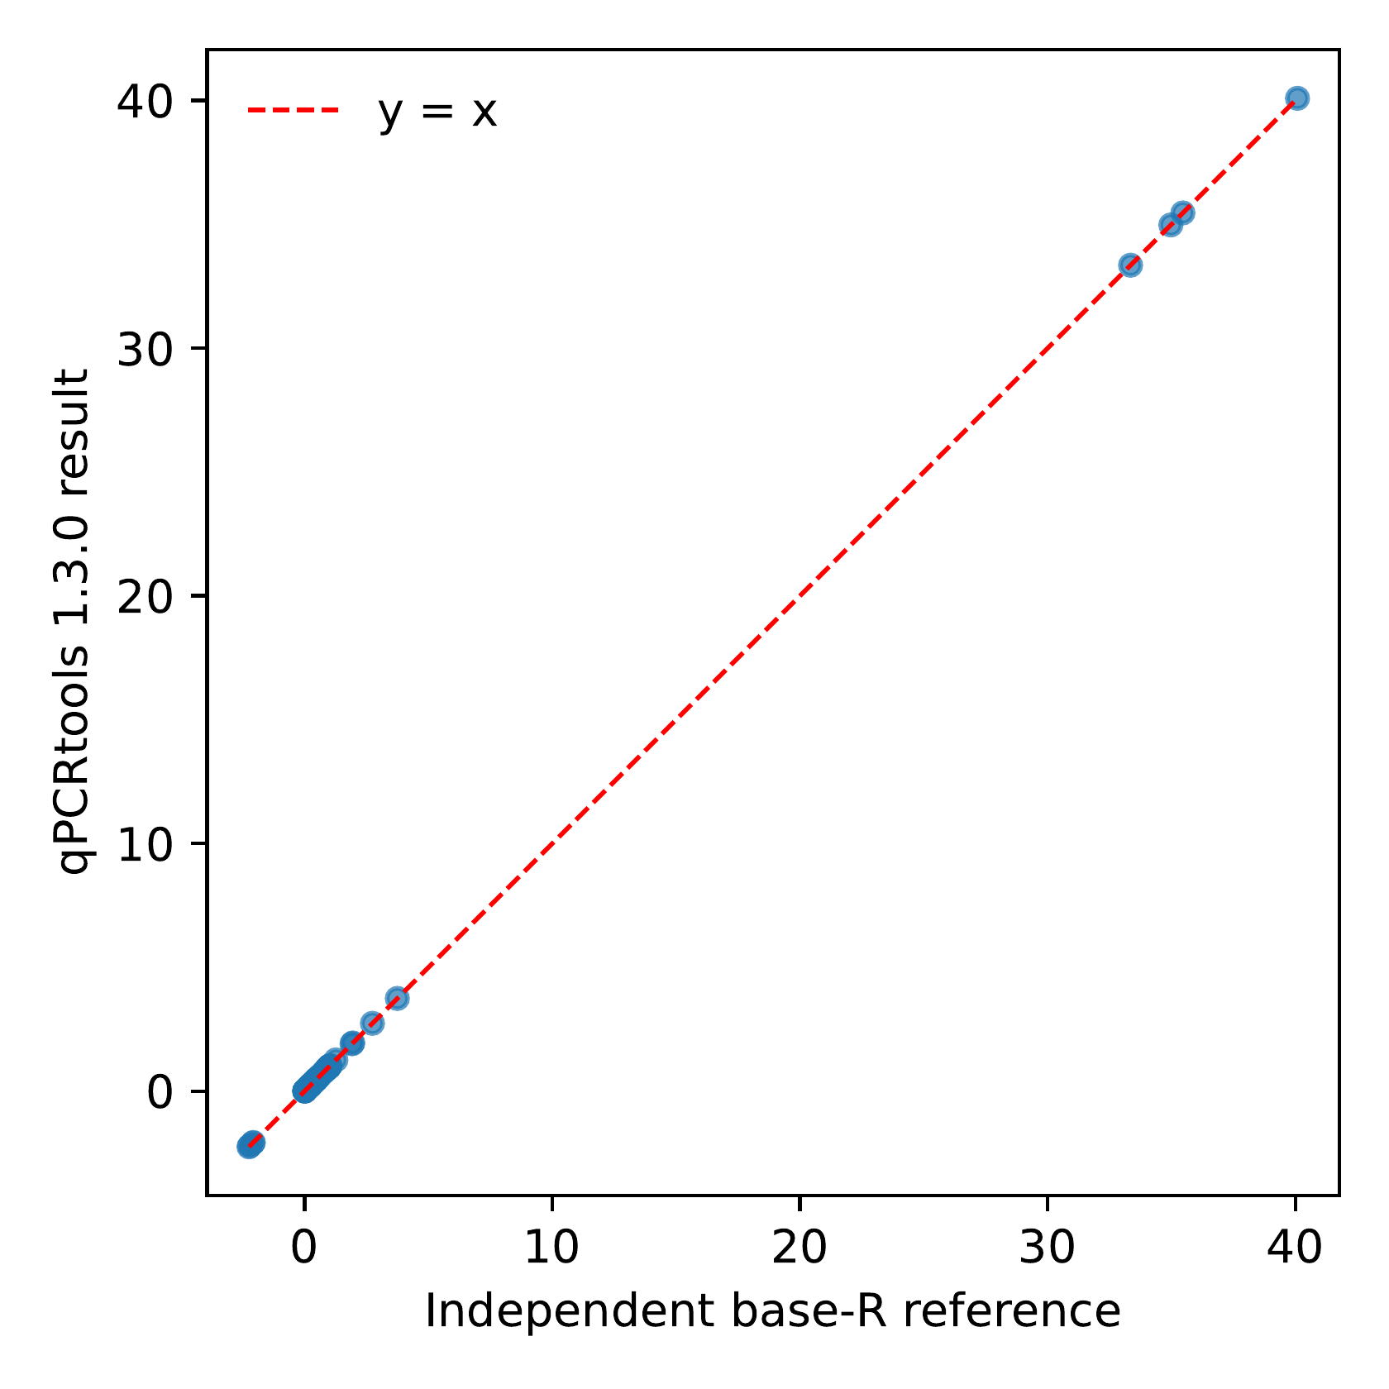
Figure S2. Agreement between the application and an independent base-R reference. Each application result is plotted against the corresponding reference value across all methods; all points fall on the line $y=x$.
Table S1. Agreement of the application with an independent base-R reference. (a) Compared quantities across all three methods; the maximum relative difference over all 58 paired values was $1.9×{10}^{−14}$. (b) Selected values from the bundled $ΔΔC_{t}$ example. The unadjusted $P$ values (0.006027 and 0.022191) are retained, and Holm adjustment within the gene gives 0.012055 and 0.022191. Generated by code/validation/ reference_base_r.R and code/validation/ compare_to_reference.R.
(a) agreement with the independent base-R reference
Method | Compared quantities | Max. rel. diff.
$ΔΔC_{t}$​ | expression, SD, raw and Holm $P$ | $1.7×{10}^{−14}$​
Standard curve | slope, intercept, $R^{2}$, efficiency | $4.2×{10}^{−15}$​
RqPCR | expression, SD, SE, raw and Holm $P$ | $1.9×{10}^{−14}$​
(b) selected values (bundled example, $ΔΔC_{t}$)
Quantity | Application (C++) | Independent base-R reference
Mean $±$ SD, group 0.0 | $1.0145±0.2098$​ | $1.0145±0.2098$​
Mean $±$ SD, group 0.5 | $1.9169±0.2060$​ | $1.9169±0.2060$​
Mean $±$ SD, group 1.0 | $2.7403±0.5580$​ | $2.7403±0.5580$​
Welch raw $P$ vs control | 0.006027 / 0.022191 | 0.006027 / 0.022191
Welch Holm $P$ vs control | 0.012055 / 0.022191 | 0.012055 / 0.022191
ANOVA $P$ (all groups) | 0.0034471 | 0.0034471
Tukey letters | b / ab / a | b / ab / a

Table S2. Sensitivity of the Welch comparison to the analysis scale. The primary analysis uses linear relative expression; the alternative uses $ΔC_{t}$. Holm correction is applied across the two treatment-control comparisons on each scale.
Scale and group | Raw $P$ | Holm-adjusted $P$
Linear relative expression, dose 0.5 | 0.006027 | 0.012055
Linear relative expression, dose 1 | 0.022191 | 0.022191
$ΔC_{t}$, dose 0.5 | 0.017565 | 0.017565
$ΔC_{t}$, dose 1 | 0.004404 | 0.008809

Table S3. End-to-end re-analysis of the published qPCRtools examples. The two plates are separate examples from the 2022 study. The workflow was run through the graphical interface and checked by code/scripts/19_verify_real_workflow.py.
Stage | Input and settings | Result
Dilution series | 96 wells; four genes; eight four-fold concentrations (4–4096); three wells per point | Gene1 $R^{2}=0.7509$ and was rejected; the other curves had $R^{2}=0.9983$–$0.9993$
Method selection | Published gene-specific efficiencies for six genes | Standard-curve expression selected instead of $2^{−ΔΔC_{t}}$
Group comparison | 96 wells; five target genes plus OsUBQ; CK versus treatment; four biological and two technical replicates | Welch tests with Holm correction: OsPR10 $P=0.0368$; OsWAK91 $P=0.00230$; the other three genes were not significant
QC and export | Default Cq and technical-replicate thresholds; summary, replicate-level table, two figures and analysis record exported | One well with $C_{q}>35$; 13 samples with technical-replicate SD $>0.5$; deterministic checker returned REAL-WORKFLOW PASS
The maximum relative difference over all compared values was $1.9×{10}^{−14}$. Numerical agreement establishes consistency with the specified algorithms, not biological correctness.
For the ANOVA path, the overall ANOVA $P$ value was 0.0034471 and the Tukey compact letter display was b / ab / a. Group 0 and group 1 differed ($P_{adj}=0.0028$), whereas group 0.5 was not separated from either ($P_{adj}=0.052$ and 0.073). The Holm-adjusted Welch comparison for the 0.5 group was $P=0.0121$, so its symbol changed from ** to * relative to the unadjusted value.

