qPCRtools2: a cross-platform C++ desktop application for qPCR data analysis with validated equivalence to its R implementation

Xiang Li^{1,2}, xxx, Huichuan Huang^{2,*}
¹ Yazhouwan National Laboratory, Sanya, Hainan Province, China
² State Key Laboratory for Conservation and Utilization of Bio-Resources in Yunnan, Yunnan Agricultural University, Kunming, China
Corresponding author email: absklhhc@gmail.com
Abstract
Quantitative real-time PCR (qPCR) is a cornerstone technique for measuring gene expression, yet rigorous analysis—primer-amplification-efficiency estimation, choice of quantification method, statistical testing, and publication-quality visualization—remains non-trivial. Existing tools either require programming, notably in R (including our own qPCRtools package), or are commercial software that is costly, closed-source, and platform-restricted, or are web services that are often discontinued and raise data-privacy concerns. Here we present qPCRtools2, a cross-platform desktop application written in C++ with Qt6 that delivers a complete qPCR analysis pipeline through a graphical interface and ships as a single executable with no runtime dependencies. The application implements standard-curve construction and amplification-efficiency estimation, the $ΔC_{t}$ and $ΔΔC_{t}$ methods, and an efficiency-based (RqPCR) method, together with extended statistical testing (independent, paired, and Welch $t$-tests, Wilcoxon tests, one-way ANOVA with Tukey’s HSD, Shapiro–Wilk normality testing, and Cohen’s $d$). We validated the C++ implementation against the original R package on multiple real datasets: across all shared methods the results agree to numerical precision, and the validation is fully reproducible from open scripts. qPCRtools2 is freely available under the MIT license for Windows and macOS, with source code compilable on Linux.

Introduction
Quantitative real-time PCR (qPCR) is among the most widely used techniques in molecular biology for quantifying nucleic acids and measuring gene expression (Bustin et al. 2009). A sound qPCR analysis involves several interdependent steps: estimating primer amplification efficiency, choosing an appropriate quantification strategy, performing statistical testing, and producing publication-quality figures (Bustin et al. 2010). When the amplification efficiencies of target and reference genes are comparable, the $2^{−ΔΔC_{T}}$ method (Livak and Schmittgen 2001) is convenient; when they differ, an efficiency-corrected or standard-curve-based approach is required instead (Pfaffl 2001). These analytical choices, combined with the need for rigorous statistics and clear visualization, make qPCR data analysis demanding for many laboratory researchers.
A range of tools address qPCR analysis (Pabinger et al. 2014), yet each carries trade-offs. R packages—including our own qPCRtools2 (Li et al. 2022) and pcr (Ahmed and Kim 2018)—implement sound algorithms but demand R programming skill and a configured software environment, which hampers reproducibility across collaborators. Commercial packages such as QuantStudio, CFX Maestro, REST, and qbase+ offer graphical interfaces but are costly, closed-source, and frequently restricted to a single operating system or instrument. Free web-based tools exist but are often discontinued and require uploading experimental data to remote servers, raising reproducibility and privacy concerns. The gap, therefore, is for a tool that combines validated algorithmic equivalence to a trusted implementation with a native, cross-platform, zero-dependency delivery, together with statistical options broader than those of the original R package.
We introduce qPCRtools2, a C++/Qt6 desktop application that reimplements the analytical core of our R package behind a point-and-click interface distributed as a single executable. This Application Note makes four contributions: (i) a C++/Qt architecture in which a tested core algorithm library is decoupled from a web-based user interface; (ii) a validation demonstrating numerical equivalence to the R package across all shared quantification methods; (iii) statistical and functional extensions beyond the original R version, including non-parametric tests, normality testing, effect sizes, and reference-gene selection; and (iv) a fully reproducible validation package.

Implementation

Architecture
qPCRtools2 is written in C++17 and built on Qt6 (The Qt Company 2024), which provides cross-platform abstractions and the native application shell. The user interface is rendered with web technologies—Bootstrap 5.3 for layout and Apache ECharts (Apache Software Foundation 2024) for interactive charts—hosted inside a QWebEngineView, and exchanges data with the native backend through Qt WebChannel via a registered bridge object. This separation lets the presentation layer iterate rapidly as HTML, CSS, and JavaScript while all numerical computation stays in compiled native code. The analytical core is isolated as a standalone static library, qpcr_core, which depends only on Qt Core and Eigen and is independent of the GUI; it is exercised directly by the unit-test suite and is also linked by the command-line equivalence driver described in Results. Statistical distribution functions use the GNU Scientific Library (GSL) for accuracy. The resulting interface is shown in Figure 1.
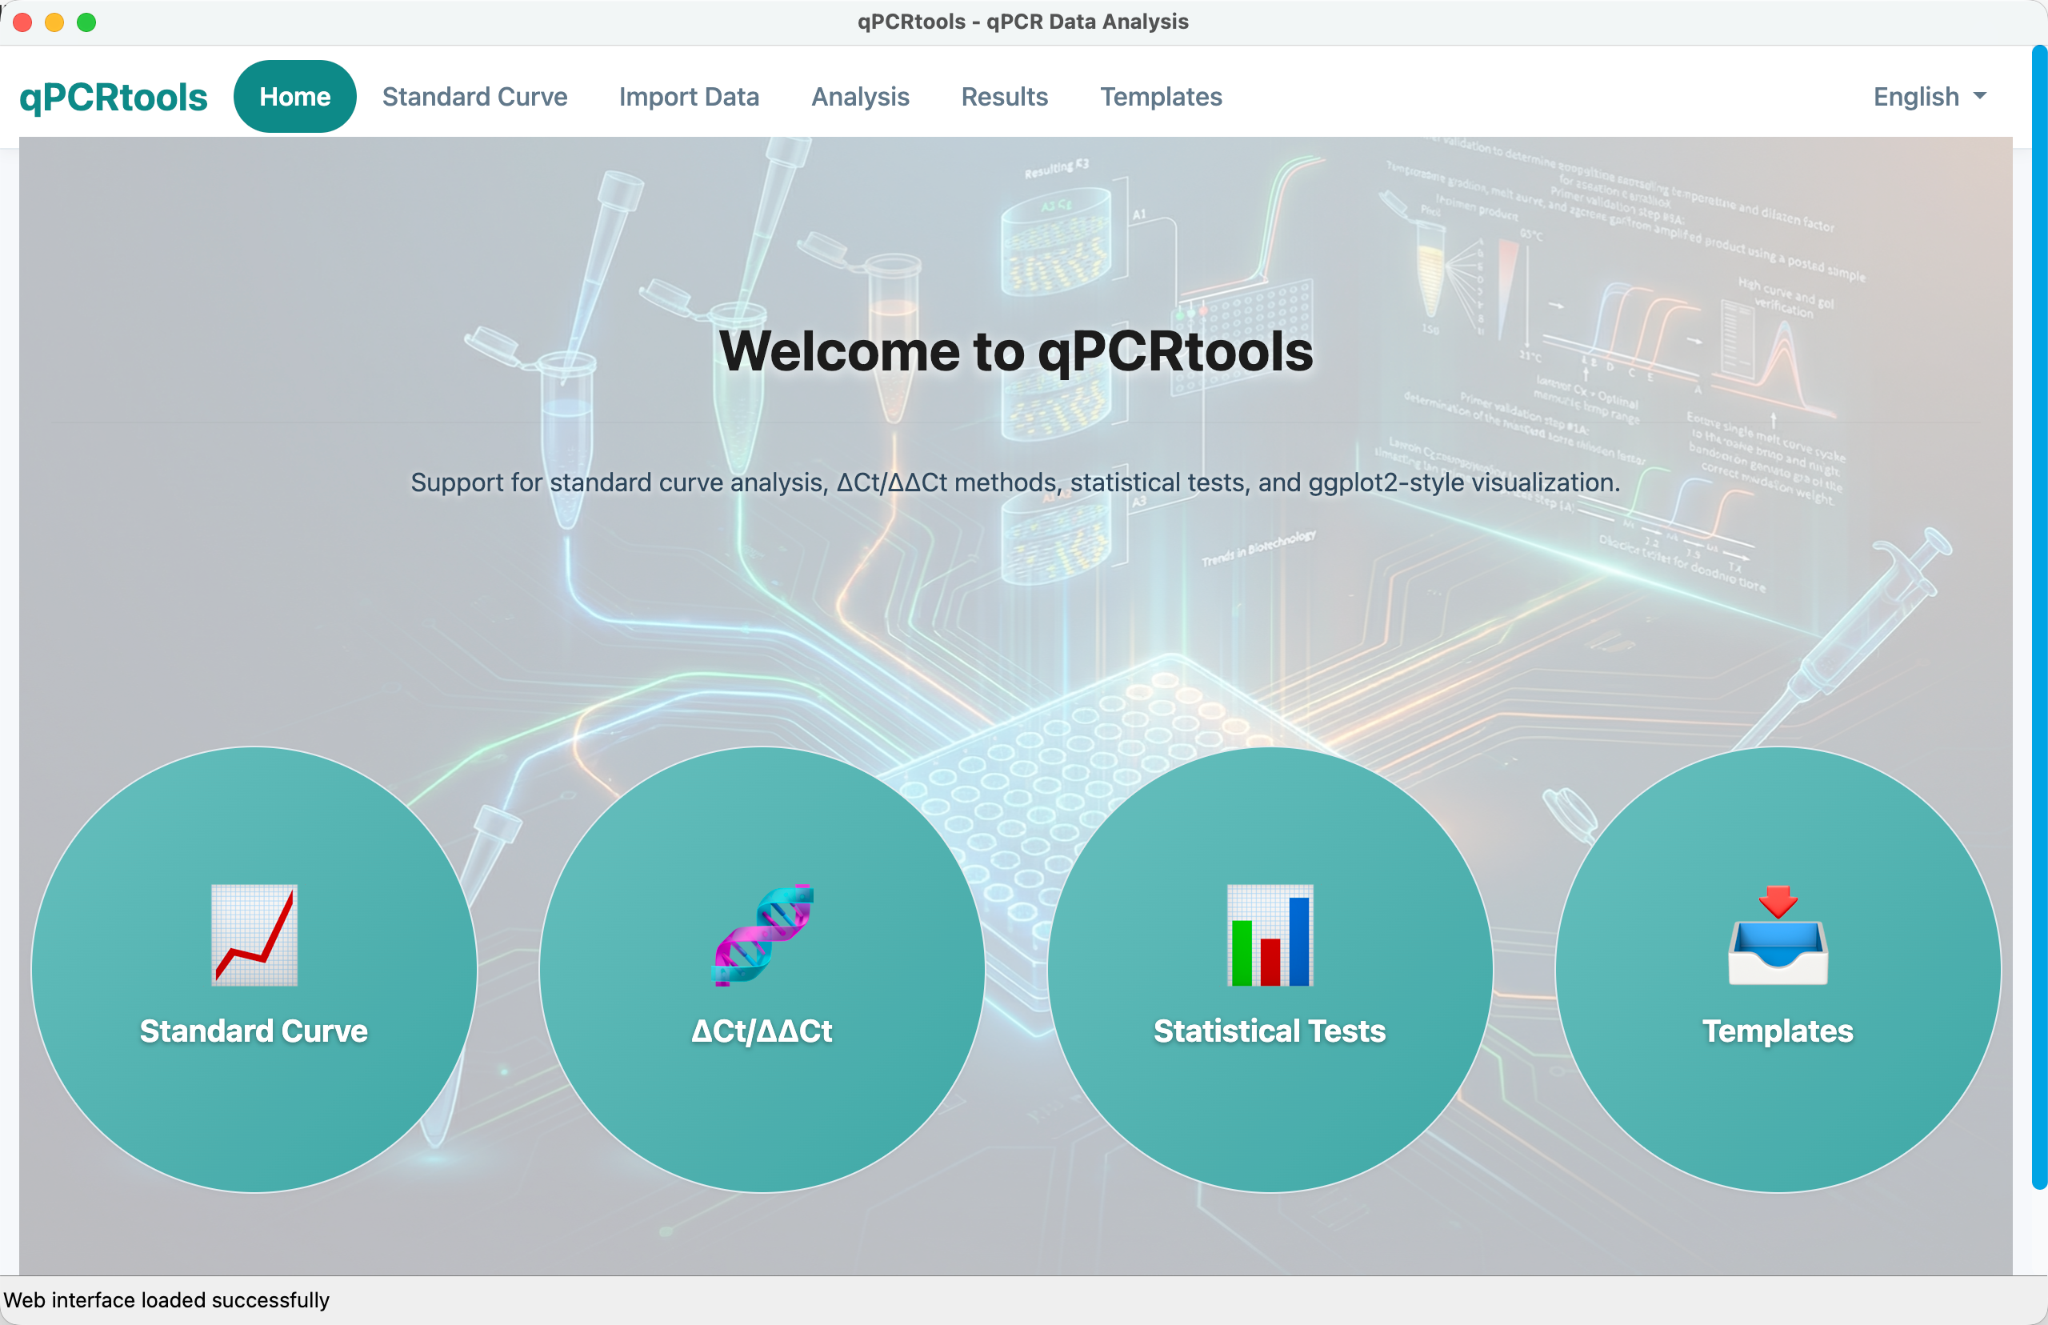
The qPCRtools2 desktop interface. A single cross-platform window hosts the web-based UI for data import, method and statistics configuration, and interactive results; no programming or runtime dependencies are required.

Quantification algorithms
The core reimplements the analytical methods of the R package. From a dilution series, amplification efficiency is obtained by ordinary least squares of $C_{q}$ on $\log_{10}(\text{concentration})$, yielding slope $s$, intercept, $R^{2}$, and a regression $p$-value; efficiency is
$$E=d^{−1/s}−1,$$
where $d$ is the dilution factor. Relative expression is computed by the $ΔC_{t}$ and $ΔΔC_{t}$ methods (Livak and Schmittgen 2001),
$$RE=2^{−\left[(C_{q,target}−C_{q,ref})_{treated}−(C_{q,target}−C_{q,ref})_{control}\right]},$$
and by an efficiency-based (RqPCR) method (Rancurel et al. 2019) in which per-sample quantities are $E^{ C_{q,min}−C_{q}}$ and are normalized by the geometric mean of one or more reference genes (Pfaffl 2001).

Statistical analysis
For each target gene the application compares groups with independent, paired, or Welch two-sample $t$-tests, the Wilcoxon rank-sum or signed-rank test, or one-way ANOVA followed by Tukey’s HSD post-hoc letter grouping. It additionally reports Cohen’s $d$ effect sizes, Shapiro–Wilk normality testing, and IQR-based outlier removal, and can select reference genes automatically by the geNorm algorithm (Vandesompele et al. 2002). These options extend the original R package, which provided $t$-test and ANOVA/Tukey testing only.

Software engineering and scope
qPCRtools2 is managed with CMake and ships with a unit-test suite. Visualization follows a ggplot2-inspired aesthetic (Wickham 2016) with configurable color palettes and significance annotations; the interface is bilingual (Chinese/English) and accepts both CSV and Excel input. The application is distributed as a single self-contained executable for Windows and macOS, requiring no R, Python, or runtime installation, and the source compiles on Linux. It is released under the MIT license. Two R functions are not yet ported—the standard-curve slope–intercept quantification (CalExpCurve) and the reverse-transcription reagent volume calculation (CalRTable)—and are planned for a future release.

Results

Typical analysis workflow
To illustrate a typical analysis, we analyzed the bundled example dataset (examples/cq.csv and examples/design.csv), comprising the target gene fos-glo-myc normalized against the reference gene Beta Actin across three treatment groups (0, 0.5, 1) with three biological replicates each. Using the $ΔΔC_{t}$ method with a two-sample $t$-test against the control group (0), relative expression rose monotonically to 1.11 at dose 0.5 and 1.59 at dose 1, both significant at $p<{10}^{−3}$ (Figure 2). Applied to a four-fold dilution series of four genes, the standard-curve module recovered slopes between $−2.07$ and $−2.24$ with $R^{2}>0.99$ for three of the four primers (efficiencies 0.85–0.95), illustrating amplification-efficiency estimation that, per MIQE guidance, determines which quantification method is appropriate. The complete workflow—import, configuration, analysis, and export—is performed through the graphical interface without writing code.
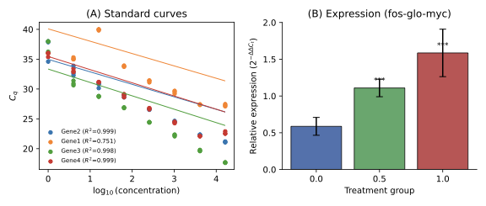
Analysis output on real data. (A) Standard curves for four genes over a four-fold dilution series, with fitted regressions and $R^{2}$. (B) Relative expression of fos-glo-myc across treatment groups ($ΔΔC_{t}$ method), with significance labels.

Equivalence to the R package
We validated the C++ implementation against the original R package (Li et al. 2022) by running both on identical inputs for every shared method—$ΔΔC_{t}$ (CalExp2ddCt), the standard curve (CalCurve), and the efficiency-based RqPCR method (CalExpRqPCR)—and comparing every resulting quantity pairwise (Table 1, Figure 3). Inputs were drawn from the repository’s example data and from a dilution series used in the original R package; both implementations read the same on-disk files, so any difference reflects the implementations alone.
Equivalence of C++ and R results across all shared methods on identical inputs. Relative difference is $|R−C++|/|R|$.
Method | Compared quantities | Pairs | Max. rel. diff.
$$ΔΔC_{t}$$ | expression, SD | 6 | $$3.8×{10}^{−15}$$
Standard curve | slope, intercept, $R^{2}$, efficiency | 16 | $$2.5×{10}^{−3}$$
RqPCR | expression, SE | 16 | $$2.1×{10}^{−15}$$
For the two expression methods, $ΔΔC_{t}$ and RqPCR, every compared quantity—expression values, standard deviations, and standard errors—matched between implementations to within floating-point precision (maximum relative difference $<4×{10}^{−15}$). For the standard curve, slope, intercept, $R^{2}$, and efficiency agreed to within $2.5×{10}^{−3}$ relative difference; the residual is attributable to the R package rounding its tabulated output to two to four decimal places, since the underlying $C_{q}$ inputs are identical. Plotting every C++ result against its R counterpart, all points fall on the line $y=x$ (Figure 3). These results confirm that the C++ reimplementation preserves the analytical behavior of the R package across all shared methods. The validation is fully reproducible from the open scripts in validation/ (see Availability).
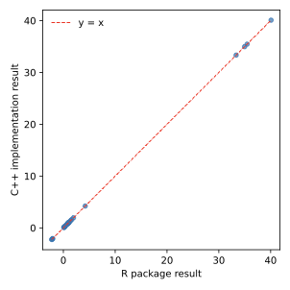
Numerical equivalence of the C++ implementation and the R package. Each C++ result is plotted against the corresponding R result across all shared methods ($ΔΔC_{t}$, standard curve, RqPCR); all points fall on the $y=x$ line.

Availability
The source code and pre-built binaries for Windows and macOS are available at https://github.com/lixiang117423/qPCRtools2_cpp under the MIT license. The repository includes documentation, a unit-test suite, example datasets, and a fully reproducible equivalence-validation package (validation/) comprising the R script, a C++ command-line driver linked against qpcr_core, and a comparison script that regenerates all validation outputs and figures. The project builds with CMake ($≥$ 3.20), requires a C++17 compiler and Qt 6 ($≥$ 6.5) with the WebEngine and WebChannel modules, and optionally links Eigen3 and GSL.

Authors’ contributions
X.L. conceived and designed the software, implemented the C++ codebase, performed the equivalence validation, and wrote the manuscript.

Acknowledgement
The author thanks the developers of the R packages and libraries on which this work builds, and the users who provided feedback during development.

Funding
This work was supported by the National Key R&D Program of China (2021YFD1000200), the National Natural Science Foundation of China (31801792, 31960554), and the Fok Ying Tung Education Foundation.

Conflict of interest
The author declares no competing interests.

References
Ahmed, Mohaned, and Dae- Ryong Kim. 2018. “pcr: An R Package for Quality Assessment, Analysis and Testing of qPCR Data.” PeerJ 6: e4473. https://doi.org/10.7717/peerj.4473.
Apache Software Foundation. 2024. Apache ECharts: A Declarative Framework for Rapid Construction of Web-Based Visualization. Https://echarts.apache.org/.
Bustin, Stephen A., Jean-François Beaulieu, Jim Huggett, et al. 2010. “MIQE Précis: Practical Implementation of Minimum Standard Guidelines for Fluorescence-Based Quantitative Real-Time PCR Experiments.” BMC Molecular Biology 11: 74. https://doi.org/10.1186/1471-2199-11-74.
Bustin, Stephen A., Vladimir Benes, Jeremy A. Garson, et al. 2009. “The MIQE Guidelines: Minimum Information for Publication of Quantitative Real-Time PCR Experiments.” Clinical Chemistry 55 (4): 611–22. https://doi.org/10.1373/clinchem.2008.112797.
Li, Xiang, Yingmin Wang, Jingyu Li, Xinyue Mei, Yixiang Liu, and Huichuan Huang. 2022. “qPCRtools2: An R Package for qPCR Data Processing and Visualization.” Frontiers in Genetics 13: 1002704. https://doi.org/10.3389/fgene.2022.1002704.
Livak, Kenneth J., and Thomas D. Schmittgen. 2001. “Analysis of Relative Gene Expression Data Using Real-Time Quantitative PCR and the $2^{−ΔΔC_{T}}$ Method.” Methods 25 (4): 402–8. https://doi.org/10.1006/meth.2001.1262.
Pabinger, Stephan, Stefan Rödiger, Anja Kriegner, Klemens Vierlinger, and Andreas Weinhäusel. 2014. “A Survey of Tools for the Analysis of Quantitative PCR (qPCR) Data.” Biomolecular Detection and Quantification 1: 23–33. https://doi.org/10.1016/j.bdq.2014.08.002.
Pfaffl, Michael W. 2001. “A New Mathematical Model for Relative Quantification in Real-Time RT-PCR.” Nucleic Acids Research 29 (9): e45. https://doi.org/10.1093/nar/29.9.e45.
Rancurel, Corinne, Thuy Van Tran, Corinne Elie, and Frédérique Hilliou. 2019. “SATQPCR: Website for Statistical Analysis of Real-Time Quantitative PCR Data.” Molecular and Cellular Probes 46: 101418. https://doi.org/10.1016/j.mcp.2019.07.001.
The Qt Company. 2024. Qt Cross-Platform Application Development Framework. Https://www.qt.io/.
Vandesompele, Jo, Katleen De Preter, Filip Pattyn, et al. 2002. “Accurate Normalization of Real-Time Quantitative RT-PCR Data by Geometric Averaging of Multiple Internal Control Genes.” Genome Biology 3 (7): research0034. https://doi.org/10.1186/gb-2002-3-7-research0034.
Wickham, Hadley. 2016. Ggplot2: Elegant Graphics for Data Analysis. Springer. https://doi.org/10.1007/978-3-319-24277-4.

