Supplementary material
qPCRtools: a cross-platform C++ desktop application for qPCR data analysis with validated equivalence to its R implementation
Xiang Li^{1,2,*} Huichuan Huang^{1,2,*}
1 State Key Laboratory for Conservation and Utilization of Bio-Resources in Yunnan, Yunnan Agricultural University, Kunming, China
2 Key Laboratory for Agro-Biodiversity and Pest Control of Ministry of Education, Yunnan Agricultural University, Kunming, China
* Corresponding authors: lixiang117423@gmail.com (X.L.), absklhhc@gmail.com (H.H.)
Present address (X.L.): Yazhouwan National Laboratory, Sanya, Hainan, China

Contents
- Figure S1 — Analysis output on the bundled example data (standard curves and $ΔΔC_{t}$ expression).
- Figure S2 — Numerical equivalence of the C++ implementation and the R package.
- Table S1 — Equivalence summary across all shared methods. Panel (a): numerical equivalence with the R package. Panel (b): the statistical layer (means, Welch $p$-values, ANOVA and Tukey letters) against an independent base-R reference.

Analysis output on the bundled example data
Figure S1 shows the two analyses discussed in the main text, produced from the application’s numerical output by the plotting script shipped in the repository (code/validation/plot_examples.py, matplotlib), which gives finer control over the layout than the in-interface figure export. The per-group means, standard deviations and $p$-values were independently reproduced without the application or the R package by code/validation/check_example_stats.R.
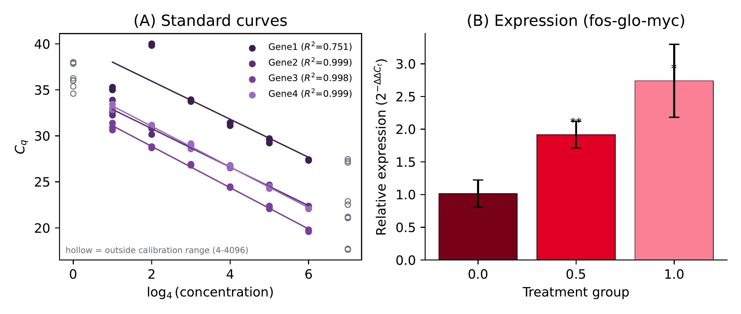
Figure S1. Analysis output on real data. (A) Standard curves for four genes over a four-fold dilution series, with fitted regressions and $R^{2}$. The abscissa is $\log_{4}$ concentration (dilution steps), matching the regression, and hollow symbols mark wells outside the calibrated range (4–4096) that are excluded from the fit. (B) Relative expression of fos-glo-myc across treatment groups ($ΔΔC_{t}$ method, calibrated to the control group), with significance labels. Reproduced from figures/fig2_results_v2.pdf.

Numerical equivalence to the R package
Both implementations were run on identical input files for every shared method—$ΔΔC_{t}$ (CalExp2ddCt), the standard curve (CalCurve) and the efficiency-based RqPCR method (CalExpRqPCR)—and every resulting quantity was compared pairwise (Figure S2, Table S1).
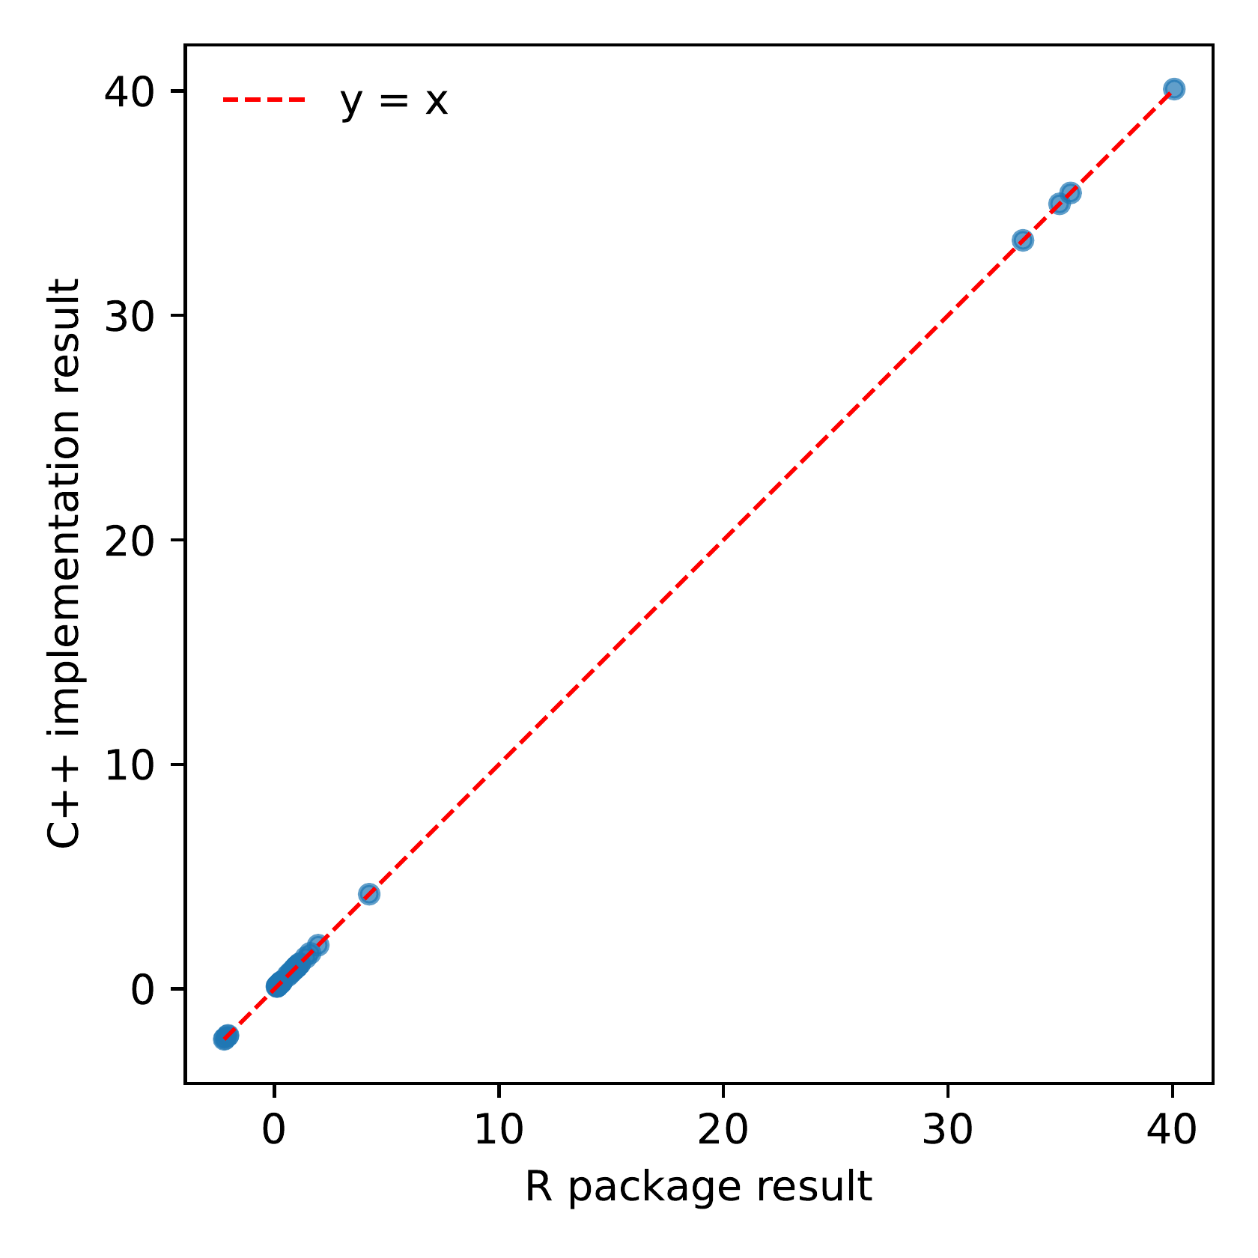
Figure S2. Numerical equivalence of the C++ implementation and the R package. Each C++ result is plotted against the corresponding R result across all shared methods; all points fall on the line $y=x$.
Table S1. Equivalence of the application (C++) with the reference implementations. (a) Numerical equivalence with the R package on identical inputs; relative difference is $|R−C++|/|R|$. (b) Statistical layer on the bundled $ΔΔC_{t}$ example, recomputed independently in base R without installing any package (code/validation/verify_stats.R).
(a) numerical equivalence to the R package
Method | Compared quantities | Max. rel. diff.
$ΔΔC_{t}$​ | expression, SD | $3.8×{10}^{−15}$​
Standard curve | slope, intercept, $R^{2}$, efficiency | $2.5×{10}^{−3}$​
RqPCR | expression, SE | $2.1×{10}^{−15}$​
(b) statistical layer (bundled example, $ΔΔC_{t}$)
Quantity | Application (C++) | Independent base-R reference
Mean $±$ SD, group 0.0 | $1.0145±0.2098$​ | $1.0145±0.2098$​
Mean $±$ SD, group 0.5 | $1.9169±0.2060$​ | $1.9169±0.2060$​
Mean $±$ SD, group 1.0 | $2.7403±0.5580$​ | $2.7403±0.5580$​
Welch $p$ vs control | 0.006027 / 0.022191 | 0.006027 / 0.022191
ANOVA $p$ (all groups) | 0.0034471 | 0.0034471
Tukey letters | b / ab / a | b / ab / a
The residual $2.5×{10}^{−3}$ for the standard curve is attributable to the R package rounding its tabulated output to two to four decimal places, since the underlying $C_{q}$ inputs are identical.
The statistical layer in Table S1(b) is reproduced by an independent base-R script that needs no package at all (code/validation/verify_stats.R), so the reported $p$-values and letter groupings can be checked without installing the R package. The letter display is the compact letter display of the Tukey HSD: group 0 and group 1 differ ($p_{adj}=0.0028$), whereas group 0.5 is not separated from either ($p_{adj}=0.052$ and $0.073$), giving b / ab / a. That borderline comparison is exactly the case in which an incorrect multiple-comparison step is exposed, and it is covered by both the script above and the regression tests in the repository.

