Self-introduction
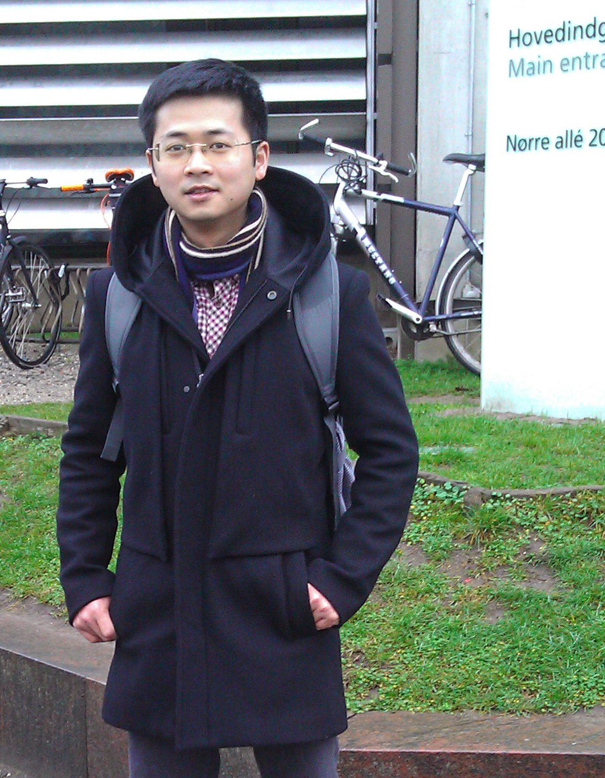
Basic information
Name: Peide Huang
Sex: Male
Age: 29
Native place: Guangdong, China
TEL：(086)151-1883-9736
Email: huangpeide1984@gmail.com
Contact address: 11th Building, Bei Shan Industrial Zone, Yantian District,Shenzhen,China

I have a background of molecular and cellular biology from my school years. I have already worked in the field of cancer genomics for more than 3 years and accumulated rich researching experience in this field. I was engaged in several studies about the pathogenesis of different kinds of cancers (eg.TCCs and ccRCCs). --------------------------------------------------------------------------------
Education
2013- Now Ph.D student
Faculty of Health and Medical Sciences, University of Copenhagen, Copenhagen, Danmark

2007-2010 Master of Science in Genetics
Jinan University, Guangdong, China
Thesis: The Study on the Promotional Effect of rhBMP-2 on Metastasis
of Breast Cancer

2003-2007 Bachelor of Science in Biotechnology
Jinan University, Guangdong, China
Thesis: The inhibitory effect of BMP-2 on the proliferation of breast cancer cell MDA-MB-231
--------------------------------------------------------------------------------
English Skills
Have a good command of both spoken and written English.
--------------------------------------------------------------------------------
Research Experience
Beijing Medicine Research Department, BGI Tech
Project leader 2012-2015
Participated in the researches of Bladder cancers (TCCs) and adrenal adenomas (ccRCCs), which supported by the National High Technology Research and Development Program of China. Identified TERT promoter mutations as discrimination biomarkers for the origin of urogenital tumors. Publish researching articles on the Journals Nature Genetics and European Urology.

Department of Science and Technology, BGI.ShenZhen
Assistant Researcher 2010– 2011
Participated in the researches of clear cell renal carcinoma (ccRCC),which supported by National High Technology Research and Development Program of China. Publish researching articles on the Journals Nature Genetics.
Developed methods for the validation of gene mutations, establish the Ofish platform for BGI.
Institute of Bioengineering,Jinan University, Guangdong, China
Master Student, 2007 – 2010
Participated in the research about the effect of human recombinant protein BMP-2 (rhBMP-2) on breast cancer cells.

Publications
- Wu S#, Huang P#, Li C, Huang Y, Li X, Wang Y, Chen C, Lv Z, Tang A, Sun X, Lu J, Li W, Zhou J, Gui Y, Zhou F, Wang D, Cai Z*. Telomerase reverse transcriptase gene promoter mutations help discern the origin of urogenital tumors: a genomic and molecular study. Eur Urol. 2014 Feb; 65(2):274-7.
- Guo G#, Sun X#, Chen C#, Wu S#, Huang P#, Li Z#, Dean M#, Huang Y, Jia W, Zhou Q, Tang A, Yang Z, Li X, Song P, Zhao X, Ye R, Zhang S, Lin Z, Qi M, Wan S, Xie L, Fan F, Nickerson ML, Zou X, Hu X, Xing L, Lv Z, Mei H, Gao S, Liang C, Gao Z, Lu J, Yu Y, Liu C, Li L, Fang X, Jiang Z, Yang J, Li C, Zhao X, Chen J, Zhang F, Lai Y, Lin Z, Zhou F, Chen H, Chan HC, Tsang S, Theodorescu D, Li Y, Zhang X, Wang J, Yang H, Gui Y, Wang J*, Cai Z*. Whole-genome and whole-exome sequencing of bladder cancer identifies frequent alterations in genes involved in sister chromatid cohesion and segregation. Nature Genet. 2013 Dec;45(12):1459-63
- Wang D, Huang P, Zhu B, Sun L, Huang Q, Wang J*. Induction of estrogen receptor α-36 expression by bone morphogenetic protein 2 in breast cancer cell lines. Mol Med Rep. 2012 Sep; 6 (3):591-6.
- Guo G, Gui Y, Gao S, Tang A, Hu X, Huang Y, Jia W, Li Z, He M, Sun L, Song P, Sun X, Zhao X, Yang S, Liang C, Wan S, Zhou F, Chen C, Zhu J, Li X, Jian M, Zhou L, Ye R, Huang P, Chen J, Jiang T, Liu X, Wang Y, Zou J, Jiang Z, Wu R, Wu S, Fan F, Zhang Z, Liu L, Yang R, Liu X, Wu H, Yin W, Zhao X, Liu Y, Peng H, Jiang B, Feng Q, Li C, Xie J, Lu J, Kristiansen K, Li Y, Zhang X, Li S, Wang J, Yang H, Cai Z*, Wang J*.Frequent mutations of genes encoding ubiquitin-mediated proteolysis pathway components in clear cell renal cell carcinoma. Nature Genet 2011;44:17-19
- Gui Y, Guo G, Huang Y, Hu X, Tang A, Gao S, Wu R, Chen C, Li X, Zhou L, He M, Li Z, Sun X, Jia W, Chen J, Yang S, Zhou F, Zhao X, Wu S, Ye R, Liang C, Liu Z, Huang P, Liu C, Jiang H, Wang Y, Zheng H, Sun L, Liu X, Jiang Z, Feng D, Chen J, Wu S, Zou J, Zhang Z, Yang R, Zhao J, Xu C, Yin W, Guan Z, Ye J, Zhang H, Li J, Kristiansen K, Nickerson ML, Theodorescu D, Li Y, Zhang X, Li S, Wang J, Yang H, Wang J*, Cai Z*.Frequent mutations of chromatin remodeling genes in transitional cell carcinoma of the bladder. Nature Genet 2011; 43:875-878
- Peide Huang, Feicheng Huang, Ju Wang.rhBMP2 enhance migration and invasion capacity of human breast cancer cells MCF-7.Chinese Journal of Pathophysiology.2010, 26(5):931-936
- [7] Wu S, Yang Z, Ye R, An D, Li C, Wang Y, Wang Y, Huang Y, Liu H, Li F, He L, Sun D, Yu Y, Li Q, Huang P, Zhang M, Zhao X, Bi T, Zhuang X, Zhang L, Lu J, Sun X, Zhou F, Liu C, Yang G, Hou Y, Fan Z, Cai Z. Novel variants in MLL confer to bladder cancer recurrence identified by whole-exome sequencing. Oncotarget. 2016 Jan 19;7(3):2629-45

