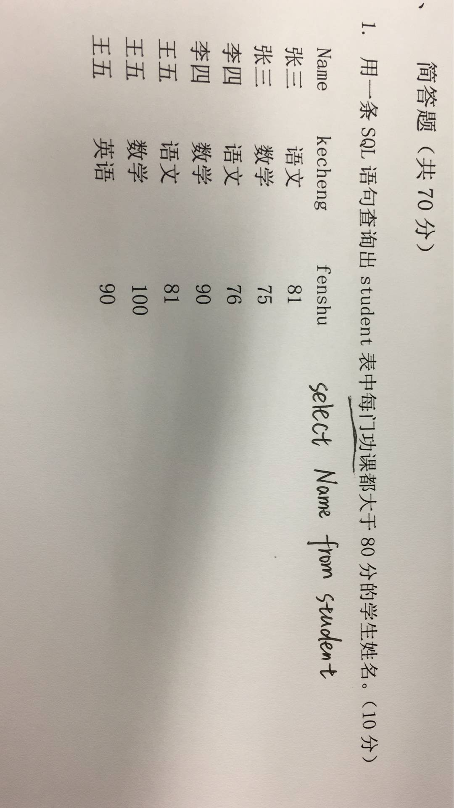

自己写法：

SELECT

NAME

FROM

(

SELECT

a. NAME,

a.beforeCount,

b.afterCount

FROM

(

SELECT

NAME,

COUNT(\*) beforeCount

FROM

student

GROUP BY

NAME

) a

INNER JOIN (

SELECT

NAME,

COUNT(\*) afterCount

FROM

student

WHERE

fenshu > 80

GROUP BY

NAME

) b ON a.`name` = b.`name`

) c

WHERE

c.beforeCount = c.afterCount;

简介写法：

SELECT DISTINCT

NAME

FROM

student

WHERE

NAME NOT IN (

SELECT DISTINCT

NAME

FROM

student

WHERE

fenshu <= 80

);

