Order模块

耦合

|  |  |  |
| --- | --- | --- |
| 类名 | CBO | DAC |
| OrderController | 8 | 2 |
| 调用其他类4，被其他类调用4 | MemberController  User |

|  |  |  |
| --- | --- | --- |
| 类名 | CBO | DAC |
| Order | 7 | 1 |
| 调用其他类4，被其他类调用3 | UserPO |

内聚

OrderController

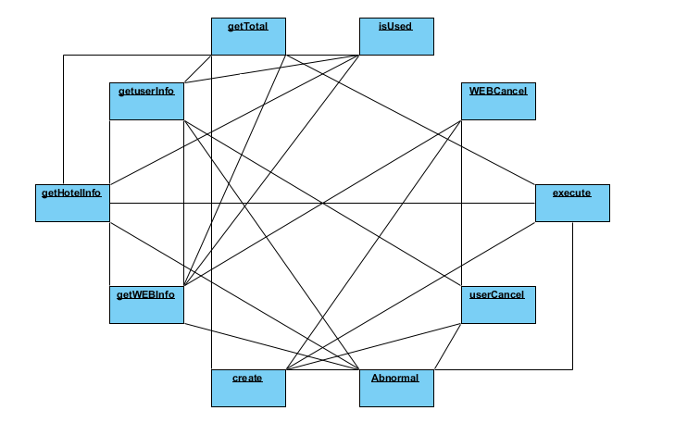

Order

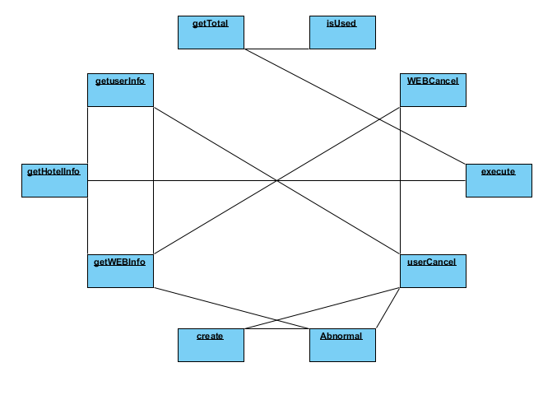

Hotel模块

耦合

|  |  |  |
| --- | --- | --- |
| 类名 | CBO | DAC |
| HotelController | 8 | 2 |
| 调用其他类4，被其他类调用4 | MemberController  User |

|  |  |  |
| --- | --- | --- |
| 类名 | CBO | DAC |
| Hotel | 7 | 1 |
| 调用其他类4，被其他类调用3 | UserPO |

内聚

HotelController

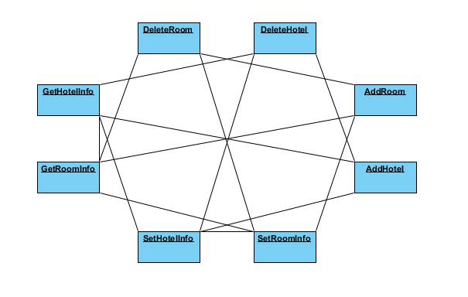

Hotel

