Member模块

耦合

|  |  |  |
| --- | --- | --- |
| 类名 | CBO | DAC |
| MemberController | 10 | 2 |
| 调用其他类6，被其他类调用4 | Member |

|  |  |  |
| --- | --- | --- |
| 类名 | CBO | DAC |
| Member | 10 | 1 |
| 调用其他类4，被其他类调用6 | MemberPO |

MemberController

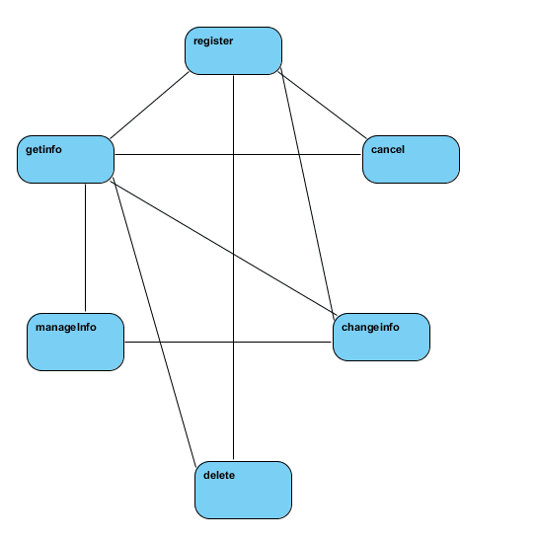

Member

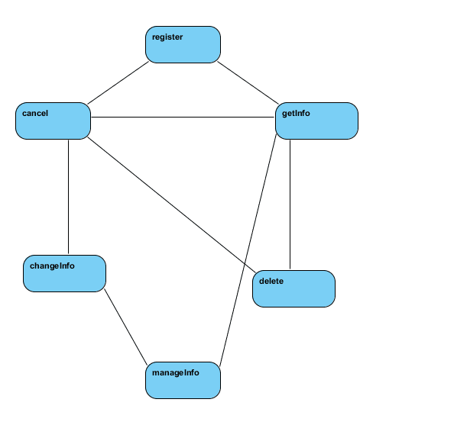

Comment模块

耦合

|  |  |  |
| --- | --- | --- |
| 类名 | CBO | DAC |
| CommentController | 4 | 1 |
| 调用其他类2，被其他类调用2 | Comment |

|  |  |  |
| --- | --- | --- |
| 类名 | CBO | DAC |
| Comment | 4 | 1 |
| 调用其他类2，被其他类调用2 | CommentPO |

CommentController

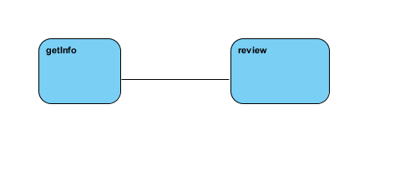

Comment

