Strategy模块

耦合

|  |  |  |
| --- | --- | --- |
| 类名 | CBO | DAC |
| StrategyController | 10 | 2 |
| 调用其他类7，被其他类调用3 | Stratgey  HotelController |

|  |  |  |
| --- | --- | --- |
| 类名 | CBO | DAC |
| Strategy | 16 | 2 |
| 调用其他类9，被其他类调用7 | StrategyPO  HotelController |

内聚

StrategyController

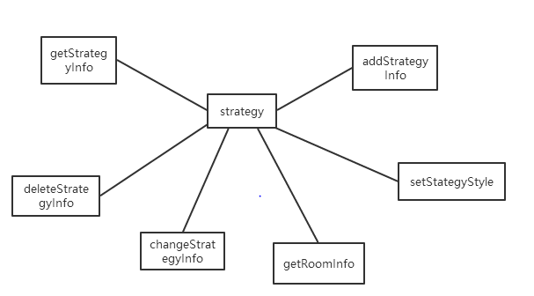

Strategy

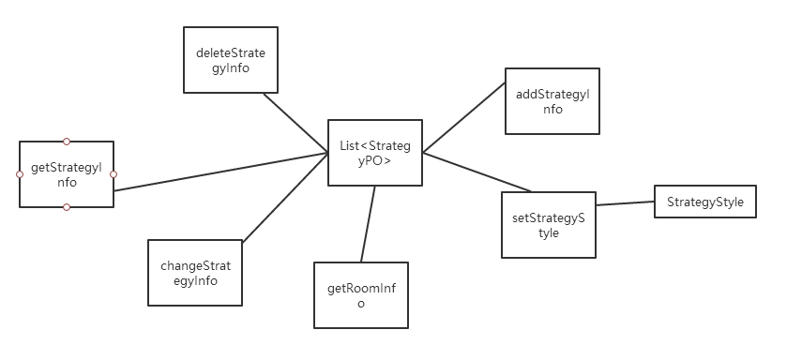

Credit模块

|  |  |  |
| --- | --- | --- |
| 类名 | CBO | DAC |
| CreditController | 8 | 2 |
| 调用其他类6，被其他类调用2 | Credit  UserController |

|  |  |  |
| --- | --- | --- |
| 类名 | CBO | DAC |
| Credit | 5 | 1 |
| 调用其他类2，被其他类调用3 | CreditPO |

CreditController

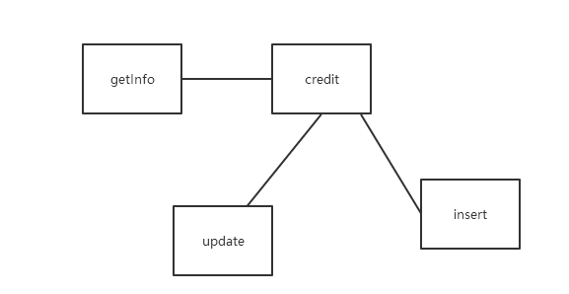

Credit

