User模块

耦合

|  |  |  |
| --- | --- | --- |
| 类名 | CBO | DAC |
| UserController | 8 | 2 |
| 调用其他类4，被其他类调用4 | MemberController  User |

|  |  |  |
| --- | --- | --- |
| 类名 | CBO | DAC |
| User | 7 | 1 |
| 调用其他类4，被其他类调用3 | UserPO |

内聚

UserController

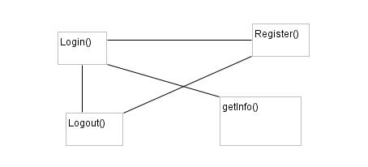

User

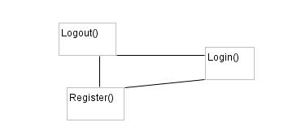

Browse模块

耦合

|  |  |  |
| --- | --- | --- |
| 类名 | CBO | DAC |
| BrowseController | 20 | 1 |
| 调用其他类10，被其他类调用10 | Browse |

|  |  |  |
| --- | --- | --- |
| 类名 | CBO | DAC |
| Browse | 26 | 7 |
| 调用其他类16，被其他类调用10 | BrowsePO  MemberController  CreditController  StrategyController  HotelController  CommentController  OrderController |

内聚

BrowseController

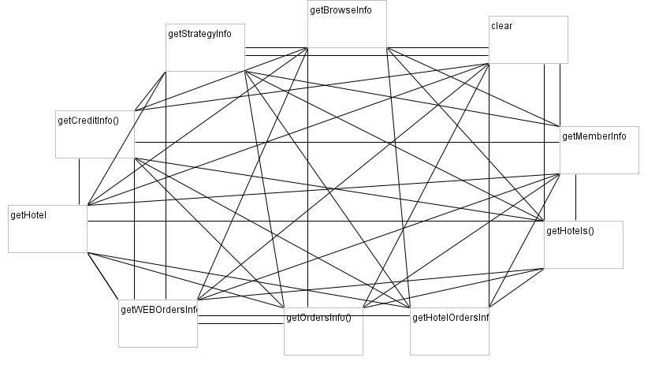

Browse

