<https://creditcards.chase.com/?CELL=6TKX%20%20>

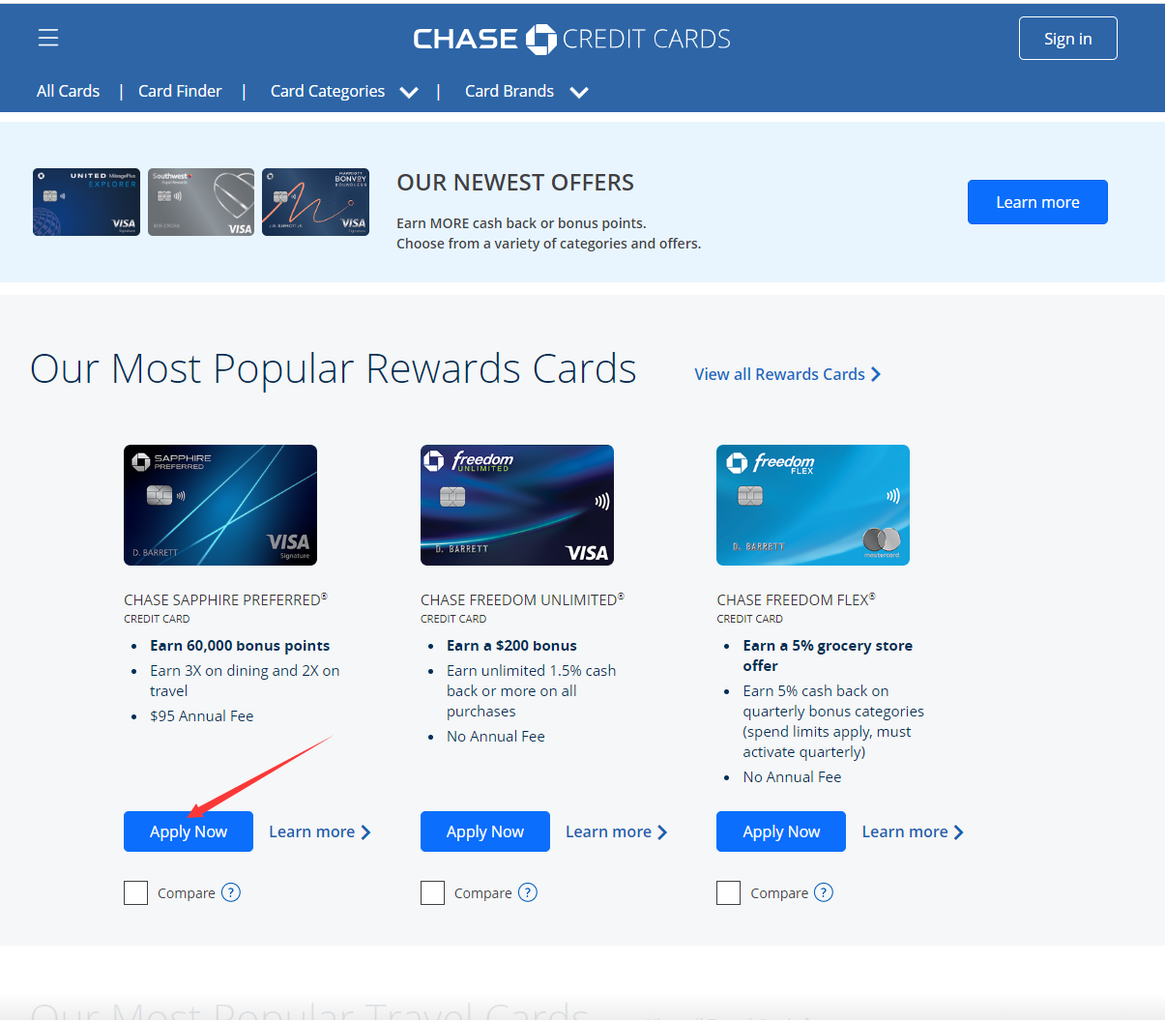

<https://secure.chase.com/web/oao/application/card?sourceCode=HJHB&action=guest&cellCode=61DS&combo=Y&flowVersion=REACT#/origination/cardDetails/index/initiateConFullApp>

