网站：https://creditcards.wellsfargo.com/?sub_channel=WEB&vendor_code=WF

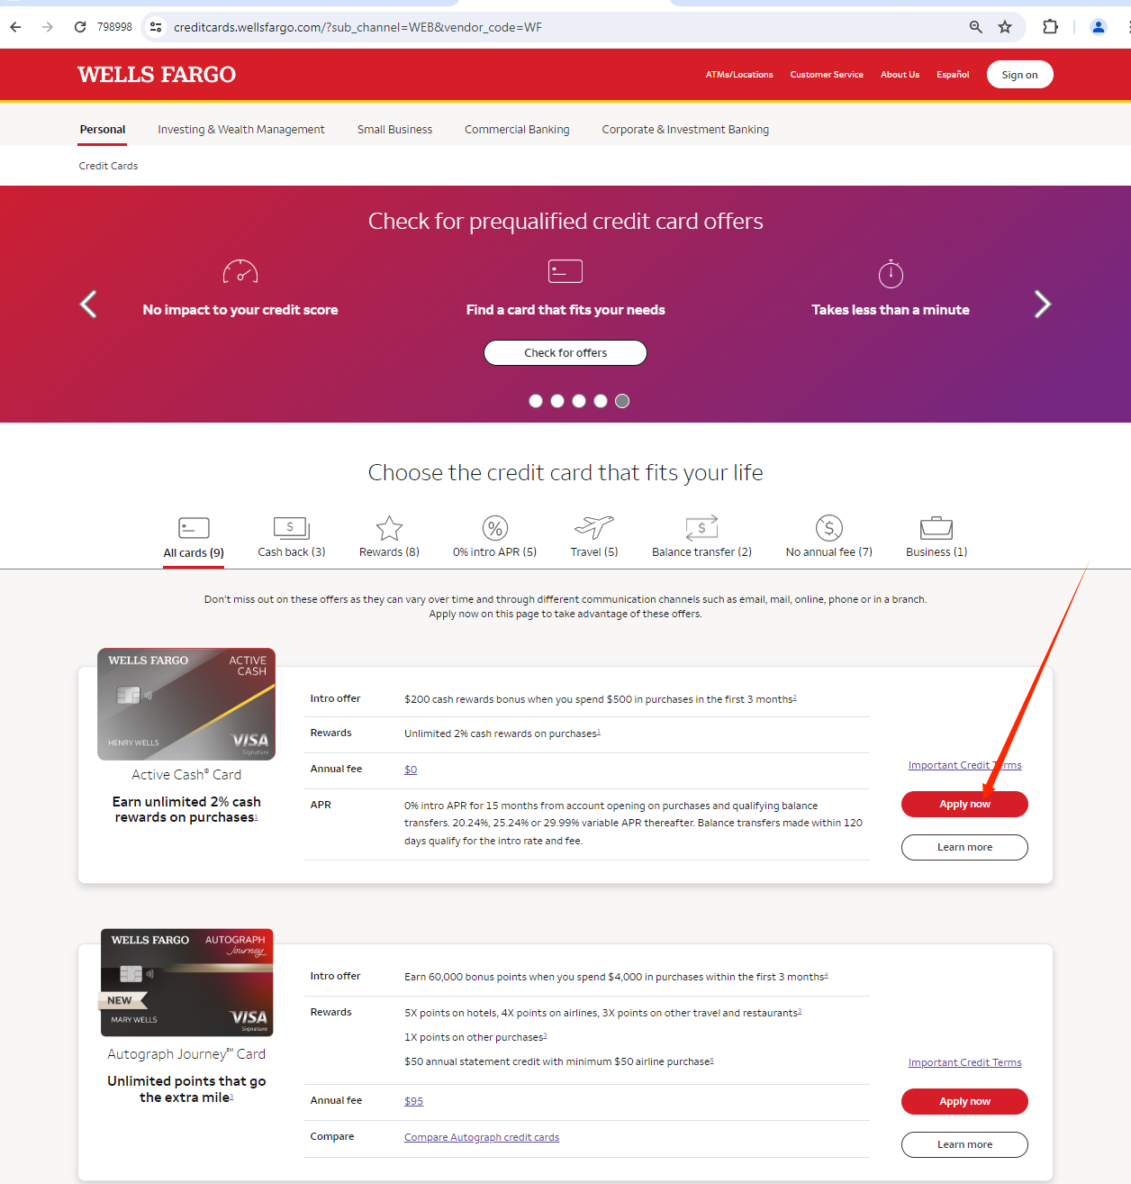

https://apply.wellsfargo.com/consumercreditcard?token=LlTkf5S0k8gW-0g4AuL2ow4QQekTRG5s#OSMA_APPL_CONSUMER_CREDITCARD_PA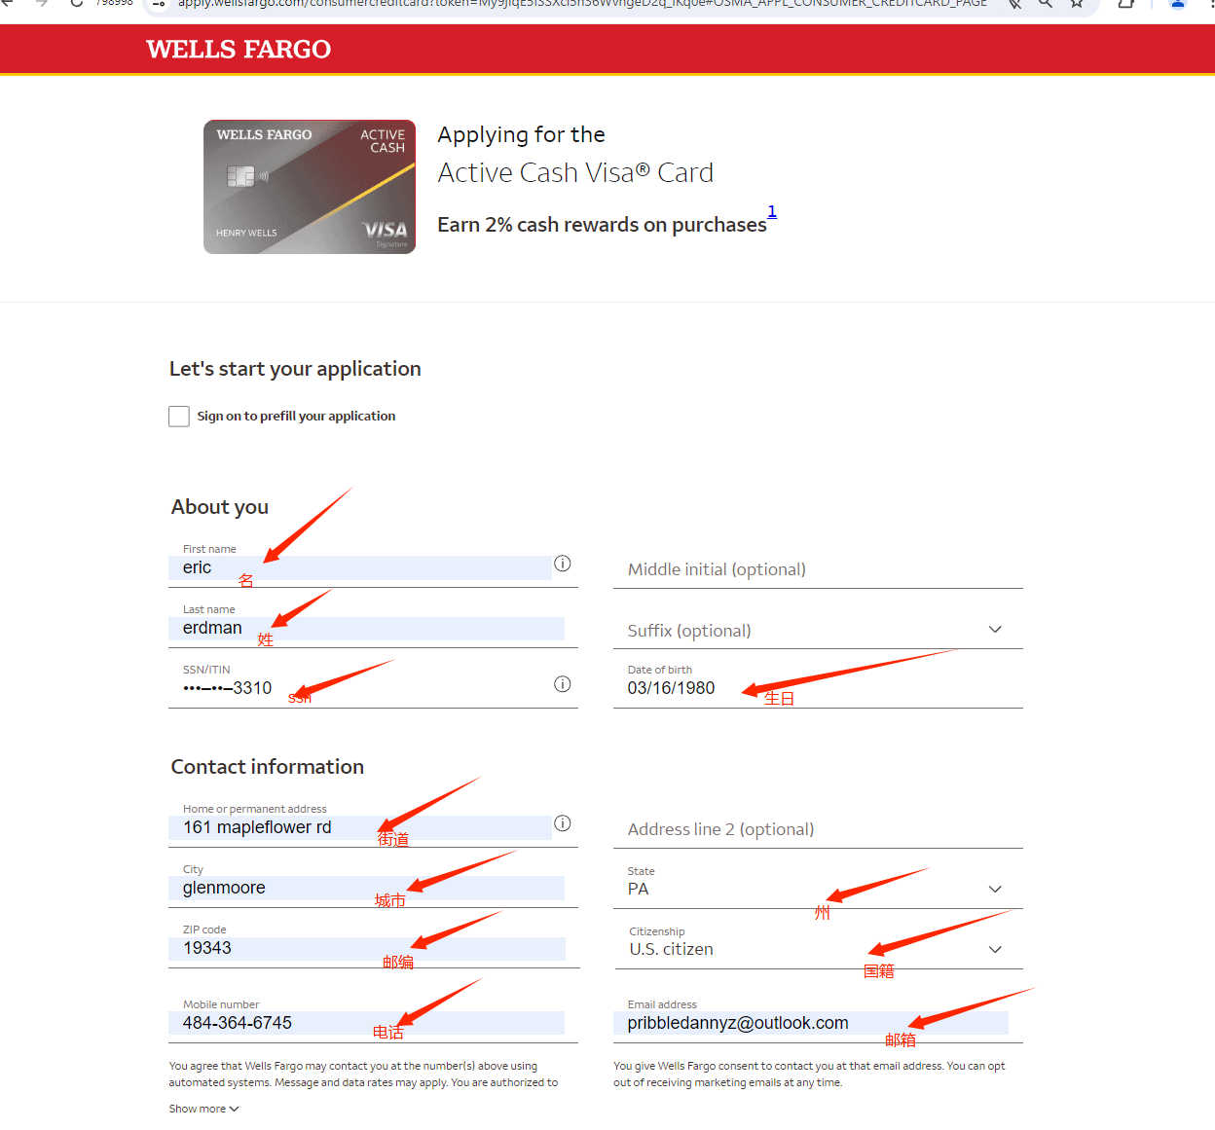
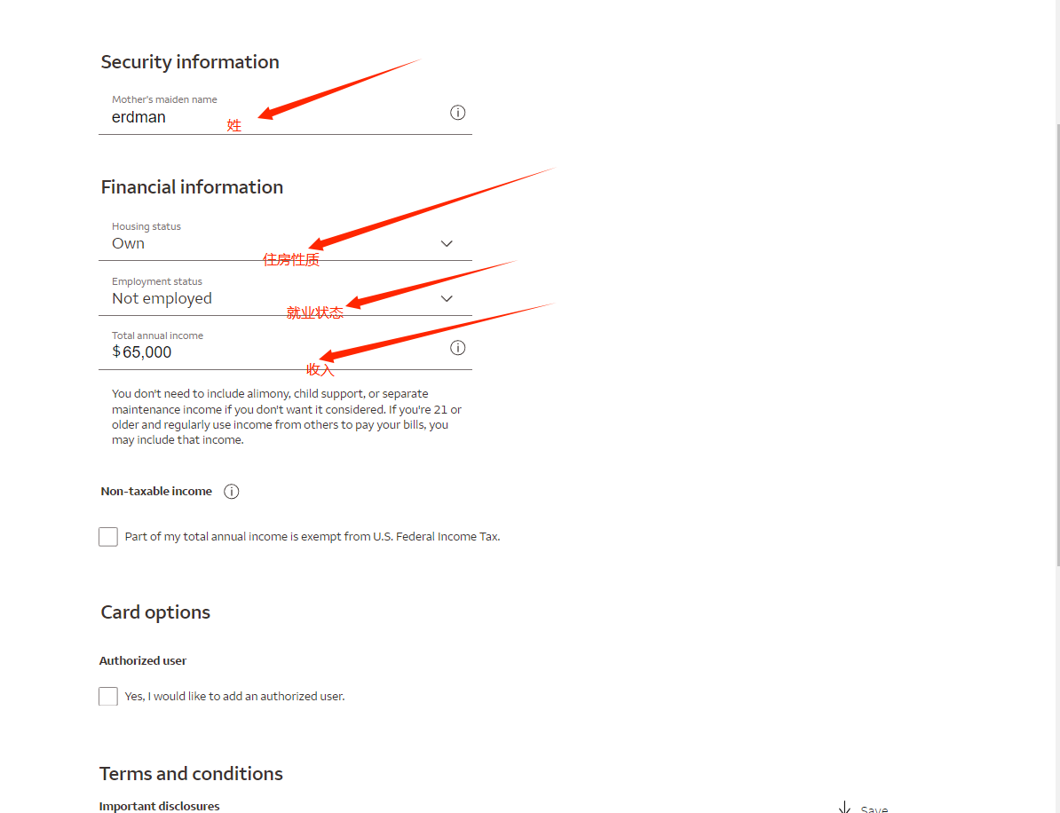
https://apply.wellsfargo.com/consumercreditcard?token=My9jIqE5ISSXcl5h36WvngeD2q_iKq0e#OSMA_APPL_CONSUMER_CREDITCARD_PAGE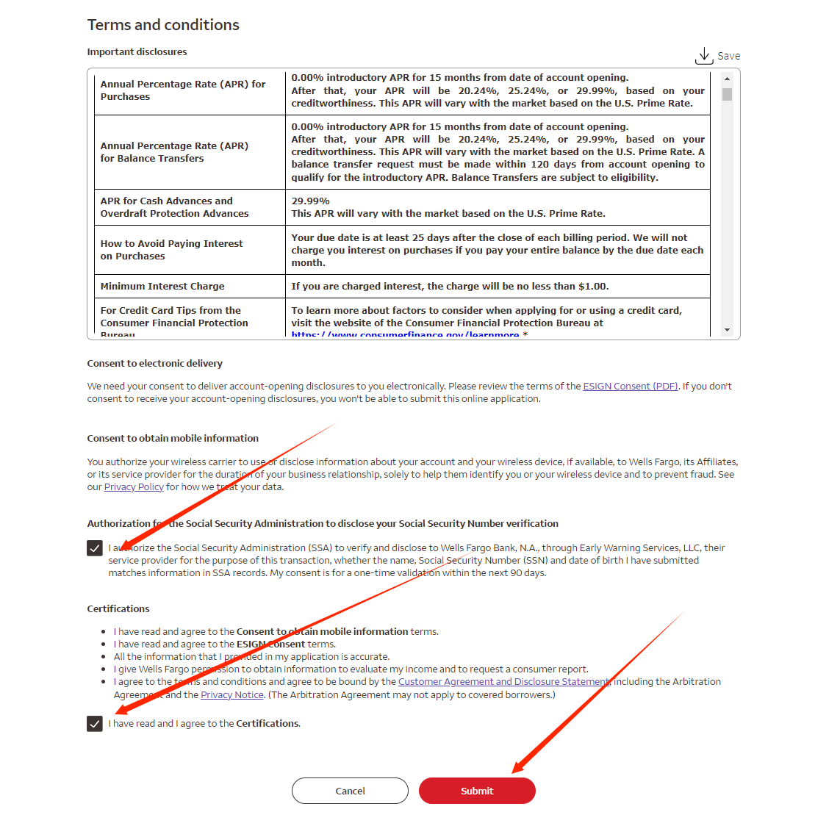

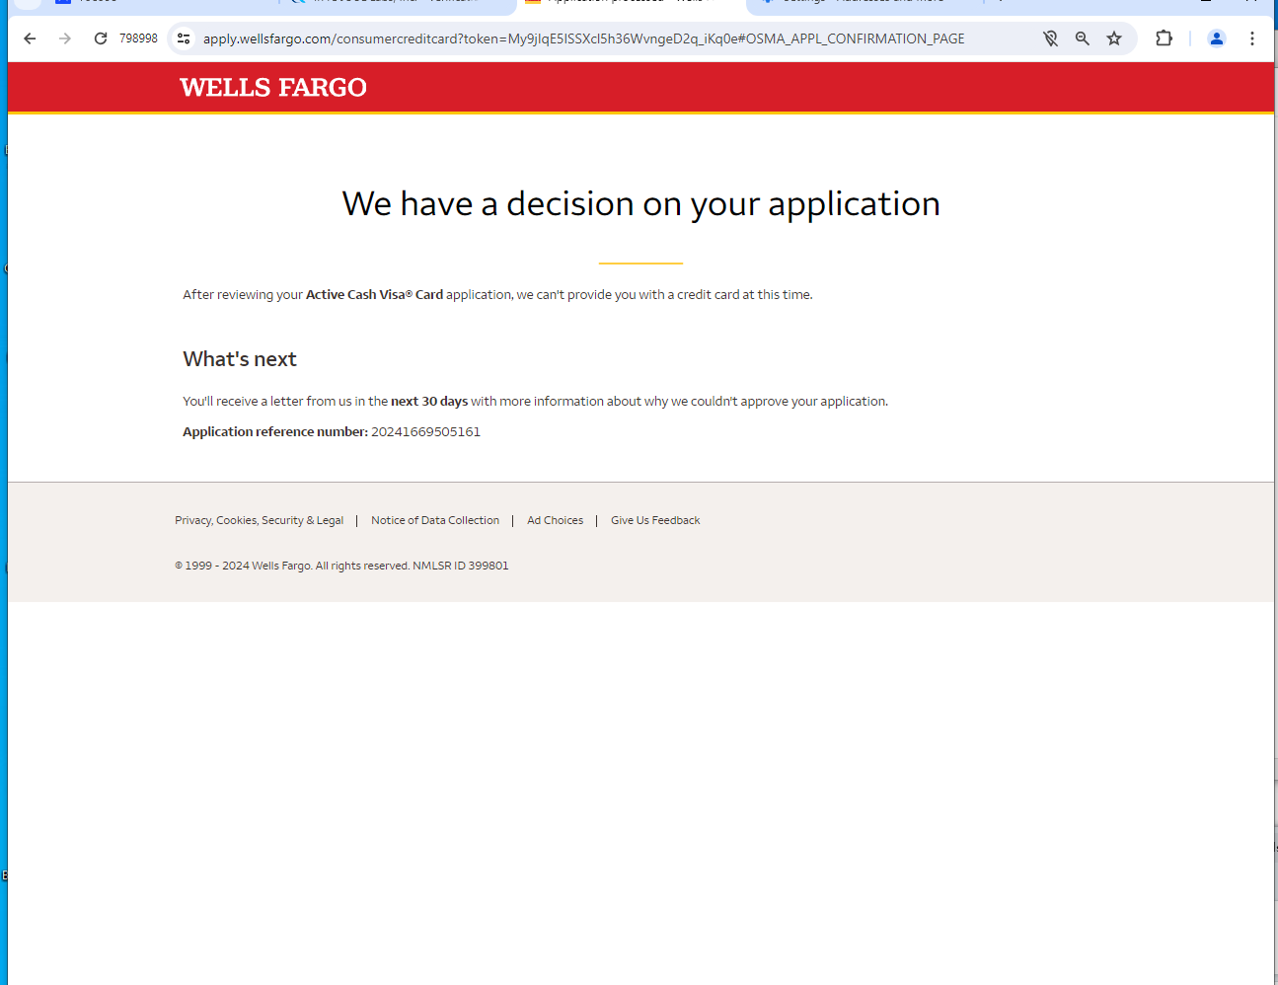
完成

