Thank you for participating in this experiment on decision-making. For your participation, you have already earned $5, but depending on your decisions to the questions in the experiment, you will have the opportunity to earn more money.

Basic Setup of the Questions

The experiment consists of twenty-five different questions. An example of the type of question you will be asked is shown below in the pie chart. For each question, you will be asked to choose one of two gambles called “Option S” and “Option L.” The amount of money you win depends on which gamble you choose and which slice of the pie (LEFT or RIGHT) is randomly selected. There is an equal chance that each slice of the pie is selected (50% for the LEFT slice and 50% for the RIGHT slice).

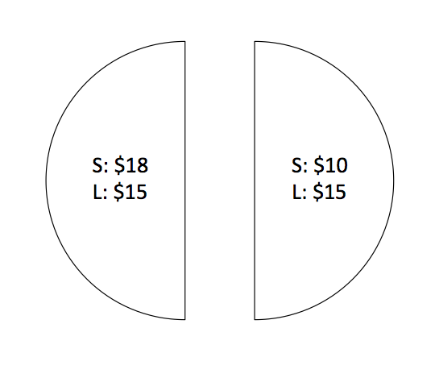

In the above example, this means that if you chose “Option S” there is a 50% chance you earn $18 and a 50% chance you earn $10. If instead you chose “Option L” you would earn $15 no matter what, since the outcome for “Option L” is the same for both slices.

At the end of the experiment, one of the twenty-five trials will be randomly selected by the computer and you will be paid according to your decision on that trial. The outcome of the gamble will be determined by a coin flip by the experimenter if you choose an option where the outcome differs across the two different slices.

Entering Your Decision on the Computer

During the experiment, your eye movements will be recorded by an electronic sensor. It is therefore very important to keep your head still as much as possible. **In order to enter your decision on each trial, press the space bar and at the same time verbally say your answer “S” or “L”.**