**Additional methods and results**

**A.1 Additional methods**

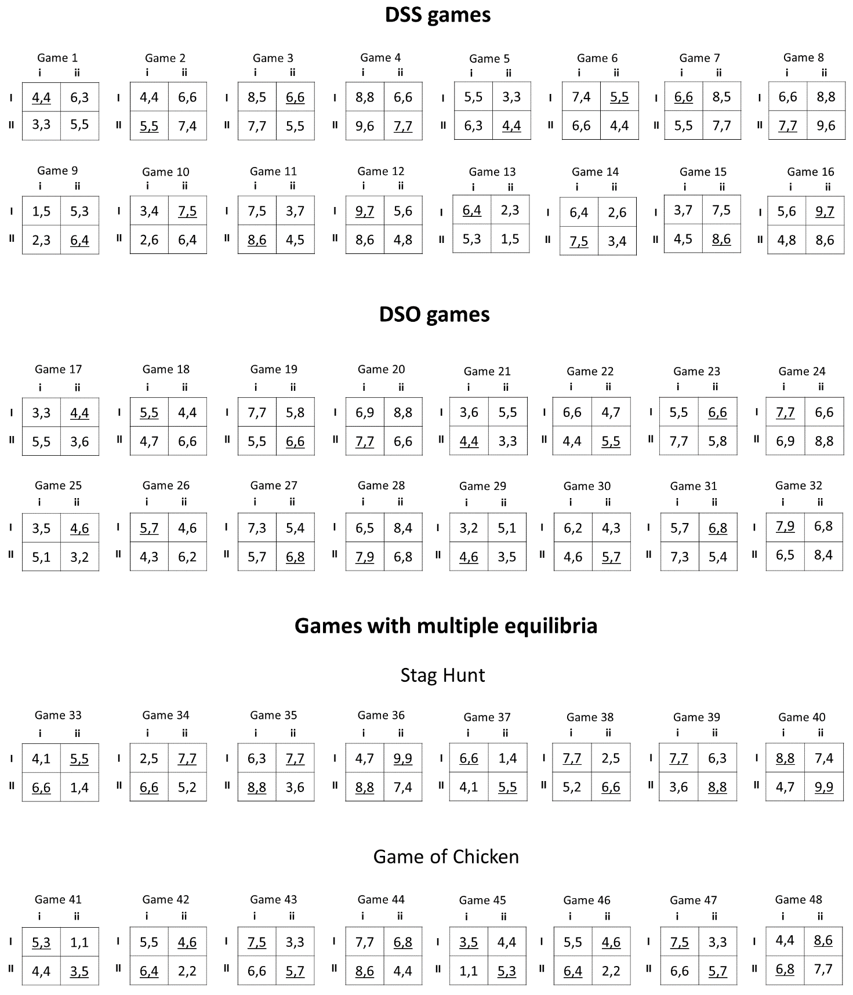

*Figure A1. Complete list of game used in the experiment. Underlined payoffs indicate Nash equilibria.*

**Eye-tracking procedure**

Participants are seated in a chair with a soft head restraint to ensure a viewing distance of 55 cm. from 1920 x 1080 resolution monitor. Stimuli are presented through a custom-made program implemented using Matlab Psychtoolbox. Eye movements are monitored and recorded using a tower mounted Eyelink 2000 system (SR. Research Ontario Canada) with a sampling rate of 2000 Hz.

We use a 13-points custom calibration in which points are placed in correspondence of the eight payoffs, the four corners of the screen and the center. After the calibration phase, a validation phase is run to ensure accuracy of the calibration. The position of points in the validation phase is identical to the one in the calibration phase. Calibration and validation procedures are re-performed in case these are unsuccessful. Before each trial, we perform a drift correction to ensure that participants do stare at the current fixation point; after 300 milliseconds of fixation in the correct location, stimuli are displayed. The payoffs in the game matrix are placed at an optimal distance between each other in to precisely distinguish types of payoff transitions in the eye-tracking analysis.

In line with the gaze analysis performed by Polonio et al. (2015), we define eight regions of interest (ROIs), centered on the matrix payoffs. ROIs have a circular shape with a size of 36000 pixels. The ROIs cover only 23% of the matrix and not overlap. Fixations outside the eight ROIs are discarded. However, although the majority of the screen space is not included in any of the ROIs, most of the fixations (83%) fall inside the ROIs.

**A.2 Additional results**

|  |  |  |  |
| --- | --- | --- | --- |
| Proportion of transitions | Own | Other | Intra-cell |
| Phase 3 (L2 group) | 0.03  (0.11) | 0.22  (0.13) | 0.02  (0.11) |
| L1 group (Phase 1) | 1.53***  (0.22) | -1.59***  (0.17) | -0.67***  (0.11) |
| Cooperative group (Phase 1) | -0.66**  (0.11) | -0.96***  (0.13) | 1.20***  (0.12) |
| Phase 3 x L1 group | -0.80*  (0.38) | 0.85*  (0.40) | 0.22  (0.22) |
| Phase 3 x Cooperative group | 0.29  (0.18) | -0.09  (0.17) | -0.31  (0.19) |
| Intercept | -0.02  (0.08) | 0.56***  (0.11) | -0.35*  (0.07) |
| N. obs. | 190 | 190 | 190 |
| N. independent obs. | 95 | 95 | 95 |

*Table A1. Random effects linear regressions with errors clustered by subject. Standard errors are robust. Proportion of own, other and intra-cell transitions are the independent variables, and phase, group and their interactions are the independent variables. Baseline: L2 group in Phase 1. We report beta coefficients and robust standard errors (in parentheses). *p < .05; **p < .01; ***p < .001.*

|  |  |  |  |  |  |  |
| --- | --- | --- | --- | --- | --- | --- |
| Prop. equilibrium responses | B | Robust SE | t | p | 95 % CI | |
| **DSS** |  |  |  |  |  |  |
| Decrease in L2 distance | -0.17 | 0.14 | -1.19 | .251 | -0.46 | 0.13 |
| **DSO** |  |  |  |  |  |  |
| Decrease in L2 distance | 0.61 | 0.13 | 4.74 | < .001 | 0.34 | 0.89 |
| **SH** |  |  |  |  |  |  |
| Decrease in L2 distance | 0.11 | 0.15 | 0.75 | .465 | -0.20 | 0.43 |
| **GOC** |  |  |  |  |  |  |
| Decrease in L2 distance | -0.38 | 0.19 | -2.01 | .060 | -0.78 | 0.02 |
| N. obs. | 19 |  |  |  |  |  |

*Table A2. Multivariate regression of increase in the proportion of equilibrium response (Phase 3 – Phase 1) in the different classes of game; decrease in L2 distance (Phase 1 – Phase 3) as independent variable. We consider L1 players only, since they are the only ones showing a significant decrease in L2 distance in their visual analysis in Phase 3.*

|  |  |  |  |  |
| --- | --- | --- | --- | --- |
| Proportion of equilibrium responses | DSS | DSO | SH | GOC |
| Effect of Phase (L1 group) | 0.00  (0.24) | 0.64  (0.33) | -0.11  (0.24) | 0.17  (0.23) |
| Effect of Phase (L2 group) | 0.12  (0.11) | 0.22  (0.17) | -0.01  (0.13) | -0.01  (0.13) |
| Effect of Phase (Cooperative group) | 0.33  (0.17) | -0.12  (0.13) | 0.12  (0.14) | 0.08  (0.14) |
| N. obs. | 190 | 190 | 190 | 190 |
| N. independent obs. | 95 | 95 | 95 | 95 |

*Table A3. Phase effects (linear combination of coefficients) by group resulting from a random effects linear regression (errors clustered by subject, robust standard errors). The proportion of equilibrium responses in DSS, DSO, SH and GOC games are the dependent variables, and phase, group and their interactions are the independent variables. We report the beta coefficient of the linear combinations. Standard errors in parentheses. No effects with p < .05.*