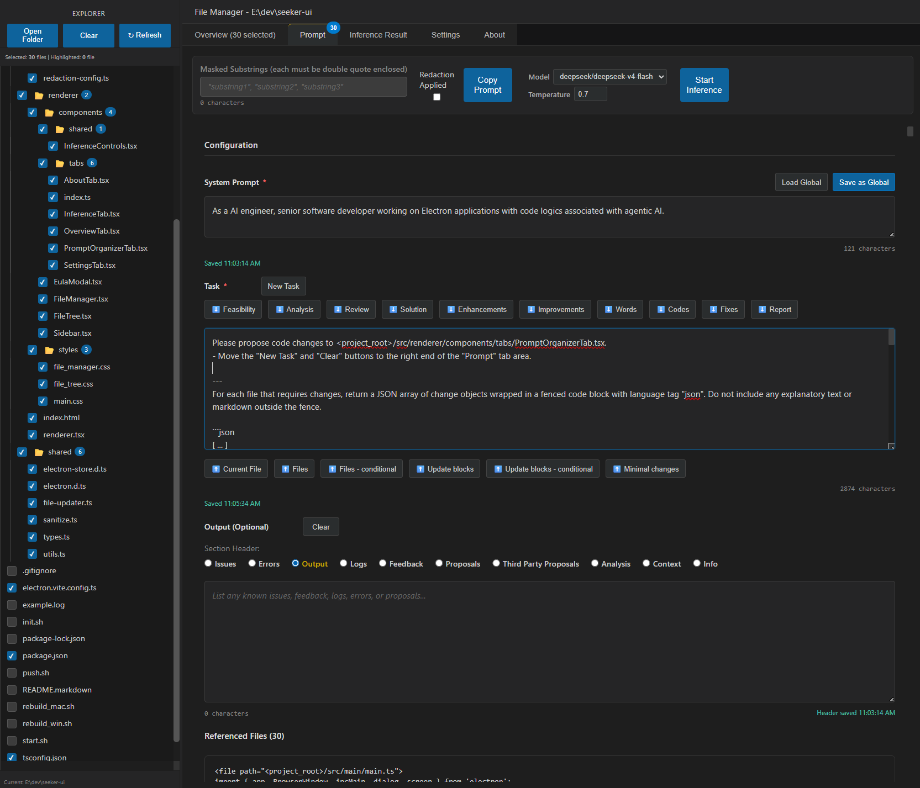
Comprehensive prompt creator
Model and temperature selections
Copy the generated prompts for inferencing with external tools

Single click to include full content of intended files in your prompt for the stateless cloud inference API with models providing a large context length
Attach information captured elsewhere to help problem solving
Get the file path in the clipboard by a single click on the file name in the File Explorer
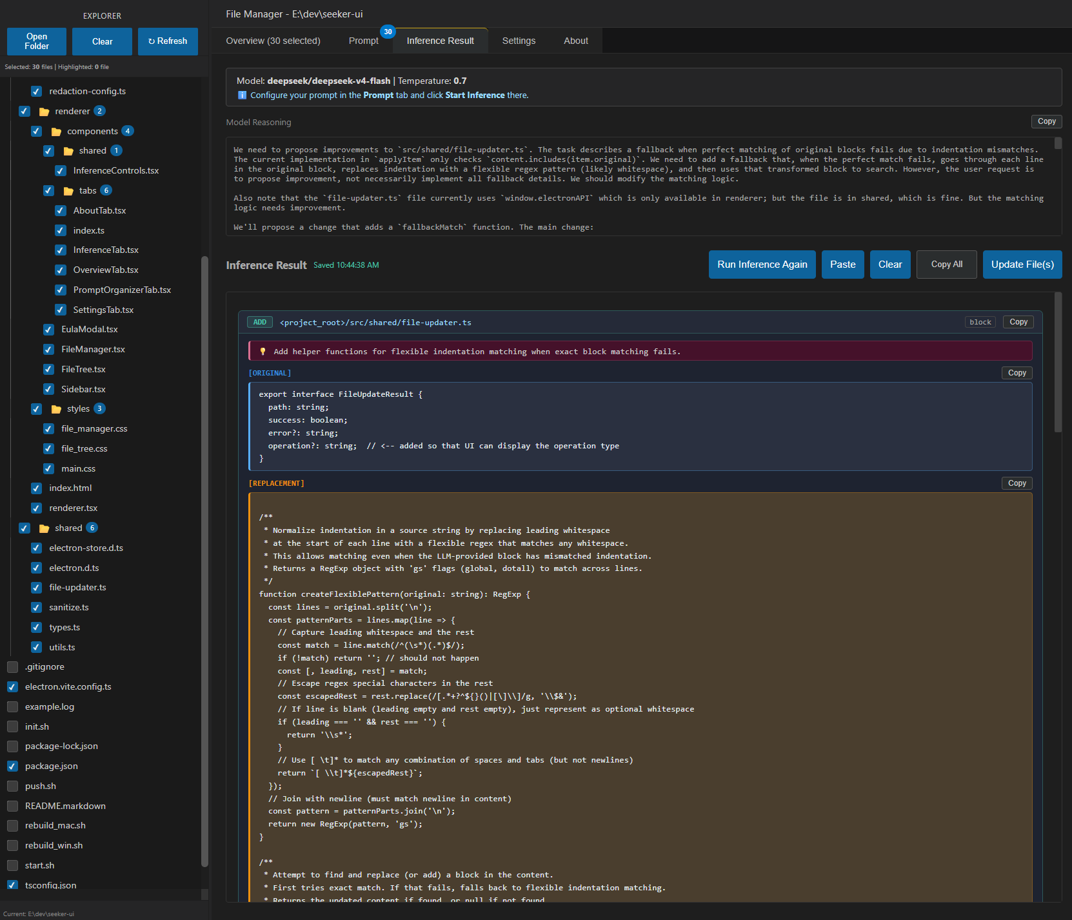
Information of extended reasoning (deep thinking)
Apply all the proposed updates to the actual files
Replacement or new text block proposed by the selected model
Existing text block in the original file for replacement, or as an anchor for adding or deletion
Operation type of the intended file update
Explanation of the intended update
Paste inference result from external tool for updating the files
Path of the file to be updated
Use the inference result returned by the selected model

