IWM 1

**Name:** Li Xin  
**Major:** Computer Science

# Project Title

**Digital Health Reminder Application**

# Short Description

The goal of this project is to develop a **Digital Health Reminder Application** that helps users maintain healthy habits through intelligent reminders and data tracking.  
 The system will allow users to schedule reminders for various daily health-related activities such as taking medicine, drinking water, exercising, and sleeping.  
It will store and visualize the user's health-related records and generate personalized suggestions for better lifestyle management.

# Project Objectives

1. To design a user-friendly application that provides automated health reminders.
2. To track user behavior and analyze health data trends.
3. To build a system that promotes time management and self-discipline in users.
4. To offer real-time notifications on desktop or mobile platforms.

# Functional Requirements

**User Registration & Login:** Secure sign-up and authentication.

**Reminder Management:** Add, edit, and delete health reminders.

**Notification System:** Pop-up or sound alerts when it’s time for an activity.

**Health Statistics Dashboard:** Visualize completed and missed tasks.

**Profile Management:** Allow users to modify their health goals and personal data.

# Non-Functional Requirements

**Usability:** Simple and intuitive interface design for all users.

**Performance:** Fast response with minimal delay for notifications.

**Security:** All personal data and reminders are securely stored.

**Portability:** The system should work on both desktop (Windows/macOS) and mobile devices.

**Maintainability:** The code will be modular and well-documented for future updates.

# Technology Stack

| **Component** | **Technology Used** |
| --- | --- |
| Programming Language | Python |
| GUI Framework | Tkinter / PyQt |
| Database | SQLite |
| Notification System | win10toast / Plyer |
| Visualization | Matplotlib |
| Version Control | GitHub |

# Initial Plan

**Week 1:** Analyze system requirements and user needs; create initial design sketches.  
**Week 2:** Develop UI prototypes and implement the reminder creation module.  
**Week 3:** Integrate notification and database functionality.  
**Week 4:** Build the statistics dashboard and generate visual reports.  
**Week 5:** Perform testing, documentation, and prepare presentation materials.

# UML Diagram

Below is the **Use Case Diagram** describing main user interactions with the system.

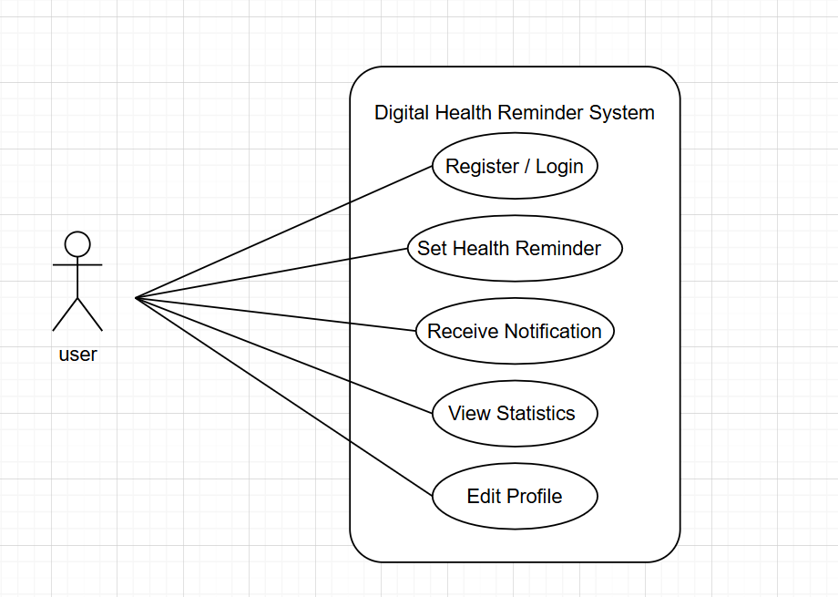

# (Optional) GitHub Repository

Repository: <https://github.com/lixin00123/health-reminder-app.git>  
It will store the UML diagram, and project report for public review.