PayPal & Braintree Integration Guide
LumenX Tactical — Sandbox Demo Store
PayPal JS SDK v6 (Expanded Checkout) · PayPal Server SDK (Orders v2) · Braintree Drop-in + Fastlane · Google Pay / Apple Pay via Braintree

1. Overview
This guide documents the payment integrations in the LumenX Tactical demo (Node.js + Express). All flows run against sandbox environments — no real charges. Two payment stacks are integrated side by side:
- PayPal — JS SDK v6 one-time payment session with a merchant-styled custom button, Expanded Checkout "Continue" flow (buyer reviews on the merchant page before capture), App Switch on mobile, and Pay Later messaging. Server side uses the PayPal Server SDK (Orders v2: create → get → patch → capture).
- Braintree — Drop-in UI (card / Venmo / wallets) with Fastlane accelerated checkout (email lookup + OTP profile autofill), plus Google Pay and Apple Pay express buttons tokenized through the Braintree gateway and charged with transaction.sale.
Run the demo:
npm install
npm start # http://localhost:3000

# .env
PAYPAL_CLIENT_ID=... PAYPAL_CLIENT_SECRET=...
BT_MERCHANT_ID=... BT_PUBLIC_KEY=...
BT_PRIVATE_KEY=... BT_TOKENIZATION_KEY=... # Google Pay client key

2. PayPal Integration (JS SDK v6 + Server SDK)

2.1 Client setup and custom button
The v6 SDK is loaded once and an instance is created with a client ID (or browser-safe client token). The PayPal button is a merchant-styled HTML button wrapped in <sdk-custom-button-wrapper>, which makes any element behave as a PayPal button while keeping full control of its look:
<script src="https://www.paypal.com/web-sdk/v6/core" async></script>

const sdk = await window.paypal.createInstance({
clientId: PAYPAL_CLIENT_ID,
components: ["paypal-payments", "paypal-messages"],
pageType: "product-details",
});

<sdk-custom-button-wrapper funding-source="paypal">
<button class="paypal-custom-btn">PayPal</button>
</sdk-custom-button-wrapper>

2.2 One-time payment session — Continue flow (API sequence)
The demo uses commit:false ("Continue" flow): the buyer approves in the PayPal sheet, returns to a merchant review page, the order is re-priced with the PayPal-selected shipping address (ordersPatch), and only then captured. The full API interaction:
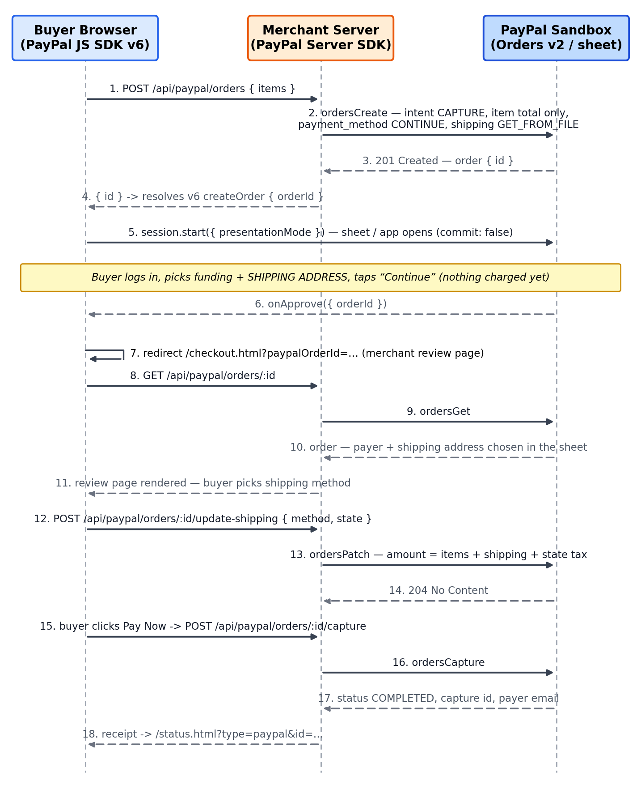
Figure 1 — PayPal Expanded Checkout (Continue flow) API sequence
Key client-side calls:
const session = sdk.createPayPalOneTimePaymentSession({
commit: false, // Continue flow — review before capture
async onApprove(data) { // buyer approved in the sheet
location.href = `/checkout.html?paypalOrderId=${data.orderId}`;
},
});
await session.start(
{ presentationMode: isMobile ? "direct-app-switch" : "auto" }, // App Switch
createOrder() // POST /api/paypal/orders
);

Server endpoints (PayPal Server SDK → Orders v2):
Endpoint | Orders v2 call | Purpose
POST /api/paypal/orders | ordersCreate | CAPTURE intent; item total only; payment_method CONTINUE; shipping GET_FROM_FILE
GET /api/paypal/orders/:id | ordersGet | Read payer + shipping address chosen in the PayPal sheet for the review page
POST /api/paypal/orders/:id/update-shipping | ordersPatch | Re-price: items + shipping + state tax for the selected address
POST /api/paypal/orders/:id/capture | ordersCapture | Final capture after buyer clicks Pay Now on the review page

2.3 App Switch (mobile)
On mobile the session is started with presentationMode "direct-app-switch", which hands off to the installed PayPal app; if the app is unavailable the SDK falls back to "auto" (popup/redirect). On return the page checks session.hasReturned() and calls session.resume() to complete the approval.
if (session.hasReturned()) { session.resume(); } // page reload after app switch

2.4 Pay Later messaging
The paypal-messages component renders Pay Later offers near the price; eligibility can be checked with sdk.findEligibleMethods() before showing funding-specific UI.

2.5 Official documentation — PayPal
- JS SDK v6 reference — https://developer.paypal.com/sdk/js/reference/
- JS SDK v6 announcement / migration — https://developer.paypal.com/community/blog/paypal-js-sdk-v6/
- Orders API v2 reference — https://developer.paypal.com/docs/api/orders/v2/
- PayPal Server SDK (Node) — https://www.npmjs.com/package/@paypal/paypal-server-sdk
- App Switch — https://developer.paypal.com/docs/checkout/standard/customize/app-switch/
- Pay Later (US) — https://developer.paypal.com/docs/checkout/pay-later/us/

3. Braintree Integration (Drop-in + Fastlane)

3.1 Server side — client token and transaction.sale
Every Braintree flow starts with a client token generated server-side and ends with a single-use payment method nonce charged server-side:
// GET /api/braintree/client-token
const { clientToken } = await gateway.clientToken.generate({});

// POST /api/braintree/checkout { nonce, deviceData, items, shipping }
const result = await gateway.transaction.sale({
amount: total.toFixed(2), // re-priced server-side
paymentMethodNonce: nonce,
deviceData,
options: { submitForSettlement: true },
});

3.2 Fastlane + Drop-in checkout (API sequence)
The checkout page initializes Fastlane (identity component) and looks up the buyer's email automatically as they type; a recognized buyer passes an OTP challenge and their saved profile prefills the shipping form. Payment method selection and tokenization happen in the Drop-in UI:
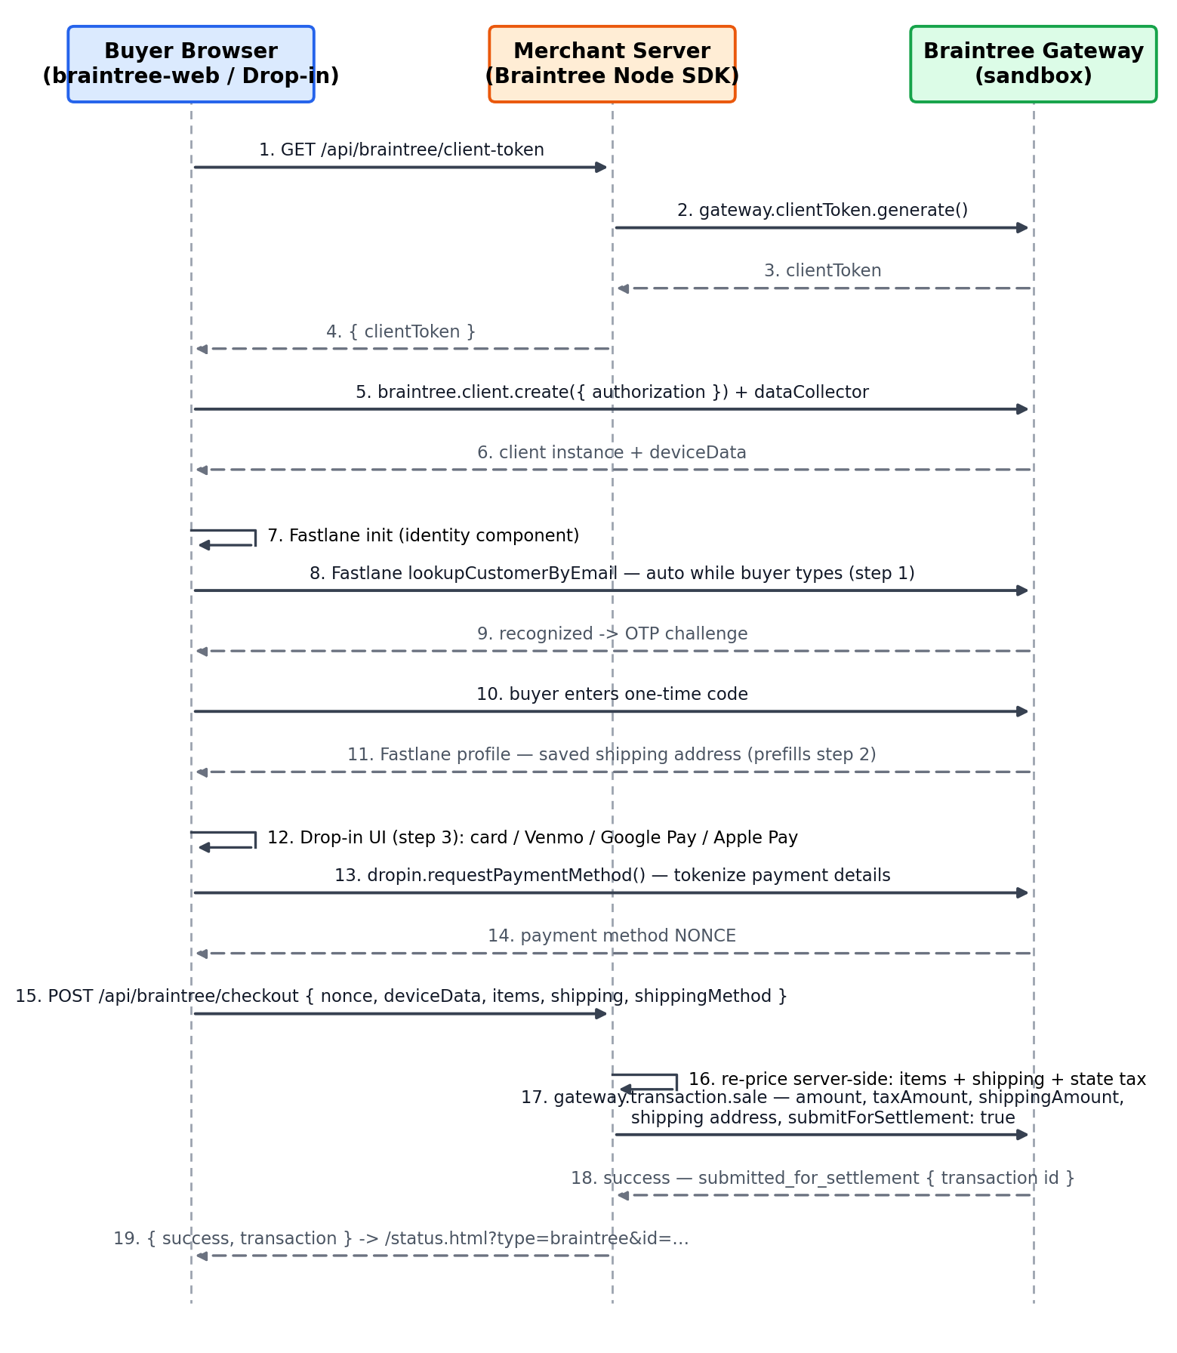
Figure 2 — Braintree Fastlane + Drop-in API sequence

3.3 Google Pay express checkout (API sequence)
Google Pay is integrated through Braintree: braintree-web's googlePayment component builds the PaymentDataRequest with a PAYMENT_GATEWAY tokenizationSpecification, so Google encrypts the card for Braintree — the merchant never sees card data. The sheet uses an ESTIMATED total with SHIPPING_ADDRESS / SHIPPING_OPTION callbacks for live re-pricing, and the returned token is parsed into a normal Braintree nonce:
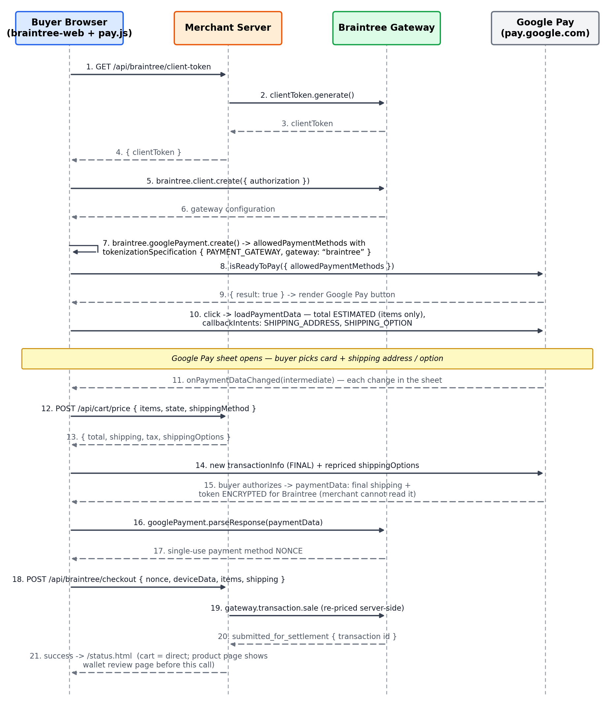
Figure 3 — Google Pay via Braintree gateway API sequence
The gateway handshake that makes this work:
const gpInstance = await braintree.googlePayment.create({
client, googlePayVersion: 2, googleMerchantId: "demo" });

const baseRequest = gpInstance.createPaymentDataRequest();
// baseRequest.allowedPaymentMethods[0].tokenizationSpecification:
{
"type": "PAYMENT_GATEWAY",
"parameters": {
"gateway": "braintree",
"braintree:merchantId": "<BT_MERCHANT_ID>",
"braintree:clientKey": "<BT_TOKENIZATION_KEY>"
}
}

const paymentData = await paymentsClient.loadPaymentData(request);
const { nonce } = await gpInstance.parseResponse(paymentData);
// nonce -> POST /api/braintree/checkout -> transaction.sale

3.4 Apple Pay
Apple Pay follows the same pattern via braintree-web's applePay component: create an ApplePaySession with a payment request from createPaymentRequest(), validate the merchant with performValidation(), tokenize the authorized payment with tokenize() to get a nonce, then charge it through the same /api/braintree/checkout endpoint. It requires Safari, an Apple Pay-capable device, and a registered merchant domain.

3.5 Official documentation — Braintree
- Drop-in UI (JavaScript v3) — https://developer.paypal.com/braintree/docs/guides/drop-in/overview/javascript/v3
- braintree-web client reference — https://braintree.github.io/braintree-web/current/
- Fastlane overview — https://developer.paypal.com/braintree/docs/guides/fastlane/overview
- Google Pay via Braintree — https://developer.paypal.com/braintree/docs/guides/google-pay/overview
- Apple Pay via Braintree — https://developer.paypal.com/braintree/docs/guides/apple-pay/overview
- Google Pay Web API — https://developers.google.com/pay/api/web/overview
- transaction.sale (Node) — https://developer.paypal.com/braintree/docs/reference/request/transaction/sale/node

4. Sandbox Testing
Flow | How to test | Expected result
PayPal Continue | Product page → PayPal button → log in with a sandbox personal account → pick shipping → Continue | Review page shows PayPal address + re-priced total; Pay Now captures (status COMPLETED)
PayPal App Switch | Open store on a phone with the PayPal sandbox app → tap PayPal | Hands off to the app; falls back to web sheet if unavailable
Braintree card | Checkout → Drop-in → card 4111 1111 1111 1111, any future expiry | transaction.sale success, submitted_for_settlement
Fastlane | Checkout → type a Fastlane-enrolled email → OTP | Profile + shipping prefilled
Google Pay | Product/cart page → GPay button (Chrome, signed-in Google account with a test card) | Sheet re-prices on address change; sale succeeds with encrypted-for-Braintree token
Pay Later | Product page price area | Pay Later message renders for eligible amounts

All payloads for every step above are visible live in the demo's API History Console (header link on every page, or /console.html), including the exact request/response bodies sent to PayPal Orders v2 and the Braintree gateway.

