Software Development Workshop I | Student ID: 0830300023
Design Specification | Student Name: 练力行 Yves
My Bank

Version | Date | Description
1 | 03/18/2010 | Initial Document
2 | 03/22/2010 | Update design Specification
3 | 05/12/2010 | Finish coding
4 | 05/30/2010 | Update design Specification
5 | 05/31/2010 | Hand in project and presentation

Table of Contents
Feature General Design 3
1.1 Description 3
1.2 Requirements 3
1.3 Design Considerations 3
1.4 Usage Scenarios 4
1.5 QA Requirements 11

Feature General Design

Description

This is a small banking system. It includes 5 basic functionalities, which are Add Customer, Setup a new account, Link Customer to Account, Client Search, Regular Deposit, and Regular Withdrawal.
The Add Customer is used to add customer’s name and contact information into the system.
The New Account Setup transaction will open a new account, and then link the account to the customer.
The Client Search is used to look for a customer and his/her accounts.
Once these are done, the customer will be able to deposit certain amount of money into the bank, and he’ll be able to withdraw money from the bank.

Requirements

Require to user requirement doc teacher provided.

Design Considerations

Not necessary to fill all information in add customer
Some information are not strong related to the customer. It is allowed for the user to ignore them if they do not want.

Input limited for the specific content
Some textbox, such as amount , Cell phone and some number input are limited that the user only can input number but not letter.
Otherwise, such as first name and last name are limited to input letters only.

Create a unique customer ID to the new customer
After the user add a new customer, the system will auto-generate a unique ID for the new customer. It is convenient to identify the customer and easy to link to existing customer. The customer ID will be added “A” at the first of the number and identified the customer.

Generate account ID by user’s input and account ID is unique
User can input a willing account ID, but account ID is unique. If it is already existed, user needs to input other one. The account ID should be 10 digit integer and will be added “B” at the first of the number.

New Account Setup button on the success page of Add Customer
After add a new customer, a new account number can be setup at the same time if customer want.

To search all the information of customer in Client Search
After fill in the first name and the last name, the system can search all the information which are suitable for the position. And then it can show in the Datagridview in Client Search page.

To view all the account information of customer in Client Search
After search the customer, user can choose the customer id and view the account information of the customer

To edit the customer information in client search and update to XML
After search the customer, user can edit the information which are shown in the datagridview, and can update the new information to XML.

Regular Deposit button on the success page of New Account Setup
After new account number is auto-generated, customer can use the new account number to deposit money at the same time if they want.

Add new button “Print Balance” in Regular Deposit
While depositing, the user can choose if the system show the balance of his/her amount.

Usage Scenarios
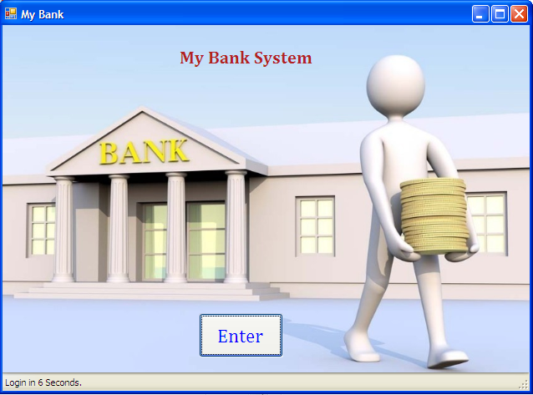

Welcome page
This page shows the entrance of My Bank system. Click Enter to start the system.
The system will be automatically enter after 10 seconds if the user does not click enter.

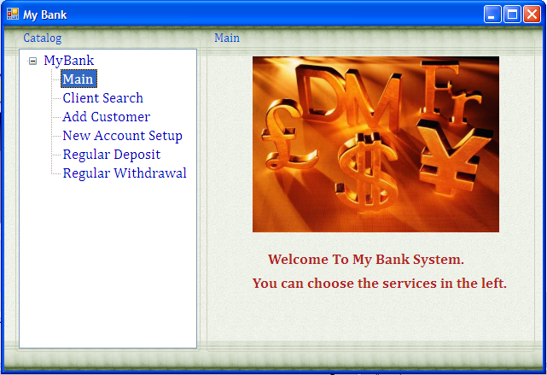

Main page
This page shows the welcome information and leads users to use the system. The left side is tree view. Include Main, Client Search, Add Customer, New Account Setup, Regular Deposit, Regular Withdrawal.

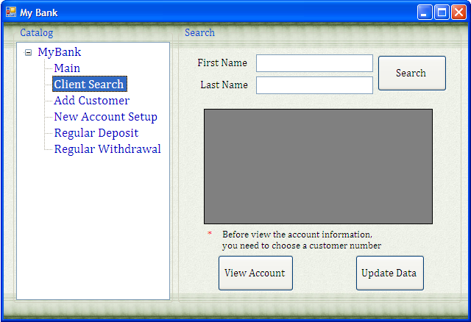
Client Search page
Client Search needs to fill in the first name and the last name. Then click “Search”, the system will search the database and show the result in the datagridview. In the search result, there will show first name, last name, address, customer ID, account ID, amount, balance, cell phone.
After search customer, user can view the account information by choosing a customer id and then click “view account” button.
After search customer, user can edit the information which shown in the datagridview. Click “Update data” button, the system will update the new information to XML file.
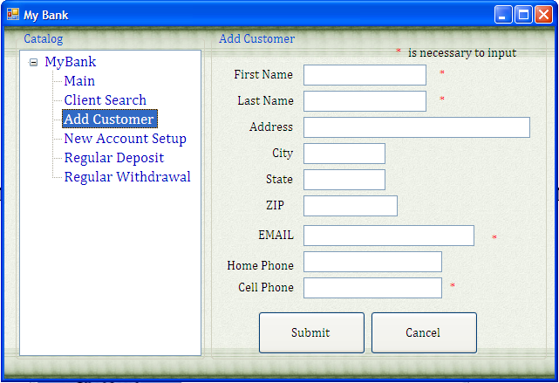

Add Customer page
There are four necessary blanks for the user to input: “First Name”, “Last Name”, “Email” and “Cell phone”. Others are not necessary to input.
For the “First Name” and “Last Name” blanks, user only can input letters. For “ZIP”, “Home Phone” and “Cell Phone” blanks, user only can input numbers.
After the user fill the information, the user need to enter “Submit” to upload the information. When submission is successful, go to “Add Customer Successfully” page. If something is wrong in the submission, the system will mention the problems.
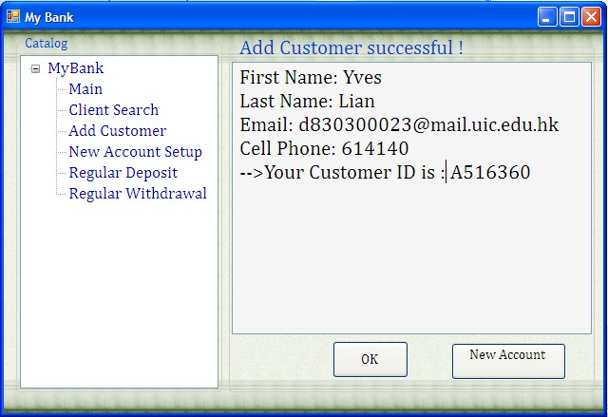

Add Customer successfully page
This page will show all the information which the customer had filled.
A unique ID number for the customer will be auto-generated. If the new customer wants to setup a new account at the same time, click “New Account” button to go to the “New Account Setup” page.
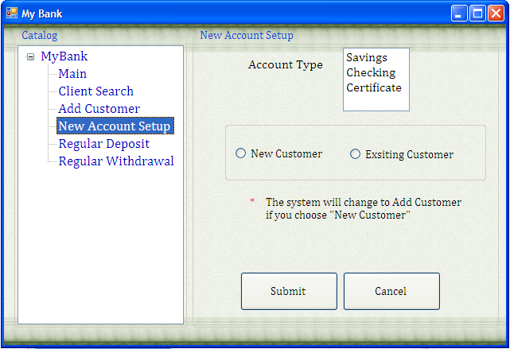

New Account Setup page
- Choose the account type and the type of customer
- After filling in information, click “Submit” button to submit.
If the user chooses New Customer, go to “Add Customer” page.
If the user chooses Existing Customer, go to “Link to Existing Customer” page.
- Click “Cancel” to return the welcome page.

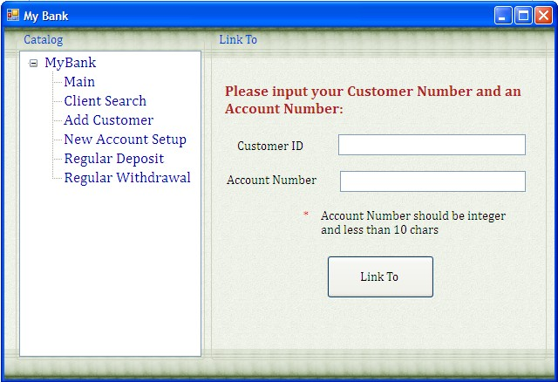

Link to Existing Customer
Ask the customer to fill in the Customer ID which he/she wants to link to. User can input a willing account number if it is not existed. When submission is successful, go to “New Account Setup Successfully” page. Otherwise, messagebox will show the problems.

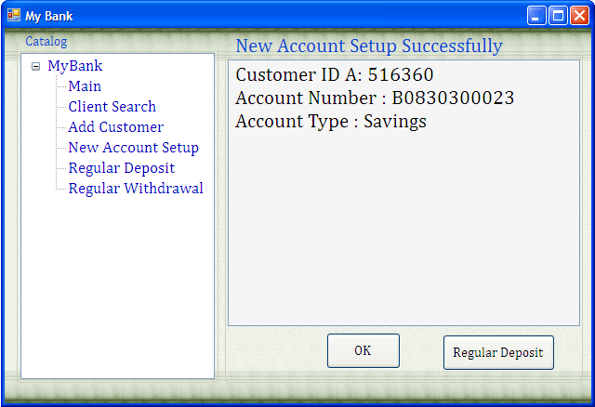

New Account Setup Successfully page
This page will show all the information which the customer had filled. If the new account needs to Deposit at the same time, click “Regular Deposit” button to go to the “Regular Deposit” page. Click “OK” button to return the main page.

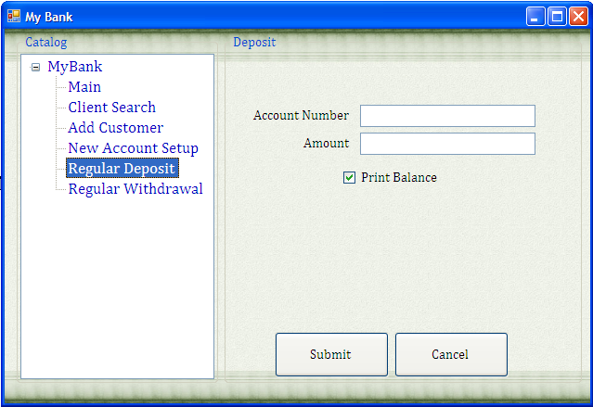

Regular Deposit page
1. User only can input numbers in “Amount” blank.
2. After filling in information, click “Submit” button to submit. When submission is successful, go to “Deposit Successful” page. If choose “print balance”, the “Deposit Successful” page will show the old balance and new balance. Otherwise, it only show the account number and amount. If something is wrong in the submission, messagebox will show the problems.
3. Click “Cancel” to clear all blanks.

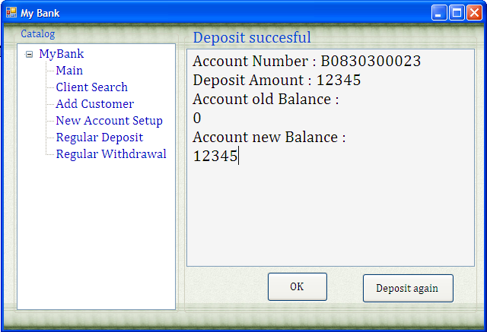

Deposit Successful page
This page will show the deposit information. If click ”OK” button, return to main page. If click “Deposit again” button, return to “Regular Deposit” page.

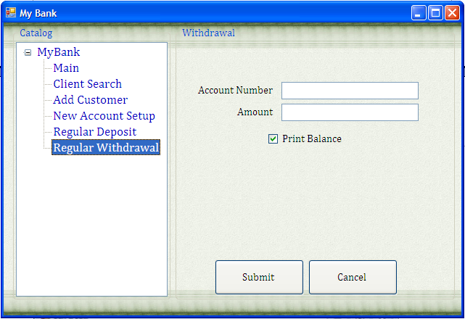

Regular Withdrawal page
1. User only can input numbers in “Amount” blank.
2. After filling in information, click “Submit” button to submit. When submission is successful, go to “Deposit Successful” page. If choose “print balance”, the “Withdrawal Successful” page will show the old balance and new balance. Otherwise, it only show the account number and amount. If something is wrong in the submission, messagebox will show the problems.
3. Click “Cancel” to clear all blanks.
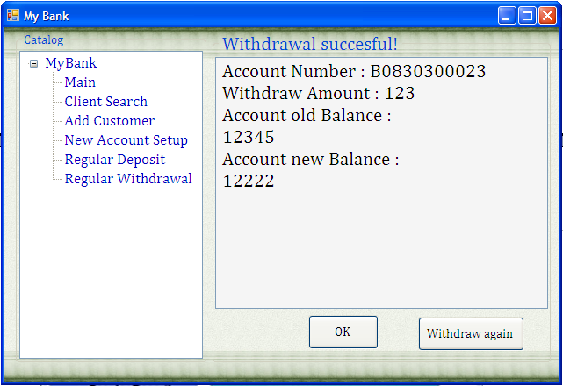

Deposit Successful page
This page will show the withdraw information. If click ”OK” button, return to main page. If click “Withdraw again” button, return to “Regular Withdrawal” page.

QA Requirements

Welcome page
Test: Enter to go to “main” page.

Client Search page
Test “Search” button. Try to fill in some data to test.

Add Customer page
- Test “Cancel” button, “Submit” button.
- Check the information which is showed in success page.

Success – New Customer page
Test “OK” button, “New Account Setup” button.

New Account Setup page
- Test “Cancel” button, “Submit” button.
- Check the information which is showed in success page.
- Use different situations to test the error page.

Link to Existing Customer
Test “Link to” button.
Use different situations to test the error page.

New Account Setup Successfully page
Test “OK” button, “Regular Deposit” button.
Regular Deposit page
- Test “Cancel” button, “Submit” button.
- Check the information which is showed in success page.
- Use different situations to test the error page.

Deposit successful page
Test “OK” button, “Deposit again” button
Regular Withdrawal page
- Test “Cancel” button, “Submit” button.
- Check the information which is showed in success page.
- Use different situations to test the error page.
Examples of error:
a) Amount is more than the balance of the account
b) Enter data is too longer.
c) No account number or amount is filled in.
Withdrawal successful page
Test “OK” button, “Withdraw again” button

Others

There are only to forms for the project. One the FormWelcome form, the other one is FormMain form. All the functions will be operate in FormMain form.
There are two XML file. One is to store the customer information, the other one is to store the account information.
Customer number and account number are unique. One customer can have many accounts with different account type and amount.

