UIC Computer Science Practice | Student ID: 0730300036
Design Specification | Student Name: KWOK YUEN LAM
My Bank

Version | Date | Description
1 | 04/07/2009 | Initial Document
2 | 04/14/2009 | Design the XML in Usage Scenarios
3 | 04/20/2009 | Add “Regular Deposit” button in “Success – New Account” page

Table of Contents
Feature General Design 3
1.1 Description 3
1.2 Requirements 3
1.3 Design Considerations 3
1.4 Usage Scenarios 5
1.5 QA Requirements 10

Feature General Design

Description

This is a small banking system for the company – My Bank. The main users of this banking system are teller and supervisor in the bank. In this banking system, there are 4 basic functions, including “Add Customer”, “New Account Setup”, “Regular Deposit” and “Regular Withdrawal”.
Add Customer
Add the name and contact information into system.
New Account Setup
Setup a new account and the new account number is
auto-generated.
Regular Deposit
Deposit money into bank.
Regular Withdrawal
Withdraw money from the bank.

Requirements

Require to user requirement doc teacher provided.

Design Considerations

Background
The colour of the user interface’s background is white which can let tellers’ eye more comfortable, since they needs to use this system all day long.

Size
The size of user interface is about 640x480 pixels. If users like to use 640x480 pixels on their computer, they also can see the full screen of the user interface.

Using the system without mouse
Some users may not like to use mouse, they also can use keyboard to totally control the system. For example, press [Ctrl + N] instead of “cancel” button in “Add customer” page.
In this system, [Enter] and [Ctrl + N] are mainly used. It is because [Enter] is easy to be used when users are using numbers buttons. And then, when users are using numbers buttons, they can just use left hand to press [Ctrl + N] not too difficultly.

Allow not to fill all information in add customer
Since there is not a relation between customer’s information and banking account in this system, allow customer not to give all their individual information to the bank if they don’t want.

New Account Setup button on the success page of Add Customer
After add a new customer, a new account number can be setup at the same time if customer want.

New account number
Let user focus on the new account number by using bold style to show the auto-generated new account number in the “Success – New Account” page.

Regular Deposit button on the success page of New Account Setup
After new account number is auto-generated, customer can use the new account number to deposit money at the same time if they want.

Regular Deposit – Print Balance
“Print Balance” is clicked by default. It is because most of customers like to keep the record about bank.

Red words in Error page
The main problem is shown in the Error page with red colour. This let user focus on the problem easily.

Usage Scenarios

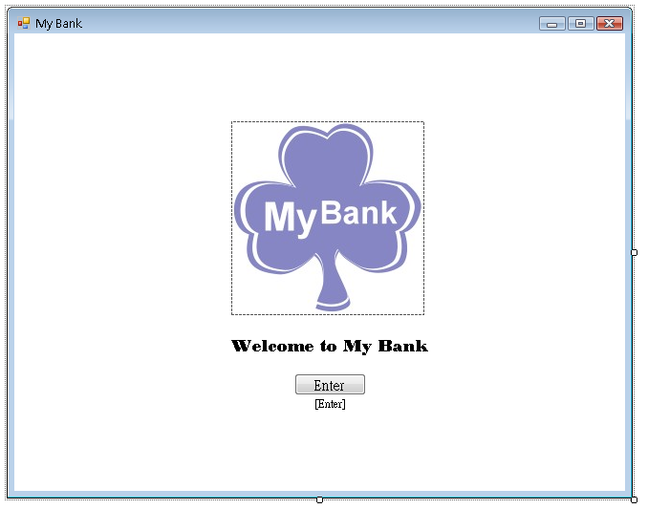
Welcome page
- Enter to go to “main” page.
- Start using the system of My Bank.
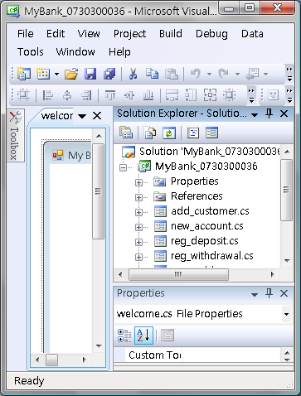
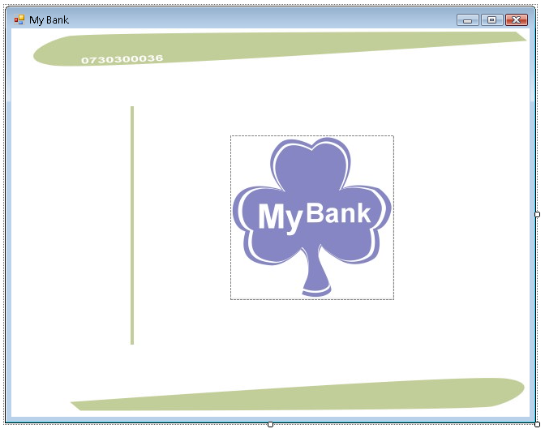
Main
Main page
The left side of main page is a tree diagram which lets user find all functions more efficiently.
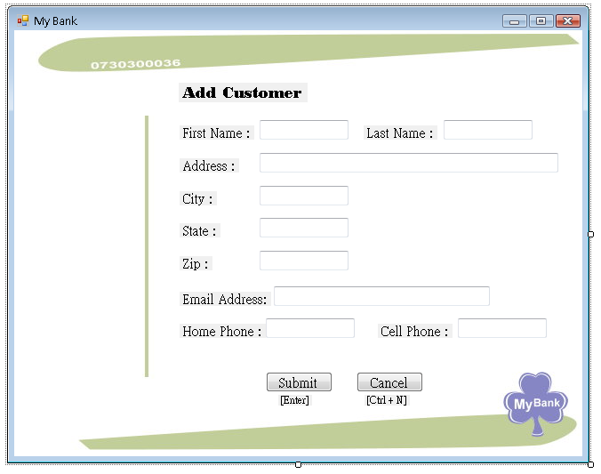  Main | <customers>  <customer>  <firstName> </firstName>  <lastName> </lastName>  <address> </address>  <city> </city>  <state> </state>  <zip> </zip>  <email> </email>  <homeTel> </homeTel>  <cellTel> </cellTel>  </customer>  </customers>
Add Customer page
- “Cancel” button is clicked or press [Ctrl + N] to return main page without adding a new customer.
- After filling in information, click “Submit” button or press [Enter] to submit.
  - When submission is successful, go to “Success – New Customer” page.
  - When something is wrong in the submission, go to “Error” page.
Examples of error:
a) Data Validation
b) Enter data longer than the specified length.
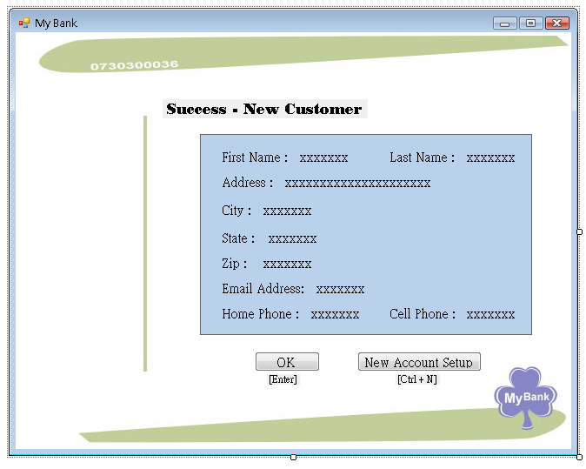
Main
Success – New Customer page
- “OK” button is clicked or press [Enter] to return main page.
- If the new customer wants to setup a new account at the same time, click “New Account Setup” button or press [Ctrl + N] to go to the “New Account Setup” page.
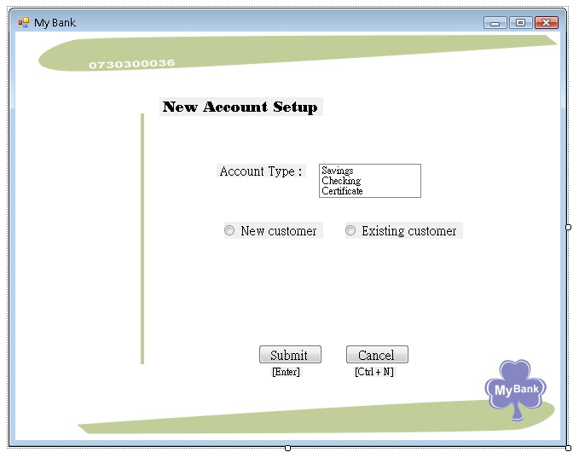  Main | <accounts nextAccNo=0>  <account>  <accNum> </accNum>  <accType> </acctype>  <accCus> </accCus>  <balance>0</balance>  </account>  </accounts>
New Account Setup page
- Choose the account type and the type of customer
- “Cancel” button is clicked or press [Ctrl + N] to return main page without setup a new account.
- After filling in information, click “Submit” button or press [Enter] to submit.
  - When submission is successful, go to “Success – New Account” page.
  - When either account type or customer type has not been chosen, go to “Error” page.
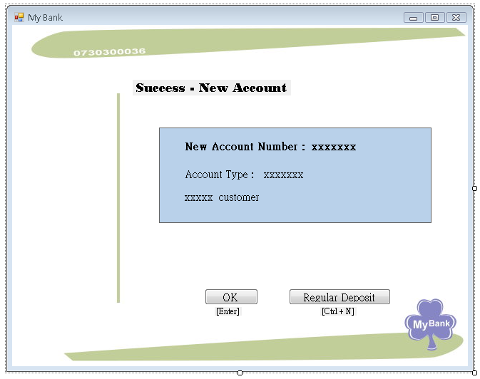
Main
Success – New Account page
- Show the new account number which is auto-generated.
- “OK” button is clicked or press [Enter] to return main page.
- If the customer wants to deposit money at the same time, click “Regular Deposit” button or press [Ctrl + N] to go to the “Regular Deposit” page.
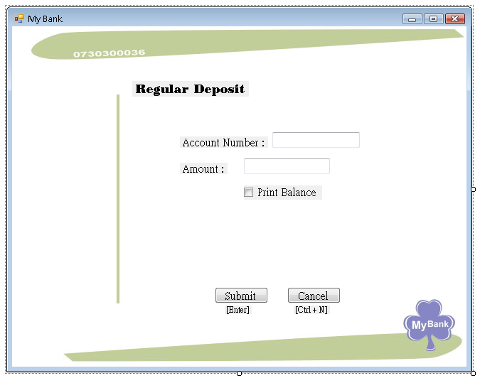
Main
Regular Deposit page
- “Cancel” button is clicked or press [Ctrl + N] to return main page.
- After filling in information, click “Submit” button or press [Enter] to submit.
  - When submission is successful, go to “Success – Account Transaction” page.
  - When something is wrong in the submission, go to “Error” page.
Examples of error:
a) Data Validation
b) Enter data longer than the specified length.
c) Either account number or amount is not filled in
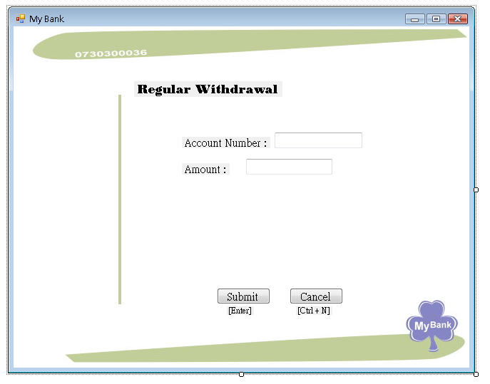
Main
Regular Withdrawal page
- “Cancel” button is clicked or press [Ctrl + N] to return main page.
- After filling in information, click “Submit” button or press [Enter] to submit.
  - When submission is successful, go to “Success – Account Transaction” page.
  - When something is wrong in the submission, go to “Error” page.
Examples of error:
a) Amount is more than the balance of the account
b) Data Validation
c) Enter data longer than the specified length.
d) Either account number or amount is not filled in
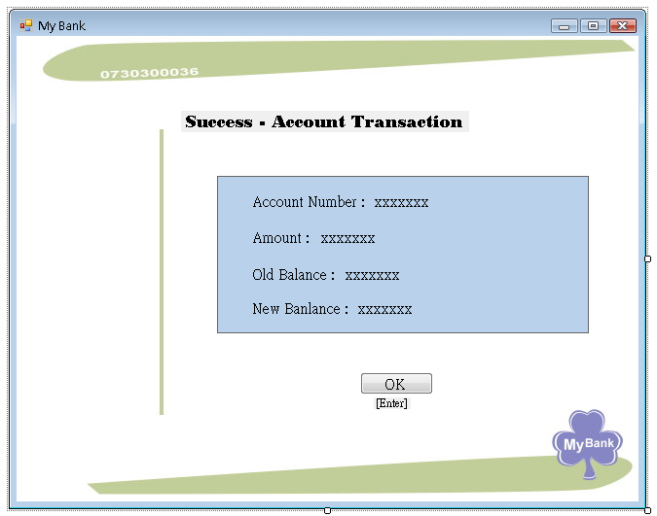
Main
Success – Account Transaction page
Main
- Show the new balance of the account.
- “OK” button is clicked or press [Enter] to return main page.
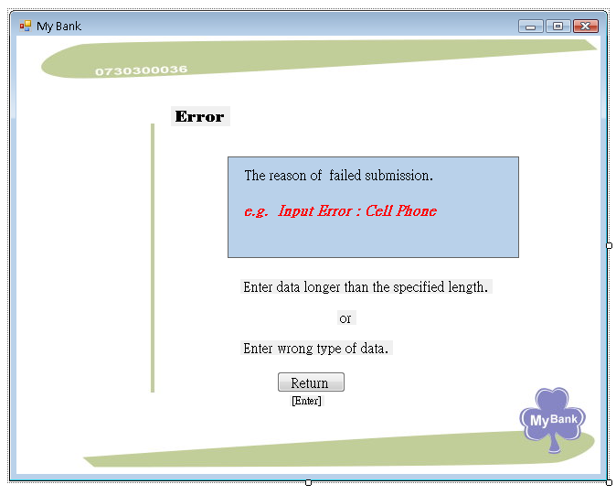
Main
Error page
- Show the problem of submission
- “Return” button is clicked or press [Enter] to return to pervious page.

QA Requirements

Welcome page
Test: Enter to go to “main” page.

Main page
Test: all links of tree diagram.

Add Customer page
- Test “Cancel” button, [Ctrl + N], “Submit” button and [Enter].
- Check the information which is showed in success page.
- Use different situations to test the error page.
Examples of error:
a) Data Validation
b) Enter data longer than the specified length.

Success – New Customer page
Test “OK” button, [Enter], “New Account Setup” button and [Ctrl + N].

New Account Setup page
- Test “Cancel” button, [Ctrl + N], “Submit” button and [Enter].
- Check the information which is showed in success page.
- Use different situations to test the error page.
Example of error:
a) Either account type or customer type has not been chosen.

Success – New Account page
Test “OK” button, [Enter], “Regular Deposit” button and [Ctrl + N].
Regular Deposit page
- Test “Cancel” button, [Ctrl + N], “Submit” button and [Enter].
- Check the information which is showed in success page.
- Use different situations to test the error page.
Example of error:
a) Data Validation
b) Enter data longer than the specified length.
c) Either account number or amount not be filled in.

Regular Withdrawal page
- Test “Cancel” button, [Ctrl + N], “Submit” button and [Enter].
- Check the information which is showed in success page.
- Use different situations to test the error page.
Example of error:
a) Amount is more than the balance of the account
b) Data Validation
c) Enter data longer than the specified length.
d) Either account number or amount not be filled in

Success – Account Transaction page
Test “OK” button and [Enter]

Error page
Test “Return” button and [Enter]

Others

Describe anything else you’d like to mention.

