Requests/endpoints for attendance app

1. Auth

Method | Endpoint | Description | Request Params | Response JSON
POST | /auth/login | Login via OAuth | { providerToken } | { userId, email, name }
GET | /auth/me | Get current user | Header: Authorization | { userId, email, name }

2. Session

Method | Endpoint | Description | Request Params | Response JSON
POST | /sessions | Create session | { name } | { sessionId, name, isActive, createdAt }
GET | /sessions/active | Get active session | – | { sessionId, name, isActive }
POST | /sessions/{sessionId}/end | End session | Path: sessionId | { success: true }

3. QR code

Method | Endpoint | Description | Request Params | Response JSON
GET | /qr/{sessionId} | Get QR token | Path: sessionId | { token, expiresAt }
GET | /qr/{sessionId}/image | Get QR image | Path: sessionId | image/png

4. Scan, Attendance and Export

Method | Endpoint | Description | Request Params | Response JSON
POST | /attendance | Submit scan | { token, deviceToken } | { success, message }
GET | /sessions/{sessionId}/attendance | Get attendance list | Path: sessionId | { sessionId, attendees: [...] }
GET | /sessions/{sessionId}/export | Export CSV/Excel | Path: sessionId | File download (CSV/XLSX)

Note:
- deviceToken will be stored in browser (localStorage),
- tokens will be short-lived QR tokens (≈10s),
- backend validates: token expiration, session validity, duplicate device/user

Database schema

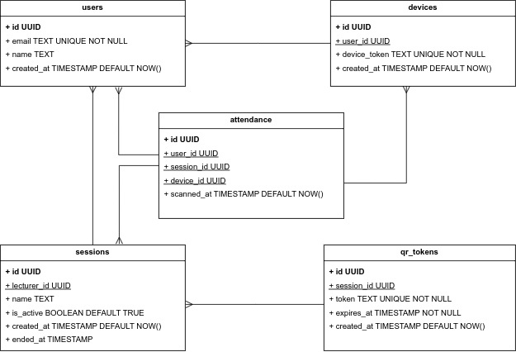
Note: this is a basic recommended schema for the application. Can be extended later.

Recommendation for backend environment

Python is a good choice because it provides simple and reliable support for QR code generation, data processing, and security-related logic. Using FastAPI allows fast development of high-performance APIs with built-in validation and automatic documentation, which is ideal for an MVP.
Python offers a cleaner implementation for token handling, QR generation, and export functionality (CSV/Excel). It also integrates well with PostgreSQL, which fits the relational structure of sessions and attendance data.

Recommended Python libraries for the app:

- FastAPI : core framework for building the API
- SQLAlchemy : database ORM for PostgreSQL
- Pydantic : request/response validation (used with FastAPI)
- qrcode : QR code generation
- python-jose : JWT token handling (auth & security)
- pandas : handling attendance data
- openpyxl : Excel export
- uvicorn : running the FastAPI app

