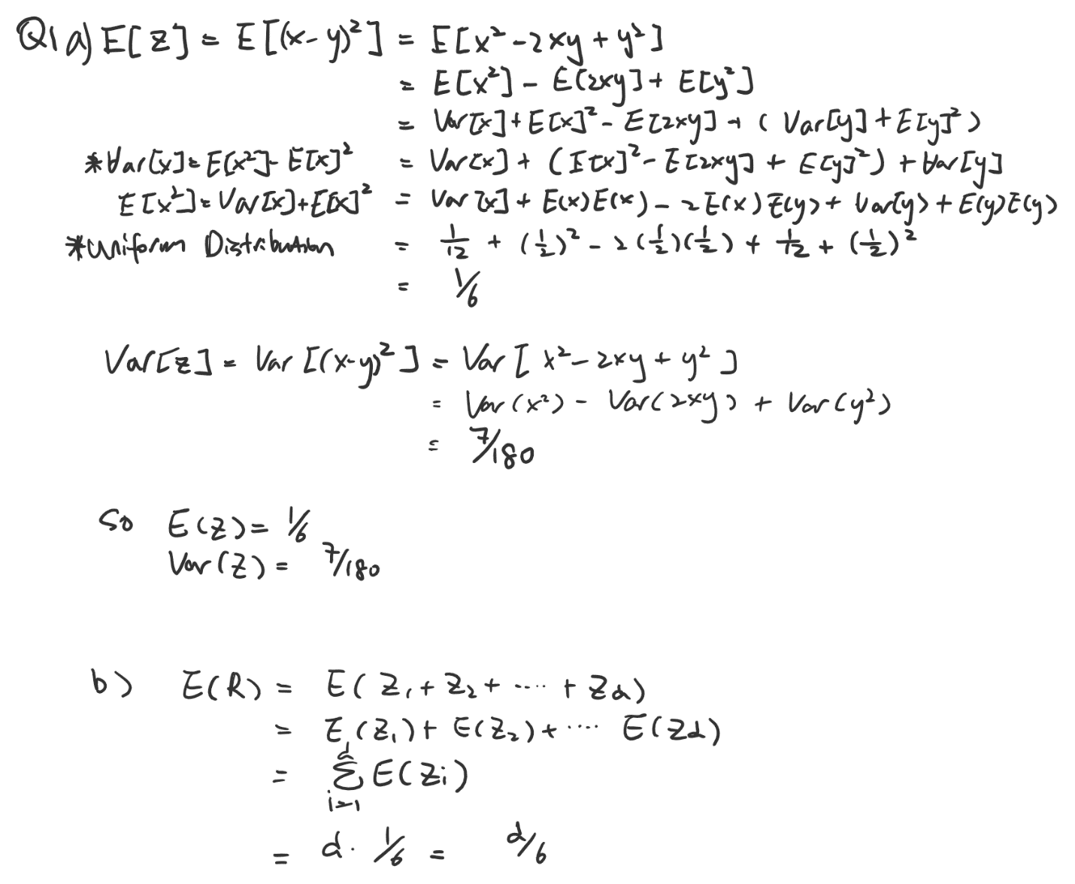

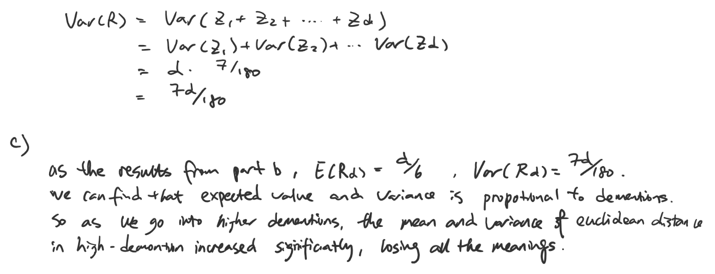

Q2.

1. See in python file
2. 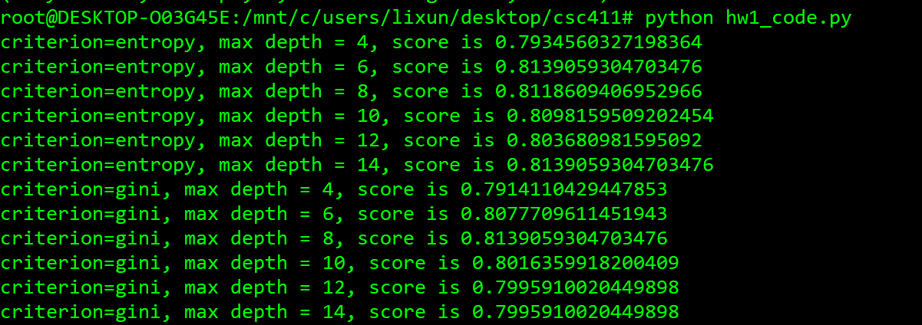
3. As the result shown above, we can see that some hyperparameters reached same validation score. So I will pick criterion= entropy with max depth 14 as example:

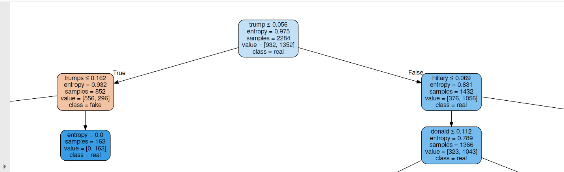

1. 