Q1.

1. Average Conditional Likelihood for training set is: -0.124624436669

Average Conditional Likelihood for test set is: -0.196673203255

1. Accuracy for training set is: 0.9814285714285714

Accuracy for test set is: 0.97275

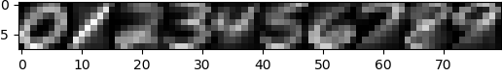

Q2.



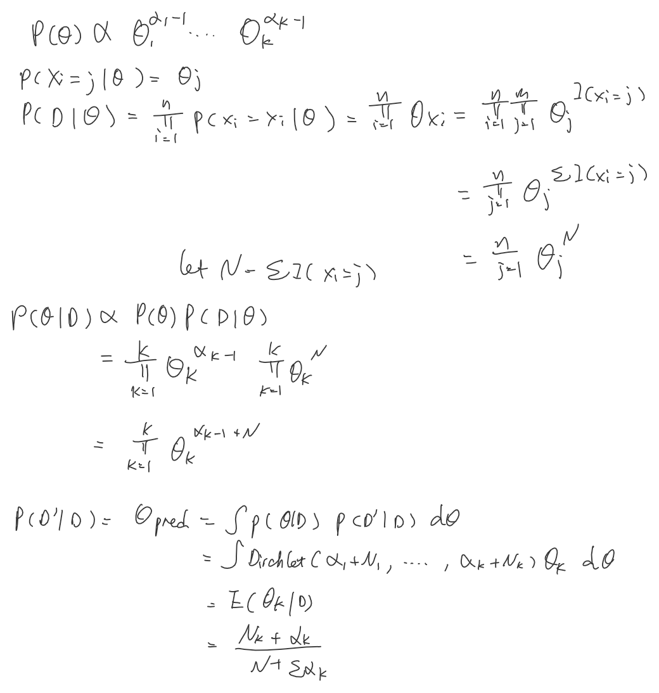

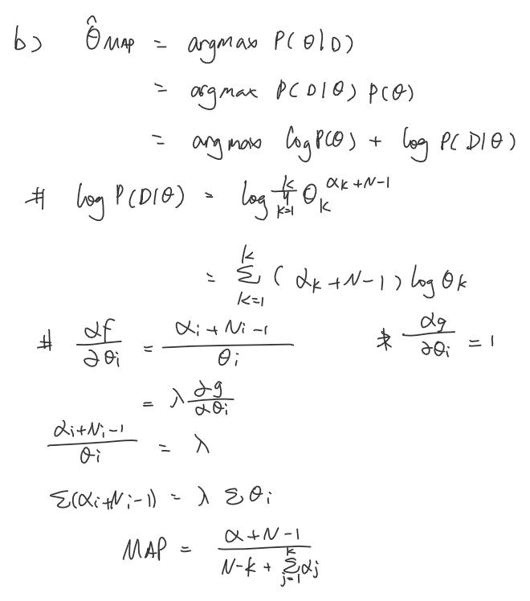

Q3.

