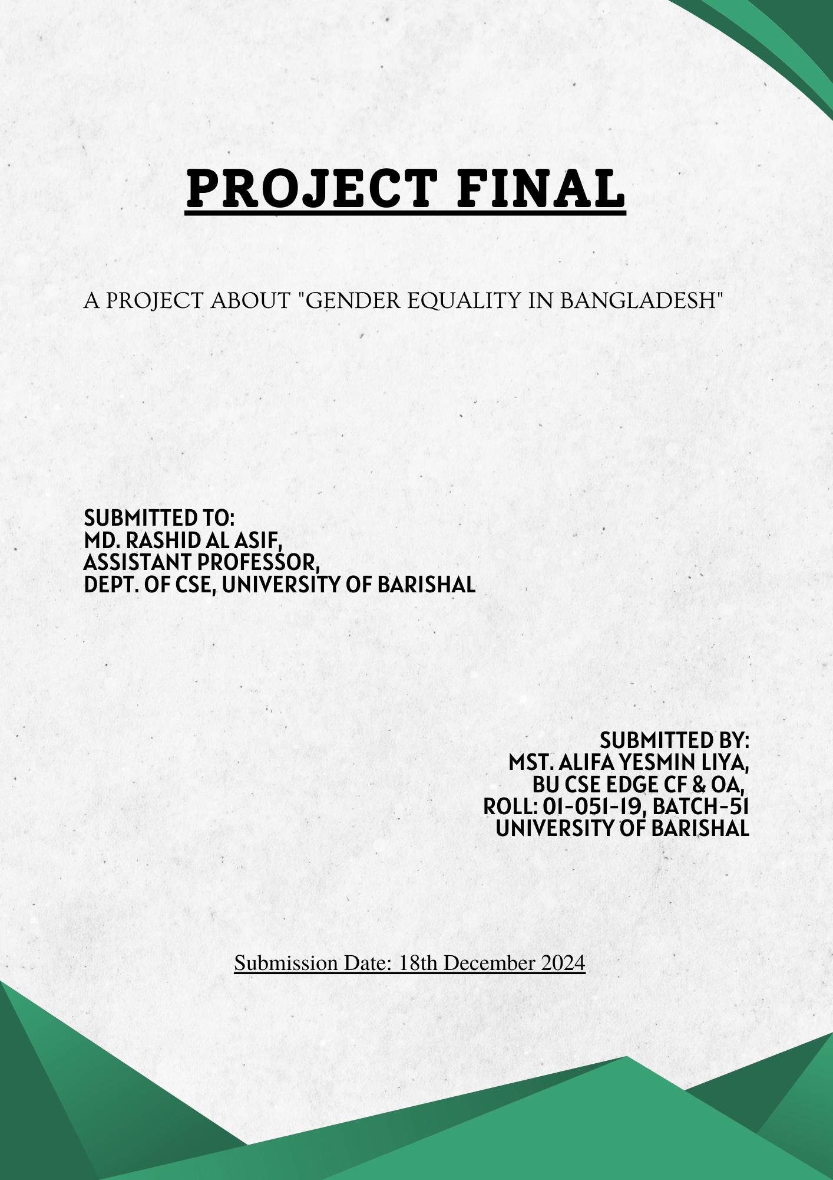

Table of Contents

“Understanding Gender and Gender Policy: Definitions and Implications” 4

“Key Principles of Gender Policy” 4

“Constitutional and Legal Framework for Gender Equality in Bangladesh” 5

“Gender Equality and Reality” 7

Challenges: 8

“Gender Equality in Private Sector : JAAGO Foundation” 10

“Recommendations” 11

References” 12

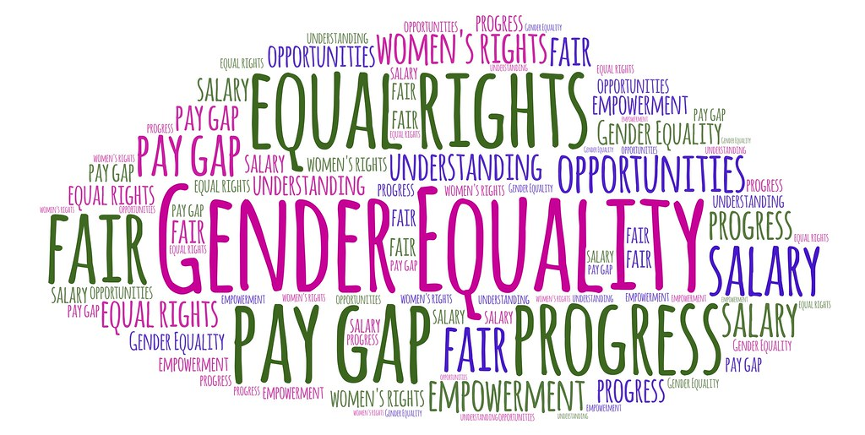

|  |
| --- |
| **“Gender Policy, Laws and Administration in Bangladesh”** |

# “Understanding Gender and Gender Policy: Definitions and Implications”

**Gender** refers to the socially constructed roles, behaviour , activities, expectations, and identities that a society considers appropriate for individuals based on their sex.

* Prominent gender theorist **Judith Butler** states that "Gender is not a noun but a verb. It is something that one does, not something one is." (Butler, 1990)
* According to **Raewyn Connell**, "Gender is a social structure that organizes relations between men and women." (Connel, 1987)

**Gender Policy:** In order to address gender equality, governments, organisations, or institutions may implement a set of rules and measures known as gender policies.

# “Key Principles of Gender Policy”

Gender policy **principles** refer to the basic guidelines or frameworks that shape and guide the development, implementation and evaluation of policies aimed at addressing gender equality. The main principles typically include:

**1.Equity and Equality.**

**2.Empowerment.**

**3.Management and Governance.**

**& 4.Working Environment**.

* ***Equity and Equality:*** *Achieving both equity (ensuring fairness through individual support) and equality (ensuring equal rights and opportunities) is essential to creating a ideal society.*
* ***Empowerment:*** *Empowering marginalized genders, especially women and LGBTQ+ people, involves improving their decision-making capabilities, access to resources, and control over their lives, ensure fundamental rights etc.*
* ***Management and Governance****: Promoting gender equality in leadership and governance ensures that all genders are equally represented in decision-making roles in both national level and regional level thereby contributing to more balanced and equitable management.*
* ***Working Environment:*** *It ensures fair, safe and inclusive workplaces for all genders, focusing on equal pay or promotion or recruitment, protection from harassment and support for work-life balance. (ILO, 2016)*

# “**Constitutional and Legal Framework for Gender Equality in Bangladesh”**

**There are some articles to ensure gender equality in the constitution of Bangladesh. These are follows:**

* **Article 27:** All citizens **are equal before law and are entitled to equal protection of law.**
* **Article 28: (1)The state shall not discriminate against any citizen on grounds only of religion, race,caste,sex or place of birth.**
* **Article (29): There shall be equality of opportunity for all citizens in respect of employment or office.**
* **Article 9: The State shall take steps in promoting local government bodies elected by representatives of the people, and shall ensure the participation of women in these bodies.**
* **Article 65(3): There shall be reserved 50 seats exclusively for women in the assembly. (Fourteen Amendment, 2004) (Bangladesh, 2024)**

**Except constitutional article,there are several laws regarding gender equality such as :**

* **Domestic Violence Act (Protection and Prevention),2010** : This law attempts to protect people from domestic abuse,especially women.It has articles that ensures victim protection,give victims shelter and remedies,and punish culprits.
* **The Dowry Prohibition Act, 1980:** This law wants to protect women from the injustice of the husband/husband's family when they demand money,furniture or vehicles as a gift.
* **The sexual Harassment of Women at workplace (Prevention) Act**, 2009: It's aim is to ensure safety of women at workplace.For this it requires a complaint body to handle incident related to harasment.
* **The Labor Act (2006):** This act was passed to ensure equal recruitment,pay, promotion,pension etc regarding all gender.It also ensures fully paid 16 weeks maternity Leave.
* **The Child Marriage Restraint Act, 1929 (Amended 2017):**The act sets the minimum age of marriage at 18 for women and 21 for men. It aims to prevent child marriages and protect girls from early marriage.
* **Prevention of Trafficking Women and Children Act, 2012**: It ensures safeguard to Women and children from getting exploited as sex workers or beggers. (Affairs, 2024)

# **“Gender Equality and Reality”**

**Achievements:**

Over the past 20 years, Bangladesh has made a tremendous growth in ensuring exclusive, gender-sensitive environment. Here is an short overview:

* **The mortality rate has been decreasing since 2000 and it continues to decline.**
* **For the past few years, govt. has included gender based lessons as well as sex education in curriculum.**
* **The enrollment of girls in schools and the numbers of woman who pursue higher education has increased.**
* **Many women are now engaging with micro enterprises as well as other jobs.Bangladesh ranked 59th in Gender Gap index of Global Economic Forum.**
* **There are 30 seats Reserved for the women in the national assembly.Bangladesh ranked 7th in gender gap report according to World Forum.**
* 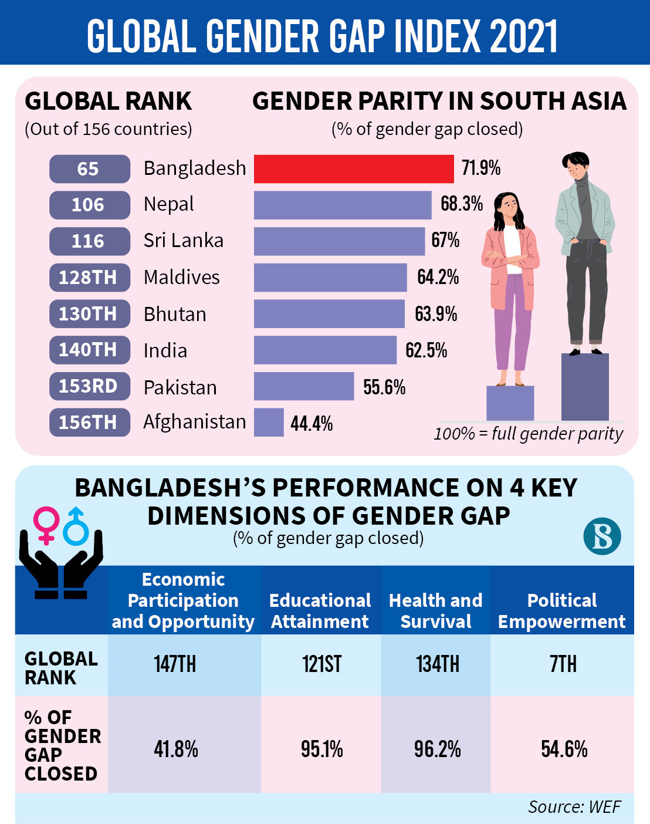**The Ministry of law,Justice and Parliamentary Affairs has taken major initiatives to reduce the rate of violence, 999 and women helpline is always alert.The rate of child marriage has decreased.**
* **Women are given maternity leave of 6 months and many organisations have feeding corner.** (Star, 2023)

**Figure 1: Global Gender Gap Index**

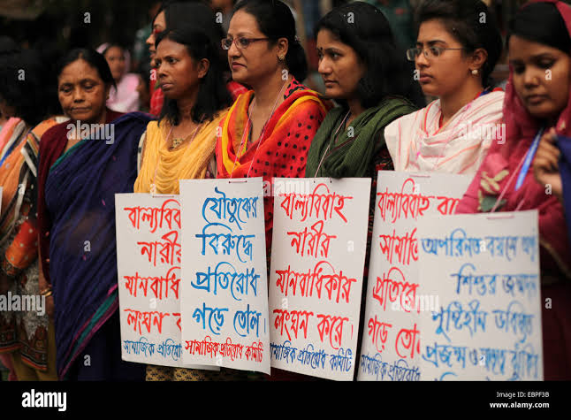

# **Challenges:**

* **The four principles of gender equality hasn’t implemented fully yet.**
* **The participation.of women in workforce is only 10.7% (WEF,2018), they face discrimination in equal pay also.**
* **More than 54.2% is the victim of domestic violence. The rate of child marriage is 58.6%.**
* **The percentage of women in corporate or administrative sector is very low. Most of them face sexual harassment.In local bodies,the decision making power is also limited for women.**
* **In garments sector,women participants is the larger yet they don’t receive equal pay and face safety issue.In many organisations, they don’t recruit women as they have to give maternity leave.**
* **Over 4,300 rape cases between 2021-2022, including 450 murders after rape has reported to Police. Among them,less than 1% of cases are investigated by police.**
* **About 176 cases has documented of dowry between January to September 2023.** (Watch, 2020)

|  |  |
| --- | --- |
| **Types of Violence** | **Percentage** |
| Domestic Violence | 51% |
| Rape | 20% |
| Sexual Abuse | 3% |
| Murder | 6% |
| Suicide | 1% |
|  |  |

**Figure 3: Violence Against Women (From April to June 2021)**

**Figure 4: Graphical Representation of Women Violence**

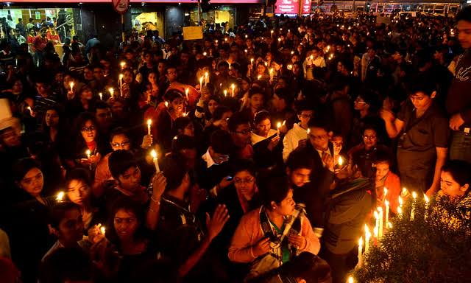

**Figure 5: Movement Against Women Violence**

# “**Gender Equality in Private Sector : JAAGO Foundation”**

One of Bangladesh's top non-governmental organisations, the **JAAGO Foundation**, works to empower and educate both genders,even though gender equality is not their main focus. Some of it’s activities are:

* **JAAGO Women Scholarship :** A joint project of **U-Go** and the JAAGO Foundation, the "JAAGO Women Scholarship" offers a four-year scholarship worth up to **BDT 2,50,000** will be awarded to chosen female students from public universities.
* **Shopner Sarothi (SeaShore Girls) Project :** This project focuses the coastline areas adolescent girls to provide life skills,sports skills,give employment. They reach out almost 2400 girls.
* **Gender-based Violence Protection Programme** : JAGGO Foundation has its own managing board who deals with the complaints of sexual harassment or violence in work place and resolve the dispute.Almost **150** stakeholders to who are trained and helping girls to create exclusive, gender-sensitive environment.
* **Volunteer for Bangladesh Programme** : It mainly focuses on creating awareness among the youth on gender based stereotypes, sex education.More than **40,000** youth are actively involved in this **VVD** programme.
* **Menstrual Health Management Practice Programme** :JAGGO Foundation works to ensure menstrual education, hygiene among the scool girls. They are providing sanitary Napkin and classes both boys and girls to break the stereotypes.

# **“Recommendations”**

* **Strengthen Legal Framework :** Only strict enforcement of laws can eradicate gender-based violence.The existing laws have to be updated and more efficient and have to introduce new laws regarding equal pay,property rights,workplace harassment.
* **Economic Opportunities expansion :** It is very necessary to take micro finance programme for women and technical skill programme. It have to be ensured to provide childcare facilities, maternity leave.
* **Education and awareness** : The govt.should launch campaigns to raise awareness about the societal sexist stereotypes of gender roles,sex education.
* **Focus on Rural Women:** The condition of urban women is comparatively better than rural women as they lack of proper education, health care etc. The govt.should establish quota-system in representation, increase health service specially maternal health.
* **Workplace Polices Reform** : The govt.should ensure gender sensitive policy such as equal pay,workplace harassment prevention action etc in both public and private sector.
* **Political Participation :** The govt. can increase the number of reserved seat in the assembly for the women.They can give more focus in local bodies as there is limited participation of women.
* **Increase budget allocation** : The govt. can increase the amount of budget for gender-based programs in education, healthcare etc.
* **Give recognition of private organisation**: Private organisation/NGO's are working to ensure gender equality in the society for a long time. If they receive govt. recognition or incentives, they will get more motivated or financially secure.
* **Media:** The media play a huge role in building the perception about women. Movies,advertisements drama that encourages violence against women,objectifying women these should be banned by the govt.

# References”

(n.d.).

Affairs, M. o. (2024, November 16). *Women Development*. Retrieved from https://mof.portal.gov.bd: https://mof.portal.gov.bd/sites/default/files/files/mof.portal.gov.bd/page/198182fc_230a_498c_b662_cd3e905c2e8e/G-1_06_130_Women_English.docx

Bangladesh, G. o. (2024, November 16). *Laws of Bangladesh*. Retrieved from http://bdlaws.minlaw.gov.bd/: http://bdlaws.minlaw.gov.bd/act-367.html

Butler, J. (1990). *Gender Trouble: Feminism and the Supervision of Identity.*

Connel, R. (1987). *Gender and Power.*

Foundation, J. (2024, November !6). *JAAGO's Vision, Mission, Values*. Retrieved from https://jaago.com.bd/: https://jaago.com.bd/vision-mission-values

ILO. (2016). *Gender equality at the heart of decent work.*

Star, T. D. (2023, June 22). *Bangladesh leading in South Asia in gender parity: WEF report*. Retrieved from https://www.thedailystar.ne: https://www.thedailystar.net/news/bangladesh/development/news/bangladesh-leading-south-asia-gender-parity-wef-report-3353151

Watch, H. R. (2020, October 29). *Bangladesh: Pivotal Moment to Stop Violence Against Women*. Retrieved from https://www.hrw.org/: https://www.hrw.org/news/2020/10/29/bangladesh-pivotal-moment-stop-violence-against-women