Algorithm to check for exam eligibility
-Liyaan Ekhlas – 22
Step 1: Start
Step 2: Accept input for Student Name and Course.
Step 3: Accept input for Roll Number. If invalid (lesser than or equal to 0), display an error message and repeat this step.
Step 4: Accept input for Attendance Percentage. If invalid (lesser than 0 or greater than 100), display an error message and repeat this step.
Step 5: Accept input for Internal Assessment Marks. If invalid (lesser than 0 or greater than 30), display an error message and repeat this step.
Step 6: Display the Online Exam Eligibility Portal Header.
Step 7: Display the Student Name, Roll Number, and Course.
Step 8: Evaluate if Attendance is greater than or equal to 75 AND Internal Assessment Marks are greater than or equal to 20.
- If true: Display the Eligibility Status and the current values.
- If false: Display the Ineligibility Status and the specific reason(s) for ineligibility.
Step 9: Display the "Thank you!" message.
Step 10: Stop

Sample User Input:
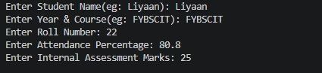

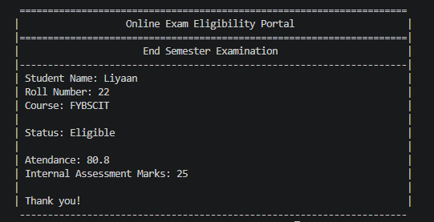
Sample Output:

