PENETRATION TESTING REPORT
FOOTPRINTING & NETWORK SCANNING PHASES
W2-PM-FINAL | CYBERSECURITY | NETWORKWALKS

Pentester Name  (Cybersecurity Professional) | Liya Mekbib
Program/Batch | B084-Networkwalks
Date | 12 November 2026
Modules completed | W2-PM1 (Multiple Kali Tools)  W2-PM5 (Zenmap Scanning)
Client/Target | 1. Networkwalks (secured written permission already)  2. My own local LAN Network
Permission secured from client? | Yes
Phases covered | Phase 1: Reconnaissance & Footprinting  Phase 2: Scanning & Network Discovery

1. Liability Disclaimer
This report presents two Week 2 internship activities at Networkwalks: domain footprinting of networkwalks.com (W2-PM1) using Kali Linux tools and scanning my own local network (W2-PM5) using Zenmap.
The activities demonstrate how public information can be gathered and how live network hosts can be identified. Each task includes the commands used, observed results, supporting screenshots, and a brief explanation of the security significance of the findings.

2. Introduction
This report presents two Week 2 internship activities at Networkwalks: domain footprinting of networkwalks.com (W2-PM1) using Kali Linux tools and scanning my own local network (W2-PM5) using Zenmap.
The activities demonstrate how public information can be gathered and how live network hosts can be identified. Each task includes the commands used, observed results, supporting screenshots, and a brief explanation of the security significance of the findings.

3. Tools Used
The table below lists each tool used in this report and its purpose.
Tool | Purpose
Kali Linux & Windows | Operating systems used.
WHOIS | Find domain registration details (owner, dates, name servers).
whatweb | Identify website technologies (server, CMS, plugins, IP).
nslookup | Resolve the domain name to its IP address using DNS.
curl -I | Read the HTTP response headers of the website.
wafw00f | Detect whether a Web Application Firewall protects the site.
dnsrecon | Discover DNS records.
Zenmap (Nmap GUI) | Scan networks and identify live hosts.
Windows CMD | Local IP and MAC address identification

4. Activities Performed

4.1 Footprinting & Reconnaissance

I performed reconnaissance against the networkwalks.com domain using six Kali Linux tools: WHOIS, WhatWeb, Nslookup, Curl, Wafw00f and DNSRecon. Each tool was used to collect a different type of information about the target.
First, I used WHOIS to obtain publicly available domain registration information and identify the domain’s name servers. The results provided information about the domain registration and hosting infrastructure.
I then used WhatWeb to identify technologies used by the website. The results identified WordPress 7.1.4 and WP Download Manager 3.3.76, along with other information exposed by the website.
Using Nslookup, I resolved the domain name to its IP address. The provided result identified 192.232.216.135.
I used Curl with the -I option to inspect the HTTP response headers. This provided additional information about the web application and exposed the WordPress REST API endpoint /wp-json/.
Next, I used Wafw00f to determine whether a Web Application Firewall was protecting the website. The result identified ModSecurity (SpiderLabs).
Finally, I used DNSRecon to enumerate DNS records. The results provided information relating to name servers, mail servers, SPF/TXT records, service records and DNS software information.

4.2 Network Scanning with Zenmap
For the second activity, I used Zenmap to perform network discovery on my local network. The practical required me to identify my local IP address and subnet, discover live hosts, identify their IP and MAC addresses, and generate a network topology.
I first used the Windows ipconfig command to identify my local IP address and LAN subnet (192.168.1.0/24). I then entered the subnet into Zenmap and selected Ping Scan to identify active hosts.
The results identified six live hosts out of 256 IP addresses scanned in 2.96 seconds:
- 192.168.1.1
- 192.168.1.2
- 192.168.1.3
- 192.168.1.5
- 192.168.1.7
- 192.168.1.8
After completing the scan, I opened the Topology section in Zenmap, enabled the legend, and saved the network topology in PDF format as required by the practical task.

5. Risk Analysis / Impact
Based on the information collected during the footprinting and network scanning activities, I identified the following potential risks.
# | Risk / Finding | Evidence / Observation | Potential Impact | Risk Level
1 | Web technology information exposed | WhatWeb identified WordPress 7.1.4 and WP Download Manager 3.3.76 | Attackers may use exposed technology/version information to identify software requiring further security review | ● Medium
2 | Server IP address identifiable | Nslookup resolved the domain to 192.232.216.135 | Provides information about the network location of the web service | ● Low
3 | HTTP technical information exposed | Curl returned HTTP response headers and exposed /wp-json/ | May assist technology fingerprinting and further enumeration | ● Low
4 | WAF technology identifiable | Wafw00f identified ModSecurity (SpiderLabs) | Reveals information about the web application’s security architecture | ● Low
5 | DNS infrastructure information exposed | DNSRecon identified DNS, mail and service-related records | DNS information can help build a broader infrastructure profile | ● Medium
6 | Multiple live hosts visible on local network | Zenmap identified six live hosts (192.168.1.1 - 192.168.1.8). Devices at .2 and .5 have unknown MAC vendors. | Unknown or unauthorized devices may potentially be present on a network | ● Medium

Risk level key: ● Critical ● Medium ● Low
The risks above are observations from the footprinting and scanning exercises, not confirmed vulnerabilities. No exploitation or vulnerability validation was performed.
The presence of software versions, IP addresses, or DNS records does not mean the system is vulnerable; further authorized testing is required to confirm actual vulnerabilities.

6. Recommendations
- Based on the observations, I recommend the following security improvements:
- Review publicly exposed technology information: Regularly check what CMS and plugin details are publicly visible.
- Keep software updated: Regularly update CMS platforms and plugins against current security advisories.
- Review HTTP headers: Ensure unnecessary technical information is not exposed in headers.
- Review DNS records regularly: Ensure only required information is publicly exposed.
- Monitor the WAF: Keep ModSecurity enabled and tuned.
- Perform regular internal network discovery: Periodically scan networks to identify active devices.
- Investigate unknown devices: Verify unexpected devices like the unknown MAC vendors at 192.168.1.2 and 192.168.1.5.
- Maintain network documentation: Keep topology and device information updated.
- Perform security testing with authorization: Only test systems with proper authorization.

7. Conclusion
During Week 2 of my internship, I completed footprinting and network scanning activities.
I used six Kali Linux tools to gather public information about the target domain. WHOIS provided registration data, WhatWeb identified WordPress 7.1.4, Nslookup resolved the IP, Curl exposed HTTP headers, Wafw00f identified ModSecurity, and DNSRecon enumerated DNS records.
Using Zenmap, I identified my local network configuration, discovered 6 active hosts, collected IP/MAC information, and created a network topology.
These exercises demonstrated that information gathering is a critical part of cybersecurity. A security professional can learn a significant amount about an environment before attempting exploitation. I also learned that clear documentation—explaining what was done, discovered, the risks, and mitigations—is essential. Finally, I confirmed that reconnaissance and scanning must always be performed within an authorized scope

8. Evidences Collected

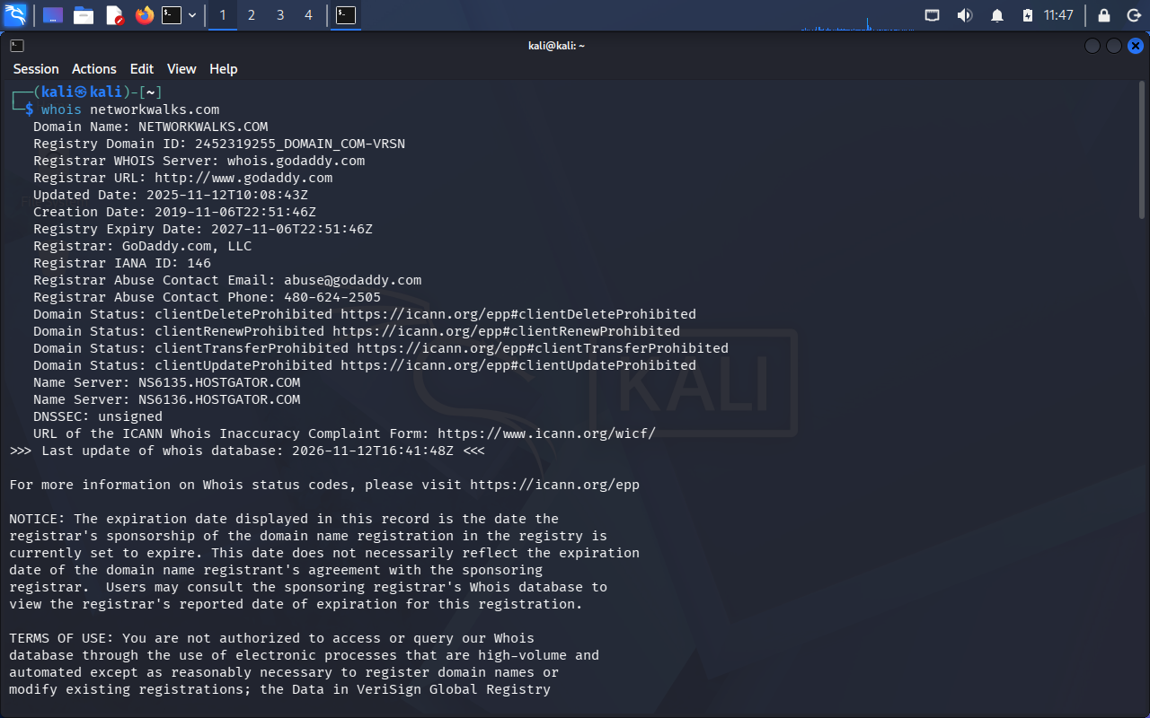

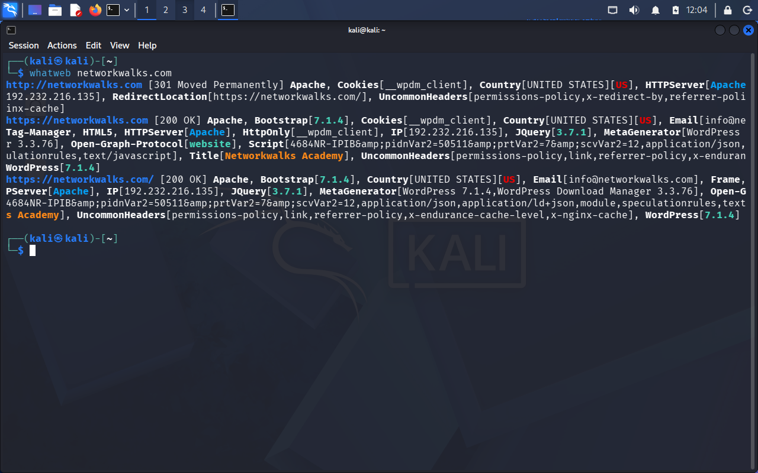

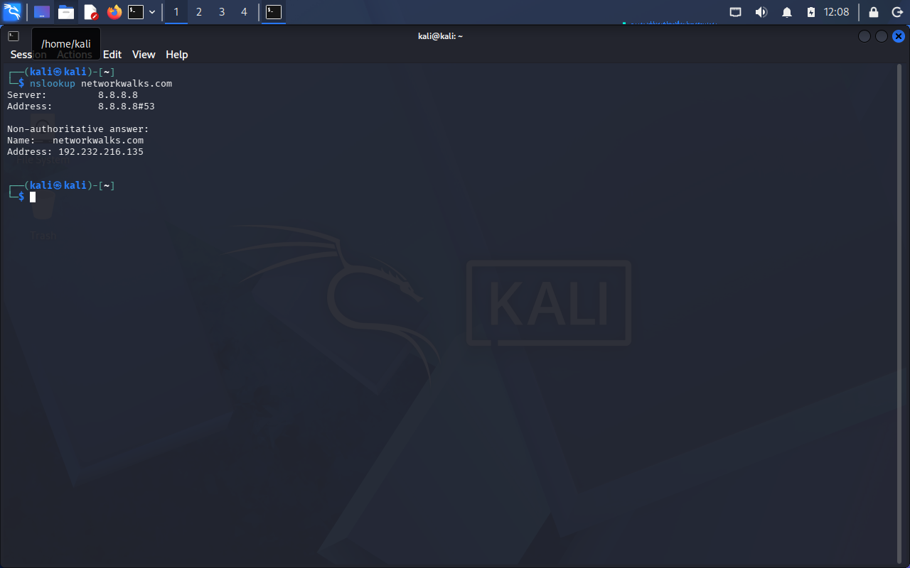

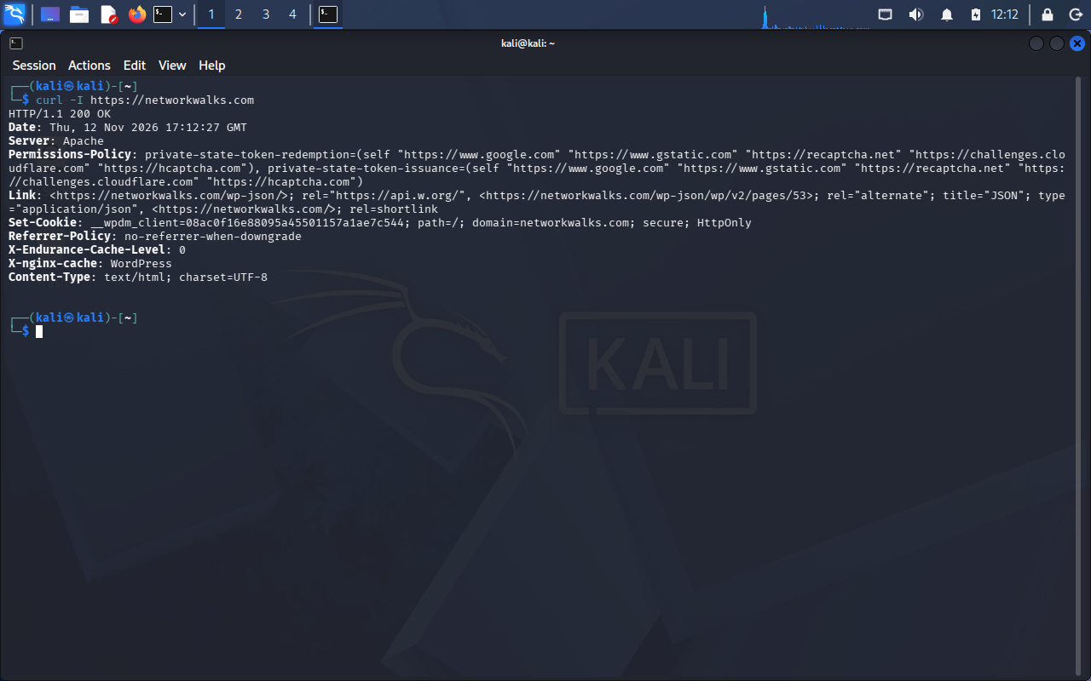
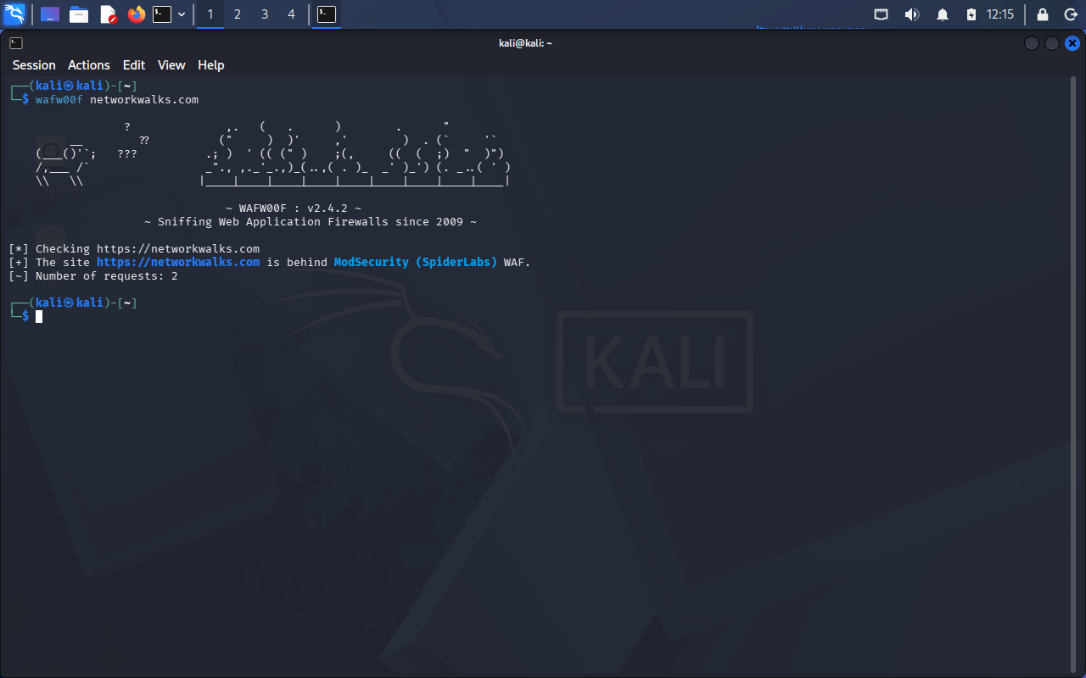

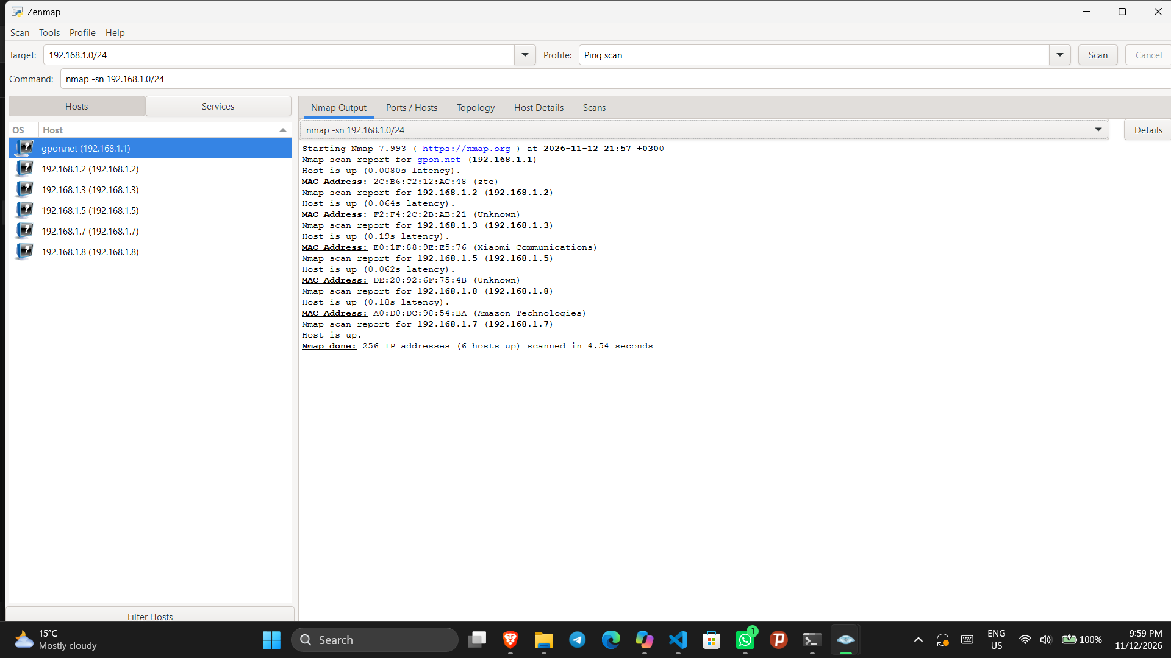
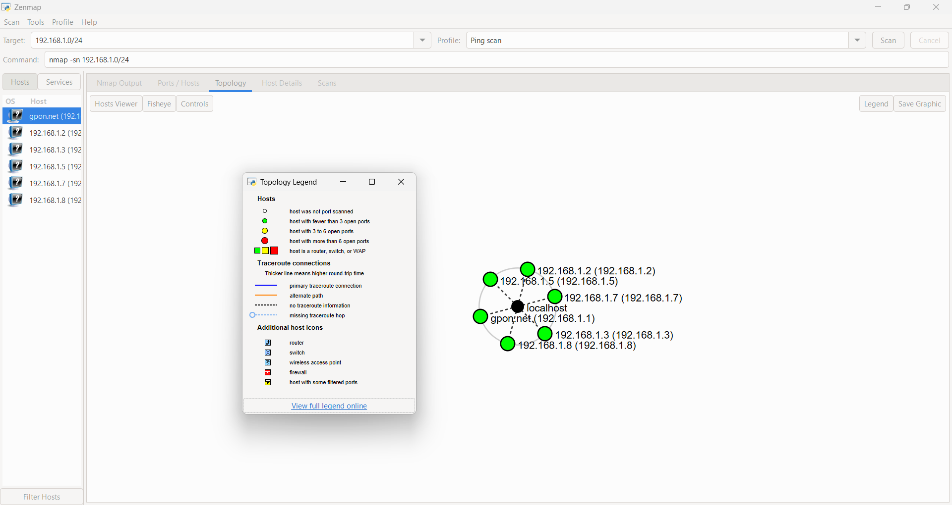

-End-

👤 Author
Liya Mekbib
LinkedIn: https://www.linkedin.com/in/waqaskarim/

📌 Project Information
Program Name: Cybersecurity program at Networkwalks | Week: 02 | Repository: GitHub

