Password Strength Checker
Intern ID: CITS8420

Full Name: Onley Zarro N

No. of Weeks: 4 weeks

Project Name: Passwords strength checker

Project Scope:

A web-based password strength checker is a client-side cybersecurity tool that evaluates user input in real time. It scores passwords based on length, uppercase and lowercase letters, numbers, and special symbols, providing instant visual feedback and tips to improve security.

• Main Goal: Build a fast, secure web tool that tests password complexity.

• User Benefit: Helps users create safer passwords to stop digital hacks.

• Core Privacy: All checks run locally in the browser so passwords never go to a server.

Overview
The Password Strength Checker is a client-side web application that lets users type a password and instantly see:
- Whether the password meets five common security requirements
- A visual strength bar (Weak / Medium / Strong)
- A summary message describing the overall strength
The app is built with plain HTML, CSS, and JavaScript — no frameworks or external libraries are required.

File Structure
File | Purpose
index.html | Page structure and markup (input field, requirement list, strength bar)
style.css | Visual styling and layout
script.js | Password validation logic and DOM updates

All three files must be kept in the same folder, since index.html references style.css and script.js by relative path.

How It Works

1. User Input
The password field (#password) is of type "password" by default, so characters are masked. A Show/Hide button (#togglePassword) toggles the input's type attribute between "password" and "text" to reveal or hide the typed characters.

2. Real-Time Validation
Every time the user types (the input event), the checkPassword() function runs and tests the current password value against five rules using regular expressions:
Requirement | Rule | Regex / Check
Minimum length | At least 8 characters | password.length >= 8
Uppercase letter | At least one A–Z character | /[A-Z]/
Lowercase letter | At least one a–z character | /[a-z]/
Number | At least one digit | /[0-9]/
Special character | At least one non-alphanumeric character | /[^A-Za-z0-9]/

3. Requirement Indicators
Each rule has a corresponding <p> element (#length, #uppercase, #lowercase, #number, #special). The updateRequirement() function:
- Shows a check mark and applies the .valid CSS class (green text) when the rule passes
- Shows a cross mark and applies the .invalid CSS class (red text) when it fails

4. Strength Scoring
Each satisfied requirement adds 1 point to a score variable (maximum score: 5). The score maps to a strength level:
Score | Strength Level | Bar Width | Message
0 | Not checked | 0% | (empty field)
1–2 | Weak | 20–40% | Your password is weak.
3–4 | Medium | 60–80% | Your password could be stronger.
5 | Strong | 100% | Excellent! Your password is strong.

The updateStrength() function updates:
- The width of #strengthBar (score × 20%)
- The text of #strengthText
- The background color and text of the #message box

Element Reference
Element ID | Description
#password | Text input where the user types their password
#togglePassword | Button that shows/hides the typed password
#strengthBar | Colored bar inside .strength-bar that visually represents score
#strengthText | Label showing the current strength category
#length, #uppercase, #lowercase, #number, #special | Requirement checklist items
#message | Feedback box summarizing overall password strength

Styling Notes
- .valid → green text (#16a34a) for met requirements
- .invalid → red text (#dc2626) for unmet requirements
- The strength bar and message background colors are set dynamically in JavaScript rather than CSS classes, based on the score range (weak = red tones, medium = amber tones, strong = green tones)
- The layout is centered on the page using flexbox on body, with a card-style .container

Customization Guide

Change minimum length
const hasLength = password.length >= 8; // change 8 to desired minimum

Add a new requirement (e.g., no spaces)
1. Add a new <p id="noSpaces"> element in index.html
2. Add a check in script.js:
const noSpaces = !/\s/.test(password);
updateRequirement(noSpacesElement, noSpaces, "No spaces allowed");
if (noSpaces) score++;

3. Adjust the max score used in strength calculations accordingly (currently out of 5)

Adjust strength thresholds
Modify the if/else if conditions inside updateStrength(score) in script.js.

Known Limitations
- Strength is measured only by character-type variety and length — it does not check for common/breached passwords, dictionary words, or patterns (e.g., "Password123!" would score as "Strong" despite being predictable).
- No backend validation — this is a front-end UX tool only and should not be relied on as the sole security check for account creation.
- No accessibility labels (aria-label) are currently set on the toggle button or strength bar; consider adding these for screen reader support.

Suggested Future Enhancements
- Integrate a library like zxcvbn for realistic strength estimation
- Add a password history/blocklist check
- Add debounce to the input event for performance on very long inputs
- Add ARIA live regions so strength updates are announced to screen readers

Output Images:

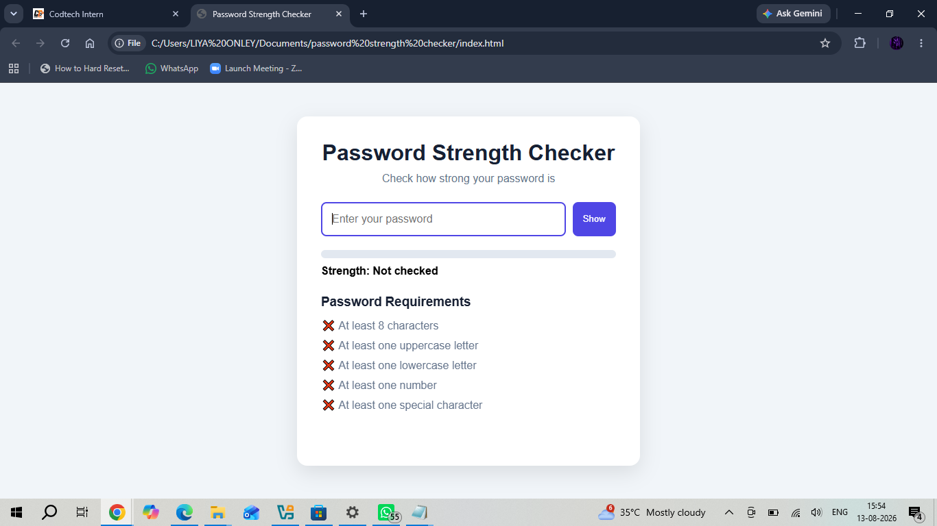
1.

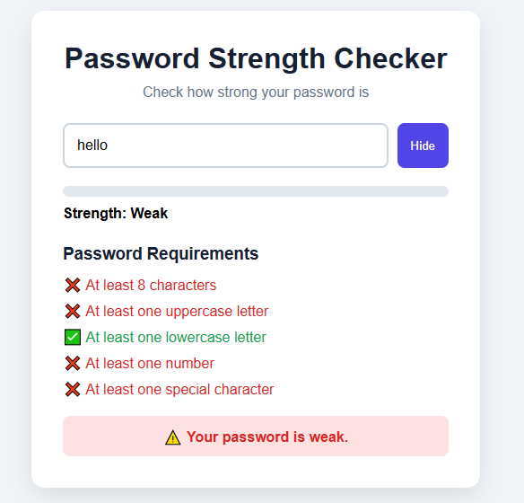

2.

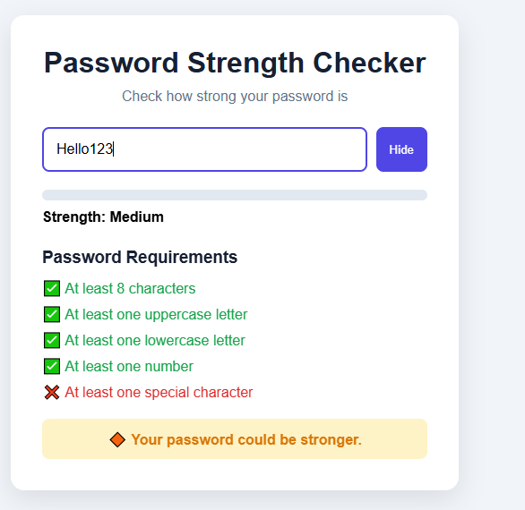
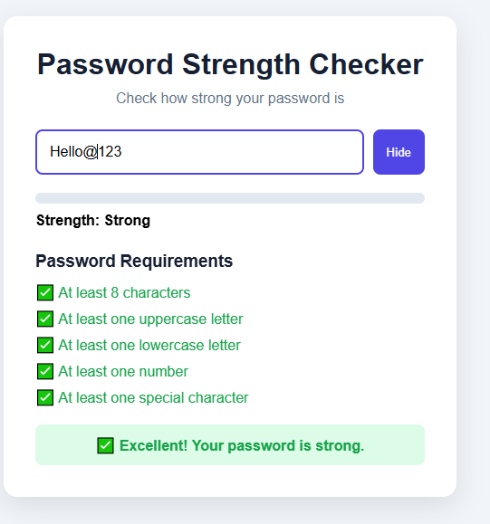
3.

4.

Conclusion:
The Password Strength Checker demonstrates how a small set of front-end technologies — plain HTML, CSS, and JavaScript — can be combined to deliver real-time, user-friendly feedback without any external dependencies. By validating five common password criteria and translating them into a live visual score, the tool helps users form better password habits at the point of entry, which is when guidance is most effective.
Its simplicity is also its main limitation: the checker measures character variety and length, not real-world guessability, so it should be treated as a UX aid rather than a security guarantee. Pairing it with server-side validation, breach/dictionary checks, and a library such as zxcvbn would make it suitable for production use.
Overall, the project provides a solid, extensible foundation. Its modular structure (separate HTML, CSS, and JS files) makes it straightforward to adjust requirements, thresholds, and styling, or to extend it with the enhancements outlined above as the application's needs grow.

