WOLLIE / PRODUCT RESEARCH
Couples finance apps:
product, UX and market research
What people use today, where it breaks, and the opportunity for Wollie
Scope: European couples using joint, separate, or mixed accounts
1 September 2026
Research method
Official product documentation, public user discussions, and three safe zero-data trial accounts. No bank account, identity verification, money movement or paid subscription was used.

Decision in one page
Wollie should be a couples-first money planning layer over the accounts people already use. It should work for one joint account, separate personal accounts, and a mixture of both.
Recommendation Do not position Wollie as another bank or a generic expense tracker. Own the space between a couple’s existing accounts and the shared decisions they need to make.

The opportunity
Across the market, couples repeatedly trade simplicity for control. A bank can hold shared money. A personal finance app can budget it. Neither reliably gives a couple one plan that respects personal boundaries, calculates contributions and stays useful when only one person wants to operate it.
1  Privacy by design  Private, shared and household-total-only views. Never force full transaction visibility. | 2  Contribution rules  Equal, fixed and income-proportional funding for shared spending and goals. | 3  Partner Light  A calm safe-to-spend and approval view for the less hands-on partner.

A critical UI distinction
EVERYDAY SPENDING | FUTURE RESERVES
Food, travel, rent and discretionary categories. | Savings, tax, pension, investment and future purchases.
A purchase reduces what is left to spend this month. | Funding builds progress toward a target. It is not spending.
Use red only for genuine overspending or an actionable overdue shortfall. A partially funded reserve is neutral progress, not a warning.

What couples use today
Direct planning products and adjacent banking apps solve different pieces of the same household problem. The comparison below focuses on their household model, not every individual feature.
PRODUCT | BEST AT | HOUSEHOLD MODEL | KEY LESSON FOR WOLLIE
YNAB | Deep intentional budgeting. | One subscription can share with up to five people. Joint, separate and mixed setups are possible. | Offer one simpler default household plan and granular visibility.
Monarch | One household dashboard across both partners’ accounts. | Separate logins and shared data under one subscription. | Never make account and transaction visibility all-or-nothing.
Wallet | Clear personal dashboard and permissions. | Premium owner creates a group; members switch between personal and group contexts. | Do not force a context switch for ‘my’ versus ‘our’ money.
Spendee | Simple wallet and category model. | Shared wallet owned by one person; bank wallets cannot be shared. | A shared plan must interpret both bank-linked and manual money.
Revolut | Joint account behaviour, cards and Pockets. | A true joint account for eligible customers. | Meet the familiar bank mental model without becoming a bank.
Wise | Cross-border money and controlled shared spending. | Spend-with-others group model in supported markets. | Be crystal-clear about ownership and what Wollie never does.
Market reading Revolut and Wise are important behaviour-setters, but they are not the same product category. Wollie should be the cross-bank planning layer that lets a couple understand money held elsewhere.

The main gaps
- A shared plan usually means broad visibility, multiple budgets or a separate shared-wallet context.
- Contribution logic is often manual: who paid, who owes, and how income should fund the plan.
- Savings, tax and pension are frequently mixed into a monthly budget as though they were spending.
- The less-engaged partner is rarely given a purpose-built light experience.

Trial-account UX gallery
The following were captured in safe zero-data research accounts on 1 September 2026. No bank account was connected, no identity verification was submitted, and no money was moved. The gallery covers representative main screens, not every workflow.

YNAB: collaborative budget onboarding
The onboarding-first experience introduces planning behaviour before showing a dense budget. It is friendly and intentional, although couples may still need to decide between multiple budget structures and manually manage personal contributions. YNAB’s couples guide supports joint, separate and mixed setups.
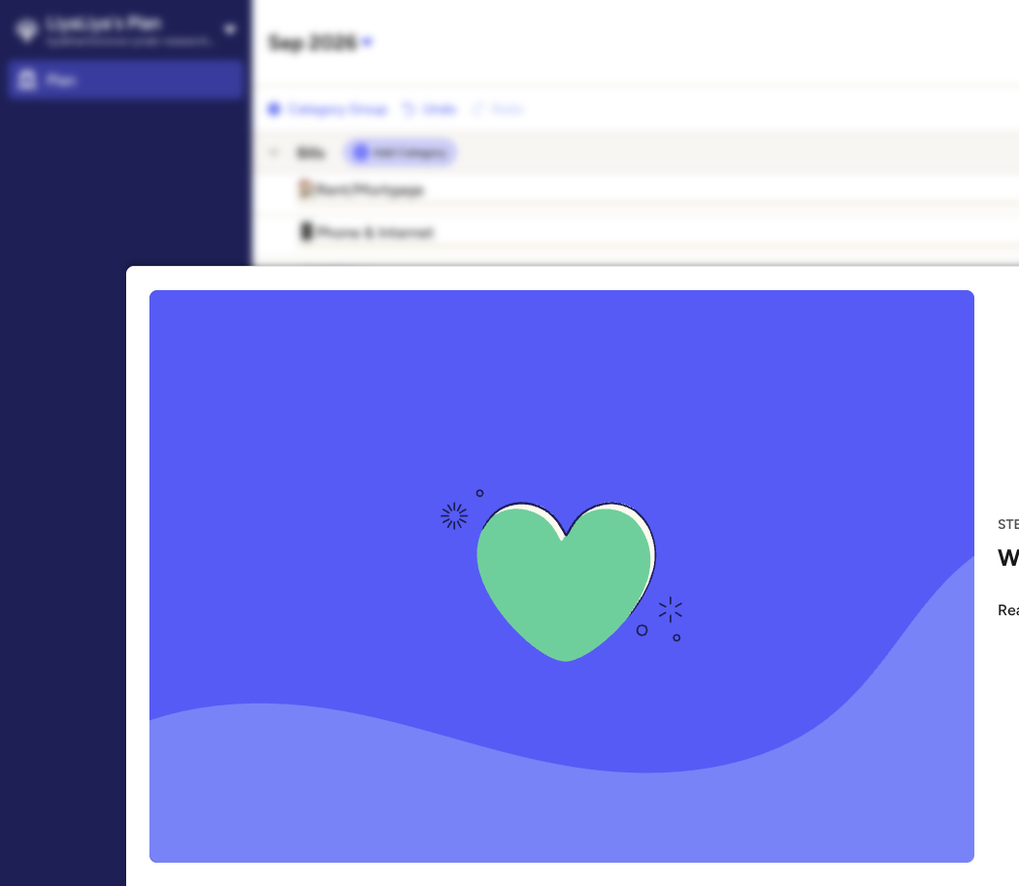
YNAB onboarding. Research account, zero data. Source: direct product observation, 1 September 2026.

Wallet by BudgetBakers: calm personal dashboard
The navigation is easy to scan: Dashboard, Accounts, Records, Analytics and Imports. The familiar personal-money structure is a strength. Its group sharing model is more limiting: the official documentation says it is unavailable on the web, uses separate group context and initially gives new members access to all accounts.
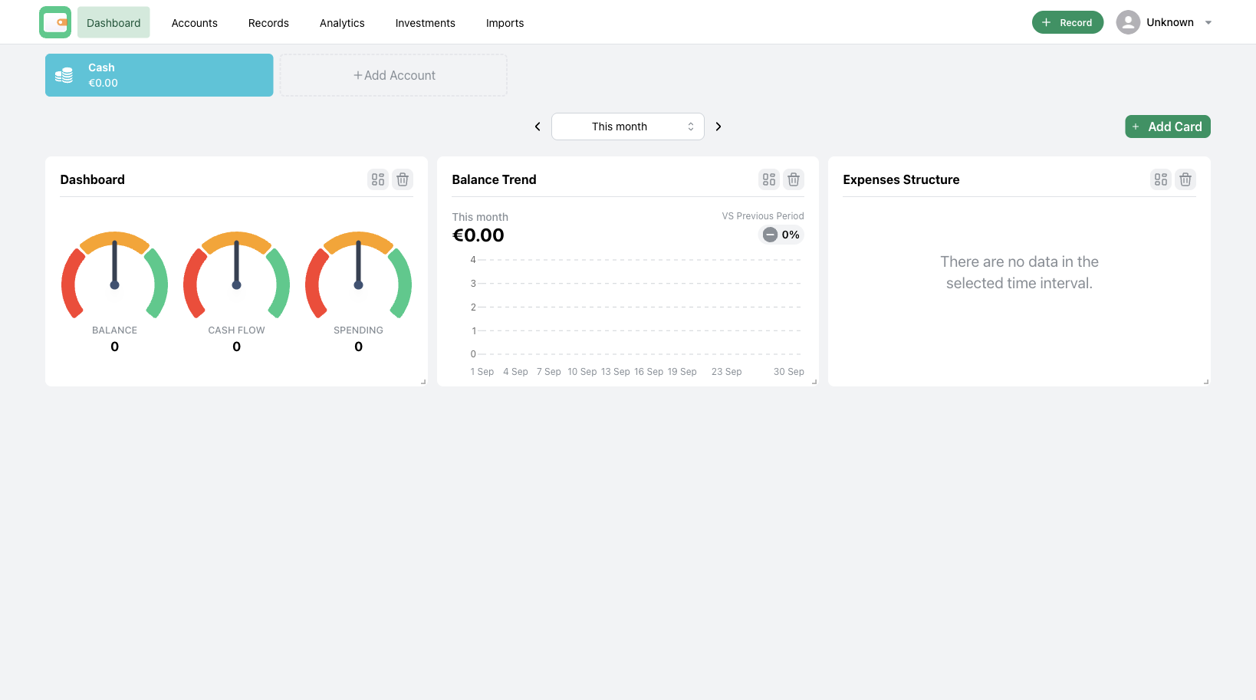
Wallet dashboard. Research account, zero data. Source: direct product observation, 1 September 2026.

Wallet: account list
The account list reinforces a simple tracker mental model. Wollie should take the calm clarity, while avoiding a separate ‘group wallet’ universe.
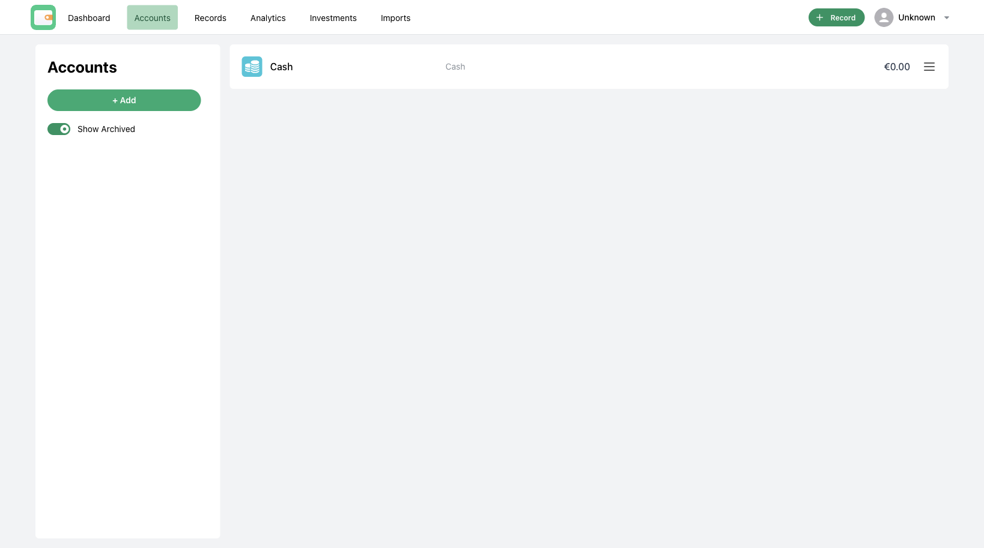
Wallet accounts. Research account, zero data. Source: direct product observation, 1 September 2026.

Spendee: simple shared-wallet idea, early paywall
Spendee makes wallets and categories approachable. In the trial account, adding a second wallet immediately reached a Premium boundary. The shared-wallet model is less complete than a shared household plan, and its help centre states that bank wallets cannot be shared.
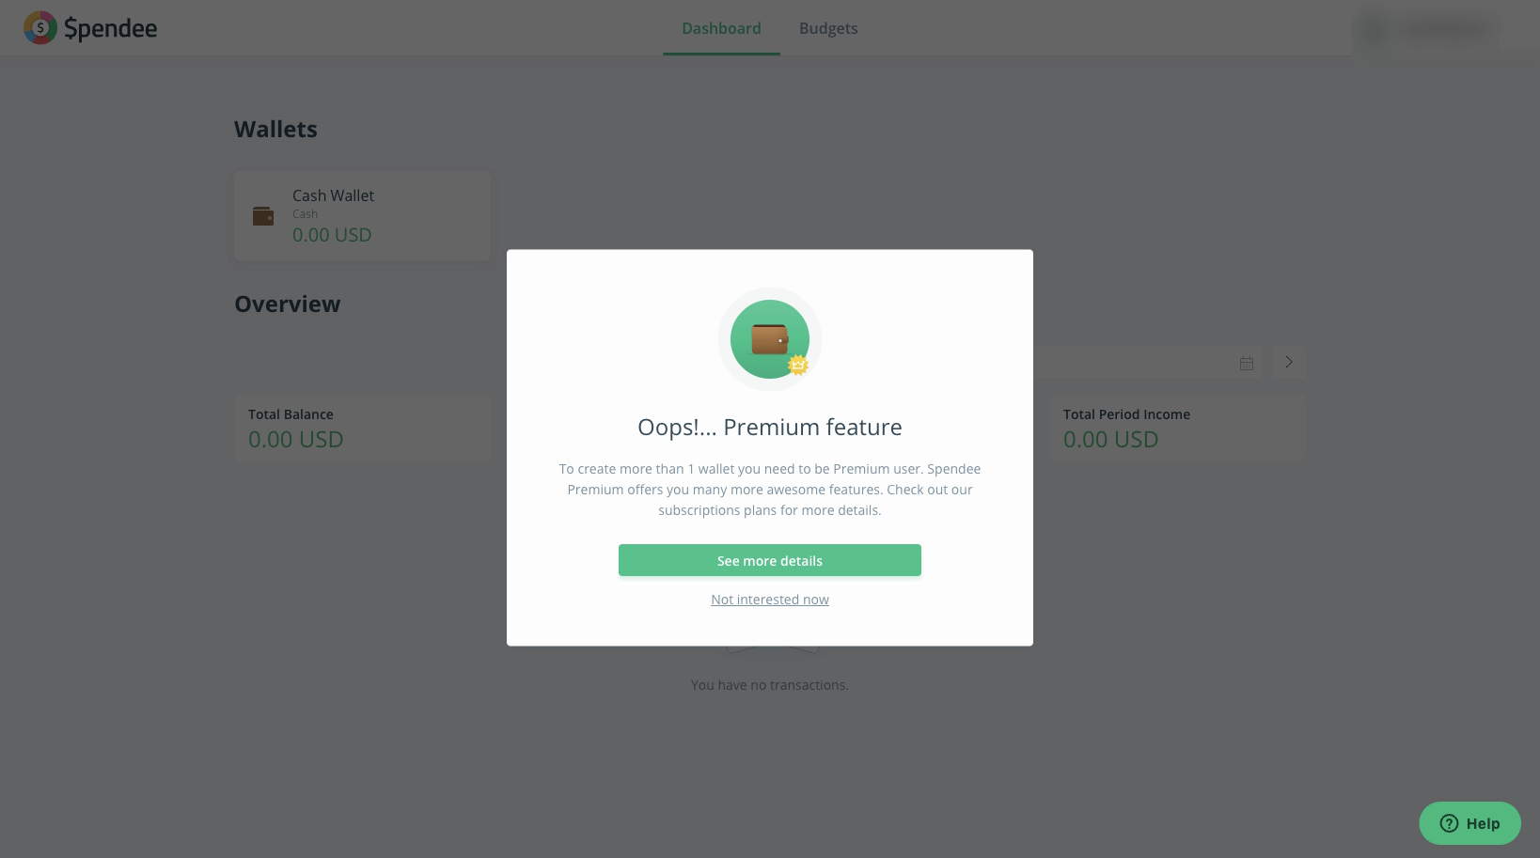
Spendee Premium boundary. Profile label is intentionally redacted. Research account, zero data. Source: direct product observation, 1 September 2026.

What users repeatedly struggle with
These are qualitative signals from public Reddit discussions. They are not survey results, but the themes recur across products and countries.
1 | Shared costs, personal autonomy  Couples want to plan rent, groceries and trips together while retaining personal spending and surprise gifts. Full mutual visibility is often too blunt.  Wollie implication: Make visibility deliberate at account, transaction and category level: Private, Shared with partner, or Household total only.

2 | One person runs the plan  Many households have a ‘money person’ and a partner who does not want daily categorisation.  Wollie implication: Create a Partner Light role with safe-to-spend, upcoming bills, approvals and a weekly digest.

3 | Separate cards create manual maths  Shared cards, personal cards and paybacks create awkward contribution calculations.  Wollie implication: Support equal, fixed and proportional-to-income rules, then show expected and actual contributions.

4 | People do not want to switch worlds  Personal records and group records often become separate product contexts.  Wollie implication: Keep one household plan. Let privacy settings change the view rather than moving the user elsewhere.

5 | The plan goes stale  Large changes need a conversation, and unrecorded transfers make the plan feel arbitrary.  Wollie implication: Show simple proposals, confirmations and a lightweight decision history for material changes.

Examples of the public discussion
YNAB privacy and gifts • YNAB shared-account setup • Monarch automatic partner budget splits • Wallet joint and personal accounts

UX principles for Wollie

1. Start with intent, not account architecture
Ask: “Which money do you want to plan together?” Then let a couple include joint accounts, selected personal accounts, or both. Do not force a ‘joint versus separate’ decision before they see the model.

2. One shared plan, layered views
MY VIEW  My accounts and my private categories. | SHARED VIEW  Money and categories both partners chose to share. | HOUSEHOLD VIEW  Combined plan and totals, respecting privacy settings.

3. Separate funding from spending
At the top of Money plan, use two clear tabs or sections:
- Spend this month: Food, travel, rent and discretionary categories. Example: ‘€800 left to spend.’
- Save and prepare: Tax, pension, savings and future goals. Example: ‘€2,250 set aside’ and ‘45% of €5,000 target.’
A card purchase should update a spending category. A funded pension or tax reserve should build progress, not appear in ‘Spent this month.’

4. Make contribution rules visible
EQUAL  Food: funded 50/50. | FIXED  Holiday: Liya €200, Alex €200 per month. | PROPORTIONAL  Tax: funded in proportion to income.

5. Make card spending feel automatic, not mysterious
Use one short explanation near transactions: “When a card purchase arrives, Wollie categorises it and updates that category’s balance.” Show the category chip, the transaction amount and the new remaining balance. Do not repeat the full envelope status below every transaction.

Recommended 90-day product priorities
1. Household scope and permissions
Define Private, Shared and Household total only visibility. Make invite, accept, leave and revoke flows safe and simple.
2. Contribution and funding rules
Support fixed, equal and proportional-to-income funding per spending category or goal. Keep a clear audit trail.
3. Spend versus reserve model
Build distinct data and UI states for monthly spending and future reserves. Never label a pension allocation as spent.
4. Partner Light
Create a quick, mobile-friendly view for safe-to-spend, bills, approvals and a weekly household summary.
5. Monthly planning conversation
Add a low-friction check-in for income received, funding progress, proposed changes and decisions.

Proposed permission model
LEVEL | BALANCE | MERCHANT | CATEGORY TOTAL | EDIT PLAN
Private | Only owner | Only owner | Optional roll-up | Owner only
Shared | Both partners | Both partners | Both partners | By household role
Household total only | Included in total | Hidden | Shared impact only | Owner controls source
The household-total-only option is strategically important. It lets a partner contribute to a shared plan without exposing every merchant.

Invite flow
- Invite by email.
- Recipient sees: “Sign in or create an account to accept.”
- If the address already has a Wollie account, accept without changing its login.
- Before connecting an account, choose: Private, Shared, or Household total only.
- Confirm what each partner can see and change.

Language, trust and competitive boundaries

Recommended customer language
USE | WHY
Money plan | Broader and calmer than ‘budget’; includes spending, savings and goals.
Spend this month | Plain label for day-to-day categories.
Save and prepare | Makes tax, pension, savings and future goals feel different from spending.
Set aside / funded | Correct language for reserves and future goals.
Available to spend | Use only when clearly tied to everyday categories.

Words to avoid
- Avoid calling a pension, investment or savings allocation ‘spent.’
- Avoid generic ‘household’ labels when the user needs to know whether an account is private, shared or total-only.
- Avoid promising bank-like capabilities. Wollie does not hold or move money.

Wollie’s trust promise
Suggested copy Wollie reads the accounts you choose. It never moves your money. You control what is shared.

What the banks teach us
Revolut is a powerful local expectation-setter: its 2025 annual report says one million customers created Joint Accounts that year, and lists joint histories, matching cards, joint budgeting tools, Pockets and savings. Read the annual report
Wise is an adjacent controlled-sharing model. In supported regions the group owner retains legal control of the funds and members receive selected spending capabilities. Read Wise’s Spend with others guide
Wollie should borrow the clarity of account ownership and card spending, while remaining a calm cross-bank planning layer rather than a financial institution.

Sources and limitations

Official product sources
All official source pages were accessed on 1 September 2026.
- YNAB pricing and trial
- YNAB subscription sharing
- YNAB guide to budgeting as a couple
- Monarch for Couples and Households
- Monarch pricing
- Wallet group sharing
- Wallet overview
- Spendee shared wallets
- Spendee Premium
- Revolut 2025 annual report
- Wise: Spend with others

Public user-discussion signals
- YNAB: couples who track expenses together
- YNAB: shared bank account setup
- YNAB: privacy and gifts
- YNAB: collaboration when one partner runs the budget
- Monarch: household member options
- Monarch: automatic partner budget splits
- Wallet: joint and personal accounts

Method limitations
This is desk research plus three safe, zero-data trial accounts. It does not test live bank connections, regulated account opening, identity verification, paid subscriptions, support quality, account closure or long-term transaction classification. Public Reddit posts are qualitative and may be dated, incomplete or unrepresentative.

