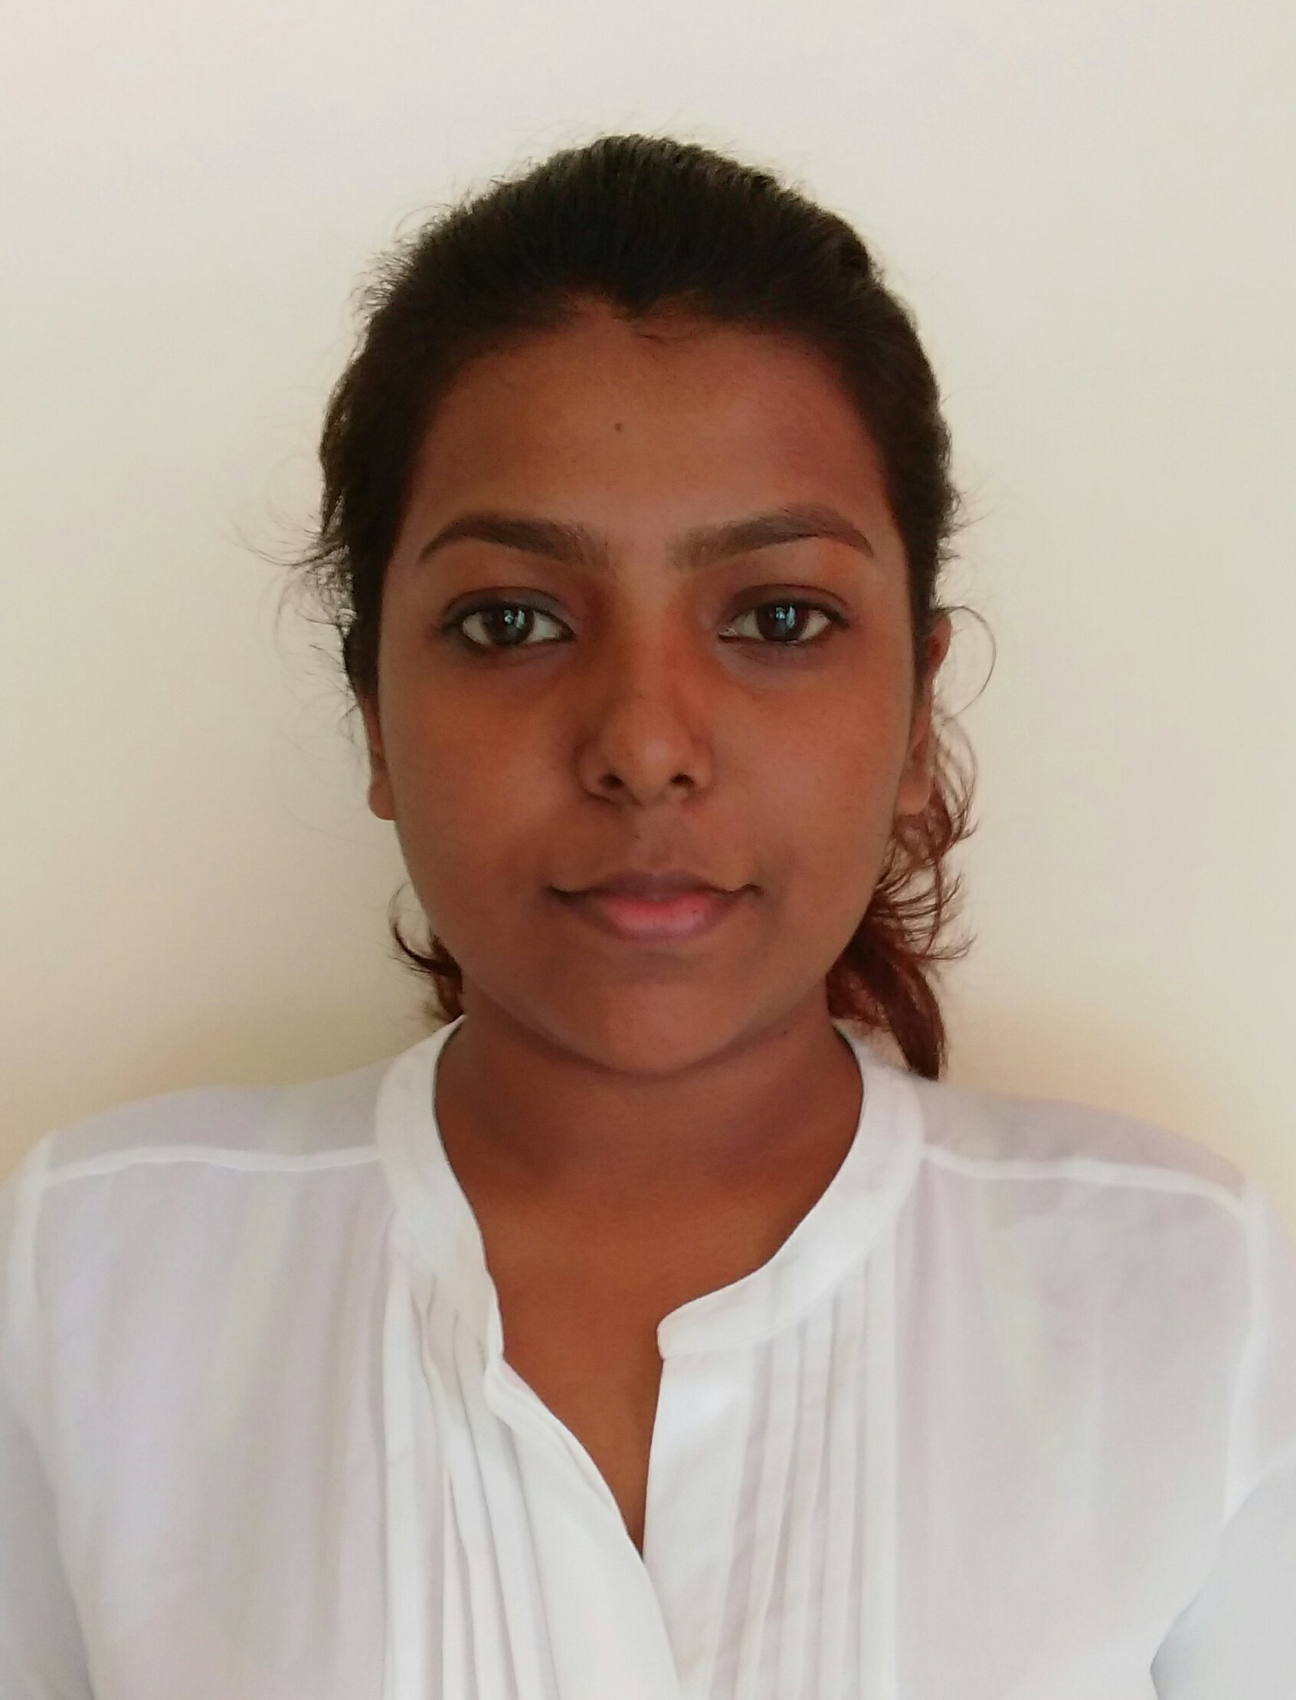

**Nadeesha Mayanthi Liyanage**

64, Dharmarama Rd, Ratmalana. • 0776457307/ 0112 739568

• [liyanagenm@gmail.com](mailto:liyanagenm@gmail.com)/[it14056376@my.sliit.lk](mailto:it14056376@my.sliit.lk)

**Internship – Software Engineering**



A self driven, versatile, highly motivated, individual. A person with good communication skills, who believes in being punctual, dedicated and honest. Actively looking for a trainee Software Engineering position in a fast paced ever changing environment where I can use my talents and skills to gain experience as well as contribute to the organizations goals.

**Education**



**B.ScSpecial (Hons) – Information Technology Expected Graduation Date – 2017**

**Specialization – Software Engineering**

Sri Lanka Institute of Information Technology

CGPA- 3.37 (upto 2nd Year 2nd Semester)

Attended Sirimavo Bandaranaike Vidyalaya, Colombo 07.

**GCE Advance Level (Mathematics) Aug 2013**

Combined Mathematics S

Physics S

Chemistry S

English A

General Information Technology A

**GCE Ordinary Level Dec 2010**

English Langugae A

Mathematics A

Science & Technology A

Buddhism A

Sinhala Language A

History A

English Literature B

Information Communication Technology A

Accounts & business studies B

**Projects and Research**



**Hotel Management System for Tangerine Beach Hotels Ltd - Project 2015**

Developed a hotel management system using .Net and c# for second year second semester project. Contributed by developing the housekeeping services module.

**Leave Management System - Project 2015**

Developed a leave management system using java for second year first semester project.

**E-Commerce website - Project 2014**

Developed an online gift store using HTML, java script, CSS and PHP for first year project.

**Key Skills and Competencies**



Computer skills - C/C++, Java, c#, .NET

Posses good proficiency in programming languages, object oriented concepts, developing, testing and designing interfaces.

Proficient in written and oral communication skills.

**Personal Details**



Date of Birth: 4th August 1994

Gender: Female

NIC number: 947170112V

Nationality: Sri Lankan

Languages: Sinhala, English

Religion: Buddhist

**Referees**



* Mrs. Dinusha Namali Manawadu

Sirimavo Bandaranaike Vidyalaya ,

Colombo 07.

Tel: (+94)71-6149272

* Ms Laksri Wijerathna

Lecturer,

Faculty of Computing,

Sri Lanka Institute of Information Technology,

Level #16,

BOC Merchant Tower,

28, St Michaels Rd,

Colombo 03.

General: (+94)11-2301904

Tel: (+94)77-2207229

E-mail: [laksri.w@sliit.lk](mailto:laksri.w@sliit.lk)

I hereby certify that above information provide by me are true and accurate to the best of my knowledge.

Yours sincerely,

N M Liyanage

NadeeshaLiyanage_SE_WE_002