Data Visualization with Python
Data visualization helps present data in graphical formats, making patterns easier to understand.

Key Points
1. Matplotlib: A widely used library for creating static plots.
2. Seaborn: Built on Matplotlib, offers high-level interface for statistical graphics.
3. Plotly: Interactive graphs and dashboards.

Example Code
import matplotlib.pyplot as plt
x = [1, 2, 3, 4]
y = [10, 20, 25, 30]
plt.plot(x, y)
plt.show()
Illustration:
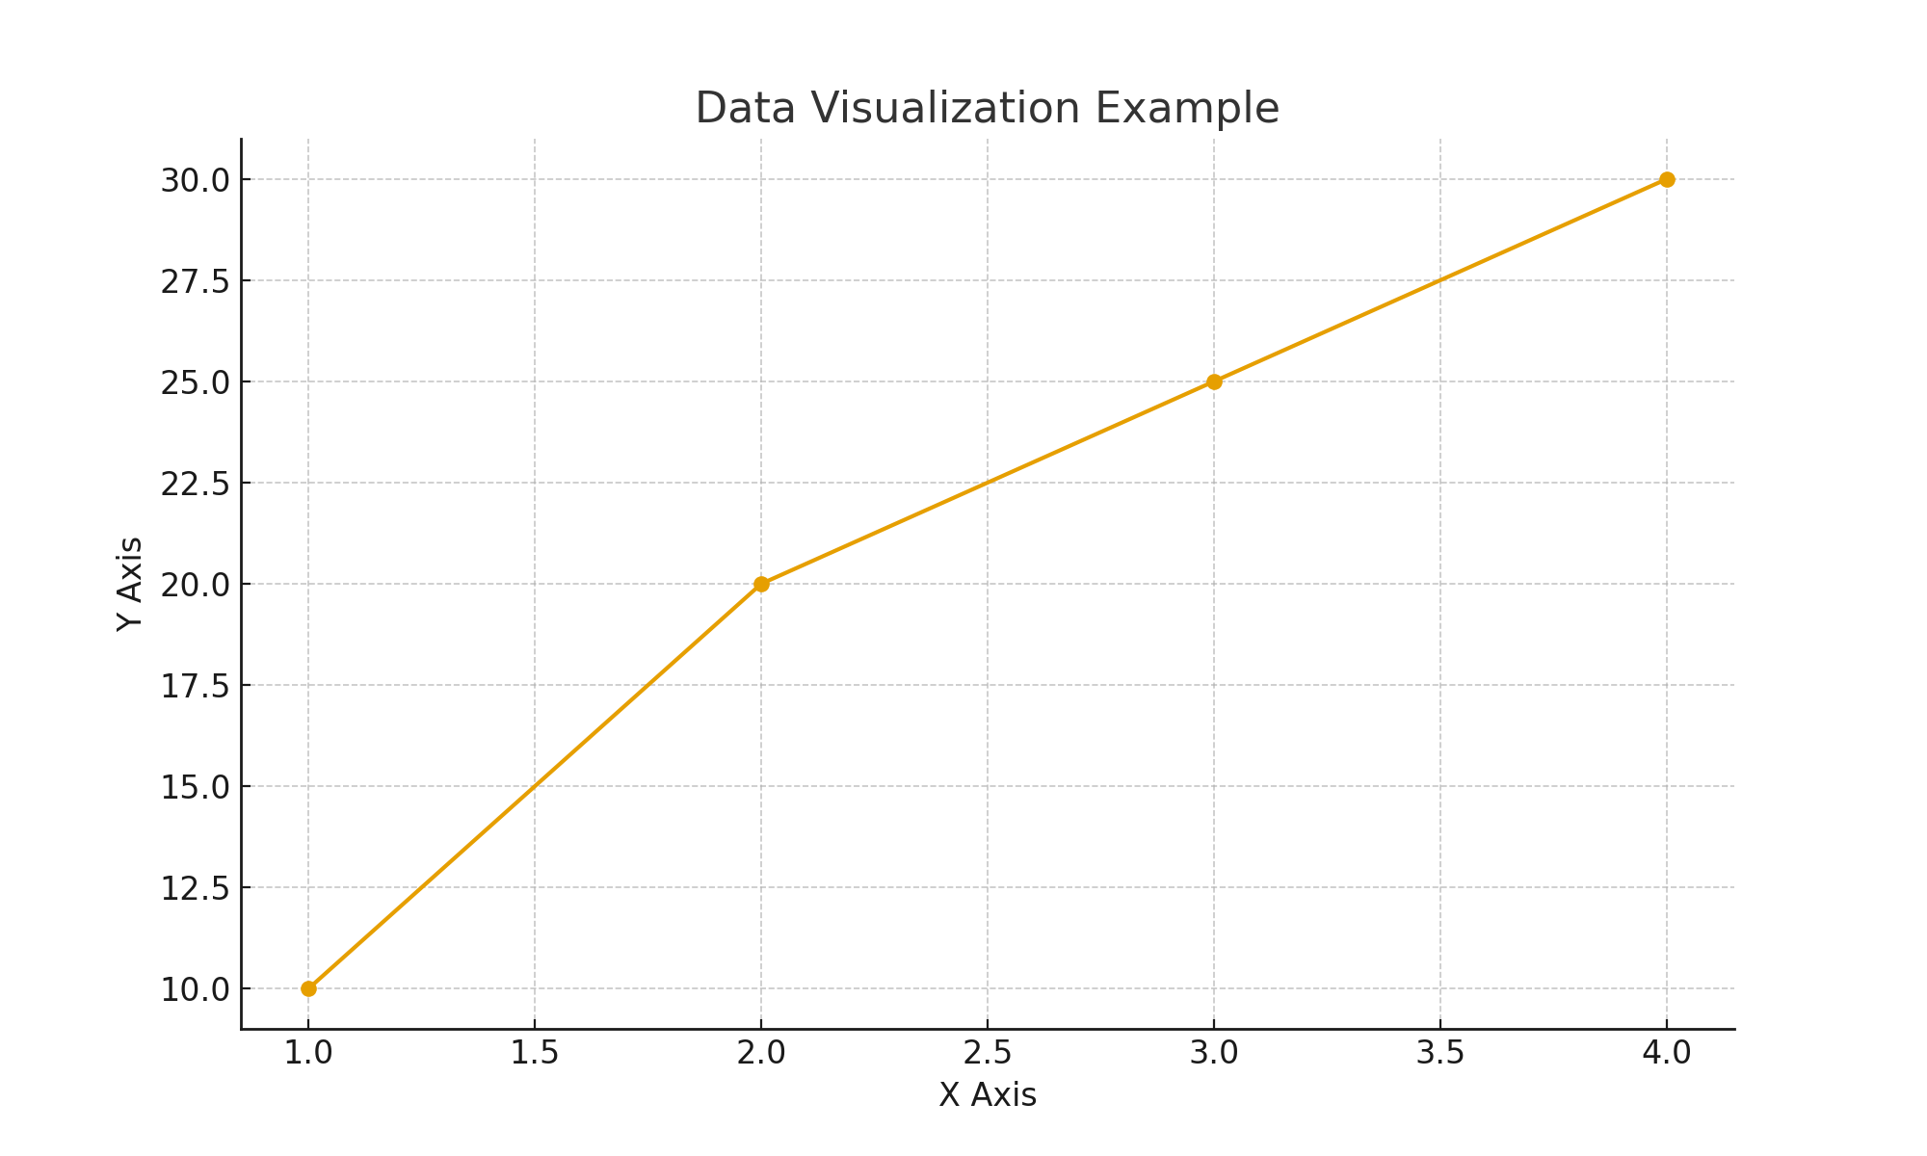

Conclusion
Visualization is key for effective data analysis.

