Cloud Computing Overview
Cloud computing provides on-demand computing resources over the internet with pay-as-you-go pricing.

Key Points
1. IaaS: Infrastructure as a Service.
2. PaaS: Platform as a Service.
3. SaaS: Software as a Service.

Example Code
services = ['IaaS', 'PaaS', 'SaaS']
for s in services:
print('Service:', s)
Illustration:
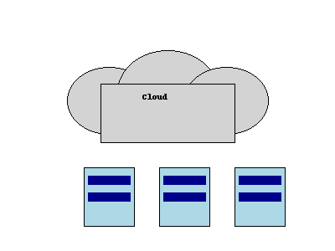

Conclusion
Cloud computing powers scalability and cost efficiency.

