Artificial Intelligence Applications
Artificial Intelligence (AI) refers to systems that mimic human intelligence to perform tasks.

Key Points
1. Natural Language Processing: Understanding human language.
2. Computer Vision: Interpreting visual input.
3. Robotics: Automating physical tasks.

Example Code
from textblob import TextBlob
text = 'I love AI applications.'
blob = TextBlob(text)
print(blob.sentiment)
Illustration:
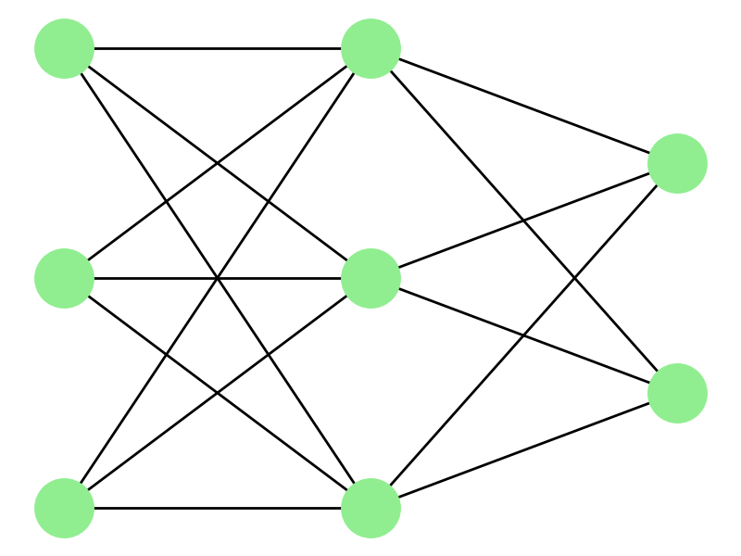

Conclusion
AI applications are transforming industries worldwide.

