|  |  |  |
| --- | --- | --- |
| **Name** | **Student ID** | **E-mail** |
| **Jiaming pan** | **1001778516** | **jiaming.pan@mavs.uta.edu** |
| **Yazhou Li** | **1001778478** | **yazhou.li@mavs.uta.edu** |
| **Weixiao Sang** | **1001780927** | **Weixiao.sang@mavs.uta.edu** |

1. **Introduction:**

Some of the problems we encounter now, when we read the article encounter problems, we often need to Google search other people's notes, and the search results are often unsatisfactory, the notes you might find will not help you solve your problems. A lot of time was wasted. So we came up with the idea of sharing notes in the same paper, where everyone could write their own notes. When you have some parts you don't understand in the paper, you just click on them and you can see others' notes. You can also ask questions for others to answer. We hope to construct a paper sharing platform to help people read papers more efficiently.

This project is a paper sharing platform. The whole system is divided into four subsystems, registration system, user management system, paper reading system and management system. Users can select articles of interest on the web page and share their notes. If there are related questions, you can ask questions and watch notes shared by others. The paper recommendation system will recommend relevant articles based on the reader's preferences

1. **competitors**

|  |  |  |  |  |
| --- | --- | --- | --- | --- |
| Competitors | Function of competitors'  products | how competitors work | Disadvantage | Our product's fuction |
| Personal blog | Uploading notes/  make Comments | Users upload their reading notes to their personal blogs. Other users can leave comments below the blog. | Personal blog can only upload personal notes, it is not public.  There may be more than one blog for the same article, which can lead notes to be scattered.  Different blogs have different concerns about the same paper，users may not be interested in this blog, so user sould search other blog  Blog search often through Google and other ways, less efficient. | You can review your notes or take notes while reading.saving the time whi takes to Google and upload your notes to your personal blog.  Users can actually rate question or answer question for specific part of the paper.User can query/write notes when thry are reading |
| Paperweekly | comments Notes paper links | Users can search for papers through searching box. Clicking the searching result to enter the page and a link to the paper is provided in this page, you can write notes and comments on the below. | It just provide a link of the paper. you can't write notes in papers directly.  the quality of notes is not good. | Exact search of notes  High quality notes and comments  Push  Q/A  Notes Grading  Thumbing up  Chatting Room |

**3. Features**

**3.1 User group**

Undergraduates, postgraduates, doctoral students, relevant staff and scientific researchers

**3.2 User case diagram：**

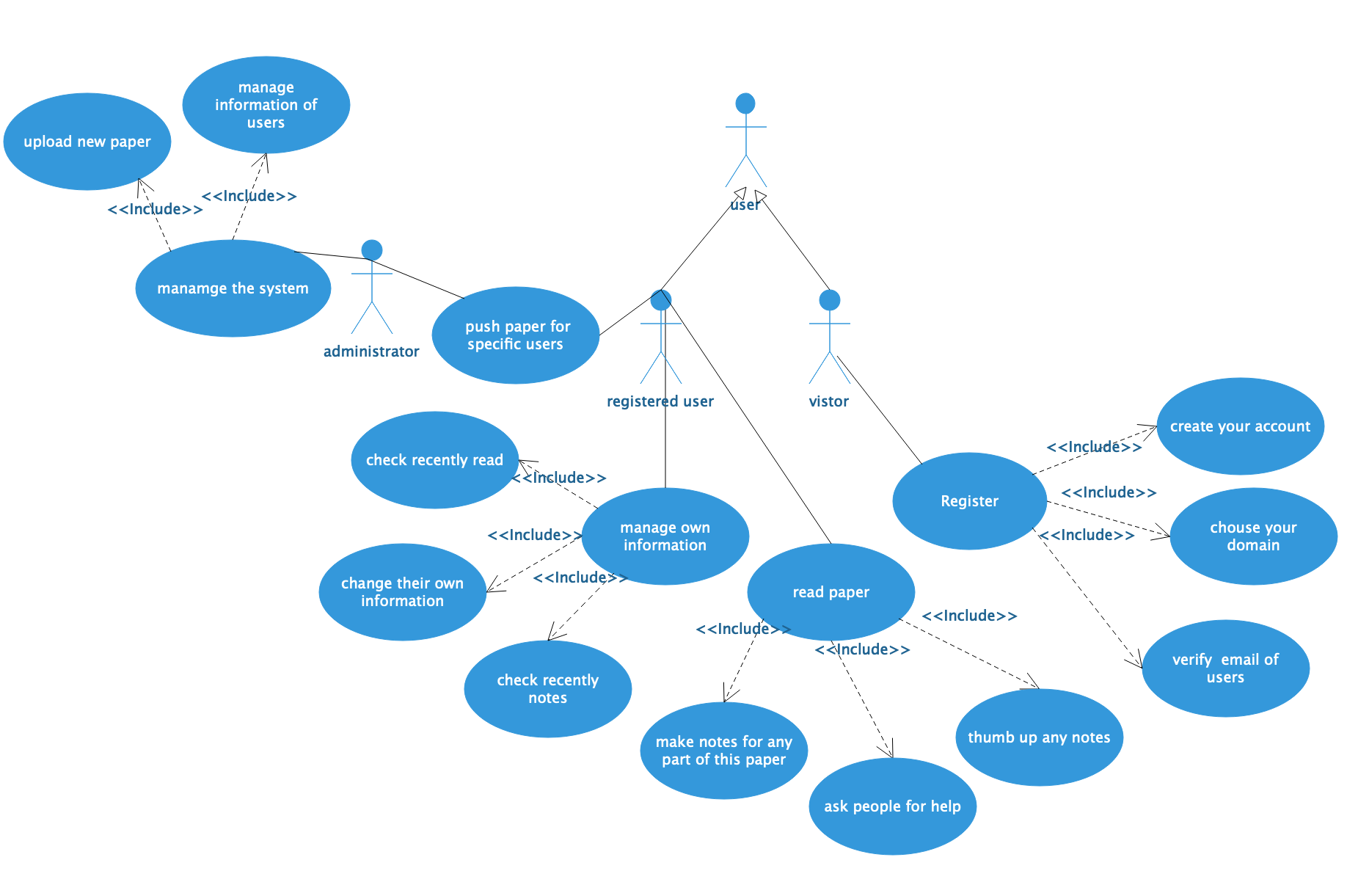

2-1 use case diagram

**3.2.1 The Register system**

a. The Register system shall make vistors to sign in first

b. Register system shall allow vistors to create their own account

c. Register system shall allow vistors to chose their domain to get recommendation from the system

d. Register system shall make sure the email is belonged to the user

**3.2.2 The user management system for users**

a. The user management system shall allow users to manage their information

b. User information management shall allow users to check recently notes

c. User information management shall allow users to manage collection of notes

d. User information management shall allow users to manage rencently notes

e. User information management shall allow users to manage their profile informaiton

**3.2.3 The paper reading subsystem**

a. The paper reading subsystem shall allow users to manage and look through paper.

b. Paper management shall allow users make notes for any parts of the paper.

c. Paper management shall allow users thumb up their favorite notes.

d. Paper management shall allow users ask people for help

e. Paper management shall allow users have chat with other users who is reading the same paper

**3.2.4 The management system for administrator**

a. The management system for administrator shall allow administrator to manage the system

1. User information management shall allow administrator to push papers for specific user
2. User information management shall allow administrator to delete informatio/comments of users
3. User information management shall allow administrator to ban specific users
4. User information management shall allow administrator to modify information/comments of users.
5. User information management shall allow administraor to upload paper for users to read

**3.2.5 Recommendation System**

a. Recommendation System shall allow the system to push specifc paper for users

b. Recommendation System shall tag users with their domain

c. Recommendation System shall tag notes with their notes

d. Recommendation System shall push paper for specific users

**3.3 Operational flow diagram：**

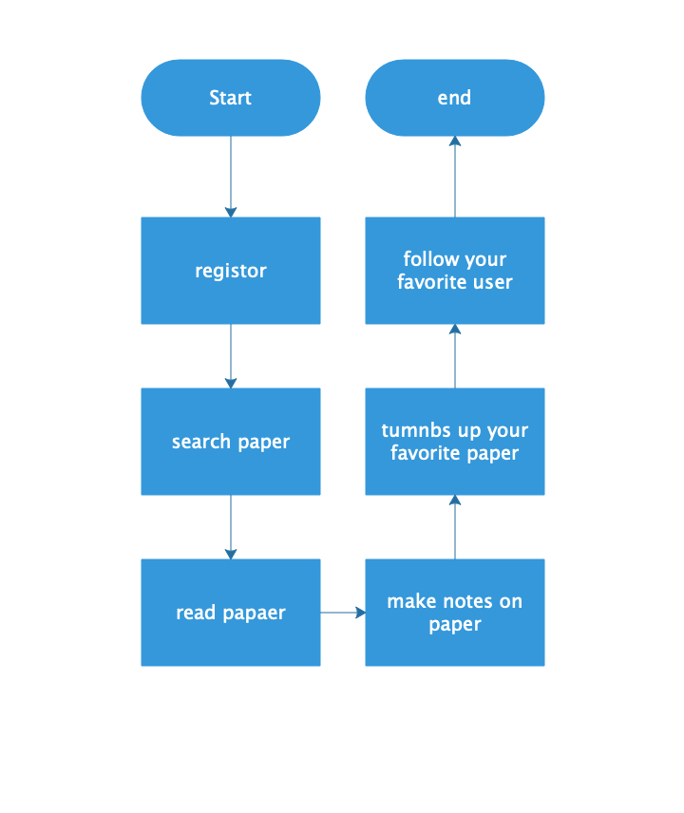

2-2 Overall Operational flow diagram

**3.3.1 register**

Fisrt of all, users visit our system as a vistor.

**3.3.2 search paper**

Then they can find some interesting articles on the platform.

**3.3.3 read paper**

They can read their favorite papers.

**3.3.4 make notes on paper**

They also can make notes on every part of this paper.

**3.3.5 tumbs up your favorite paper**

They also can thumb up their favoriter paper.

**3.3.6 follow your favorite user**

Meanwhile，they could follow their favoriter users.

**3.4 core function flow diagram**

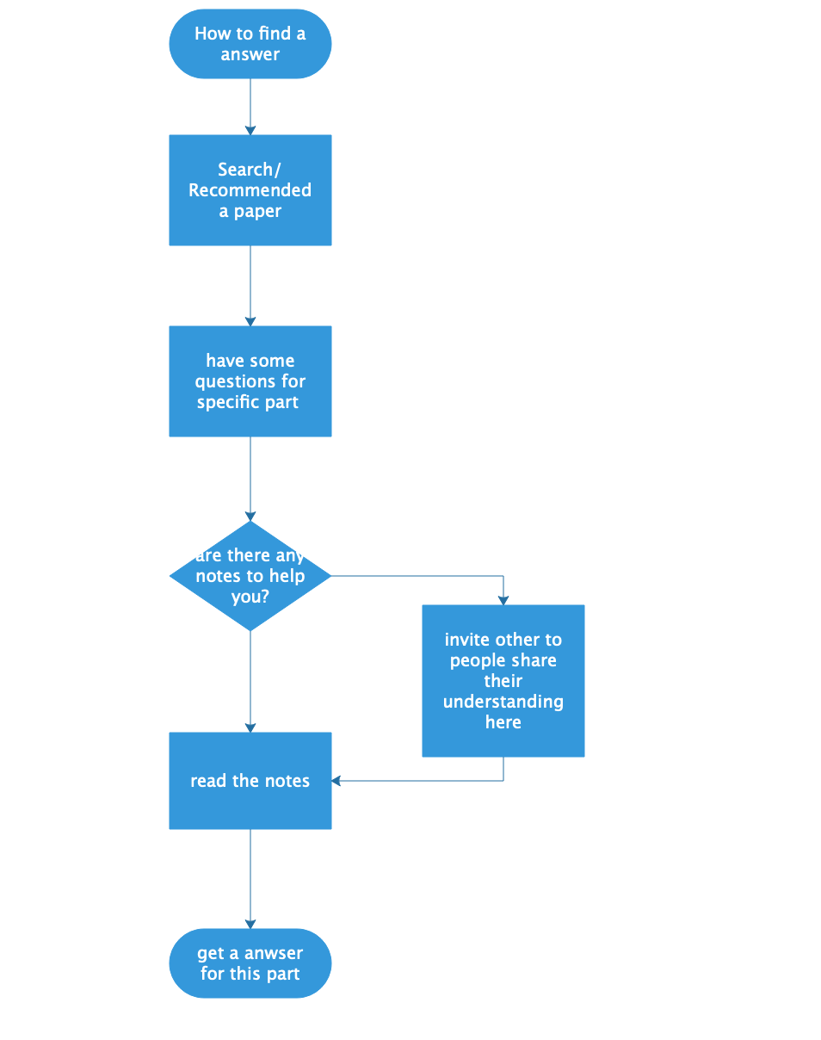

2-3 core function flow diagram

diagram 2-3 show the process about how an user looking for the valuable information from our system. First of all user are able to get a paper from search function or recommendation system. Then when users read the paper when they have questions on some sentences ,formula or expressions. users could select these part and check if there have any notes to help them understand this question .If there is no any notes there, they could invite other users who understand this part to make notes here to share their knowledge.it will also help other users who has the same problem here .when every people do the something here, it will generate a knowledge sharing environment on more concreate question.

**3.5 screen flow**

**3.5.1 Home page**

The first page is our home page, the left side shows the different scientific fields, and the right side is the top ten articles selected according to the heat.

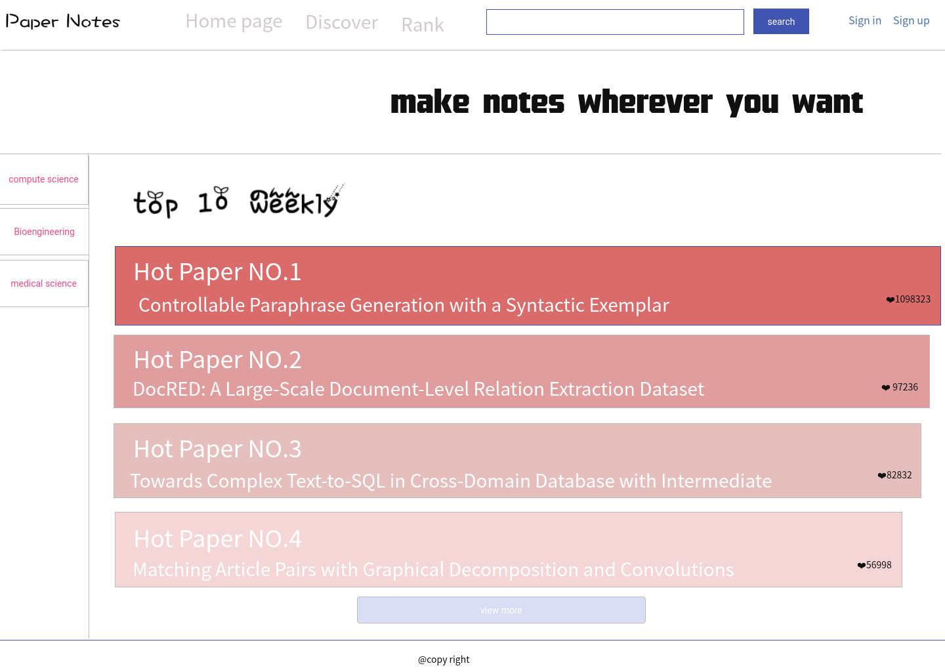

**3.5.2 sign up 1**

The second page is our registration page. First we need to fill in the username, user email, and password.

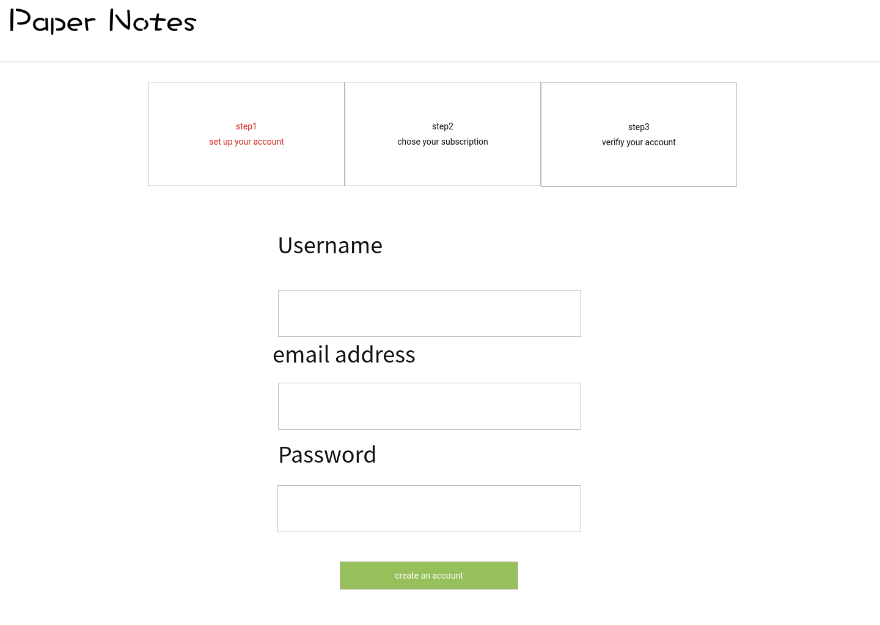

**3.5.3 sign up 2**

Then we need to choose our school, profession, and the field we like.

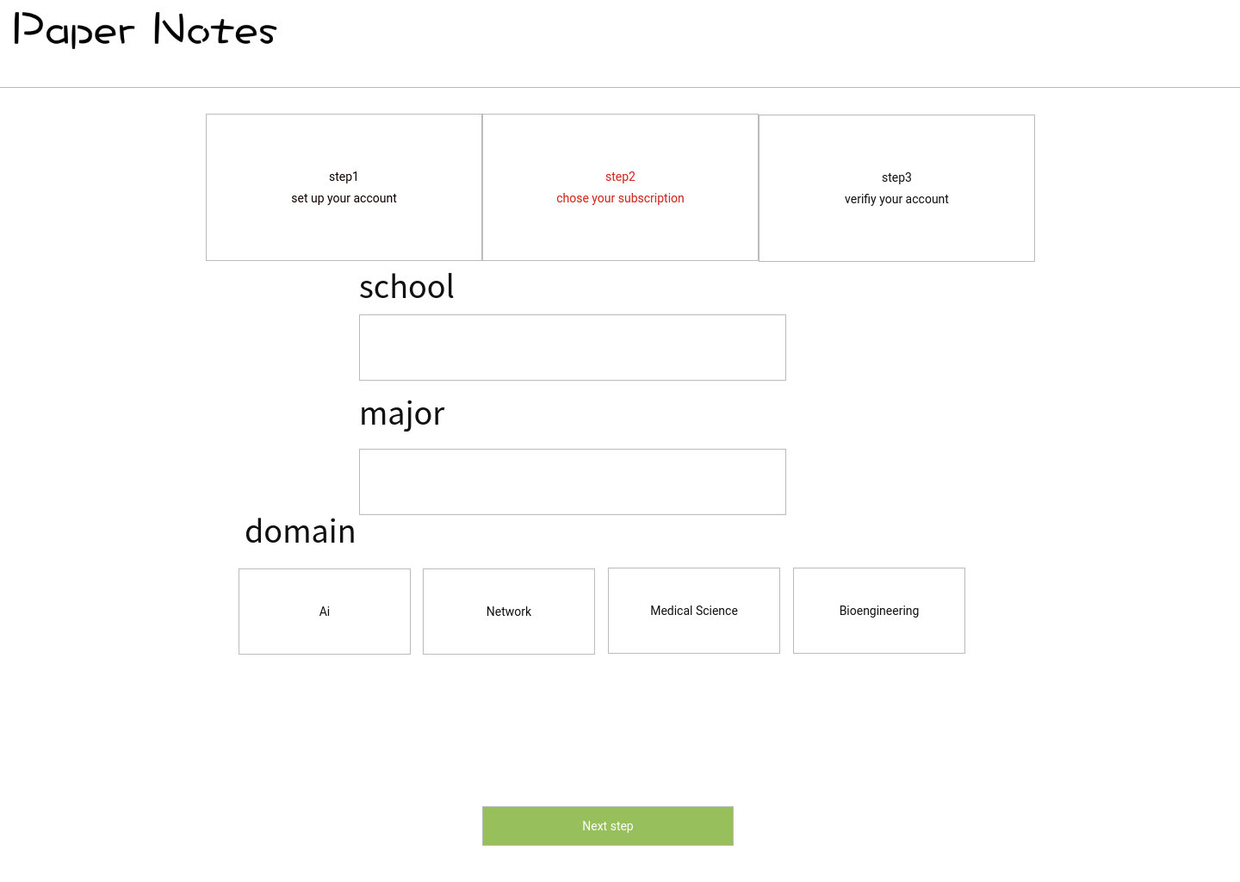

**3.5.4 sign up 3**

The final step in registration requires us to verify the identity using the verification code of the mailbox.

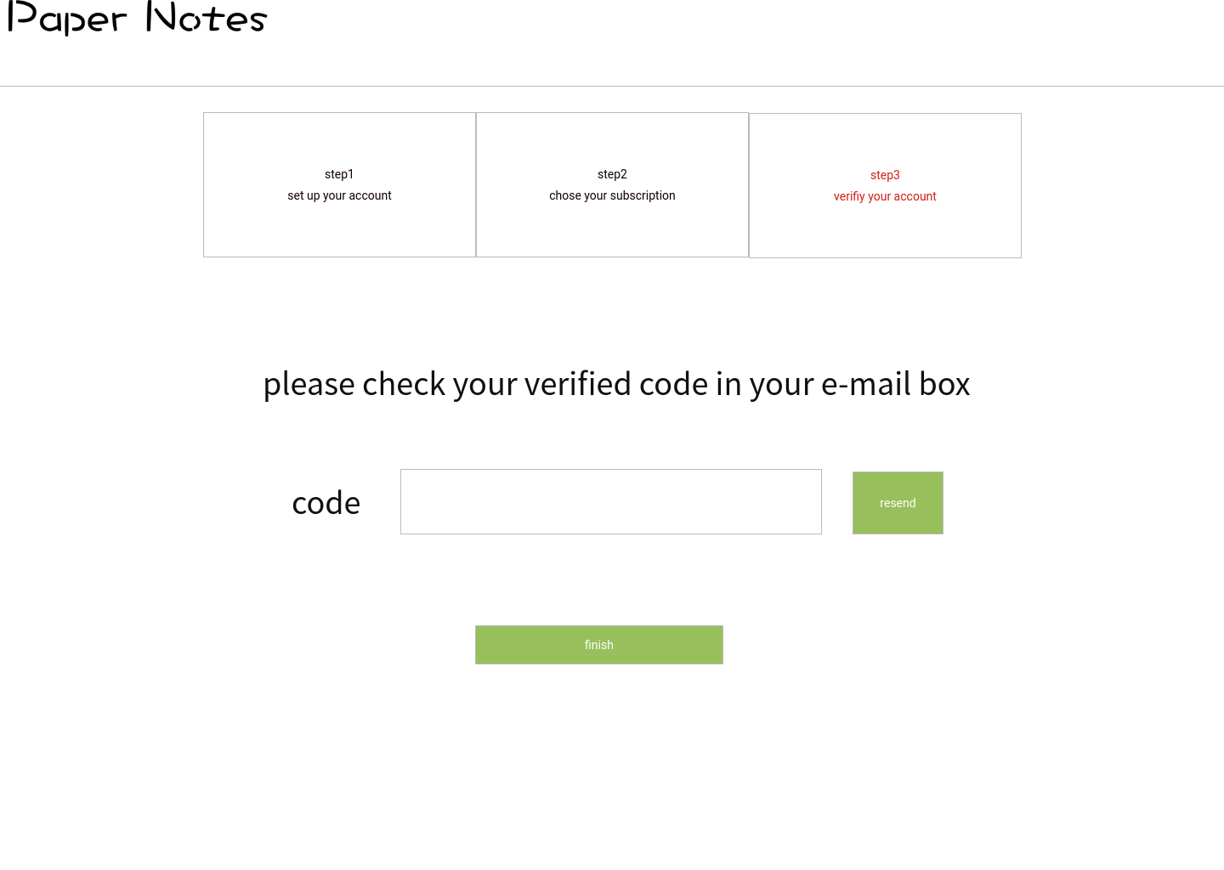

**3.5.5 sign in**

Users input their account and password to sign in, If you dont have account you can just creat a account.

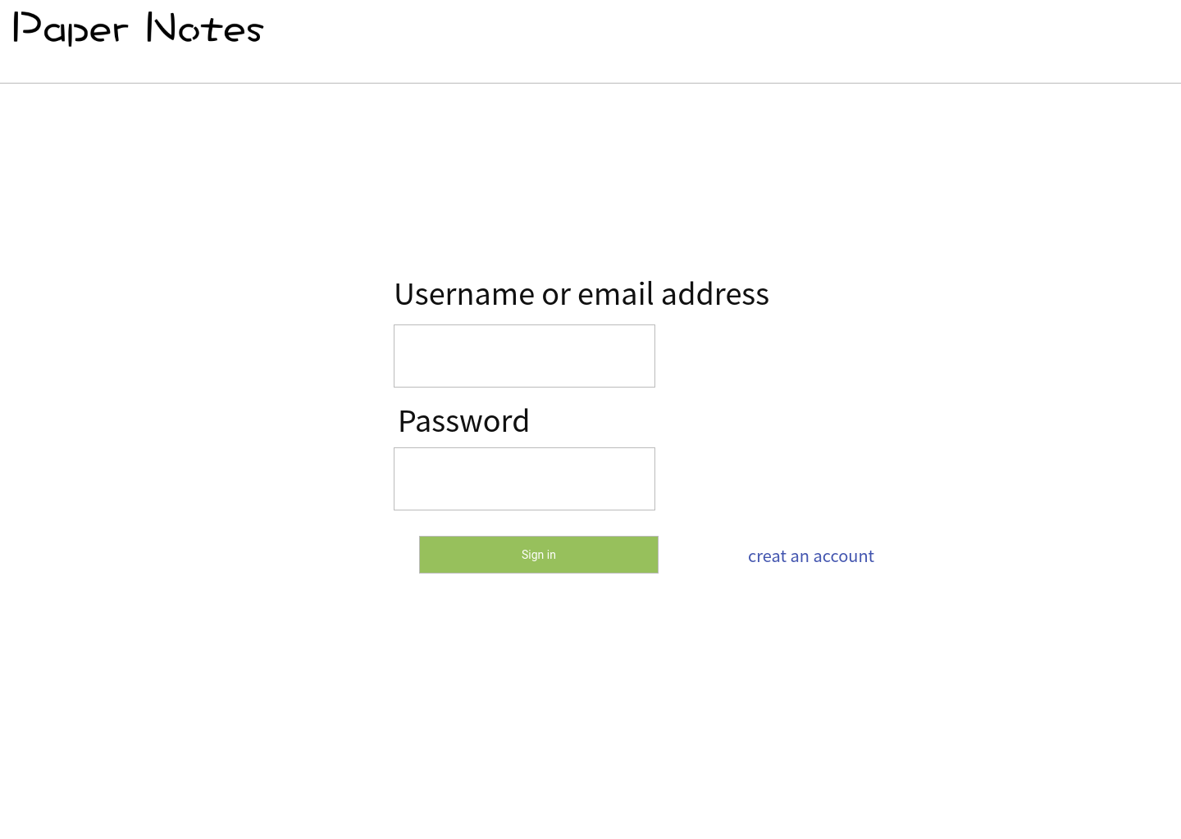

**3.5.6 User center**

In user center, user can edit personal information. Browsing the recommended papers, question and notes.

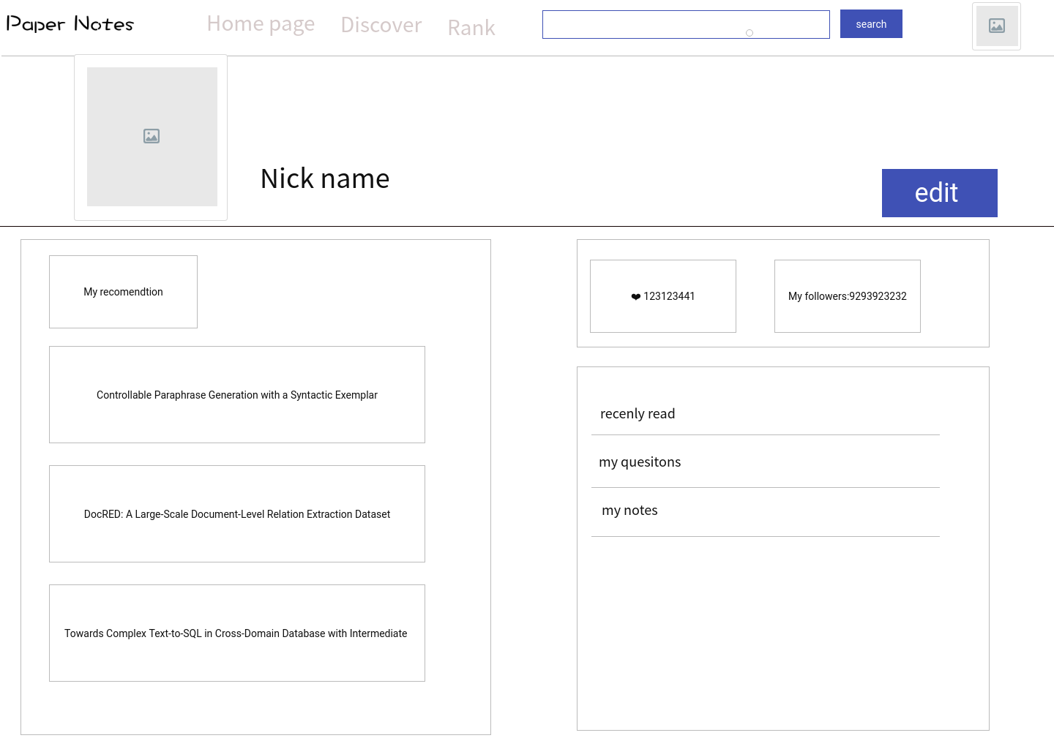

**3.5.7 Search page**

User can search paper through the search box and the searching result will display on the web page.

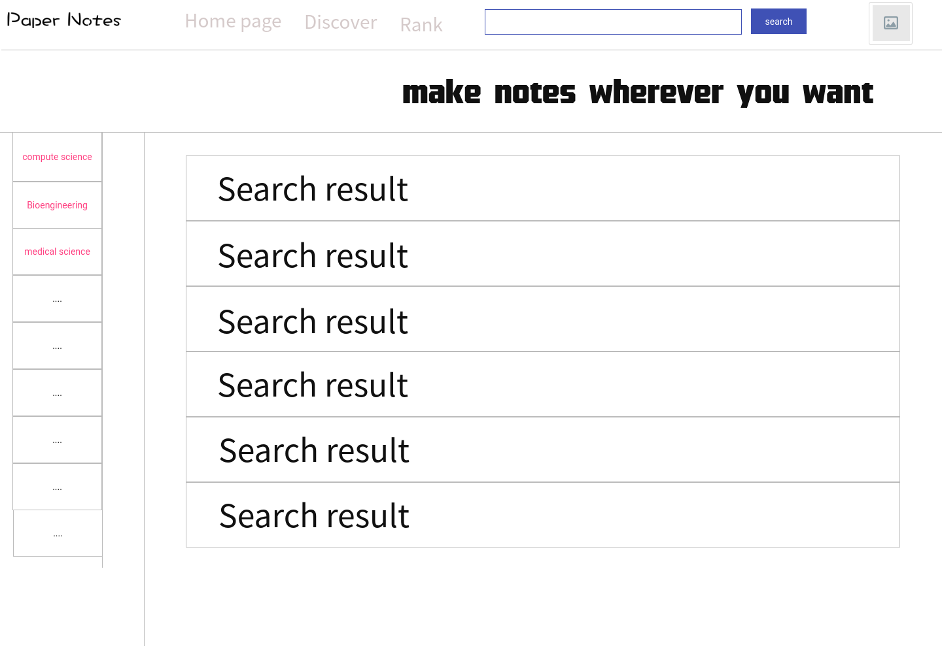

**3.5.8 Paper page**

In the paper which is displayed on the web page, users can use the mouse to choose which part they want to search a note or want to write a note and then will display a note list . When the part which user want to check the note but no notes,this part will be marked in red, it indicates that this part needs somebody's help,you can ask for a help or make a note for others.And each note or comment can be graded by users, note or comments which has low score will be deleted by admin, it can ensures notes and comments have high quality.

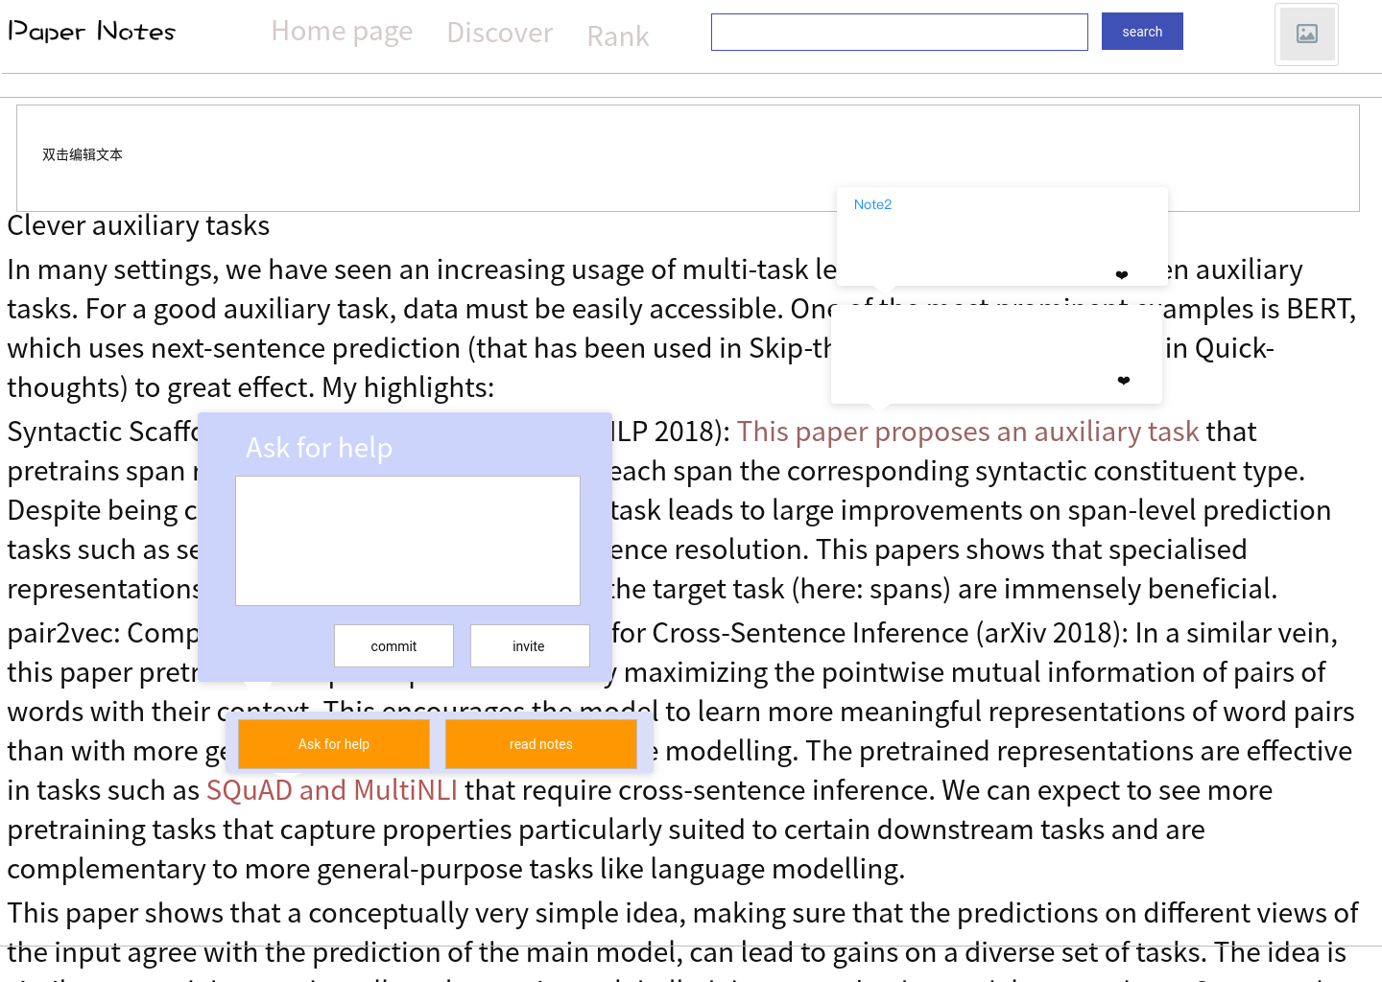

**3.5.9 link**

https://org.modao.cc/app/arpt8h5nfjmk0a9n6us54lh1flsz0m

**4.Risk：**

|  |  |  |
| --- | --- | --- |
| **Risk** | **Reason/Solution** | severity |
| **Copyright** | The upload of the paper requires the consent of the relevant website. | **90%** |
| **User number** | The promotion of software is not in place, and there are not many users. | **80%** |
| **Notes' quality** | The user's comments are  mixed. We can score according to the user's second evaluation, sort according to the score, select good comments, and discard the poor comments. | **80%** |
| **Bugs** | **Fix bugs** | **30%** |
| **Profit** | **Advertisement** | **30%** |