HARDWARE EMBEDDED LINK MODULE (HELM)
Sculpture Networks Inc.
Version 18.0 – 3/27/2015

- Interface
  - RS232 – module default to 11520 Baud 8N1
  - Ethernet – module output 239.1.1.1, port 55556
Module input listening port 55555 (it will listen on any ip address)
- Message protocol
The messages have the following format:
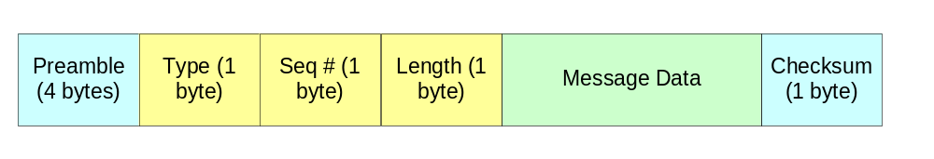
- Preamble: a fixed pattern to identify the start of a message. The preamble is always 0xAA995566.
- Type: the message type.
- Sequence number: each command message has a unique sequence number. The sequence number increases by one for each command message sent. The sequence number for a status message in response to a command message (such as write confirmation messages, read block status messages) is the same that of the command message.
- Length: the length of the message data in bytes. The maximum number of bytes in the message data field is limited to 255 bytes.
- Checksum: the checksum of the type, sequence number, length, message data fields. The checksum is calculated by adding all the bytes together.
- Page: Offset registers are separated into pages. This field gives the register page index.
- Offset: this gives the register offset number within each page. This is effectively the register index value within each page.

Followings are the supported messages:

- Block write command message:

Preamble | Type | Seq # | Length | Message Data | Checksum
0xAA995566 | 0x00 | Seq # | 3 + write_len | Page (1Byte), Offset (1Byte), write_len (1Byte), Write data(max = 252 bytes) | Checksum

- Byte write command message:

Preamble | Type | Seq # | Length | Message Data | Checksum
0xAA995566 | 0x01 | Seq # | 4 | Page (1Byte), Offset (1Byte), byte_val (1Byte), byte_mask(1Byte) | Checksum

- Byte Write confirmation message: (response from a byte write)

Preamble | Type | Seq # | Length | Message Data | Checksum
0xAA995566 | 0x80 | Same as Cmd Seq # | 4 | Page (1Byte), Offset (1Byte), Read_len (1Byte), Read data (1 byte) | Checksum

This confirmation message is effectively the block read response message with the read_len set to “1”. After the single byte data is written, a block read, with a read length of 1 byte, is performed on the same location (page/offset). A resulting message is then sent out by the hardware.

- Block read command message:

Preamble | Type | Seq # | Length | Message Data | Checksum
0xAA995566 | 0x02 | Seq # | 3 | page (1Byte), offset (1Byte),  read_len (1Byte) | Checksum

- Block read status message:

Preamble | Type | Seq # | Length | Message Data | Checksum
0xAA995566 | 0x81 | Same as Cmd Seq # | 3 + read_len | Page (1Byte), Offset (1Byte), read_len (1Byte), Read data (max = 252 bytes) | Checksum

Example Sequence
(Uses the serial program Teraterm to test)

Single Byte Read from page 0 address 0x00 Example -------------------------------
Display send message
0xAA, 0x99, 0x55, 0x66, 0x02, 0x00, 0x03, 0x00, 0x00, 0x01, 0x06
Teraterm program line:
$aa$99$55$66$02$00$03$00$00$01$06

SN Encoder/Decoder reply:
0xAA, 0x99, 0x55, 0x66, 0x81, 0x00, 0x04, 0x00, 0x00, 0x01, 0x00, 0x86

Four Byte Read from page 0 address 0x06 Example ----------------------------------
Display send message
0xAA, 0x99, 0x55, 0x66, 0x02, 0x01, 0x03, 0x00, 0x06, 0x04, 0x10
Teraterm program line:
$aa$99$55$66$02$01$03$00$02$04$0c

SN Encoder/Decoder reply:
0xAA, 0x99, 0x55, 0x66, 0x81, 0x01, 0x07, 0x00, 0x06 , 0x04,
0x00, 0xb4, 0xc0, 0xd8, 0xDF

