This procedure initializes the FW mem with the NIOS software so that the SOF runs w/ NIOS software.

Under the **top menu**, go to **Nios II --> BSP Editor** to change stdin, stdout, and stderror output to none.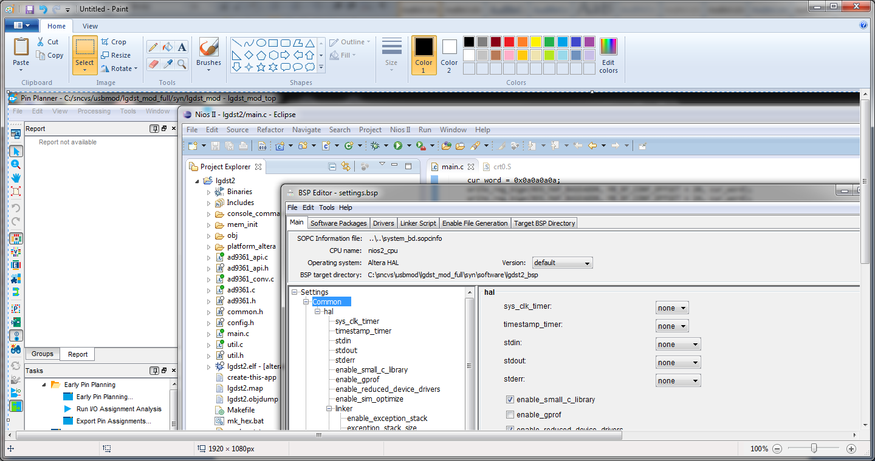

Right click on project and choose **Nios** **II --> Nios II Command Shell**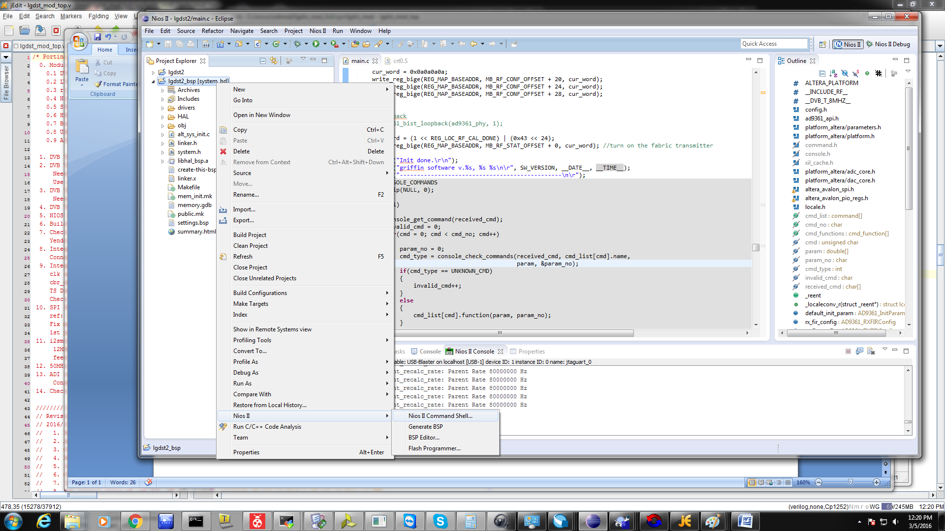

In the command shell type the command shown below.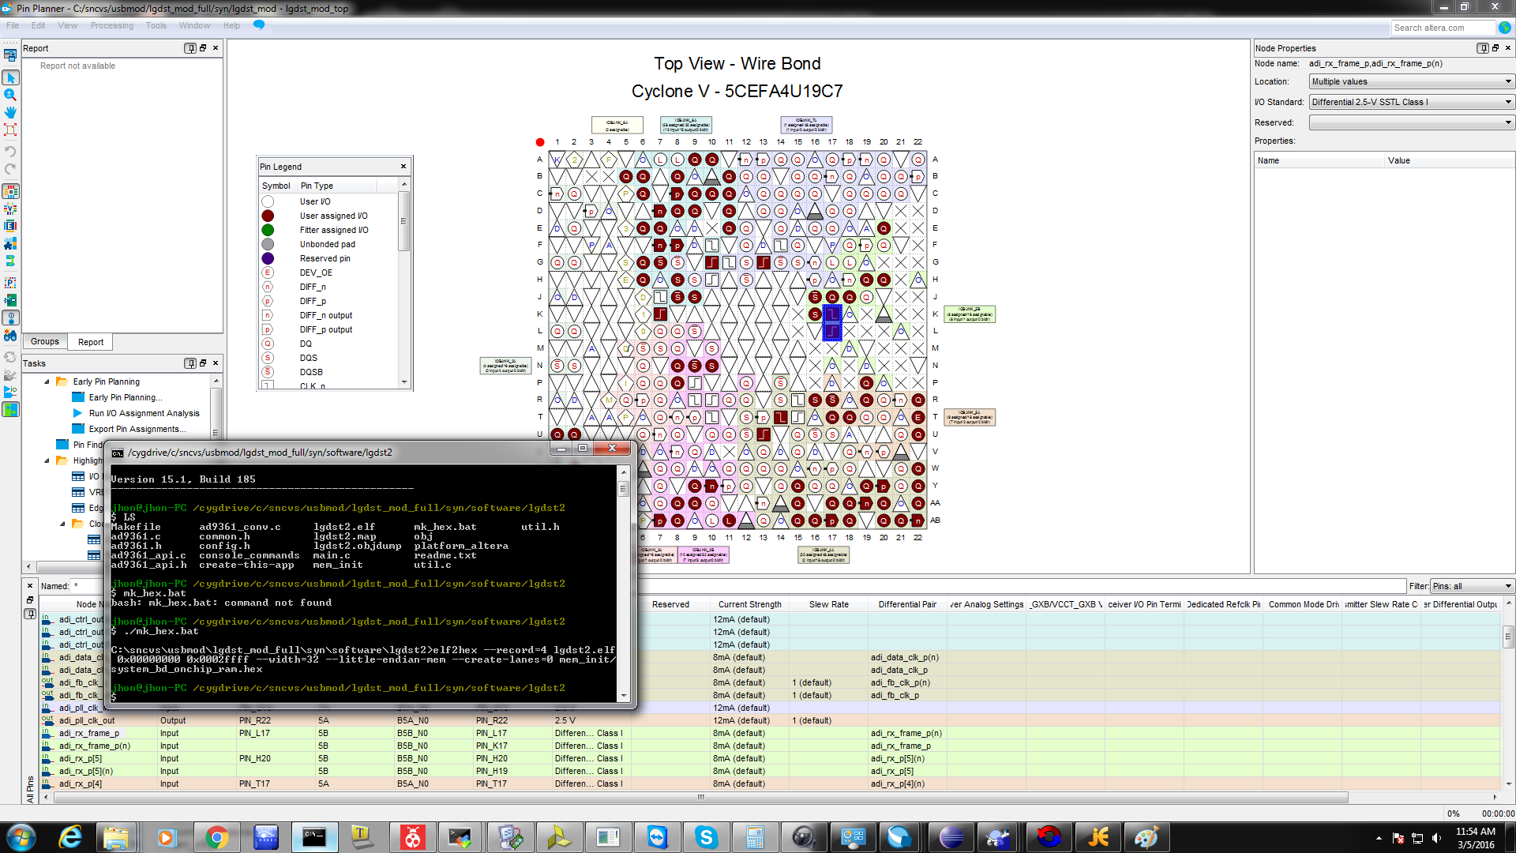

Output hex file is shown below.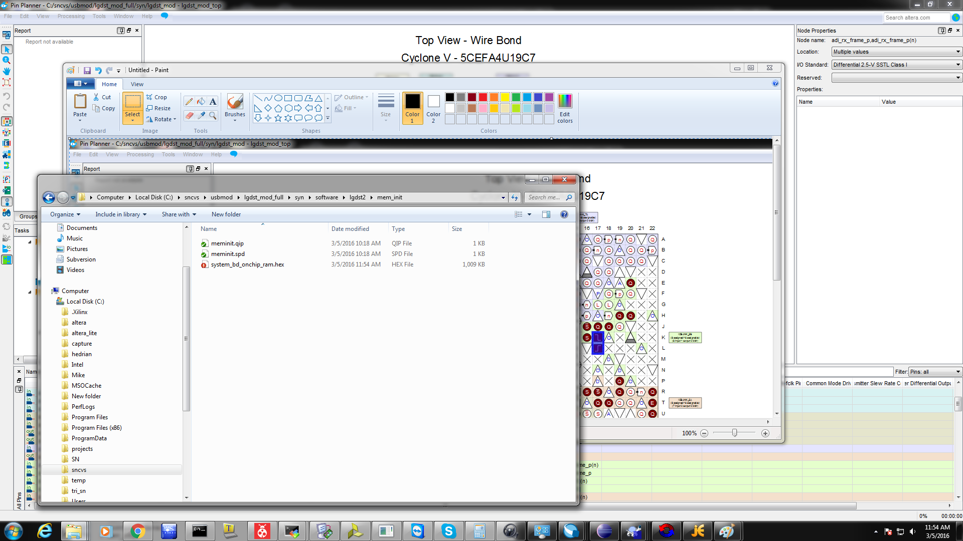

In Quartus merge SW, Top Menu **Processing --> Update Memory Initialization file** with the new hex.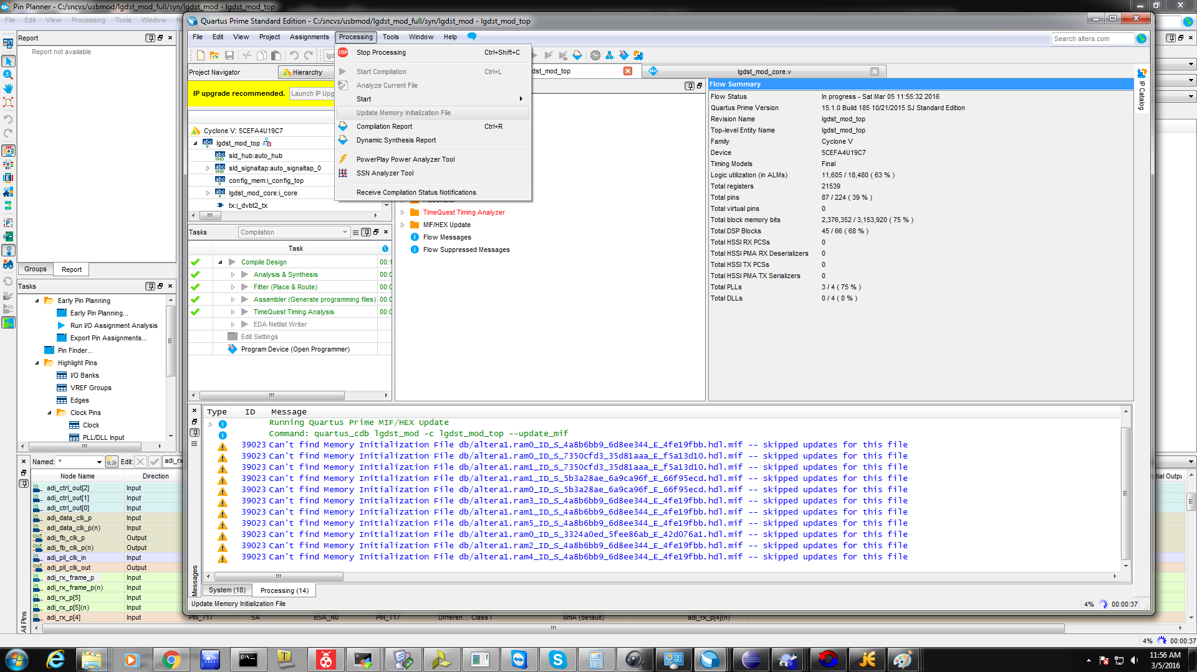

Rebuild SOF file. 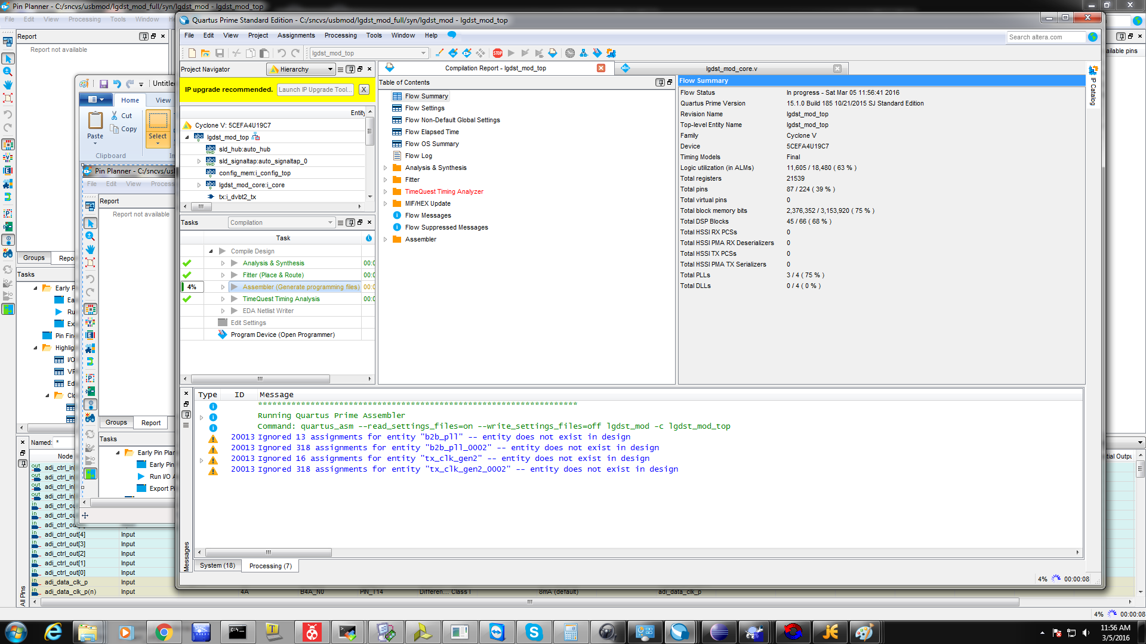

Previous debug output settings shown for reference. 