Name: Liye Zhu

Class ID:40

1. **Introduction**

This report is written for the lab assignment 1 of Deep Learning courses and it’s mainly talking about how to implement the logistic regression with tensorflow.

1. **Objective**
2. Using new data set to implement the logistic regression.
3. Calculate the weights.
4. Show the graph using tensorboard.
5. **Approaches/Methods**
6. Loss: Loss is used to compare the difference between predicted value of B and the real B. It helps the program get the values of weights.
7. Optimizer: This function is used to minimize the loss, while the loss get smaller, the weights become more accurate.
8. **Workflow**

The first step is download data set and read it from the .xls file in program. And then, create placeholders for the parameters in dataset and variables for the weights. Step 3, set the model for predicted values and the loss. Step 4, Using optimizer function to minimize loss. Finally, by training the model, I get the values of 4 weights.

1. **Datasets**

The data set of gas consumption versus local conditions is used in this lab assignment which has 48 rows, 5 columns and the last one is depend on the other four.

1. **Parameters**

Relative parameters in the data set are:

A1, the petrol tax;

A2, the per capita income;

A3, the miles of paved highway;

A4, the proportion of drivers;

B, the consumption of petrol.

The model implied is:

B = A1*x1+A2*x2+A3*x3+A4*x4

1. **Evaluation&Discussion**

Here are the screen shots, they show the results of weights and the graph by using plt and tensorboard:

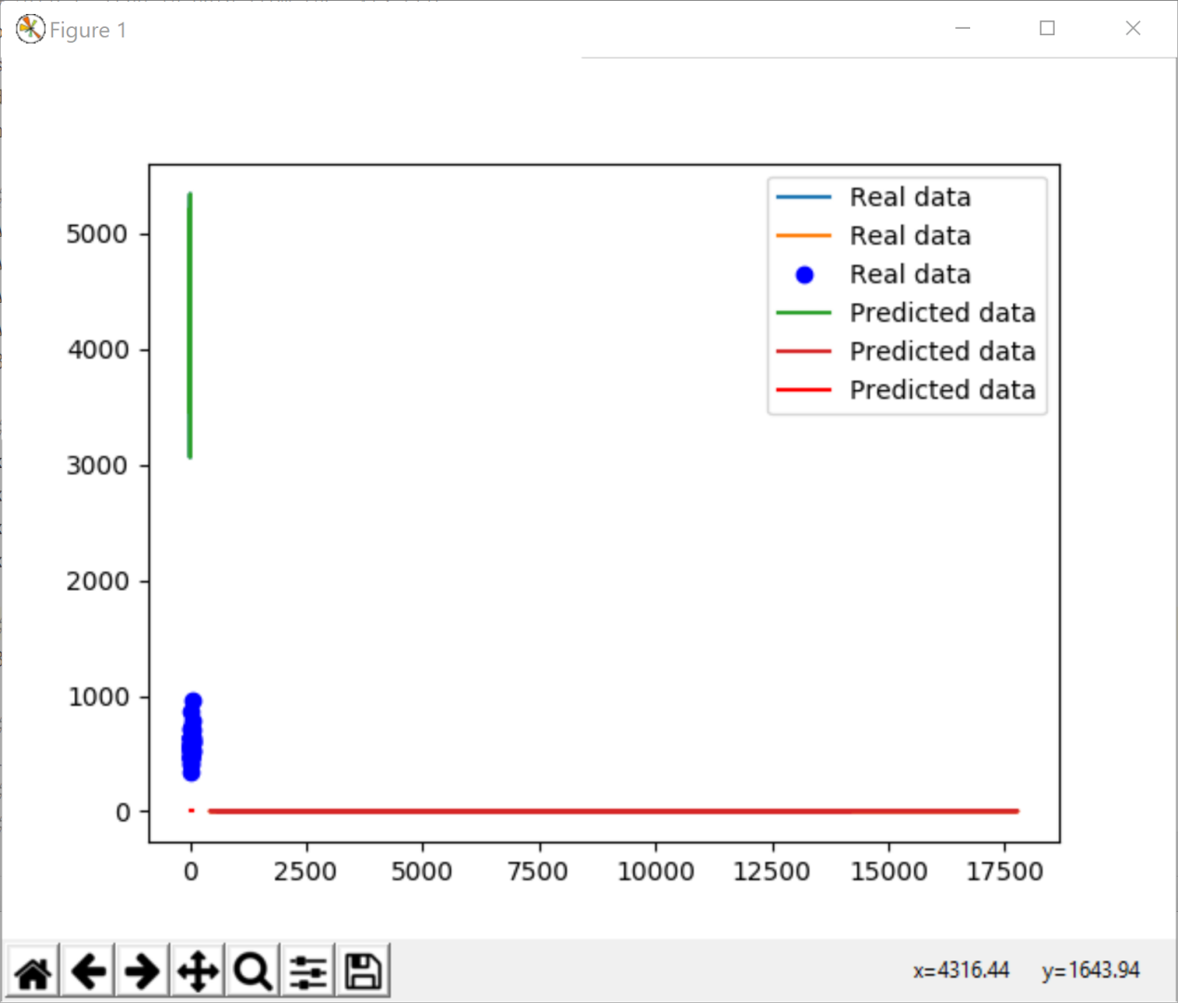

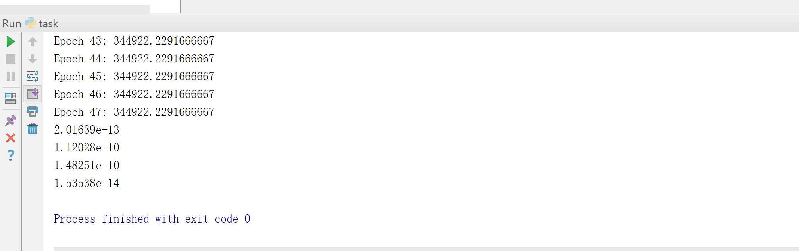

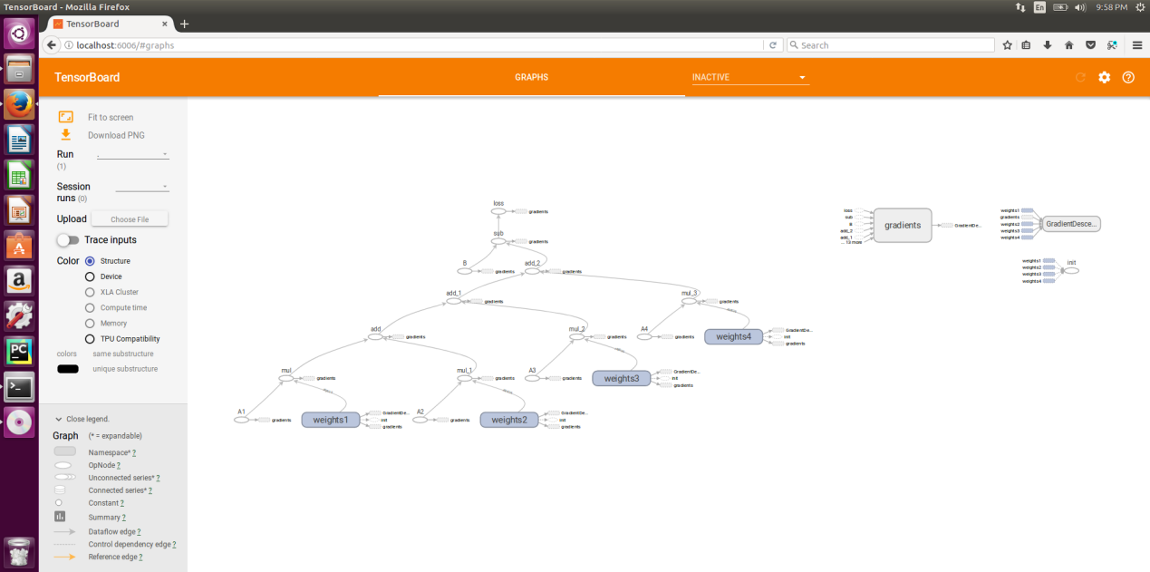

1. **Conclusion**

By developing the program I get a deep understanding about how to using tensorflow to implement the logistic regression with more than one parameters which is not a typical linear regression model. The most important thing is using optimizer function to minimize the loss. When training the model with the data, this function can help the system make the weights more accurate.