Name: Liye Zhu

Class ID:40

1. **Introduction**

This report is written for the lab assignment 2 of Deep Learning courses and it’s mainly talking about how to implement Text classification with CNN model with more than 2 classes.

1. **Objective**
2. Using at least 5 classes of new data set to implement text classification.
3. Show the graphs using tensorboard.
4. **Approaches/Methods**
5. Loss: Loss is used to compare the difference between predicted value and the real one.
6. Optimizer: This function is used to minimize the loss, while the loss get smaller, the result become more accurate.
7. CNN model: CNN model is used to implement text classification.
8. **Workflow**

Step1: Prepare data set. Download appropriate data set and divide it into 5 classes.

Step2: Data preparation. In this step, data from the 5 classes should be modified and split to train and test set to fit the model. First, by reading data from the data set and set labels to get the value of x_test and y. Then, build vocabulary. Finally, generate random shuffle data, and using it to split train/test set.

Step3: Training. In this step, CNN model is used. In each single training step, using optimizer function to minimize loss and maximize accuracy. Then evaluate model on the test set generated in Step2.

1. **Datasets**

The data set of comments on a restaurant is used in this lab assignment.

1. **Parameters**

The original data set has 2 columns, user’s rate and comment. The range of rate is 1 to 5, so I divide the data set to 5 classes according to the rate.

1. **Evaluation&Discussion**

Below are the screen shots, they show the graphs by using tensorboard. We can see in the graphs that the result is inconsistent with expectation, loss is getting bigger although accuracy is getting bigger too. For the improvement, I think there are two ways. First is using cross-validation at the step of splitting train/test set. Second is changing parameters like learning rate to make the result more accuracy.

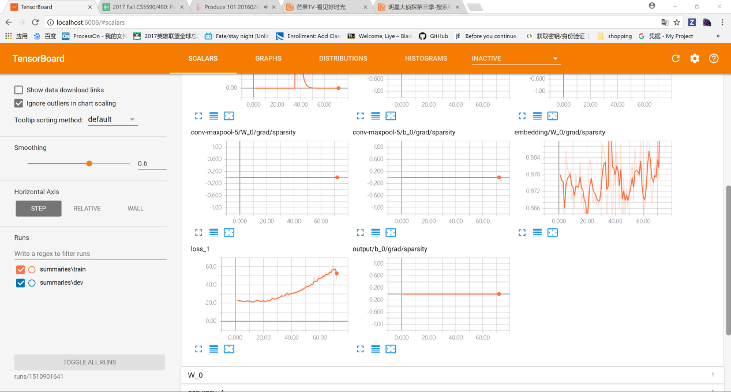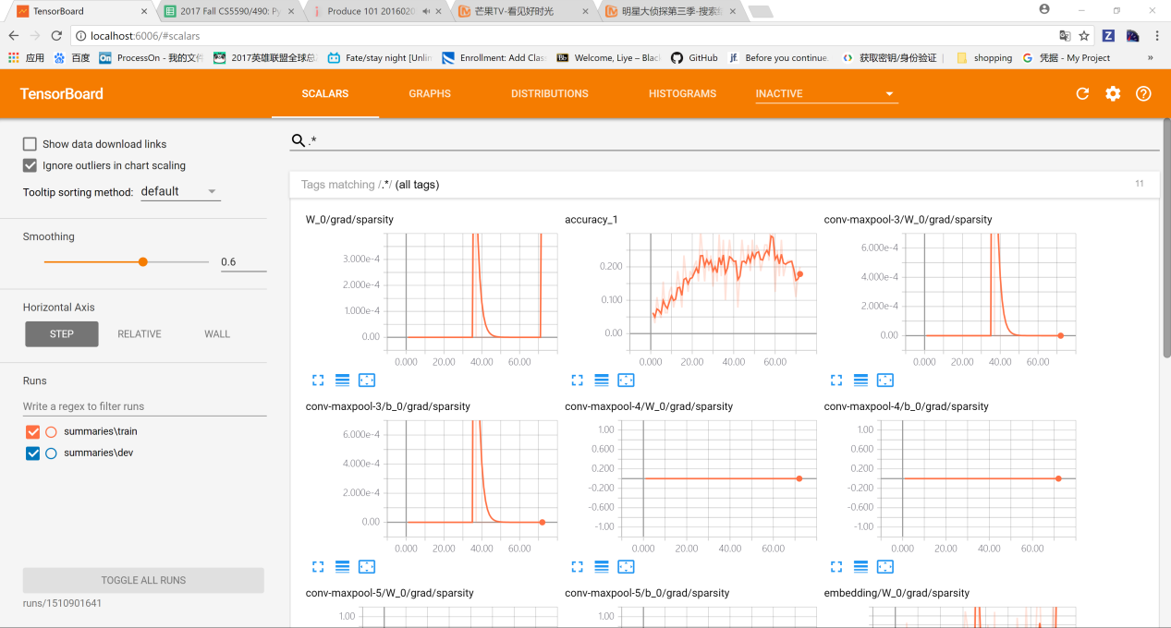

1. **Conclusion**

By developing the program I get a deep understanding about CNN and how data is prepared to implement text classification. We can think of a convolution as a sliding window function applied to a matrix. Also, I learned the concept of activation function which is used in output layer and allows you to model a response variable.