Name: Liye Zhu

Class ID:40

1. **Introduction**

This report is written for the lab assignment 3 of Deep Learning courses and it’s mainly talking about the difference between CNN, RNN and LSTM model for text classification.

1. **Objective**
2. Implement Text classification with RNN model with new data set which is not used in class.
3. Implement the Text classification with LSTM model with new data set which is not used in class.
4. Compare results of CNN, RNN and LSTM for text classification (same data set for 3 models for comparison) and describe, which model is best for text classification based on your results
5. **Approaches/Methods**
6. Loss: Loss is used to compare the difference between predicted value and the real one.
7. Optimizer: This function is used to minimize the loss, while the loss get smaller, the result become more accurate.
8. CNN model: CNN model is biologically inspired variants of Multilayer perceptron. It’s a class of feedforward neural network which is the simplest type of neural network.
9. RNN model: RNN is a class of Artificial neural network whose goal is compute the probability of a sentence or sequence of words.
10. LSTM model: LSTM is defined to solve the main problems of RNN which are long-term memory vanishes quickly and during training gradients explode/vanish easily because of depth in time.
11. **Workflow**

Step1: Prepare data set. Download appropriate data set.

Step2: Data preparation. In this step, data should be modified and split to train and test set to fit the model. First, by reading data from the data set and set labels to get the value of x_test and y. Then, build vocabulary. Finally, generate random shuffle data, and using it to split train/test set.

Step3: Training with RNN model. In this step, BasicRNN cell is used. In each single training step, using optimizer function to minimize loss and maximize accuracy. Then evaluate model on the test set generated in Step2.

Step4: Training with LSTM model. In this step, change the cell in Step3 to 2-layer LSTM cell. Then, by training the model to get result.

Step5: Compare results.

1. **Datasets**

The data set of comments on a restaurant is used in this lab assignment.

1. **Evaluation&Discussion**

Below are the screen shots of LSTM for text classification, they show the graphs by using tensorboard. We can see that the average loss begins with 4 and comes to 1.000 at the end. Also, the average accuracy increases from 7% to 75% at the end.

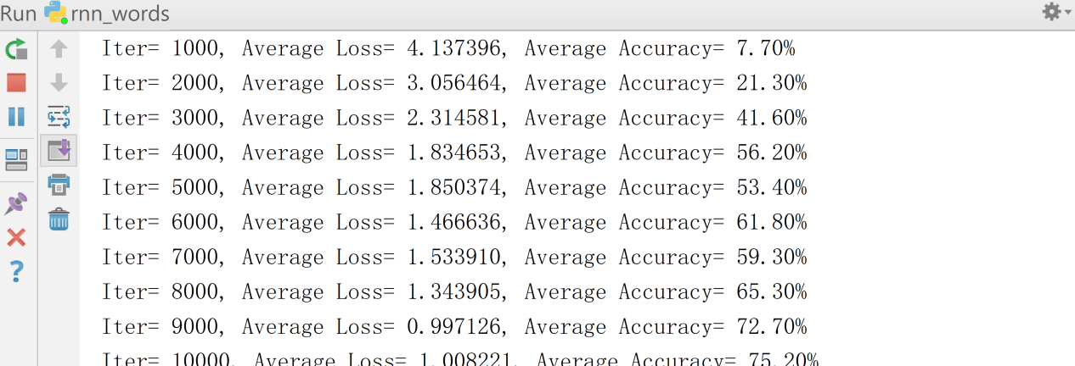

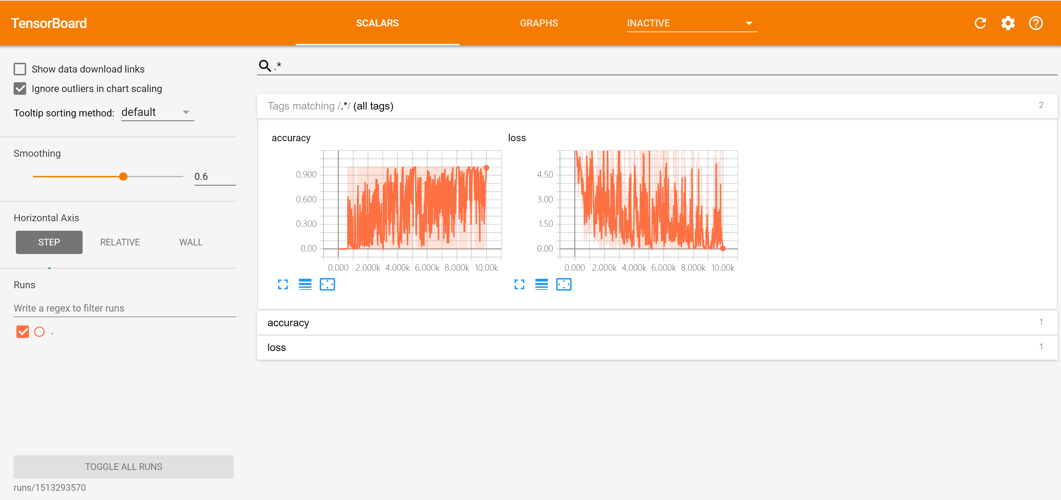

Below are the screen shots of RNN for text classification, they show the graphs by using tensorboard. We can see that the average loss begins with 20 and comes to 7 at the end. And the average accuracy increases from 2.5% to 8.6% at the end.

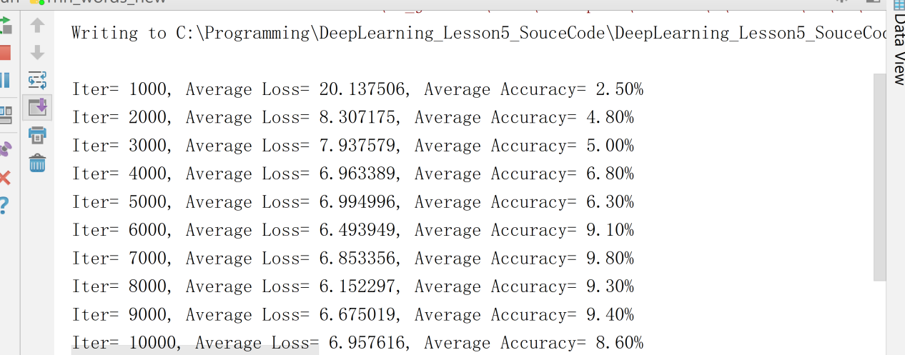

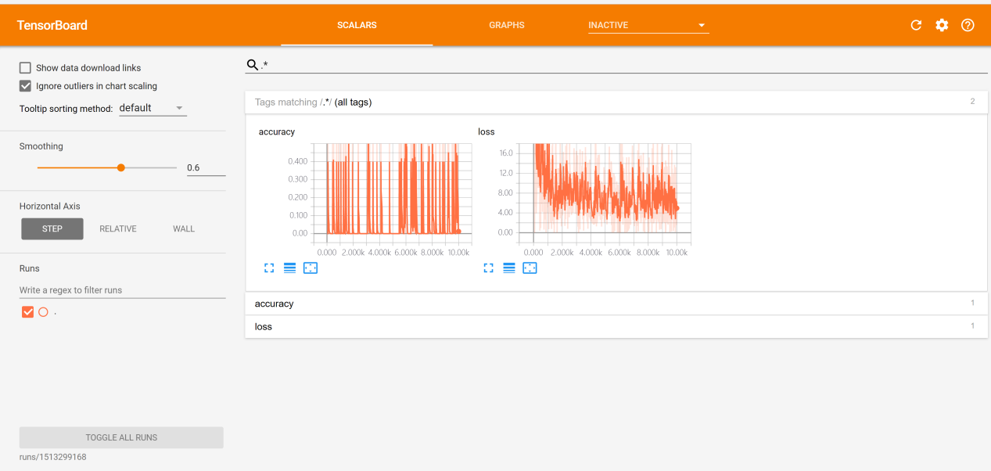

By comparing the results, we can find that LSTM is most efficient while RNN is least. At the beginning, LSTM does a better job that its average loss starts with 4 while RNN’s starts with 20. After the training done, LSTM still does a better job than RNN. The increase of average accuracy of LSTM is much bigger than RNN. So, we can get the result that LSTM is most efficient for text classification, then CNN and the least efficient one is RNN.

As we learned, RNN has two main problems,long-term memory vanishes quickly and during training gradients explode/vanish easily because of depth in time. In text classification, data is too large and too long for RNN to remember. So as a result, it returns the worst result. However, LSTM solves the problems by using gating method, so it’s the most efficient model for text classification compared within CNN, RNN and LSTM.

1. **Conclusion**

By developing the program I learned the difference between CNN, RNN and LSTM. RNN is not suitable for text classification which has a long-term memory. But LSTM solves the problem by using gating method, cell.is defined to make an improvement.