The Impact of the Interest-Rate Hiking Cycle on Hong Kong Residential Mortgage Risks
DSC5002 · Group 31 · Monthly exploratory analysis, 2018–2025

1. Executive Summary
This project integrates HKMA mortgage and negative-equity surveys, HIBOR, Land Registry residential transactions, and Census & Statistics Department macro indicators into a 96-month analytical dataset (January 2018 – December 2025).
During the hiking window (March 2022 – August 2023), average monthly mortgage applications were 25.3% lower than before the cycle, approvals fell 17.8%, and residential transactions fell 24.3%. Three-month HIBOR has correlations of −0.70 with applications, −0.67 with approvals and −0.46 with transactions.
Applications and transactions peak at zero lag (r=0.67). Reversing the pair mirrors the same cross-correlation rather than adding independent evidence, so the result supports a largely synchronous market cycle rather than a stable one-way transmission.
Negative equity is a lagged risk. Within the pre-set ±12-month search window, the strongest HIBOR relationship appears at the positive boundary (+12 months, r=0.85); this is a search-window limit rather than an identified transmission period, and the result is sensitive to the window and to the transformation.
The equal-weight Housing Mortgage Stress Index peaks at 58.7/100 in July 2024. The rate-dominant variant peaks at 60.7 in July 2024 and the borrower-dominant variant at 59.9 in September 2024, so the three schemes agree on a high-stress window but not on an identical peak month.

2. Data
The sample covers January 2018 through December 2025 (96 monthly rows).
Domain | Source | Variables | Frequency
Mortgage activity | HKMA T0307 | Applications, approvals, LTV, approved value | Monthly
Negative equity | HKMA T0316 | Cases, borrower share, value, unsecured portion | Quarterly
Rates | HKMA T060302 | 3-month HIBOR | Monthly average
Property market | Land Registry | Residential ASP cases and value | Monthly
Labour market | Census & Statistics Dept. | Unemployment rate | Rolling three-month
Inflation | Census & Statistics Dept. | Composite CPI YoY | Monthly
GDP is excluded because it is quarterly and is not one of the four proposed index components; CPI is retained as contextual evidence.
Negative-equity data are published quarterly; quarter-end values are carried forward only for visual and index continuity and are not treated as independent monthly observations. Values marked ‘*’, ‘N.A.’ or ‘−’ in official tables are converted to missing rather than zero.

3. Method

Comparison windows
- Pre-hiking: January 2018 – February 2022
- Hiking cycle: March 2022 – August 2023
- Post-hiking: September 2023 – December 2025
The boundaries are analyst-defined from the sustained 3-month HIBOR rise and subsequent plateau; they are comparison windows, not estimated structural breaks. August 2023 is a researcher-chosen transition point, not the sample’s HIBOR peak: the monthly-average 3M HIBOR reached its maximum of 5.438% in November 2023.

Stress index
Four sample-standardized components are combined: 3-month HIBOR, negative-equity cases, negative three-month transaction change, and the unemployment rate.
stress_index = clip(50 + 10 × Σ weightᵢ × zᵢ, 0, 100)
Three weighting schemes are tested (equal, rate-dominant, borrower-dominant). The output is a relative-risk gauge, not a default probability.

Lead-lag diagnostics
Pearson correlations are computed from −12 to +12 months using corr(driver.shift(lag), outcome); a positive lag means the first variable leads. The maximum absolute correlation is exploratory and is not a causal or Granger test.

4. Results
Metric | Pre-hiking | Hiking | Post-hiking
Average 3M HIBOR | 1.25% | 3.28% | 4.01%
Monthly applications | 12,544 | 9,370 | 7,301
Monthly approvals | 8,957 | 7,365 | 5,395
Residential transactions | 5,168 | 3,911 | 4,514
Approval/application ratio | 72.3% | 78.6% | 74.8%
Unemployment rate | 4.15% | 3.80% | 3.23%
Stress index | 47.6 | 50.2 | 54.5
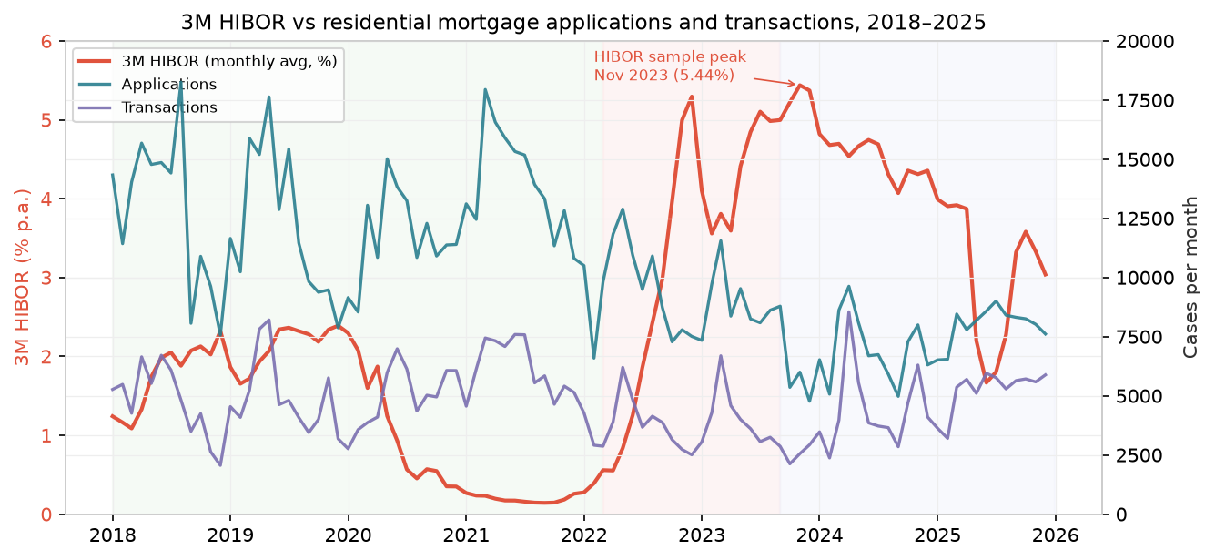
Figure 1. 3M HIBOR versus residential mortgage applications and transactions. Rates and mortgage activity move in opposite directions. The sample HIBOR peak is November 2023 (5.44%), not August 2023.
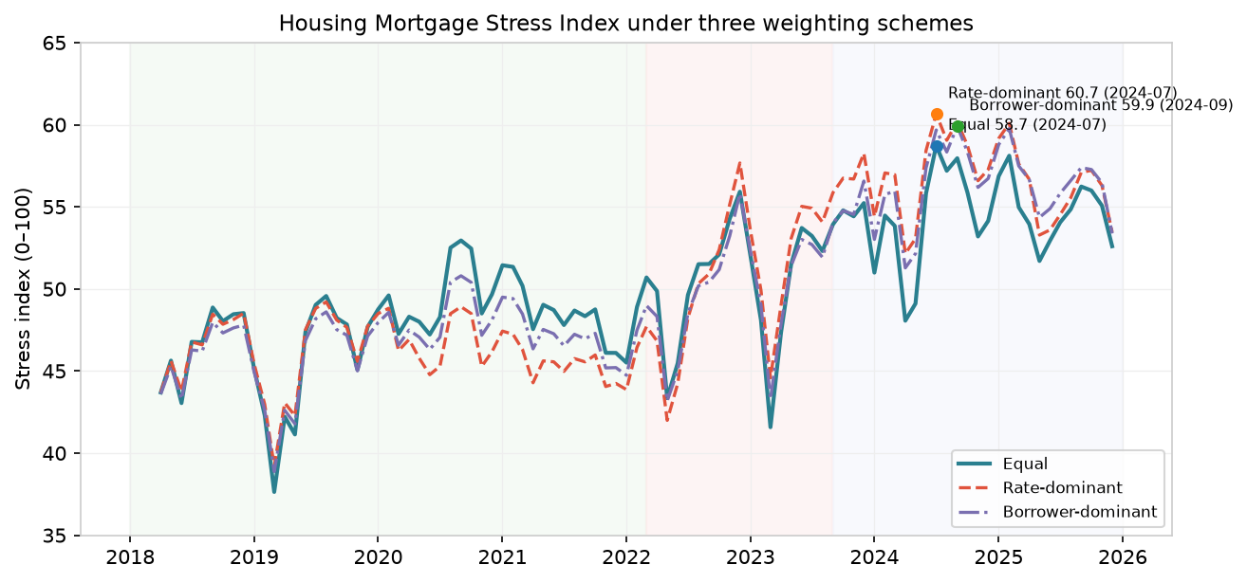
Figure 2. The stress index under three weighting schemes. Peaks: equal 58.7 (2024-07), rate-dominant 60.7 (2024-07), borrower-dominant 59.9 (2024-09). High-stress windows agree but peak months differ.

Transactions and mortgage activity
Applications and transactions peak at zero lag (r=0.67). Approvals and transactions are most correlated at a one-month transaction lead (r=0.61): corr(approvals.shift(−1), transactions) is the highest-|r| lag, so transactions lead approvals by one month. The reverse construction yields the mirror lag with the same coefficient, so the data support synchronicity rather than a stable directional lead.

Negative equity
Negative-equity cases rose from 533 in 2022 Q3 to 12,164 in 2022 Q4, 32,073 in 2024 Q1 and 40,741 in 2025 Q1, before falling to 21,304 in 2025 Q4.
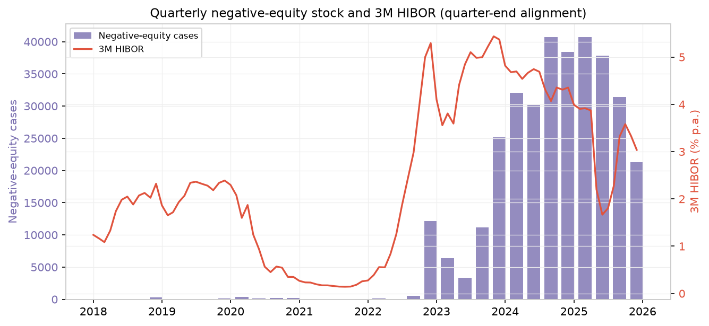
Figure 3. Quarterly negative-equity stock (quarter-end bars) and 3M HIBOR. Negative equity is a quarterly stock, not monthly market flow.
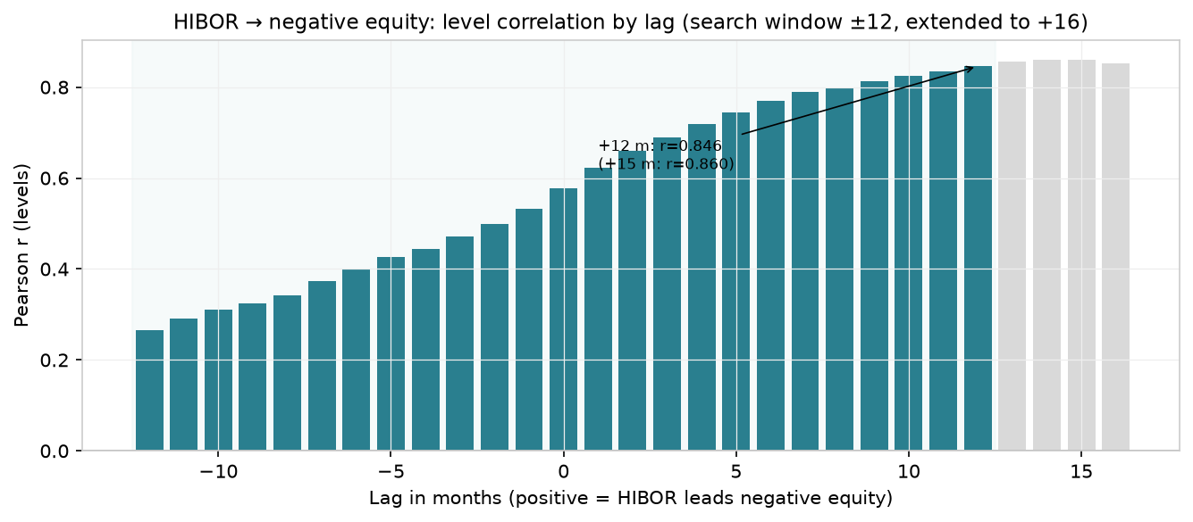
Figure 4. HIBOR → negative-equity level correlation by lag. Within ±12 months the maximum is at the +12-month boundary (r=0.846); extending to +15 months gives r=0.860, so ‘exactly 12 months’ is a search limit, not an identified transmission lag.

5. Robustness Appendix
Pair | Best lag (±12 m) | r | n | Extended check
3M HIBOR → negative equity (levels) | +12 | 0.8464 | 84 | +15 months: r=0.8605, n=81
3M HIBOR → negative equity (quarterly, levels) | +4 quarters | 0.8572 | 28 | +5 quarters: r=0.8568, n=27
3M HIBOR → negative equity (quarterly, first diff.) | +4 quarters | 0.2657 | 27 | +5 quarters: r=0.5916, n=26
Approvals → transactions (levels) | −1 | 0.6077 | 95 | transactions lead approvals by 1 month
Applications → transactions (levels) | 0 | 0.6652 | 96 | synchronous
The quarterly comparisons align quarter-end HIBOR with quarter-end negative equity and use fewer, different observations, so their sample sizes are not directly comparable to the monthly results. The first-difference correlation is far weaker than the level correlation, indicating the level results partly reflect common trends. These checks show the ‘12-month’ result is a boundary of the search window and is sensitive to the window and transformation, not a robustly identified one-year transmission lag.
Seasonality: a dedicated seasonal adjustment and a negative-equity growth-rate analysis were proposed but are not yet implemented. Negative equity is a quarterly stock; its month-to-month change within a quarter is zero by construction after forward-filling, so it is not analysed as a monthly growth series. This scope reduction should be stated explicitly in the final submission.

6. Limitations
- The sample includes COVID-19 and major policy changes.
- Negative equity is quarterly and forward-filled only for continuity.
- Approvals/applications is a ratio of separate flows, not a cohort approval rate.
- Correlation and lag selection can be affected by common trends and omitted variables.
- Aggregate monthly data cannot measure borrower-level default risk.
- The analysis is educational and is not an investment, underwriting or regulatory model.

7. References
Hong Kong Monetary Authority, Monthly Statistical Bulletin, Tables 3.7, 3.16 and 6.3.2.
Hong Kong Land Registry, Monthly Statistical Data.
Census and Statistics Department, Hong Kong, Table 210-06103 and Table 510-60001A.
Project Proposal for DSC5002, Group 31.

