From Transient Encounters to Committed Sampling:
A Multi-Objective Adaptive Sampling Strategy for Rare Protein Conformational States
Yiru Wang^{1,2} and Ying Li^{1,2}
1 Beijing Key Laboratory of Biomass Waste Resource Utilization, College of Biochemical Engineering, Beijing Union University, Beijing, 100023, China.
2 Beijing Key Laboratory of Bioactive Substances and Functional Foods, College of Biochemical Engineering, Beijing Union University, Beijing, 100023, China.

Abstract
Adaptive sampling is widely used to accelerate molecular dynamics simulations of rare protein conformational changes, yet its success is often evaluated by the first time a trajectory enters a predefined target window. A first encounter, however, does not establish that the target state has been sampled: a trajectory may briefly enter the target region and rapidly leave it. We therefore distinguish first hit, committed visit, and target-basin occupancy as measures of encounter, stabilization, and persistent sampling, respectively. We introduce multi-objective adaptive sampling (MOAS), which ranks candidate seeds according to novelty, boundary exploration, and target proximity using equal percentile ranks with a diversity constraint. MOAS was evaluated against matched Random, LAST, least-counts, and kNN-AS campaigns on chignolin folding, adenylate kinase open-to-closed transition, and apo maltose-binding protein domain closure. Across these systems, evaluating campaigns by committed visits and target-basin occupancy revealed differences that were not captured by first-hit times alone. MOAS achieved committed sampling in all three independent replicates for each benchmark system and generally produced sustained target-basin occupancy, while exploration-oriented methods could achieve early target encounters without establishing persistent sampling. Importantly, LAST also performed well on specific systems, including complete commitment across the chignolin replicates and high occupancy in one MBP campaign. These results support a broader evaluation framework in which adaptive sampling of target states is assessed by committed and persistent sampling rather than first encounter alone.

1. Introduction
Molecular dynamics (MD) simulations provide structural, thermodynamic, and kinetic information that is difficult to obtain from static structures, but biologically relevant conformational transitions often occur on timescales far beyond those accessible to a single unbiased trajectory. Adaptive sampling addresses this limitation by repeatedly harvesting configurations from previously visited trajectories, ranking candidate configurations, and launching short simulations from selected seeds. Most adaptive strategies therefore focus on where to sample next—for example, poorly explored, low-density, or frontier regions of conformational space. However, for target-state sampling, where a simulation campaign aims to establish a particular conformational state rather than merely discover new regions, the definition of a successful sampling event is equally important.
A first encounter with a target region does not necessarily indicate that the target state has been sampled. We distinguish three progressively stronger outcomes: first hit, the first entry into a predefined target window; committed visit, continuous residence within that window for a specified minimum duration; and target-basin occupancy, the fraction of the total simulation budget spent in the target region. First hit measures discovery, whereas commitment and occupancy measure stabilization and sustained sampling. An exploration-oriented strategy can therefore achieve an early first hit or high conformational coverage while contributing little persistent sampling of the target state. We argue that these quantities should be treated as complementary campaign outcomes rather than collapsed into a single measure of adaptive-sampling efficiency.
This distinction also defines the scope of the present benchmark. We compare methods that share the same seed-selection framework—an initial unbiased ensemble, short trajectories, pooling of visited configurations, and ranking of candidate seeds—including Random, least-counts, LAST, and kNN-AS. These methods emphasize unbiased restarting, under-sampled regions, frontier exploration, or low-density exploration, respectively. Other rare-event approaches, including weighted-ensemble methods, adaptive Markov-state-model schemes, reinforcement-learning approaches, and enhanced-sampling or path-based methods, address related rare-event problems but alter the sampling architecture or introduce additional statistical or biasing machinery; they are therefore not treated as matched seed-selection baselines here.
Here we introduce multi-objective adaptive sampling (MOAS), which combines novelty, LAST-style boundary exploration, and target proximity through equal percentile ranks with a diversity constraint. Rather than optimizing first-hit time alone, we evaluate adaptive campaigns using committed visits and target-basin occupancy as the primary endpoints, with first hit and conformational coverage retained as discovery diagnostics. MOAS is benchmarked against Random, LAST, least-counts, and kNN-AS under matched simulation budgets on CLN025 folding, adenylate kinase open-to-closed transition, and apo maltose-binding protein domain closure (n = 3). Our working hypothesis is that combining continued exploration with explicit target proximity can convert transient target encounters into committed and persistent target-state sampling, without assuming that any single adaptive strategy is universally optimal across different sampling objectives.

2. Materials and Methods

2.1 Molecular dynamics protocol
All production and adaptive segments were run in GROMACS with AMBER99SB-ILDN and TIP3P water at 300 K and 0.15 M NaCl. The time step was 2 fs with LINCS constraints on hydrogen-involving bonds, PME electrostatics, and a Verlet cutoff. Short adaptive trajectories used GPU update and PME. Initialization MD was unbiased and shared across methods within a system and replicate, so that differences arise only from seed selection. Box padding was 1.2 nm; MBP used a rhombic dodecahedron to limit solvent cost. Further MDP settings are in the Supporting Information (Table S1).

2.2 MOAS framework
MOAS is an iterative adaptive-sampling loop (Figure 1). An unbiased initialization trajectory supplies the first pool of configurations. At every round, candidate windows are scored on three objectives (novelty, boundary, target proximity), ranks are mixed, and a diversity constraint selects six seeds. Each seed launches a short MD segment; the new frames are appended to the pool; and the cycle repeats until a fixed aggregate budget is reached. No method receives extra simulation time. The production method in this paper is the static equal-weight mix (MOAS-static). Dynamic and Pareto variants exist in the code base but are not used in the main comparison. The workflow is introduced with the evaluation criteria in Section 3.1.

2.3 Novelty score
Novelty favors configurations in sparsely sampled regions of the two-dimensional CV space (Figure 1B). A 24 × 24 histogram is built from the pooled frames. For a candidate window q, let b(q) be the bin that contains q and let n_b(q) be that bin’s count. Local density and the novelty score are
$$ρ_{q} = n_{b(q)}, s_{nov}(q) = \frac{1}{ρ_{q} + ε}$$ | (1)

with ε = 10⁻⁶. The score is then divided by its maximum over the current candidate list so that s_nov ∈ (0, 1]. High scores mark empty or rarely visited bins and discourage re-sampling of already dense regions. Least-counts uses s_nov alone.

2.4 Boundary score
Boundary exploration follows a LAST-style frontier construction (Figure 1C). Occupied CV bins that have at least one empty 4-neighbor are labeled as the rim F of the visited cloud. CVs are scaled before binning (σ_x = 0.05 nm and σ_y = 4° on AdK/MBP; RMSD and Rg on CLN025) so that one axis does not dominate. Let r̂(q) be the Euclidean distance of q to the cloud centroid, divided by the maximum such distance, and let ρ̂(q) be the bin count at q divided by the maximum bin count. The boundary score is
$$s_{bnd}(q) = 1.5 1_{F}(q) + r̂(q) [1 − 0.5 ρ̂(q)]$$ | (2)

where 1_F(q) = 1 if q lies in a frontier bin and 0 otherwise. The first term places mass on the rim; the second prefers the outer, low-density edge of a thick frontier. This term expands coverage and does not encode the target basin. LAST uses s_bnd alone.

2.5 Target-proximity score
Target proximity is the only objective that encodes where the scientifically relevant basin lies (Figure 1D). Let x* be the closed or folded reference in CV space. On AdK and MBP a scaled distance to that reference is
$$d_{*}(q) = ∥z(q) − z^{*}∥, z = (\frac{x}{σ_{x}}, \frac{y}{σ_{y}})$$ | (3)

with the same (σ_x, σ_y) as in Section 2.4. The target score on AdK and MBP, and the CLN025 analogue using Cα-RMSD, are
$$s_{tgt}(q) = \frac{1}{d_{*}(q) + 5} (AdK, MBP)$$ | (4)

$$s_{tgt}(q) = \frac{1}{max(RMSD − 0.25 nm, 0) + 0.05 nm} (CLN025)$$ | (5)

so that s_tgt is large near the target and decays smoothly away from it. On CLN025, candidates already inside the folded cutoff RMSD < 0.25 nm are not further distinguished by this term.

2.6 Ranking, weighting, and diversity-constrained seed selection
The three raw scores have incommensurate units. Each active score s_α is converted to a percentile rank over the N candidates of the current round (Figure 1E). If π_α(q) is the 0-based rank of s_α(q) after stable sorting,
$$r_{α}(q) = \frac{π_{α}(q)}{N − 1}, α ∈ \{nov, bnd, tgt\}$$ | (6)

Production MOAS uses equal weights on all three ranks. Ablation campaigns drop unused terms and average over the active subset A:
$$S(q) = \frac{\sum_{α ∈ A}{r_{α}(q)}}{|A|} A = \{nov, bnd, tgt\} for full MOAS$$ | (7)

Seeds are then accepted in order of decreasing S(q) subject to a diversity constraint in the same scaled CV coordinates z = (x/σ_x, y/σ_y) (Figure 1F). A candidate i is kept only if it is at least δ = 1 from every already chosen seed,
$$∥z_{i} − z_{j}∥ ≥ δ for all chosen j$$ | (8)

The selected frames are dumped from the parent short trajectory and used as starting coordinates for the next round.

2.7 CLN025
CLN025 is a 10-residue fast-folding mini-protein. Campaigns start from an unfolded structure in water. The CVs are Cα-RMSD to the native reference and radius of gyration. The target window is RMSD < 0.25 nm; a committed visit requires that this predicate hold contiguously for at least 40 ps. Each campaign uses a 10 ns unbiased initialization, then 12 rounds of 6 × 1 ns short trajectories (aggregate budget 82 ns).

2.8 Adenylate kinase
Apo adenylate kinase (AdK) is scored on the LID–CORE and NMP–CORE angles. Campaigns start from the open apo conformation. The closed window is the side-aware cut between open and closed references: LID < 114.4° and NMP > 41.8°. A committed visit requires both angles to remain in that window for at least 200 ps. Each campaign uses a 20 ns open initialization, then 15 rounds of 6 × 2 ns short trajectories (aggregate budget 200 ns).

2.9 Maltose-binding protein
Apo maltose-binding protein (MBP) undergoes large-scale domain closure. Campaigns start from open apo 1OMP; the closed reference is 1ANF with maltose removed. The CVs are the CA center-of-mass distance between the N- and C-terminal domains (residues 1–109 + 264–309 and 114–258 + 316–370) and a hinge angle at residues 109–114 / 258–264 / 309–316. The closed window is distance < 2.885 nm and hinge < 115.9°. Commitment requires both CVs in that window for at least 200 ps. Each campaign uses a 20 ns open initialization, then 82 rounds of 6 × 2 ns short trajectories (aggregate budget 1 μs). The protocol is summarized with CLN025 and AdK in Table 1.
System | Transition | CVs | Init | Short MD | Budget | Commit
CLN025 | folding (unfolded start) | Cα-RMSD to native, Rg | 10 ns | 1 ns × 6 × 12 | 82 ns | RMSD < 0.25 nm for ≥ 40 ps
AdK | open → closed, apo | LID–CORE and NMP–CORE angles | 20 ns | 2 ns × 6 × 15 | 200 ns | both angles in closed window ≥ 200 ps
MBP | domain closure, apo | N/C-domain CA-COM distance, hinge angle | 20 ns | 2 ns × 6 × 82 | 1 μs | both CVs in closed window ≥ 200 ps

Table 1. Simulation protocol. Closed windows for AdK and MBP are side-aware cuts between the open and closed reference structures. CLN025 starts unfolded; AdK and MBP start from the open apo crystal conformation.

2.10 Baseline methods
Every system was run with five methods under identical initialization, short-MD length, seed count, diversity rule, and budget. The inclusion criterion is that a method can replace only the ranking function inside the protocol of Sections 2.2–2.9; weighted ensemble, adaptive MSM, and reinforcement-learning samplers change the engine and are not used as matched controls. Random assigns uniform scores to eligible windows. LAST uses only the boundary score of Section 2.4. Least-counts uses only the inverse-density novelty score of Section 2.3. kNN-AS follows Rovers et al. (J. Chem. Theory Comput. 2025): the visited CV cloud is subsampled with probability P = 0.5 and each candidate is scored from its k = 5 nearest neighbors as
$$s_{knn}(q) = ∥\sum_{j}{(z_{j} − q)}∥$$ | (9)

Interior points cancel; boundary points retain a long resultant. There is no target term. MOAS-static is the three-objective mix of Section 2.6. TAPS, a target-aware predecessor used in earlier CLN025 work, is reported only in the Supporting Information and is not a main-text baseline. Independent replicates use random seeds 0, 1, and 2.

2.11 First hit
Metrics are computed on the concatenated, time-ordered pool of each campaign. Let 1_W(x_t) = 1 if frame x_t lies in the target window W (RMSD < 0.25 nm on CLN025; both closed-window CVs on AdK and MBP) and 0 otherwise. First hit is
$$t_{hit} = min \{ t_{i} | 1_{W}(x_{i}) = 1 \}$$ | (10)

It is reported for completeness. It is not the primary success criterion: a campaign may hit and still fail to remain in the basin. First hit answers whether the window was encountered. It does not answer whether the target state was sampled.

2.12 Committed visit
A committed visit is the primary endpoint. With frame spacing Δt, it is the first time a contiguous sojourn inside W reaches duration τ (τ = 40 ps on CLN025; 200 ps on AdK and MBP). Equivalently, a committed visit occurs when the longest contiguous sojourn in W is at least τ:
$$t_{com} = min \{ t_{i} | 1_{W}(x_{i−n+1}) = ⋯ = 1_{W}(x_{i}) = 1, nΔt ≥ τ \}$$ | (11)

The clock is accumulated campaign time, not wall-clock time. A campaign that records a first hit but never meets this sojourn is classified as transient-only. The production values of τ are system-specific and are not treated as universal constants. To test whether ranking by committed sampling depends on that choice, the same pooled trajectories were re-scored at neighboring thresholds without additional MD (CLN025: 20, 40, 60, and 80 ps; AdK and MBP: 100, 200, 300, and 500 ps). Committed fraction, time-to-commit, and occupancy at each τ are reported in Supporting Information Figure S1 and Table S6. Occupancy is independent of τ by construction.

2.13 Target-basin occupancy
Target-basin occupancy is the fraction of the N pooled frames that lie in W over the full budget,
$$f_{W} = \frac{1}{N}\sum_{i = 1}{1_{W}(x_{i})}$$ | (12)

It measures persistent sampling after—or in the absence of—commitment, and is the quantity that distinguishes a brief encounter from continued exploration of the target state. Occupancy is a time average of 1_W and therefore depends on both how often a trajectory enters W and how long it remains. To examine the same trajectories without choosing τ, each contiguous sojourn inside W is retained as a residence time T, using the production duration definition of Section 2.12. The empirical survival P(T ≥ t) is averaged over the n = 3 campaigns (a campaign with no visit contributes 0), and the longest sojourn of each campaign is reported (Supporting Information Figure S2A–F and Table S7). A committed visit is the event that the longest sojourn is at least τ, so commitment is one slice of the residence-time distribution rather than a separate success definition. Separately, occupancy is recomputed under neighboring definitions of W—CLN025 RMSD cutoffs 0.15–0.40 nm, AdK LID/NMP margins of ±4° and ±8° about the production rectangle, and MBP tighter and looser domain-distance / hinge-angle windows—to test whether the occupancy ranking is an artifact of the production window (Figure S2G–I and Table S8). Coverage of the 24 × 24 CV histogram is stored as an exploration diagnostic and is not used as a success criterion.

2.14 Statistical analysis
Main comparisons use n = 3 independent adaptive campaigns per method and system. We report replicate counts (for example 3/3 committed), per-replicate hit and commit times, and median occupancy with the interquartile range. Time to committed visit is summarized with Kaplan–Meier estimators of the probability of not yet committing; campaigns that never committed are right-censored at the campaign budget. Uncertainty on the Kaplan–Meier median time-to-commit, the commitment probability, and the median occupancy is reported as 95% percentile bootstrap intervals from 10,000 resamples of the n = 3 campaigns. When fewer than half of the campaigns in a sample committed, the Kaplan–Meier median is not reached. With n = 3 the bootstrap interval for a 0/3 or 3/3 proportion is degenerate at 0 or 1, and the interval for a 1/3 or 2/3 proportion spans [0, 1]; occupancy and Kaplan–Meier medians remain informative. Ablation of objective combinations is n = 1 on AdK and MBP.

3. Results

3.1 First-hit detection does not establish successful target-state sampling
The MOAS loop is summarized in Figure 1 so that later panels can be read against a single scoring diagram. An unbiased initialization fills the first pool. Each round scores candidate windows for novelty (inverse local density; Figure 1B), boundary (LAST-style frontier; Figure 1C), and target proximity (Figure 1D). The three scores are converted to percentile ranks and averaged (Figure 1E), and six seeds are accepted under a diversity constraint (Figure 1F). Short MD from those seeds updates the pool, and the cycle repeats to a fixed budget. The remainder of this subsection does not ask whether that mix already outperforms other methods. It asks whether first hit, as commonly reported, is a sufficient definition of success.
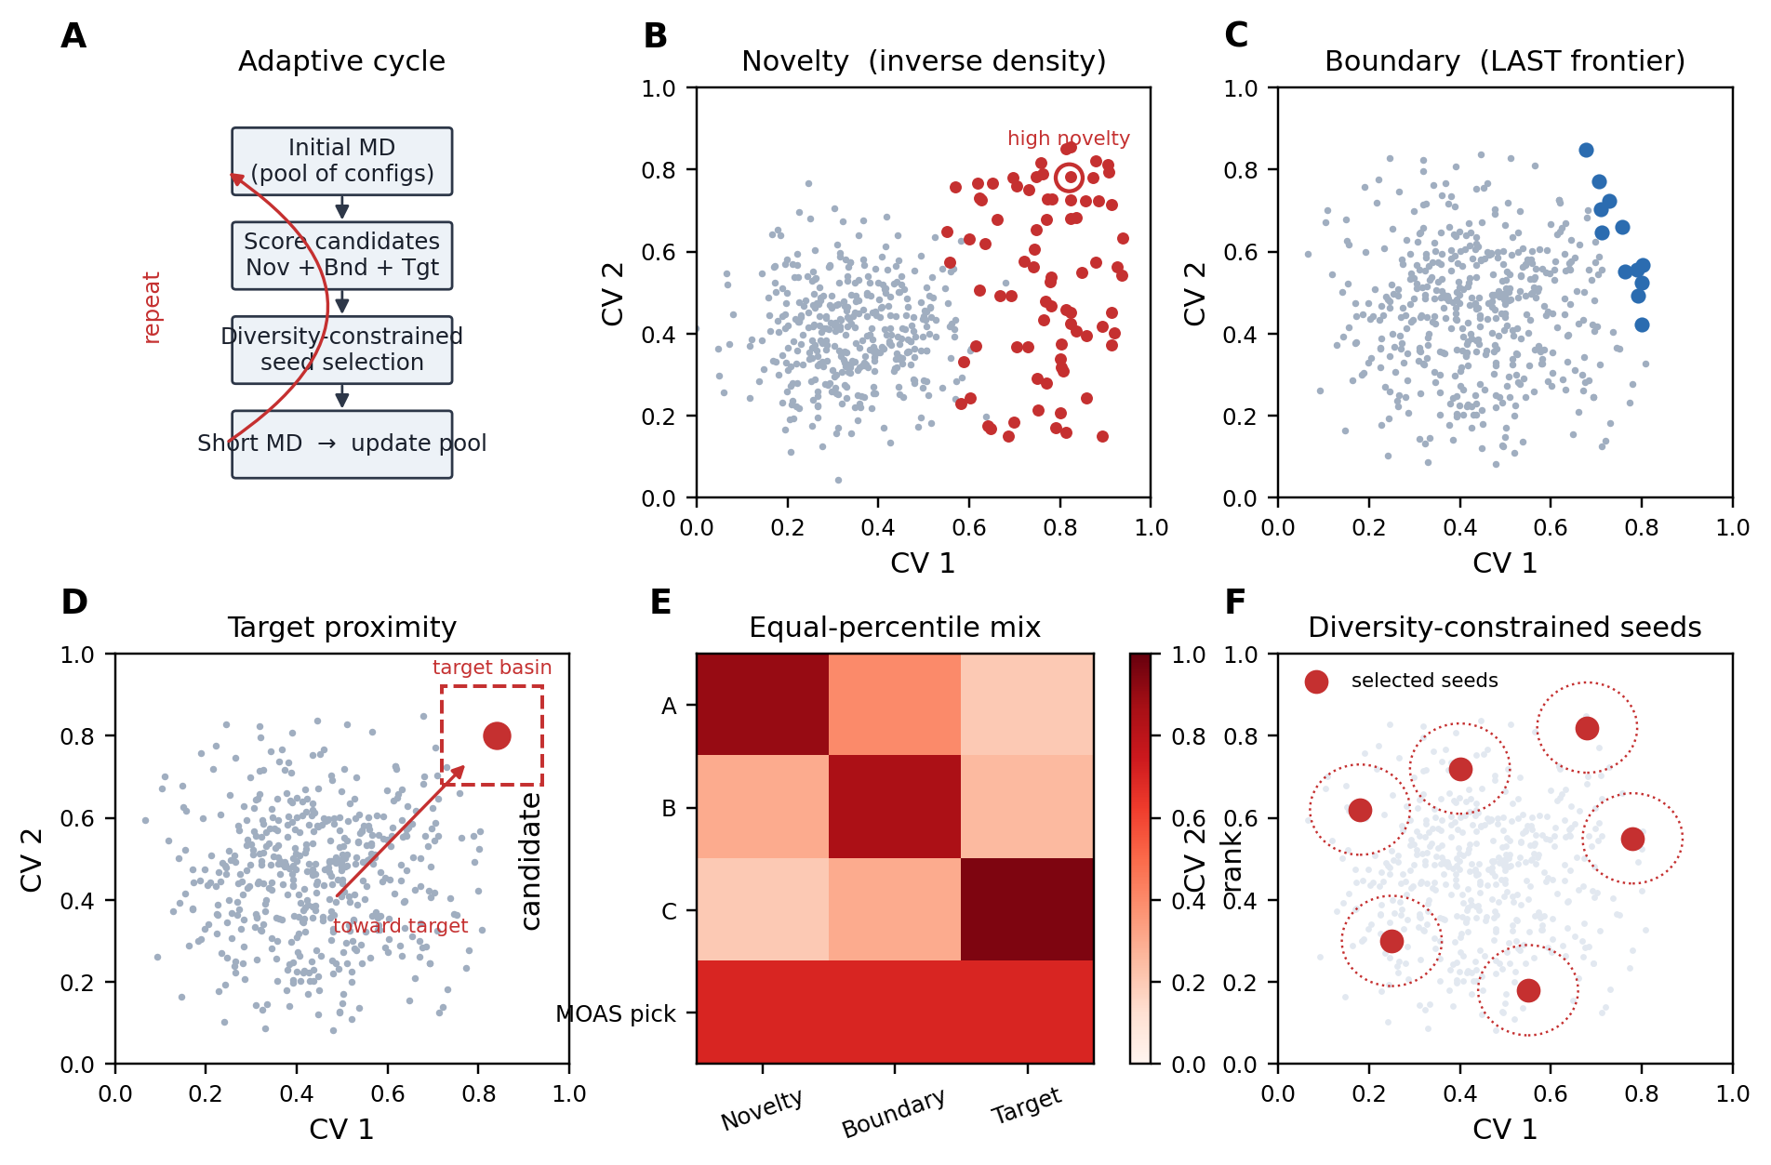
Figure 1. MOAS workflow. (A) Iterative adaptive cycle. (B) Novelty: inverse local density, favoring poorly sampled configurations. (C) Boundary: LAST-style frontier of the visited cloud. (D) Target proximity: candidates near the predefined target basin. (E) Equal-percentile mixing of the three ranks. (F) Diversity-constrained selection of multiple seeds per round.
CLN025 and AdK trajectories show that entering the target window is not the same as sampling the target state. On CLN025, TAPS reached the folded RMSD window in all three replicates (first hits 30.5, 31.6, and 51.6 ns) but committed in only 1/3, with median occupancy 0.24%. Rolling occupancy of the folded window remains a brief spike for TAPS, whereas LAST and MOAS accumulate longer folded sojourns (Figure 2A). kNN-AS likewise hit in 3/3 CLN025 campaigns and committed in only 1/3 (median occupancy 0.14%). Random sampling recorded two CLN025 hits and zero commits.
The same dissociation is visible on AdK. Random seed 0 first entered the closed-angle window at 83.3 ns and never committed; rolling occupancy stayed near zero after that hit. MOAS on the same initialization established repeated closed-basin residence after commitment (Figure 2B). Across systems, an early first hit did not predict high occupancy: several LAST, least-counts, and kNN-AS campaigns hit and still finished below 1% occupancy (Figure 2C). Conversion of a hit into a committed visit was complete for LAST and least-counts on CLN025, and for MOAS on every system; it was incomplete for several LAST, least-counts, and kNN-AS campaigns on AdK and MBP (Figure 2D). A trajectory can therefore have a short first-hit time and essentially no useful target-state sampling. Subsequent sections do not ask which method is fastest. They ask how campaigns read once success is defined as a committed visit and as target-basin occupancy, not as first hit alone.
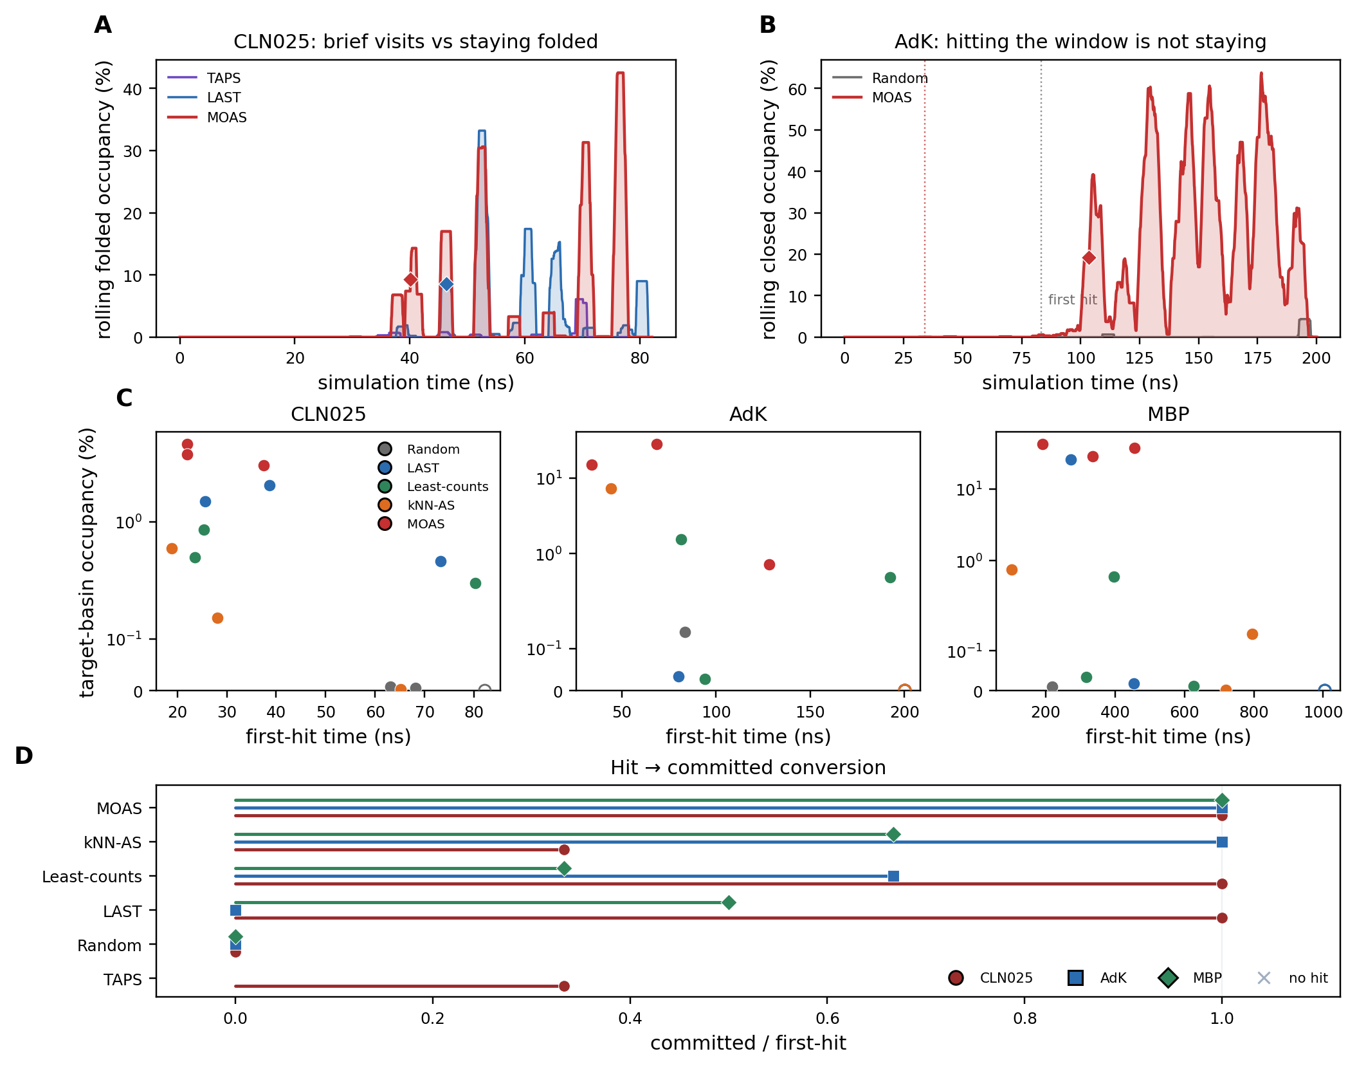
Figure 2. First-hit detection does not establish successful target-state sampling. (A) CLN025 rolling occupancy of the folded window (2 ns kernel) for TAPS, LAST, and MOAS (seed 0); filled area is the same trace, diamonds mark committed visits. (B) AdK rolling closed occupancy: Random hits at 83 ns and escapes; MOAS remains in the basin. (C) First-hit time versus occupancy on each protein; open symbols did not hit (plotted at the budget). (D) Fraction of hits that later committed; × marks method–protein pairs with no first hit. TAPS is shown only for CLN025.

3.2 Committed sampling across three conformational transitions
The evaluation criteria of Section 3.1 were applied to three conformational transitions of increasing scale: CLN025 folding from an unfolded start (82 ns budget; commit ≥ 40 ps in RMSD < 0.25 nm), apo AdK open-to-closed (200 ns; both LID/NMP angles in the closed window ≥ 200 ps), and apo MBP domain closure (1 μs; domain distance and hinge angle in the closed window ≥ 200 ps). Each method used the same initialization, short-MD length, six seeds per round, and n = 3 independent campaigns (Table 1).
Committed-replicate counts are summarized in Figure 4A–C. MOAS committed in 3/3 campaigns on every protein. Random committed in 0/9 campaigns. LAST committed in 3/3 CLN025 runs, 0/3 AdK runs, and 1/3 MBP runs. Least-counts committed in 3/3, 2/3, and 1/3. kNN-AS committed in 1/3, 1/3, and 2/3. Per-replicate outcomes are classified in Figure 4F as no hit, hit only, or committed: the three levels of the evaluation framework (no encounter, encounter without stabilization, and committed sampling). The pattern is not that MOAS is always the first to hit, and it is not that LAST failed. LAST and least-counts also committed in 3/3 CLN025 campaigns. What differs across proteins is whether a frontier or least-counts objective, built for discovery, also yields a committed visit. MOAS, which mixes those exploration ranks with target proximity, recorded a committed visit on every replicate of every transition. That is a statement about the sampling objective, not a ranking of methods by speed.
Time-to-commit is shown as Kaplan–Meier curves of the probability of not yet committing (Figure 3). Crosses mark campaigns that reached the budget without a committed visit and are right-censored there. On CLN025, both LAST and MOAS fall to zero: all three replicates of each method committed. Random remains at one on every protein. LAST stays high on AdK and MBP, where it did not reach three commits. Least-counts and kNN-AS occupy intermediate paths that depend on the system. Table 2 reports the Kaplan–Meier median time-to-commit, the commitment probability, and the median occupancy, each with a 95% bootstrap interval. MOAS medians are 36.1 ns on CLN025 [34.1, 40.1], 105.7 ns on AdK [103.4, 192.3], and 442.8 ns on MBP [216.8, 503.5]. Occupancy intervals for MOAS do not overlap those of Random on any system. Those intervals are not a claim that MOAS is uniformly faster than LAST. Where fewer than two of three campaigns committed, the Kaplan–Meier median is not reached.
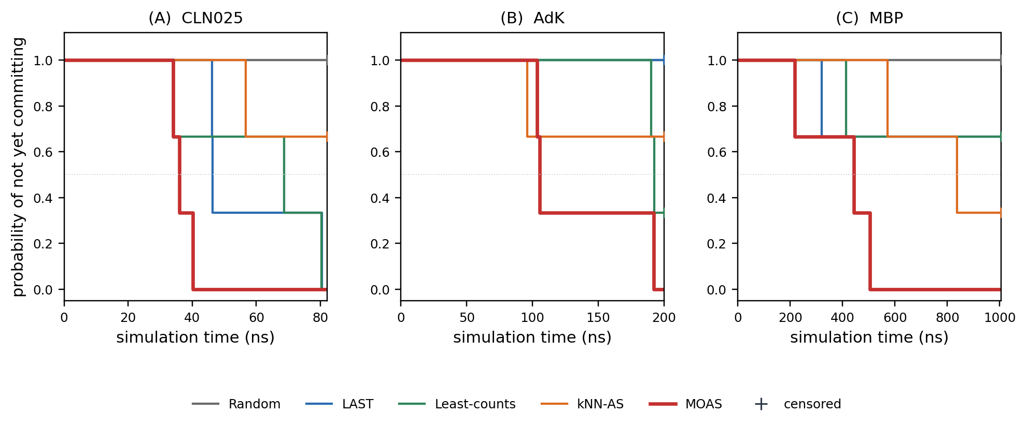
Figure 3. Kaplan–Meier estimates of the probability of not yet committing (n = 3). (A) CLN025, (B) AdK, (C) MBP. Crosses are campaigns that never committed, censored at the budget. The dotted line is S(t) = 0.5.
System | Method | KM median ttc (ns) | P(commit) | Occupancy (%)
CLN025 | Random | n.r. | 0.00 [0.00, 0.00] | 0.01 [0.00, 0.01]
CLN025 | LAST | 46.4 [46.2, 80.5] | 1.00 [1.00, 1.00] | 1.66 [0.38, 2.48]
CLN025 | Least-counts | 68.6 [34.1, 80.3] | 1.00 [1.00, 1.00] | 0.42 [0.22, 0.83]
CLN025 | kNN-AS | n.r. | 0.33 [0.00, 1.00] | 0.14 [0.00, 0.52]
CLN025 | MOAS | 36.1 [34.1, 40.1] | 1.00 [1.00, 1.00] | 5.25 [4.05, 6.79]
AdK | Random | n.r. | 0.00 [0.00, 0.00] | 0.00 [0.00, 0.14]
AdK | LAST | n.r. | 0.00 [0.00, 0.00] | 0.00 [0.00, 0.03]
AdK | Least-counts | 192.5 [190.4, 192.5] | 0.67 [0.00, 1.00] | 0.48 [0.03, 1.53]
AdK | kNN-AS | n.r. | 0.33 [0.00, 1.00] | 0.00 [0.00, 7.31]
AdK | MOAS | 105.7 [103.4, 192.3] | 1.00 [1.00, 1.00] | 14.85 [0.72, 27.83]
MBP | Random | n.r. | 0.00 [0.00, 0.00] | 0.00 [0.00, 0.01]
MBP | LAST | n.r. | 0.33 [0.00, 1.00] | 0.02 [0.00, 26.01]
MBP | Least-counts | n.r. | 0.33 [0.00, 1.00] | 0.03 [0.01, 0.60]
MBP | kNN-AS | 836.8 [572.6, 836.8] | 0.67 [0.00, 1.00] | 0.14 [0.00, 0.76]
MBP | MOAS | 442.8 [216.8, 503.5] | 1.00 [1.00, 1.00] | 37.15 [28.40, 42.12]

Table 2. Bootstrap 95% percentile intervals (10,000 resamples of n = 3). KM median ttc is the Kaplan–Meier median time-to-commit; n.r., not reached (S(t) never falls to 0.5). Occupancy is the median across replicates. With n = 3, bootstrap intervals for a 0/3 or 3/3 proportion are degenerate.
Among campaigns that committed, the corresponding point estimates match Figure 4D. On CLN025 the three methods that committed in 3/3 did so at 36.1 ns (MOAS), 46.4 ns (LAST), and 68.6 ns (least-counts). Those times are not ranked: MOAS is not claimed to be faster than LAST. On MBP, LAST’s single success was at 320 ns, earlier than the MOAS median of 442.8 ns, so LAST’s Kaplan–Meier median is not reached. kNN-AS on MBP committed later (Kaplan–Meier median 837 ns). Target-basin occupancy for all replicates is shown in Figure 4E and is examined in Section 3.3.
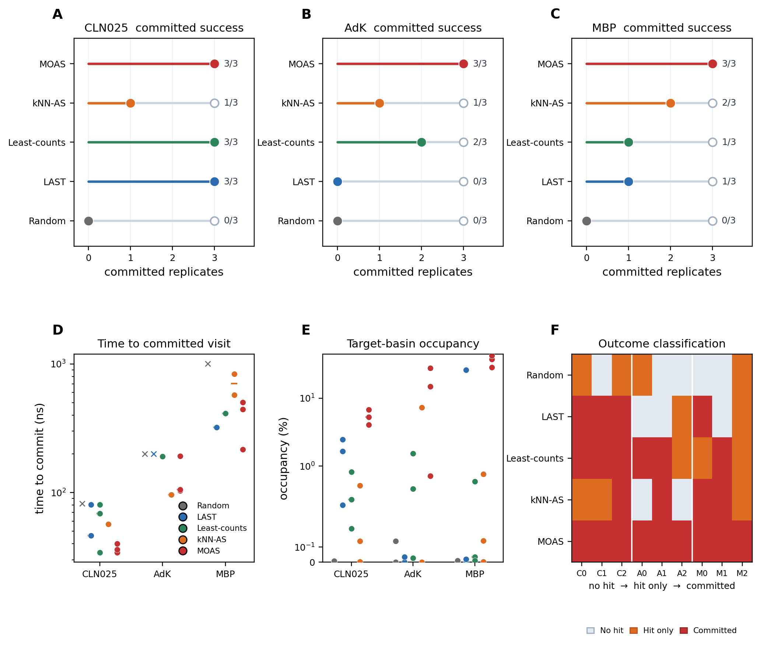
Figure 4. Committed sampling across three conformational transitions (n = 3). (A–C) Committed replicates out of three on CLN025, AdK, and MBP. The filled marker is the observed count; the open marker is complete success (3/3), so the gap is campaigns that did not commit. (D) Time to committed visit (log scale); × marks campaigns that never committed (plotted at the budget). (E) Target-basin occupancy. (F) Per-replicate classification: no hit, hit only, or committed (no encounter, encounter, and stabilization).
Because τ is a protocol choice, the same trajectories were re-scored at neighboring sojourn thresholds (Supporting Information Figure S1 and Table S6). No additional MD was run. On CLN025, MOAS remained 3/3 committed from 20 to 80 ps. LAST and least-counts were 3/3 at 20–40 ps and dropped to 2/3 and 1/3 at 60–80 ps; kNN-AS fell from 2/3 at 20 ps to 1/3 at the production 40 ps and 0/3 at 60–80 ps; TAPS was 3/3 only at 20 ps (1/3 thereafter); Random never committed. On AdK, MOAS was 3/3 at 100–300 ps and 2/3 at 500 ps; LAST was 0/3 at every τ; least-counts was 2/3 until 300 ps and 1/3 at 500 ps; kNN-AS was 1/3 throughout; Random committed in 1/3 only at 100 ps. On MBP, MOAS was 3/3 from 100 to 500 ps; LAST was 2/3 at 100 ps and 1/3 thereafter; least-counts 1/3; kNN-AS 2/3 until 300 ps and 1/3 at 500 ps; Random 1/3 only at 100 ps. Median time-to-commit for MOAS moved little except a modest delay on CLN025 at 60–80 ps (36.1 to 40.1 ns) and on AdK at 500 ps (105.7 to 121.8 ns among the two remaining commits). Occupancy does not depend on τ: MOAS medians remained 5.25% (CLN025), 14.85% (AdK), and 37.15% (MBP), above the exploration methods at every threshold. Thus the ranking of MOAS versus Random, LAST, least-counts, and kNN-AS is not an artifact of the production 40 ps / 200 ps choice.

3.3 Committed visits are associated with sustained target-basin occupancy
Section 3.2 established that a committed visit occurred. This section asks whether that visit is associated with more useful sampling of the target basin, as opposed to a single qualifying sojourn followed by escape. Occupancy is the fraction of the full budget spent inside the target window.
Median occupancies for MOAS were 5.25% on CLN025 (IQR 4.65–6.02), 14.85% on AdK (IQR 7.78–21.34), and 37.15% on MBP (IQR 32.78–39.63), with the three replicates shown as shown in Figure 5A–C. The AdK MOAS replicate that committed only at 192 ns remained at 0.72% occupancy: commitment without large occupancy is possible, which is why the two quantities are reported separately. LAST’s CLN025 occupancy median was 1.66%, against 5.25% for MOAS, with both methods committing in 3/3. LAST’s MBP median was 0.02%, despite one replicate that reached 26% after committing at 320 ns. That replicate shows that LAST is capable of substantial occupancy when a frontier trajectory enters and remains in the basin; it is not a failed method. Median occupancy still differs because the other LAST MBP campaigns did not occupy the closed window. kNN-AS medians were 0.14%, ~0%, and 0.14% on the three systems. Bootstrap 95% intervals on these occupancy medians are in Table 2.
CV densities show where that occupancy sits. On AdK, where LAST did not commit, density remains in the open LID–NMP cloud, whereas MOAS accumulates inside the closed window (Figure 5D). On MBP, pooled LAST density stays near the open reference even though one replicate occupied the closed basin at 26% (Figure 5E), because the other two campaigns did not. Restricting the comparison to campaigns that recorded a first hit does not remove the occupancy gap (Figure 5F). Hitting the window is therefore not the event that distinguishes the methods; remaining in the basin is. We describe this as an association between committed visits and sustained occupancy, not as a claim that commitment causally produces occupancy in the absence of further analysis, and not as a claim that LAST cannot occupy the target.
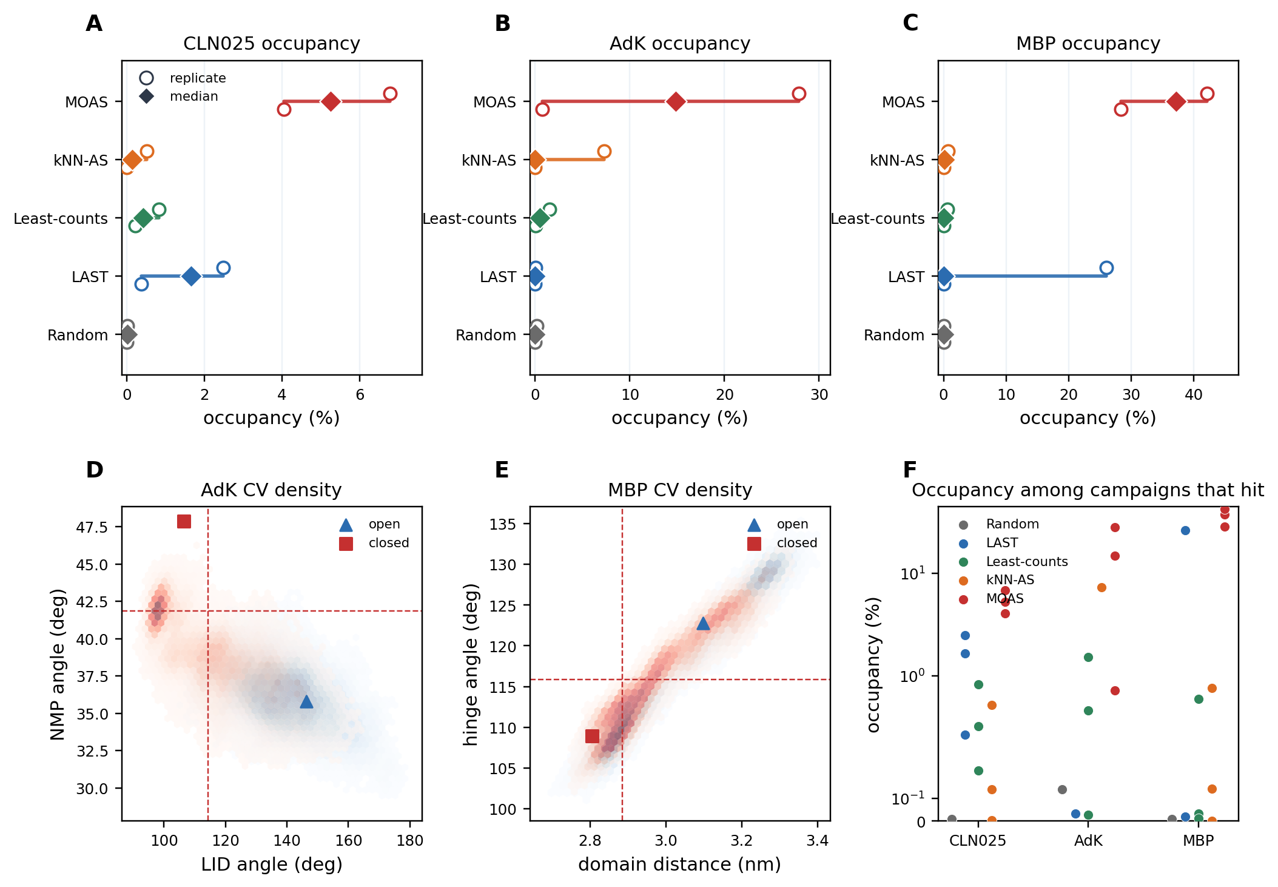
Figure 5. Committed visits are associated with sustained target-basin occupancy. (A–C) Occupancy of three independent replicates (circles), with the median (diamond) and min–max range. (D) AdK LID–NMP density for LAST (blue) and MOAS (red); dashed lines mark the closed window. (E) Analogous MBP domain-distance / hinge-angle density. (F) Occupancy restricted to campaigns that recorded a first hit.
Occupancy is the time average of the indicator of W. It therefore mixes how often a trajectory enters the window with how long it stays. The latter is the residence-time distribution of contiguous sojourns (Supporting Information Figure S2A–C). A committed visit is the event that at least one sojourn exceeds τ, equivalently that the longest sojourn exceeds τ (Figure S2D–F). Typical visits remain short for every method (median sojourn 2–20 ps); the distinction is the tail. The median longest sojourn was 0.34 ns for MOAS on CLN025, against 0.15 ns for LAST, 0.05 ns for least-counts, 0.02 ns for kNN-AS, 0.03 ns for TAPS, and <0.01 ns for Random (Table 3). On AdK the corresponding medians were 1.82 ns (MOAS) and 0.33 ns (least-counts); Random, LAST, and kNN-AS had median longest sojourns of 0 because at least two of three campaigns never entered or never stayed (one kNN-AS replicate reached 9.8 ns). On MBP they were 36.5 ns (MOAS), 0.33 ns (kNN-AS), 0.12 ns (LAST), 0.07 ns (least-counts), and 0 (Random). The production threshold is one horizontal cut through Figure S2D–F; the ranking of longest sojourns does not require choosing that cut.
The same occupancy ranking is recovered under neighboring definitions of W (Figure S2G–I). Tightening the CLN025 RMSD cutoff from 0.25 to 0.20 nm lowers every occupancy but leaves MOAS highest (0.79% versus 0.01% for LAST). Widening to 0.30 or 0.40 nm does likewise (MOAS 12.4% and 31.9%; LAST 6.0% and 16.5%). On AdK, expanding or shrinking the LID/NMP rectangle by 4–8° does not produce a ranking in which an exploration method overtakes MOAS at the production window or looser; at −8° the window is empty for all methods. On MBP, a tighter closed window still retains 17.1% MOAS occupancy against ≤0.02% for the other methods. Occupancy is therefore not an artifact of the particular production rectangle.
System | Method | Median longest residence (ns) | Occupancy (%)
CLN025 | Random | 0.002 | 0.01
CLN025 | LAST | 0.15 | 1.66
CLN025 | Least-counts | 0.046 | 0.42
CLN025 | kNN-AS | 0.020 | 0.14
CLN025 | MOAS | 0.34 | 5.25
AdK | Random | 0.000 | 0.00
AdK | LAST | 0.000 | 0.00
AdK | Least-counts | 0.33 | 0.48
AdK | kNN-AS | 0.000 | 0.00
AdK | MOAS | 1.82 | 14.85
MBP | Random | 0.000 | 0.00
MBP | LAST | 0.12 | 0.02
MBP | Least-counts | 0.070 | 0.03
MBP | kNN-AS | 0.33 | 0.14
MBP | MOAS | 36.47 | 37.15

Table 3. Threshold-free residence and occupancy (n = 3). Median longest residence is the median, over three campaigns, of each campaign’s longest contiguous sojourn in the production window W (0 if the campaign never entered). Occupancy is the production f_W of Section 2.13. Full sojourn survivals and neighboring-window occupancies are Supporting Information Figure S2 and Tables S7–S8.

3.4 Seed selection reallocates from exploration to target-state sampling
Seed selection is the policy that implements the sampling objective. Figure 6 asks how that policy is used over time on AdK, not which method is fastest. Each map is the same LID–NMP plane. The shaded region is the closed-state target window (LID < 114.4°, NMP > 41.8°). Selected seeds are colored by adaptive round, from early (blue) to late (red). Random, LAST, and MOAS are seed-0 campaigns; kNN-AS is the AdK campaign for which per-round seed coordinates were archived (replicate 2).
Random seeds remain in the open cloud through late rounds (Figure 6A). LAST seeds track the expanding frontier of the visited ensemble (Figure 6B, dashed contour of the sampled cloud). kNN-AS spreads into low-density regions and does not concentrate in the closed window (Figure 6C). MOAS seeds begin in the open cloud in rounds 1–5, approach the window in rounds 6–10, and enrich the closed basin in rounds 11–15 (Figure 6D). The dark line in D is the centroid of the six seeds selected in each round: exploration, then transition, then target-directed sampling, rather than a jump of points from left to right.
That sequence is quantified in Figure 6E–F. The fraction of selected seeds inside the target window is not itself the objective: a target-only rule would raise it immediately. The complementary coordinate is the median Euclidean distance, in LID–NMP space, from the six seeds to the closed reference. MOAS distance decreases over rounds while the in-window fraction rises late. Random, LAST, and kNN-AS do not show that reallocation. The policy therefore shifts from exploration toward target-state sampling; it does not dump seeds into the window from the first round. Figure 6G reconstructs the mean novelty, boundary, and target percentile ranks of those six MOAS seeds relative to the candidate pool of each round. The mixing weights never change. Novelty percentile of selected seeds remains near one in every round, so exploration is not switched off. Target percentile is already high in the transition, when the closed basin is still rare among candidates, and then declines as the pool itself occupies that basin. A relative rank cannot stay exclusive once many windows sit near the target. Reallocation is therefore a change in the pool, not a change in the weights.
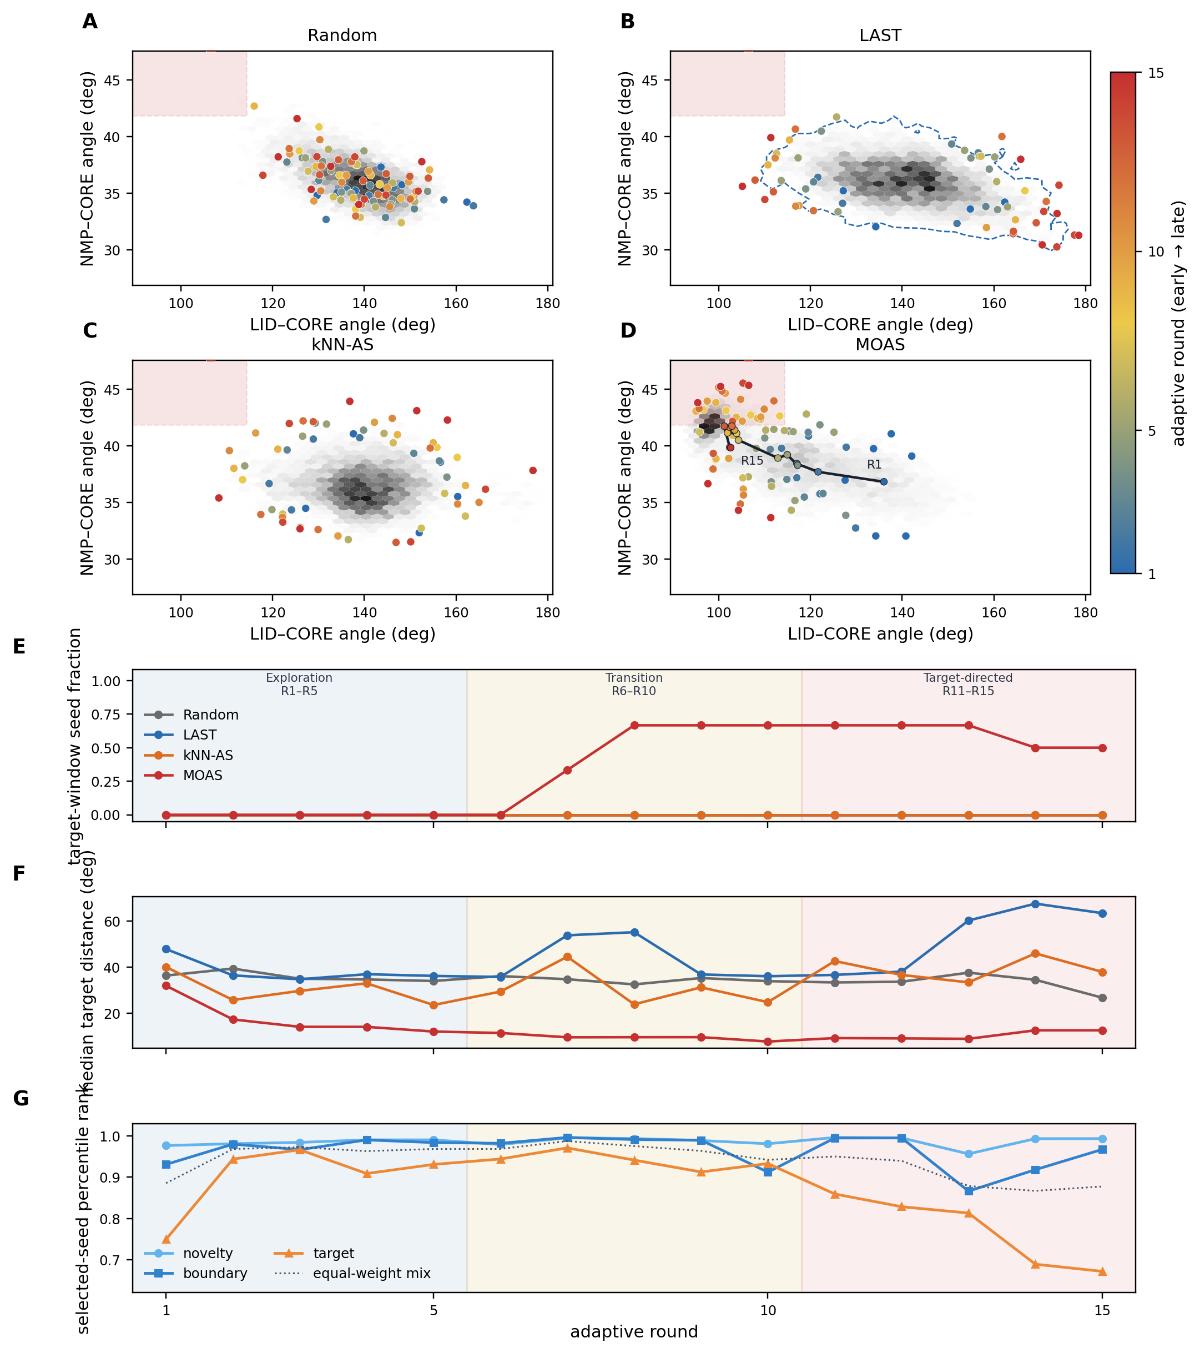
Figure 6. Temporal evolution of seed selection on AdK: from exploration to target-state sampling. (A–D) LID–NMP maps for Random, LAST, kNN-AS (replicate 2), and MOAS. Grey hexbin: sampled density. Points: selected seeds colored by adaptive round (early → late). Shaded rectangle: closed-state target window (LID < 114.4°, NMP > 41.8°). LAST (B) includes a dashed contour of the visited cloud. MOAS (D) includes the centroid trajectory of the six seeds in each round. (E) Fraction of selected seeds inside the target window versus round. (F) Median target distance of those seeds versus round. (G) Mean novelty, boundary, and target percentile ranks of the six MOAS seeds, recomputed from that round’s candidate pool; the dotted line is the equal-weight mix. Shaded bands mark exploration (R1–R5), transition (R6–R10), and target-directed sampling (R11–R15). A late rise in (E) with a gradual drop in (F) indicates reallocation toward the basin. (G) shows that this is not a change of weights: novelty rank stays high, and target rank falls once the pool is itself near the basin.

3.5 Contribution of individual objectives to MOAS sampling behavior
The preceding sections report full MOAS. Here the three scores are switched on or off under the same AdK and MBP budgets (n = 1) to describe their relative contribution, not to prove that every term is indispensable. Full MOAS is the already completed static campaign and was not rerun.
On AdK, novelty only and boundary only each hit the closed window (108 ns and 174 ns) and did not commit (occupancy 0.27% and 0.32%). Novelty+boundary never hit. Target only committed at 92 ns with 16.8% occupancy; novelty+target committed at 92 ns with 17.9%; boundary+target committed at 144 ns with 5.0%; full MOAS committed at 103 ns with 14.8% (Figure 7A, C). Occupancy-versus-time traces show that the target-containing mixes accumulate closed-window frames after commitment, whereas novelty and boundary remain near 1% after a first hit. Restricting occupancy to frames after the committed visit gives 28.6% (target), 30.0% (novelty+target), 27.5% (full MOAS), and 15.4% (boundary+target). Target proximity is therefore strongly associated with commitment on this protein. Adding novelty or boundary to target changes occupancy more than it changes the binary commit call; novelty+target is slightly above full MOAS in occupancy in this single replicate, so equal three-term mixing is not claimed to be uniquely optimal.
On MBP, novelty only and novelty+boundary never hit. Boundary only committed (417 ns, 6.0% occupancy). Target only committed late (731 ns, 3.8%). Novelty+target hit at 561 ns and committed only at 964 ns, with 0.36% occupancy. Boundary+target hit at 849 ns and did not commit (occupancy ~0%). Full MOAS committed at 443 ns with 28.4% occupancy (Figure 7B–D). No single- or two-term mix matches that occupancy. After commitment, full MOAS spends 49.9% of remaining frames in the closed basin, compared with 9.9% (boundary), 13.5% (target), and 2.9% (novelty+target); the hit-to-commit interval is 107 ns for full MOAS versus 404 ns for novelty+target, which converts late and still does not occupy the basin. Exploration without a target term either fails to hit or, if it commits, occupies far less of the 1 μs budget than the three-term mix; a target term without the full exploration mix can convert an encounter into a late commit and still leave almost no ensemble in the closed basin. The two classes of term are complementary on this larger transition.
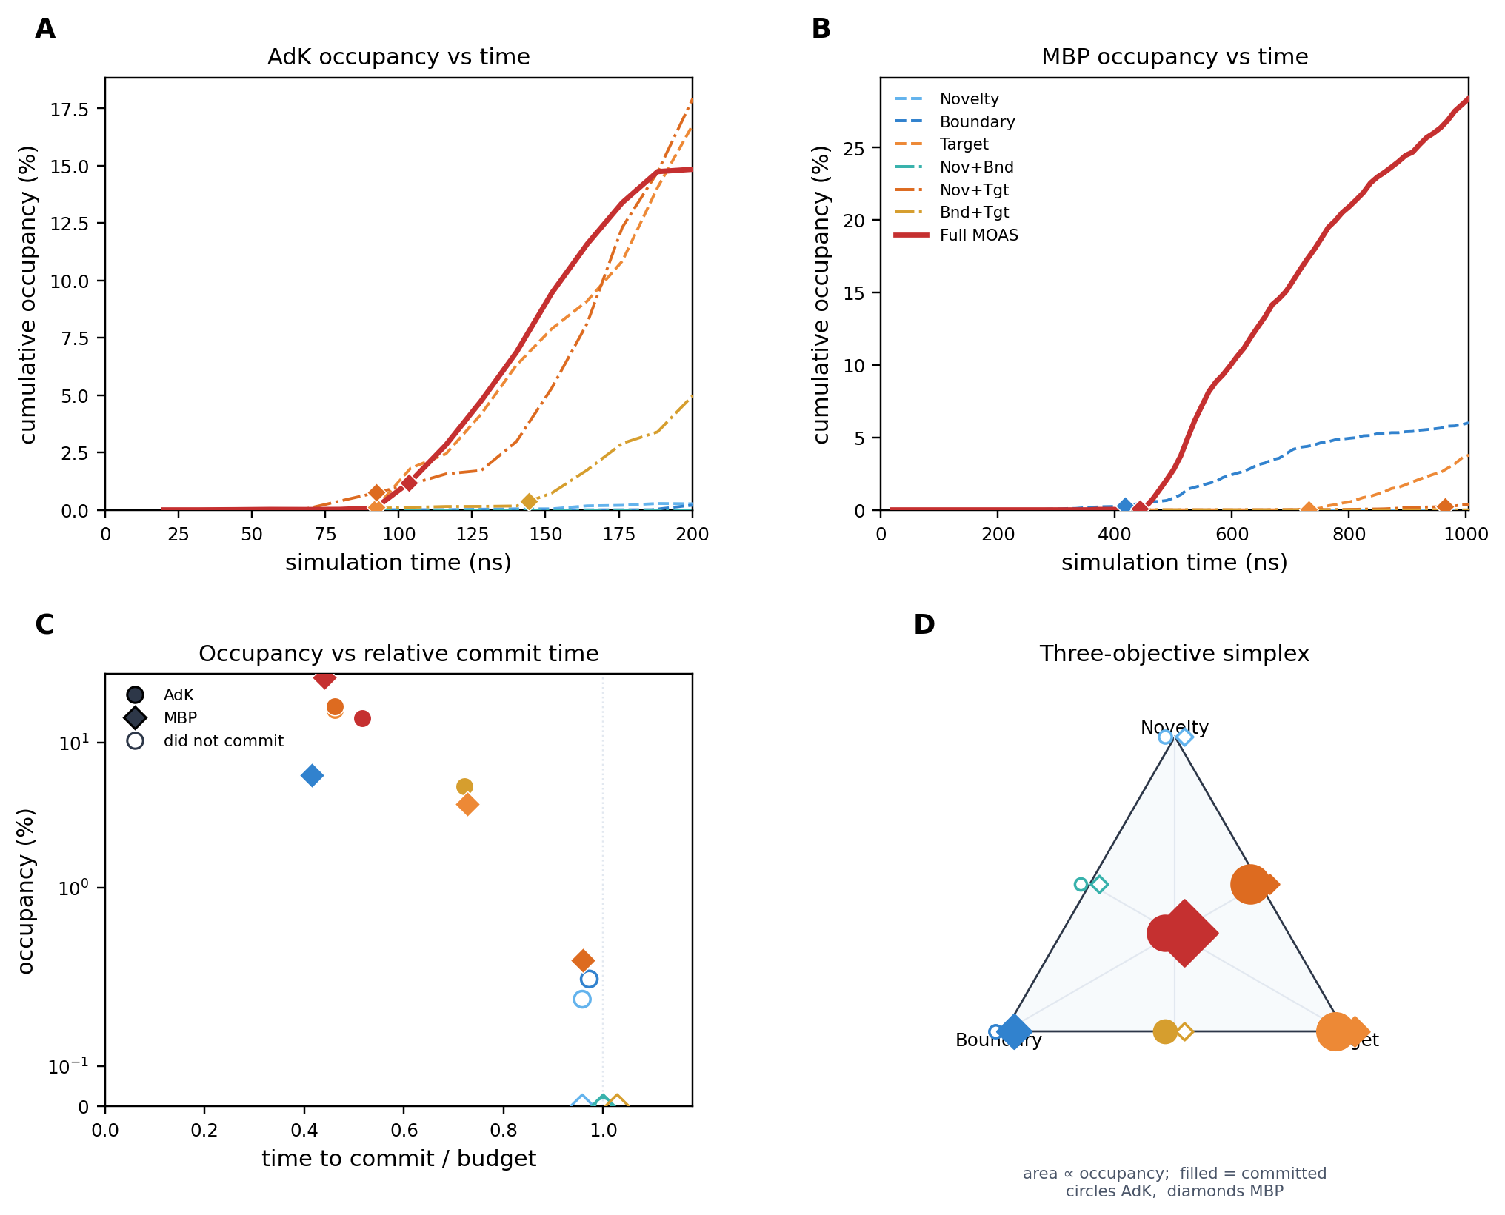
Figure 7. Contribution of individual MOAS objectives (n = 1). (A, B) Cumulative target-basin occupancy versus simulation time on AdK and MBP; diamonds mark the committed visit. Dashed lines are single-term mixes, dash-dot two-term mixes, and the solid red line is full MOAS. (C) Occupancy versus time to commit as a fraction of the budget (open markers did not commit). (D) The same campaigns on the three-objective simplex (Novelty–Boundary–Target); marker area is proportional to occupancy, filled markers committed (circles, AdK; diamonds, MBP).

3.6 Exploration coverage and target-state occupancy represent complementary sampling objectives
Figure 8A–C place every n = 3 campaign on two axes: the filled fraction of a 24 × 24 CV histogram (coverage) and target-basin occupancy. LAST, kNN-AS, and least-counts occupy the high-coverage, low-occupancy region on AdK and MBP. That placement is consistent with an exploration objective: those methods visit more histogram bins. MOAS occupies the high-occupancy side at comparable or slightly lower coverage. CLN025 coverage is compressed for all methods because the peptide fills few bins of the same 24 × 24 grid; occupancy still ranks MOAS above LAST (medians 5.25% versus 1.66%), while LAST itself is well above Random and kNN-AS. The two axes are different sampling objectives, not proxies for one another.
Exploration-oriented methods and MOAS can therefore be compared in one frame without treating either axis as a universal score. If the scientific question is whether new conformational space was visited, coverage and frontier scores remain appropriate. If the question is whether a predefined target state was established as a sampled basin, committed visit and occupancy are the relevant endpoints. The two questions are two definitions of success. Changing the definition changes which method looks successful. Adaptive sampling should be evaluated not only by how much of conformational space is explored, but also by whether the intended target state is sampled in a committed and sustained manner.
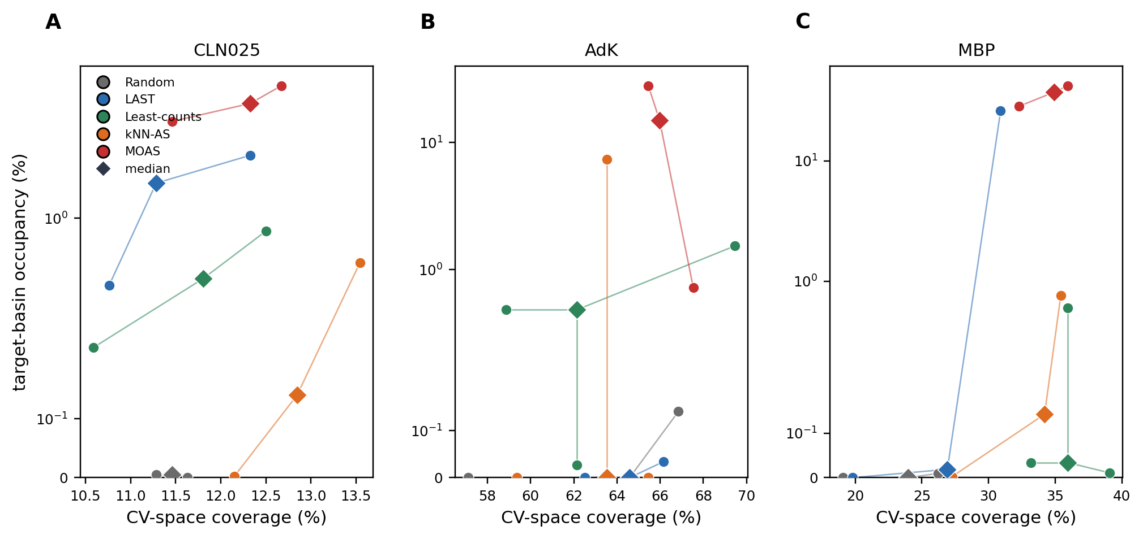
Figure 8. Exploration coverage and target-state occupancy are complementary sampling objectives. Each panel is one protein; each point is one n = 3 campaign. Lines join each campaign to the method median (diamond). Coverage is the filled fraction of a 24 × 24 CV histogram. Occupancy is the target-window fraction. MOAS separates on the occupancy axis; LAST, kNN-AS, and least-counts separate on coverage for AdK and MBP.

4. Discussion
The central result of this study is not that MOAS universally accelerates adaptive sampling, but that first-hit time alone does not adequately define successful sampling of a target conformational state. A trajectory can enter a predefined target window early, leave it rapidly, and contribute almost no subsequent sampling to that state. The distinction among first hit, committed visit, and target-basin occupancy therefore separates three different levels of outcome: encounter, stabilization, and sustained sampling. Figure 2 illustrates why these quantities should not be collapsed into a single measure. First-hit time remains useful for describing how rapidly a target region is encountered, but when the scientific objective is to obtain an ensemble of a metastable target state, successful sampling must also account for whether the trajectory remains in that state and accumulates meaningful residence time. This distinction provides the basis for the evaluation framework used throughout this study.
MOAS was designed to align seed selection with this definition of success while retaining the exploratory behavior of adaptive sampling. Its three components—novelty, LAST-style boundary exploration, and target proximity—address complementary aspects of the sampling problem. Novelty and boundary scores promote exploration of poorly represented or frontier regions, whereas target proximity provides an explicit mechanism for directing sampling toward the basin of interest. Equal percentile normalization places these otherwise incommensurate scores on a common relative scale, while the diversity constraint prevents the selected seeds from collapsing onto a single local region. Importantly, the apparent shift from exploration toward target-directed sampling does not require time-dependent weights. As the sampled ensemble evolves, the relative ranks of candidate configurations change, and configurations near the target can become increasingly competitive with frontier configurations. Figure 6 illustrates this behavior: early selection remains distributed across the open-state ensemble, whereas later rounds become progressively enriched near the target basin. Thus, the balance between exploration and target-directed sampling emerges from the evolving candidate pool rather than from an explicitly scheduled change in objective weights. The ablation results further suggest that target proximity is important for achieving commitment, whereas retaining exploratory objectives can improve the accumulation of target-basin occupancy.
The comparison with existing adaptive strategies should therefore be interpreted as a comparison of sampling objectives rather than a universal performance ranking. LAST, in particular, was not uniformly inferior to MOAS: it achieved commitment in all CLN025 replicates and produced high occupancy in one MBP campaign. These results are consistent with the fact that frontier exploration can, depending on the underlying landscape, naturally lead into and remain within a target basin. Random provides an unbiased restart reference, least-counts emphasizes under-sampled regions, and both LAST and kNN-AS favor exploration of poorly represented regions of conformational space. These strategies are appropriate when the principal question is where the trajectory has not yet explored. The present results instead address the complementary question of whether a predefined target state has been sufficiently sampled. MOAS extends this exploratory framework by adding target proximity, rather than replacing exploration with purely target-directed selection. The separation between coverage and occupancy in Figure 8 further emphasizes that exploration and target-state accumulation are related but distinct objectives.
This distinction also motivates the broader use of committed sampling as an evaluation framework. The framework is applicable whenever the scientific objective is to accumulate sampling within a defined metastable state rather than merely detect its existence. Under this framework, first hit represents discovery, whereas a committed visit and subsequent occupancy represent stabilization and ensemble accumulation. The commitment threshold should not be regarded as a universal constant. In the present study, 40 ps was used for CLN025 and 200 ps for AdK and MBP to reflect differences in the characteristic timescales of the systems; critically, the same criterion was applied to all methods within each system. Re-scoring the same trajectories over a neighborhood of τ (Supporting Information Figure S1 and Table S6) left the ranking of MOAS versus the exploration methods unchanged. MOAS remained the only method with 3/3 committed replicates on all three proteins at the production thresholds, and it retained that count at every neighboring τ except AdK at 500 ps (2/3). Occupancy, which does not depend on τ, preserved the same order. Commitment is one slice of the residence-time distribution: a committed visit occurs when the longest sojourn exceeds τ, while occupancy is the time average of those sojourns (Supporting Information Figure S2A–F and Table 3). Recomputing occupancy under neighboring definitions of W (Figure S2G–I) left MOAS highest at the production window and at every looser or moderately tighter cutoff that is still populated. More broadly, a physically motivated, system-specific commitment criterion can be incorporated into benchmarks of protein conformational transitions, ligand-linked state changes, enzyme open/closed dynamics, membrane-protein conformational switching, and other rare-event problems in which persistence within a target state is scientifically meaningful.
Several limitations define the current scope of the method. First, MOAS assumes a predefined target basin in CV space and is therefore a target-directed sampler rather than a method for discovering unknown metastable states. Second, the CVs used here were selected a priori: Cα-RMSD and Rg for CLN025, LID/NMP angles for AdK, and domain distance and hinge angle for MBP. The effectiveness of target-directed sampling may therefore depend on whether these coordinates adequately resolve the relevant conformational transition. Integration with learned representations, such as time-lagged or variational embeddings, graph-based features, or Koopman/TICA-type coordinates, could reduce this dependence. Third, the equal weighting of the three MOAS objectives is intended as a transparent and reproducible baseline rather than an optimized universal choice; adaptive weighting based on sampling stage, uncertainty, target distance, occupancy, or objective redundancy remains to be explored. Finally, the present benchmark contains three protein systems with three independent campaigns per main-text method, while the ablation analysis uses single campaigns. These data establish consistent behavior across the tested systems but do not justify universal claims about MOAS performance. Larger replicate sets, broader protein classes, and standardized committed-sampling benchmarks will be needed to determine the generality and statistical robustness of this framework.

5. Conclusions
The contribution of this work is a change in what success means for adaptive sampling of a rare conformational state. First hit records an encounter and is not sufficient evidence that the target basin has been sampled. A committed visit and persistent occupancy record whether that basin was established as an ensemble. MOAS operationalizes that definition by ranking seeds on novelty, boundary exploration, and target proximity, mixed by equal percentile ranks and subject to a diversity constraint, so that exploration of poorly sampled regions is kept in play while sampling is progressively directed toward the intended state. Across CLN025 folding, the AdK open-to-closed transition, and apo MBP domain closure, this mix was associated with a committed visit in every replicate. LAST and least-counts achieved the same commit count on CLN025; LAST also produced a high-occupancy MBP campaign. Those results are not a demonstration that MOAS is faster, or that it supersedes LAST. They show that an exploration objective and a target-state sampling objective are different questions, and that the ranking of methods depends on which question is asked. The same ranking is recovered from the full residence-time distribution and from occupancy recomputed under neighboring definitions of W. The practical implication is to score adaptive sampling of target states by committed residence and persistent occupancy, and to treat exploration and target-directed stabilization as complementary objectives rather than as a single performance number.

Associated Content

Supporting Information
Simulation parameters (Table S1); replicate-level hit, commit, occupancy, and coverage (Tables S2–S5); ablation numerics (Table S4); commitment-threshold robustness (Figure S1, Table S6); residence-time distributions and neighboring-window occupancy (Figure S2, Tables S7–S8); campaign tags (S11). Ranking code, CV JSON, and commitment functions corresponding to this article are at https://github.com/liying0128/TAPS (directory paper/protocol/).

Data and Software Availability
The data underlying this study are available in the published article, the Supporting Information, and at https://github.com/liying0128/TAPS. The scripts and code used to generate and analyze the results are in the same repository. Ranking (novelty, LAST frontier, target proximity, equal-percentile mixing, diversity-constrained seed selection), CV window definitions, and commitment / occupancy / residence-time functions are deposited in paper/protocol/. Production adaptive loops are taps-gromacs/stage13_cln025_discover.py (CLN025), moas-adk/stage_adk_discover.py (AdK), and moas-mbp/stage_mbp_discover.py (MBP). Machine-readable numerical tables underlying Figures 2–8 and S1–S2 are in paper/tables/. Custom code is released under the MIT license. MD was run with open-source GROMACS 2024.3 (production GPUs) and checked with GROMACS 2025.1, AMBER99SB-ILDN and TIP3P. Python 3 with NumPy was used for ranking and CV evaluation. Full GROMACS trajectories and checkpoints are not stored on GitHub (hundreds of GB); they are available from the corresponding author upon request. Campaign tags are listed in Supporting Information section S11.

Acknowledgements
This work is financially supported by the Project of Cultivation for Young Top-notch Talents of Beijing Municipal Institutions (BPHR202203209).

