Supporting Information
From Transient Encounters to Committed Sampling:
A Multi-Objective Adaptive Sampling Strategy for Rare Protein Conformational States
Yiru Wang^{1,2} and Ying Li^{1,2}
1 Beijing Key Laboratory of Biomass Waste Resource Utilization, College of Biochemical Engineering, Beijing Union University, Beijing, 100023, China.
2 Beijing Key Laboratory of Bioactive Substances and Functional Foods, College of Biochemical Engineering, Beijing Union University, Beijing, 100023, China.

S1. Simulation parameters
Force field: AMBER99SB-ILDN protein, TIP3P water. Temperature 300 K, pressure 1 bar (NPT production), 0.15 M NaCl. Box buffer 1.2 nm; rhombic dodecahedron for MBP, cubic/dodecahedral boxes as prepared for CLN025 and AdK. Integrator and constraints follow the repository MDP files (md_prod / md_short_1ns / md_short_2ns): 2 fs time step, LINCS on H-bonds, PME electrostatics, Verlet cutoff. Short adaptive segments use GPU update / PME. Initialization trajectories are shared across methods within a system and replicate: 10 ns unfolded cMD (CLN025) or 20 ns open apo cMD (AdK, MBP).
Item | CLN025 | AdK | MBP
Start | unfolded | open apo (4AKE-like) | open apo (1OMP)
Target reference | native 5AWL/2RVD | closed 1AKE | closed 1ANF, ligand removed
CVs | Cα-RMSD, Rg | LID angle, NMP angle | N–C CA-COM distance, hinge angle
Target window | RMSD < 0.25 nm | LID < 114.4° and NMP > 41.8° | dist < 2.885 nm and θ < 115.9°
Commit duration | ≥ 40 ps | ≥ 200 ps | ≥ 200 ps
Init unbiased MD | 10 ns | 20 ns | 20 ns
Short MD | 1 ns | 2 ns | 2 ns
Seeds / round | 6 | 6 | 6
Rounds | 12 | 15 | 82
Aggregate budget | 82 ns | 200 ns | 1000 ns
Replicates | seeds 0, 1, 2 | seeds 0, 1, 2 | seeds 0, 1, 2

Table S1. Protocol details shared by Random, LAST, least-counts, kNN-AS, and MOAS.
MOAS mixing (production): percentile ranks of novelty, LAST boundary, and target proximity, averaged with equal weights. Ablation campaigns zero the unused ranks and renormalize over the active subset. kNN-AS: visited CV cloud subsampled with P = 0.5, k = 5 nearest neighbors, score ||Σ (z_j − q)||; no target term. Least-counts: inverse histogram count of the candidate’s CV bin. LAST: frontier / boundary score of the visited set. Random: uniform among eligible windows subject to the same diversity rule where implemented.

S2. Replicate-level outcomes
Table S2 lists every main-text campaign. First hit and commit times are in nanoseconds of accumulated simulation time. Occupancy is the fraction of pooled frames inside the target window. Coverage is the filled fraction of a 24 × 24 CV histogram. Empty commit entries are campaigns that never satisfied the sojourn criterion.
System | Method | Rep | Hit (ns) | Commit (ns) | Occupancy (%) | Coverage (%)
CLN025 | Random | 0 | 68.17 | — | 0.005 | 11.3
CLN025 | Random | 1 | — | — | 0.000 | 11.6
CLN025 | Random | 2 | 63.02 | — | 0.008 | 11.5
CLN025 | LAST | 0 | 38.59 | 46.37 | 2.476 | 12.3
CLN025 | LAST | 1 | 25.70 | 46.18 | 1.656 | 11.3
CLN025 | LAST | 2 | 73.21 | 80.49 | 0.378 | 10.8
CLN025 | Least-counts | 0 | 80.21 | 80.27 | 0.221 | 10.6
CLN025 | Least-counts | 1 | 25.34 | 34.12 | 0.825 | 12.5
CLN025 | Least-counts | 2 | 23.62 | 68.62 | 0.415 | 11.8
CLN025 | kNN-AS | 0 | 65.12 | — | 0.003 | 12.2
CLN025 | kNN-AS | 1 | 28.08 | — | 0.140 | 12.8
CLN025 | kNN-AS | 2 | 18.93 | 56.65 | 0.521 | 13.5
CLN025 | MOAS | 0 | 37.48 | 40.12 | 4.046 | 11.5
CLN025 | MOAS | 1 | 22.04 | 34.09 | 6.792 | 12.7
CLN025 | MOAS | 2 | 22.05 | 36.06 | 5.249 | 12.3
AdK | Random | 0 | 83.34 | — | 0.140 | 66.8
AdK | Random | 1 | — | — | 0.000 | 64.6
AdK | Random | 2 | — | — | 0.000 | 57.1
AdK | LAST | 0 | — | — | 0.000 | 62.5
AdK | LAST | 1 | — | — | 0.000 | 64.6
AdK | LAST | 2 | 80.11 | — | 0.034 | 66.1
AdK | Least-counts | 0 | 192.24 | 192.52 | 0.484 | 58.9
AdK | Least-counts | 1 | 81.48 | 190.35 | 1.531 | 69.4
AdK | Least-counts | 2 | 94.15 | — | 0.027 | 62.2
AdK | kNN-AS | 0 | — | — | 0.000 | 59.4
AdK | kNN-AS | 1 | 44.29 | 96.09 | 7.311 | 63.5
AdK | kNN-AS | 2 | — | — | 0.000 | 65.5
AdK | MOAS | 0 | 34.07 | 103.44 | 14.846 | 66.0
AdK | MOAS | 1 | 128.17 | 192.27 | 0.719 | 67.5
AdK | MOAS | 2 | 68.40 | 105.67 | 27.829 | 65.5
MBP | Random | 0 | — | — | 0.000 | 24.0
MBP | Random | 1 | — | — | 0.000 | 19.1
MBP | Random | 2 | 218.51 | — | 0.010 | 26.2
MBP | LAST | 0 | 272.39 | 320.42 | 26.011 | 30.9
MBP | LAST | 1 | — | — | 0.000 | 19.8
MBP | LAST | 2 | 454.67 | — | 0.019 | 26.9
MBP | Least-counts | 0 | 317.50 | — | 0.034 | 33.2
MBP | Least-counts | 1 | 395.98 | 414.01 | 0.596 | 35.9
MBP | Least-counts | 2 | 626.49 | — | 0.011 | 39.1
MBP | kNN-AS | 0 | 795.10 | 836.83 | 0.142 | 34.2
MBP | kNN-AS | 1 | 102.26 | 572.60 | 0.760 | 35.4
MBP | kNN-AS | 2 | 718.72 | — | 0.002 | 27.3
MBP | MOAS | 0 | 335.75 | 442.83 | 28.405 | 32.3
MBP | MOAS | 1 | 455.04 | 503.54 | 37.145 | 34.9
MBP | MOAS | 2 | 191.06 | 216.76 | 42.118 | 35.9

Table S2. Main-text n = 3 campaigns (TAPS omitted; see Table S5).

S3. First-hit data
First hit is reported for completeness and is not the primary endpoint. Several campaigns hit and never committed (transient-only): CLN025 Random (2 hits / 0 commits), CLN025 kNN-AS (3/1), AdK Random (1/0), AdK LAST (1/0), AdK least-counts (3/2), MBP Random (1/0), MBP LAST (2/1), MBP least-counts (3/1), MBP kNN-AS (3/2). LAST and least-counts converted every CLN025 hit into a commit (3/3). MOAS converted every hit into a commit on all three systems (9/9). Those counts are reported as conversion under each objective, not as a ranking in which LAST is the losing method.

S4. Representative CV traces
Rolling target occupancy for CLN025 (TAPS / LAST / MOAS) and AdK (Random / MOAS) is Figure 2 of the main text. Two-dimensional CV densities for AdK and MBP are Figure 5D–E. Additional seed-level CV trajectories live in each campaign’s cvs.npz (keys: CLN025 t_ps, rmsd, rg; AdK t_ps, lid, nmp, closed; MBP t_ps, dist, theta, closed). They can be replotted without new MD.

S5. kNN-AS full results
kNN-AS was run with the same CVs, commit protocol, initialization, short-MD length, and budget as the other four methods (Rovers et al., J. Chem. Theory Comput. 2025, 10.1021/acs.jctc.5c00462). It is a frontier / low-support baseline and contains no target-proximity term. Table S3 isolates those nine campaigns.
System | Method | Rep | Hit (ns) | Commit (ns) | Occupancy (%) | Coverage (%)
CLN025 | kNN-AS | 0 | 65.12 | — | 0.003 | 12.2
CLN025 | kNN-AS | 1 | 28.08 | — | 0.140 | 12.8
CLN025 | kNN-AS | 2 | 18.93 | 56.65 | 0.521 | 13.5
AdK | kNN-AS | 0 | — | — | 0.000 | 59.4
AdK | kNN-AS | 1 | 44.29 | 96.09 | 7.311 | 63.5
AdK | kNN-AS | 2 | — | — | 0.000 | 65.5
MBP | kNN-AS | 0 | 795.10 | 836.83 | 0.142 | 34.2
MBP | kNN-AS | 1 | 102.26 | 572.60 | 0.760 | 35.4
MBP | kNN-AS | 2 | 718.72 | — | 0.002 | 27.3

Table S3. kNN-AS n = 3. Hits are common on CLN025 and MBP; commitment and occupancy remain low except AdK seed 1 (commit 96 ns, occupancy 7.3%) and MBP seeds 0–1 (occupancy 0.14% and 0.76%).

S6. Ablation numerical table
Objective switches: nov, novelty only; bnd, LAST boundary only; tgt, target proximity only; plus the three pairwise combinations; moas is the full equal mix (same trajectory as main-text seed 0).
System | Combination | Hit (ns) | Commit (ns) | Hit→commit (ns) | Occupancy (%) | After commit (%) | Last 25% (%)
AdK | Novelty | 108.41 | — | — | 0.266 | — | 0.778
AdK | Boundary | 173.51 | — | — | 0.316 | — | 1.107
AdK | Target | 68.15 | 92.46 | 24.31 | 16.790 | 28.605 | 41.238
AdK | Nov+Bnd | — | — | — | 0.000 | — | 0.000
AdK | Nov+Tgt | 62.74 | 92.36 | 29.62 | 17.938 | 30.024 | 52.831
AdK | Bnd+Tgt | 80.42 | 144.43 | 64.02 | 4.986 | 15.385 | 16.222
AdK | Full MOAS | 34.07 | 103.44 | 69.38 | 14.846 | 27.478 | 33.443
MBP | Novelty | — | — | — | 0.000 | — | 0.000
MBP | Boundary | 237.59 | 417.20 | 179.61 | 6.012 | 9.890 | 10.089
MBP | Target | 693.78 | 730.84 | 37.05 | 3.782 | 13.526 | 14.652
MBP | Nov+Bnd | — | — | — | 0.000 | — | 0.000
MBP | Nov+Tgt | 560.71 | 964.17 | 403.46 | 0.363 | 2.856 | 1.390
MBP | Bnd+Tgt | 848.84 | — | — | 0.000 | — | 0.002
MBP | Full MOAS | 335.75 | 442.83 | 107.09 | 28.405 | 49.902 | 57.300

Table S4. Ablation campaigns (n = 1). All combinations completed the budget. After commit is the closed-window fraction of frames after the committed visit. Last 25% is the occupancy of new frames in the final quarter of the budget. Occupancy trajectories and the three-objective simplex are Figure 7 of the main text.

S7. Seed-selection mechanism
Selected seeds store the mixed score in the per-round seed records, not the three raw objectives. Figure 6 of the main text shows the AdK seed maps, target-window seed fraction, target distance, and the novelty / boundary / target percentile ranks recomputed from each round’s candidate pool, matching the production windowing (50 ps windows, 10 ps stride) and the same scoring functions used in the AdK discover loop. Window indices in seeds_round*.json match the rebuilt candidate arrays in every round. Coverage versus occupancy for the n = 3 campaigns is Figure 8 of the main text.

S8. TAPS on CLN025 (additional comparison)
TAPS is a target-aware adaptive method previously applied to CLN025. It is not a main-text baseline. Under the same 82 ns folded-discovery protocol it hit the RMSD < 0.25 nm window in 3/3 replicates and committed in 1/3 (seed 1 at 80.2 ns). Occupancies were 0.24%, 0.67%, and 0.09%. This is the canonical transient-encounter example in Figure 2A: a fast first hit that does not become persistent folded sampling. On the same protein LAST also committed in 3/3 (occupancy median 1.66%). MOAS committed in 3/3 with occupancy 4.0–6.8%. The SI comparison is therefore TAPS as a same-loop target-aware control, not a claim that MOAS supersedes LAST.
Tag | Rep | Hit (ns) | Commit (ns) | Occupancy (%)
discover_taps | 0 | 30.54 | — | 0.237
discover_s1_taps | 1 | 31.60 | 80.18 | 0.674
discover_s2_taps | 2 | 51.58 | — | 0.089

Table S5. CLN025 TAPS replicates (supplementary only).

S9. Commitment-threshold robustness
The production commitment thresholds (τ = 40 ps on CLN025; 200 ps on AdK and MBP) are system-specific protocol choices, not universal constants. To test whether ranking by committed sampling depends on that choice, every finished n = 3 campaign was re-scored from its existing cvs.npz trajectory at neighboring sojourns. No additional MD was run. CLN025 used 20, 40, 60, and 80 ps. AdK and MBP used 100, 200, 300, and 500 ps. CLN025 commitment is a contiguous sojourn whose duration t_end − t_start + Δt ≥ τ, matching the main text. AdK and MBP use the production implementation: at least round(τ/Δt) consecutive frames inside W, with Δt = 2 ps. Occupancy is the fraction of pooled frames inside W and does not depend on τ.
Figure S1 reports committed fraction, median time-to-commit among campaigns that committed, and median occupancy versus τ. The dotted vertical line is the production threshold. Table S6 lists the same numbers: each cell is committed replicates out of three, with the median time-to-commit (ns) in parentheses when at least one campaign committed. Columns τ₁–τ₄ are 20/40/60/80 ps for CLN025 and 100/200/300/500 ps for AdK and MBP; the production threshold is τ₂. MOAS remained 3/3 on CLN025 at every τ, 3/3 on AdK except 2/3 at 500 ps, and 3/3 on MBP at every τ. Exploration methods either matched MOAS only at the milder CLN025 thresholds (LAST and least-counts at 20–40 ps) or remained below 3/3. Occupancy ranking is unchanged because occupancy does not depend on τ (MOAS medians 5.25%, 14.85%, and 37.15%). The conclusion that MOAS converts encounters into committed sampling more consistently than Random, LAST, least-counts, or kNN-AS is therefore not manufactured by the production 40 ps / 200 ps choice.
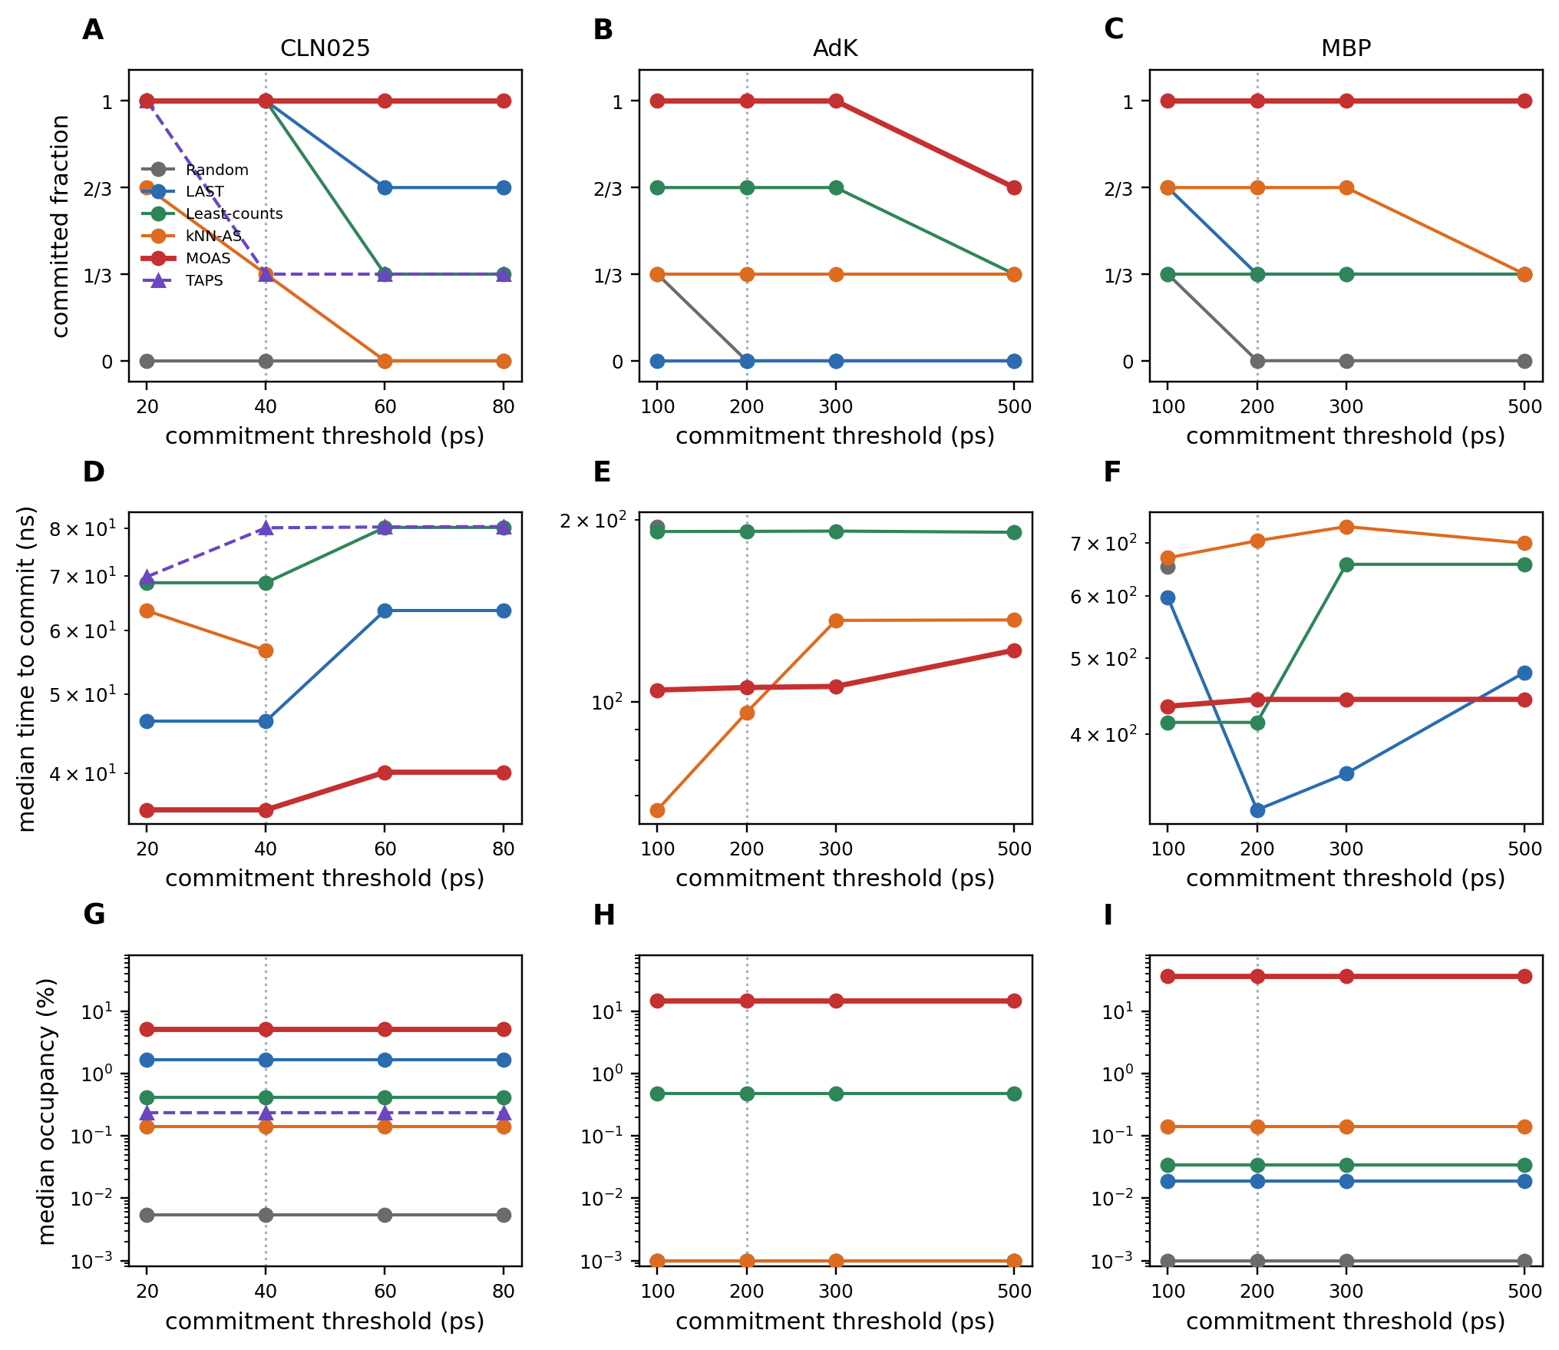
Figure S1. Commitment-threshold robustness from existing trajectories (no new MD). (A–C) Committed fraction versus τ on CLN025, AdK, and MBP (n = 3). (D–F) Median time-to-commit among campaigns that committed (log scale); a method is omitted at a threshold where no replicate committed. (G–I) Median target-basin occupancy, which is independent of τ by construction (values ≤ 0.001% are plotted at 0.001%). The dotted vertical line is the production threshold (40 ps on CLN025; 200 ps on AdK and MBP). TAPS is shown only for CLN025.
System | Method | τ₁ | τ₂ | τ₃ | τ₄ | Occupancy (%)
CLN025 | Random | 0/3 | 0/3 | 0/3 | 0/3 | 0.01
CLN025 | LAST | 3/3 (46.4) | 3/3 (46.4) | 2/3 (63.4) | 2/3 (63.4) | 1.66
CLN025 | Least-counts | 3/3 (68.6) | 3/3 (68.6) | 1/3 (80.3) | 1/3 (80.3) | 0.42
CLN025 | kNN-AS | 2/3 (63.4) | 1/3 (56.6) | 0/3 | 0/3 | 0.14
CLN025 | MOAS | 3/3 (36.1) | 3/3 (36.1) | 3/3 (40.1) | 3/3 (40.1) | 5.25
CLN025 | TAPS | 3/3 (69.8) | 1/3 (80.2) | 1/3 (80.4) | 1/3 (80.5) | 0.24
AdK | Random | 1/3 (195.0) | 0/3 | 0/3 | 0/3 | 0.00
AdK | LAST | 0/3 | 0/3 | 0/3 | 0/3 | 0.00
AdK | Least-counts | 2/3 (191.3) | 2/3 (191.4) | 2/3 (191.6) | 1/3 (190.8) | 0.48
AdK | kNN-AS | 1/3 (66.3) | 1/3 (96.1) | 1/3 (136.4) | 1/3 (136.7) | 0.00
AdK | MOAS | 3/3 (104.6) | 3/3 (105.7) | 3/3 (106.1) | 2/3 (121.8) | 14.85
MBP | Random | 1/3 (653.4) | 0/3 | 0/3 | 0/3 | 0.00
MBP | LAST | 2/3 (597.2) | 1/3 (320.4) | 1/3 (356.4) | 1/3 (479.4) | 0.02
MBP | Least-counts | 1/3 (414.0) | 1/3 (414.0) | 1/3 (657.8) | 1/3 (657.8) | 0.03
MBP | kNN-AS | 2/3 (670.4) | 2/3 (704.7) | 2/3 (734.8) | 1/3 (699.9) | 0.14
MBP | MOAS | 3/3 (434.1) | 3/3 (442.8) | 3/3 (442.8) | 3/3 (442.9) | 37.15

Table S6. Commitment versus sojourn threshold. Each cell is committed replicates / 3 (median time-to-commit in ns among campaigns that committed). τ₁–τ₄ are 20, 40, 60, and 80 ps for CLN025 and 100, 200, 300, and 500 ps for AdK and MBP. Production thresholds are τ₂. Occupancy is independent of τ.

S10. Residence times and neighboring windows
Occupancy f_W is the fraction of frames inside the production target window. A reviewer may ask whether that window, or the commitment threshold τ, manufactures the result. This section reuses the same cvs.npz trajectories with no additional MD. Each contiguous sojourn inside the production W is a residence time T, scored with the production duration definition (CLN025: t_end − t_start + Δt; AdK/MBP: n_frames × 2 ps). Figure S2A–C shows the empirical survival P(T ≥ t), averaged over the three campaigns (a campaign with no visit contributes 0, so each replicate has equal weight). Figure S2D–F shows the longest sojourn of each campaign; the dotted line is the production τ. A committed visit is the event that this longest sojourn is ≥ τ, so commitment is one horizontal cut through D–F rather than a separate endpoint. Typical sojourns are short for every method (median 2–20 ps). What differs is the tail: the median longest sojourn is 342 ps (MOAS), 152 ps (LAST), and 2 ps (Random) on CLN025; 1.82 ns, 0.33 ns, and 0 on AdK; 36.5 ns, 0.12 ns, and 0 on MBP (Table S7; main-text Table 3).
Figure S2G–I recomputes occupancy under neighboring definitions of W. CLN025 uses RMSD cutoffs 0.15, 0.20, 0.25 (production), 0.30, and 0.40 nm. AdK expands or shrinks the closed LID/NMP rectangle by Δ = −8, −4, 0, +4, +8 degrees. MBP uses paired shifts of the domain-distance and hinge-angle thresholds (−0.06 nm/−6°, −0.03 nm/−3°, production, +0.03 nm/+3°, +0.06 nm/+6°), labeled −2 to +2. MOAS remains the highest occupancy at the production window and at every looser or moderately tighter cutoff that is still populated. At the tightest CLN025 (0.15 nm) and AdK (−8°) settings the window is empty for all methods.
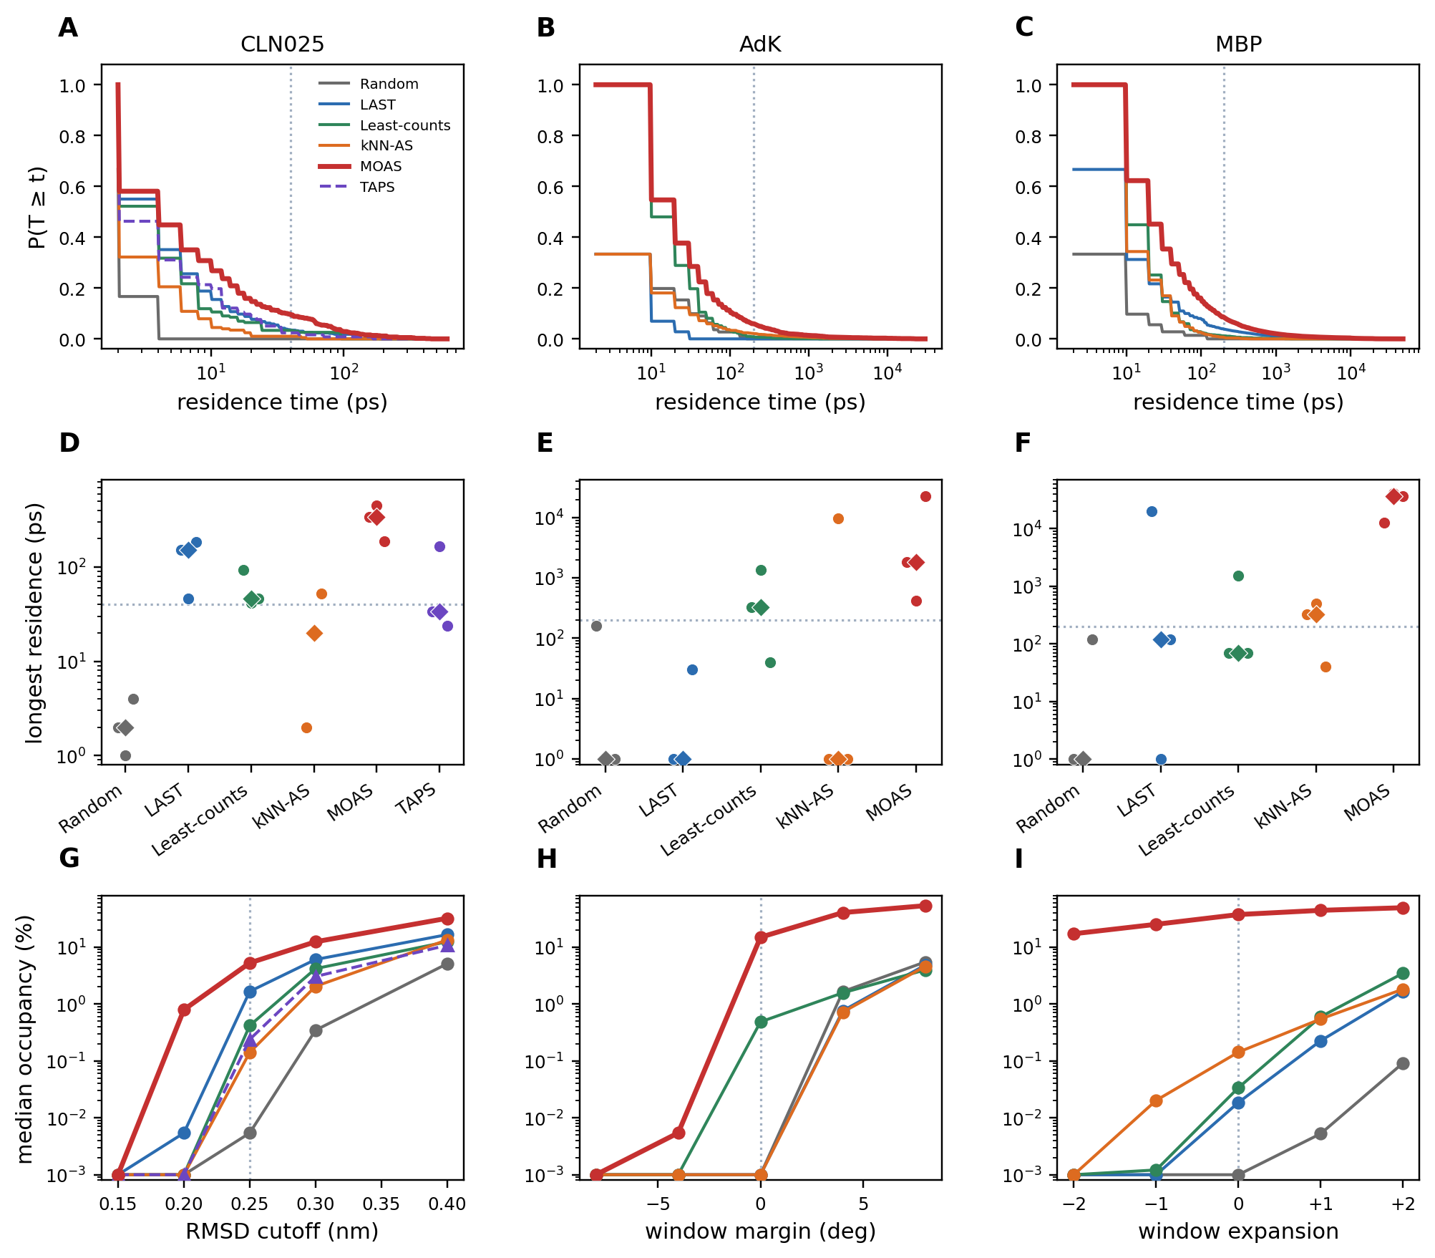
Figure S2. Residence times and neighboring-window occupancy (existing trajectories; no new MD). (A–C) Mean of three campaign-wise empirical survivals P(T ≥ t) of contiguous sojourns in the production window W; campaigns with no visit contribute 0. The dotted vertical line is the production commitment threshold τ. (D–F) Longest sojourn of each replicate (circles) and the median of those three values (diamond); zeros are plotted at 1 ps. The dotted horizontal line is τ. (G–I) Median occupancy under neighboring definitions of W; the dotted vertical line is the production window. TAPS is shown only for CLN025. Values ≤ 0.001% are plotted at 0.001%.
System | Method | Visits | Med. n | Med. T (ps) | Mean T (ps) | Med. max (ps) | P(T≥τ) | Occ. (%)
CLN025 | Random | 4 | 2 | 2.5 | 2.5 | 2.0 | 0.000 | 0.01
CLN025 | LAST | 381 | 167 | 4.0 | 9.6 | 152.0 | 0.036 | 1.66
CLN025 | Least-counts | 205 | 65 | 4.0 | 4.8 | 46.0 | 0.033 | 0.42
CLN025 | kNN-AS | 90 | 24 | 2.0 | 4.3 | 20.0 | 0.010 | 0.14
CLN025 | MOAS | 748 | 266 | 4.0 | 16.1 | 342.0 | 0.097 | 5.25
CLN025 | TAPS | 80 | 25 | 2.0 | 7.0 | 34.0 | 0.024 | 0.24
AdK | Random | 37 | 0 | 20.0 | 34.9 | 0.0 | 0.000 | 0.00
AdK | LAST | 24 | 0 | 10.0 | 12.9 | 0.0 | 0.000 | 0.00
AdK | Least-counts | 588 | 145 | 10.0 | 30.8 | 330.0 | 0.009 | 0.48
AdK | kNN-AS | 681 | 0 | 20.0 | 98.9 | 0.0 | 0.022 | 0.00
AdK | MOAS | 4065 | 917 | 20.0 | 48.0 | 1820.0 | 0.060 | 14.85
MBP | Random | 24 | 0 | 10.0 | 19.6 | 0.0 | 0.000 | 0.00
MBP | LAST | 8886 | 47 | 15.0 | 82.5 | 120.0 | 0.040 | 0.02
MBP | Least-counts | 803 | 106 | 15.0 | 20.8 | 70.0 | 0.012 | 0.03
MBP | kNN-AS | 1854 | 235 | 10.0 | 23.3 | 330.0 | 0.007 | 0.14
MBP | MOAS | 35461 | 13216 | 20.0 | 157.6 | 36470.0 | 0.087 | 37.15

Table S7. Sojourn statistics in the production window W. Visits is the total number of contiguous sojourns across n = 3 campaigns. Med. n is the median number of sojourns per campaign. Med. T and mean T are medians, over campaigns that entered W, of that campaign’s median and mean sojourn. Med. max is the median of the three longest sojourns, including 0 for campaigns that never entered. P(T≥τ) is the mean over campaigns of the fraction of sojourns that meet the production τ (empty campaigns contribute 0). Occ. is production occupancy.
System | Method | w−2 | w−1 | w₀ | w+1 | w+2
CLN025 | Random | 0.00 | 0.00 | 0.01 | 0.35 | 5.08
CLN025 | LAST | 0.00 | 0.01 | 1.66 | 6.03 | 16.48
CLN025 | Least-counts | 0.00 | 0.00 | 0.42 | 4.17 | 12.36
CLN025 | kNN-AS | 0.00 | 0.00 | 0.14 | 2.04 | 13.31
CLN025 | MOAS | 0.00 | 0.79 | 5.25 | 12.35 | 31.92
CLN025 | TAPS | 0.00 | 0.00 | 0.24 | 3.03 | 10.72
AdK | Random | 0.00 | 0.00 | 0.00 | 1.65 | 5.45
AdK | LAST | 0.00 | 0.00 | 0.00 | 0.76 | 4.80
AdK | Least-counts | 0.00 | 0.00 | 0.48 | 1.57 | 3.95
AdK | kNN-AS | 0.00 | 0.00 | 0.00 | 0.72 | 4.56
AdK | MOAS | 0.00 | 0.01 | 14.85 | 40.21 | 53.17
MBP | Random | 0.00 | 0.00 | 0.00 | 0.01 | 0.09
MBP | LAST | 0.00 | 0.00 | 0.02 | 0.23 | 1.66
MBP | Least-counts | 0.00 | 0.00 | 0.03 | 0.60 | 3.46
MBP | kNN-AS | 0.00 | 0.02 | 0.14 | 0.54 | 1.82
MBP | MOAS | 17.09 | 25.03 | 37.15 | 44.05 | 48.97

Table S8. Median occupancy (%) under neighboring definitions of W. Columns w−2…w+2 are RMSD cutoffs 0.15, 0.20, 0.25, 0.30, 0.40 nm for CLN025; LID/NMP margins −8, −4, 0, +4, +8 degrees for AdK; and MBP window expansions −2…+2 as defined in the text. Production windows are w₀.

S11. Campaign tags
CLN025 Random: moas_random, moas_s1_random, moas_s2_random. LAST: discover_last, discover_s1_last, discover_s2_last. Least-counts: discover_lc, discover_s1_lc, discover_s2_lc. kNN-AS: discover_knn, discover_s1_knn, discover_s2_knn. MOAS: moas_static, moas_s1_static, moas_s2_static. TAPS: discover_taps, discover_s1_taps, discover_s2_taps.
AdK seed 0: adk_random, adk_last, adk_lc, adk_knn, adk_static. Seed 1: adk_s1_*. Seed 2: adk_s2_*. Ablation: adk_nov, adk_bnd, adk_tgt, adk_novbnd, adk_novtgt, adk_bndtgt.
MBP analogously mbp_*, mbp_s1_*, mbp_s2_*. Ablation: mbp_nov, mbp_bnd, mbp_tgt, mbp_novbnd, mbp_novtgt, mbp_bndtgt.

