1. 数据通路（见SingleCPU.v）：这个文件里已经介绍了各个模块的作用
2. 结果说明

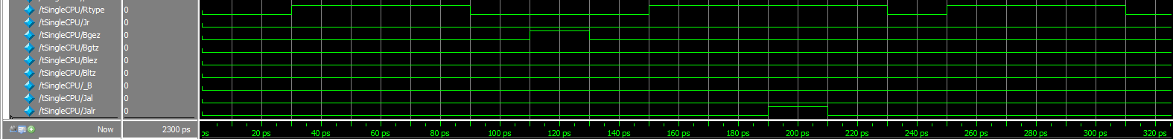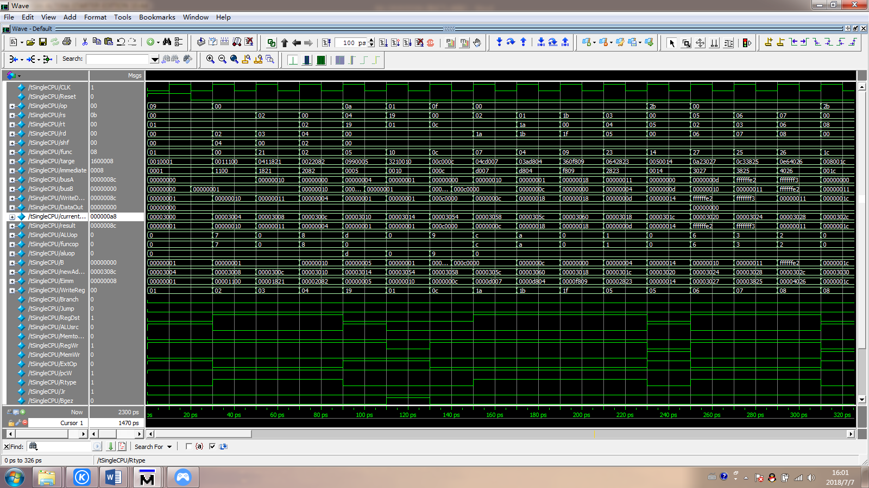

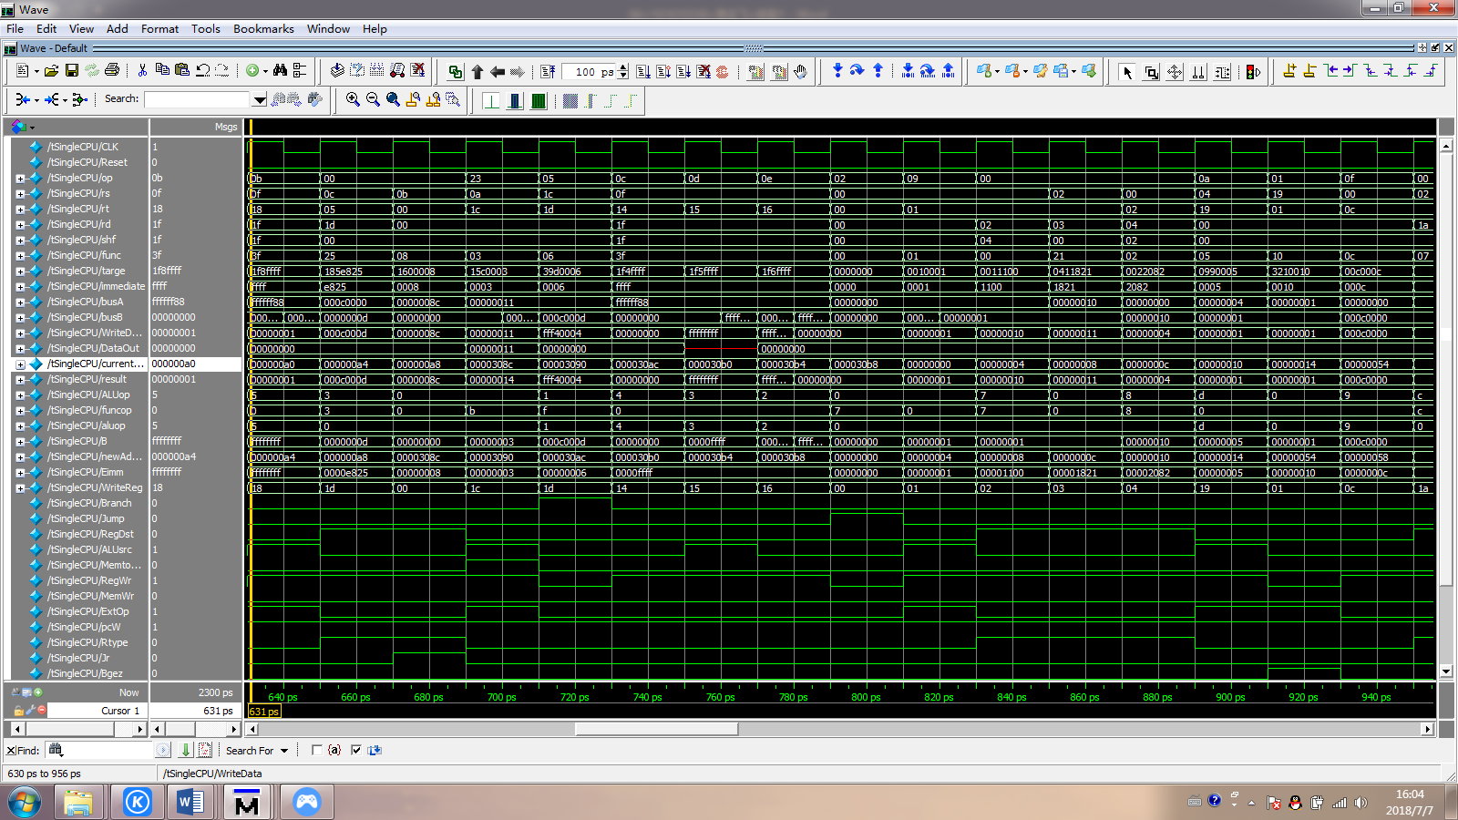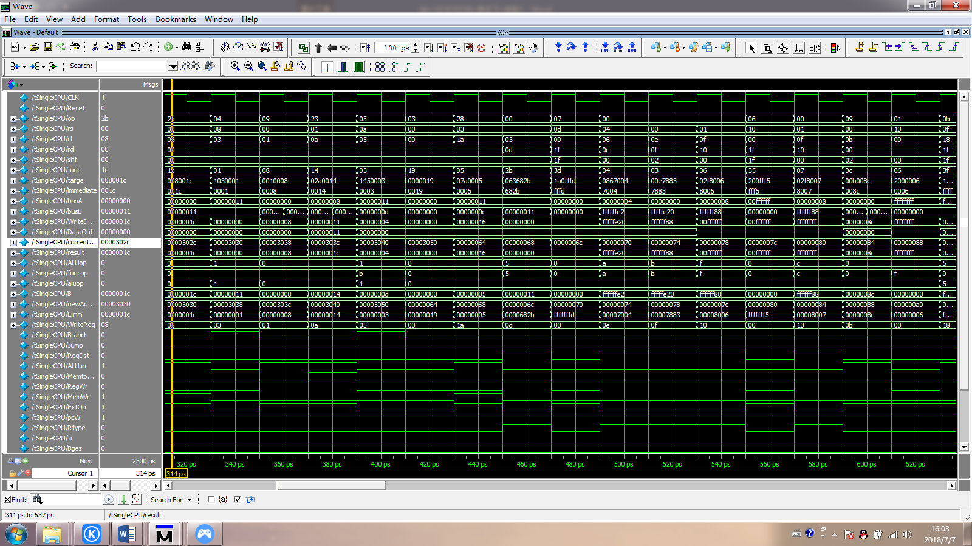

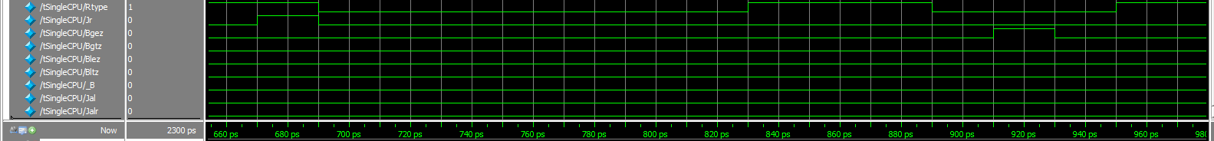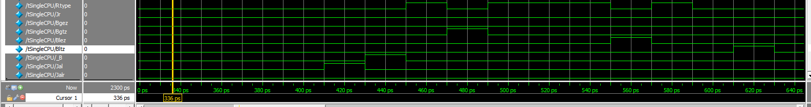

1. 测试代码说明

|  |  |  |  |  |
| --- | --- | --- | --- | --- |
| **指令地址** | **汇编指令** | **结果描述** | **机器指令的机器码** | |
| **16进制** | **二进制** |
| 00H | addiu $1, $0,#1 | [$1] = 0000_0001H | 24010001 | 0010_0100_0000_0001_0000_0000_0000_0001 |
| 04H | sll $2, $1,#4 | [$2] = 0000_0010H | 00011100 | 0000_0000_0000_0001_0001_0001_0000_0000 |
| 08H | addu $3, $2,$1 | [$3] = 0000_0011H | 00411821 | 0000_0000_0100_0001_0001_1000_0010_0001 |
| 0CH | srl $4, $2,#2 | [$4] = 0000_0004H | 00022082 | 0000_0000_0000_0010_0010_0000_1000_0010 |
| 10H | slti $25,$4,#5 | [$25] = 0000_0001H | 28990005 | 0010_1000_1001_1001_0000_0000_0000_0101 |
| 14H | bgez $25,#16 | 跳转到54H | 07210010 | 0000_0111_0010_0001_0000_0000_0001_0000 |
| 18H | subu $5, $3,$4 | [$5] = 0000_000DH | 00642823 | 0000_0000_0110_0100_0010_1000_0010_0011 |
| 1CH | sw $5, #20($0) | Mem[0000_0014H] = 0000_000DH | AC050014 | 1010_1100_0000_0101_0000_0000_0001_0100 |
| 20H | nor $6, $5,$2 | [$6] = FFFF_FFE2H | 00A23027 | 0000_0000_1010_0010_0011_0000_0010_0111 |
| 24H | or $7, $6,$3 | [$7] = FFFF_FFF3H | 00C33825 | 0000_0000_1100_0011_0011_1000_0010_0101 |
| 28H | xor $8, $7,$6 | [$8] = 0000_0011H | 00E64026 | 0000_0000_1110_0110_0100_0000_0010_0110 |
| 2CH | sw $8, #28($0) | Mem[0000_001CH] = 0000_0011H | AC08001C | 1010_1100_0000_1000_0000_0000_0001_1100 |
| 30H | beq $8, $3,#2 | 跳转到38H | 11030002 | 0001_0001_0000_0011_0000_0000_0000_0010 |
| 34H | slt $9, $6,$7 | 不执行 | 00C7482A | 0000_0000_1100_0111_0100_1000_0010_1010 |
| 38H | addiu $1, $0,#8 | [$1] = 0000_0008H | 24010008 | 0010_0100_0000_0001_0000_0000_0000_1000 |
| 3CH | lw $10,#20($1) | [$10] = 0000_0011H | 8C2A0014 | 1000_1100_0010_1010_0000_0000_0001_0100 |
| 40H | bne $10,$5,#4 | 跳转到50H | 15450004 | 0001_0101_0100_0101_0000_0000_0000_0100 |
| 44H | and $11,$2,$1 | 不执行 | 00415824 | 0000_0000_0100_0001_0101_1000_0010_0100 |
| 48H | sw $11,#28($1) | 不执行 | AC2B001C | 1010_1100_0010_1011_0000_0000_0001_1100 |
| 4CH | sw $4, #16($1) | 不执行 | AC240010 | 1010_1100_0010_0100_0000_0000_0001_0000 |
| 50H | jal #25 | 跳转到64H,  [$31] = 0000_0054H | 0C000019 | 0000_1100_0000_0000_0000_0000_0001_1001 |
| 54H | lui $12,#12 | [$12] = 000C_0000H | 3C0C000C | 0011_1100_0000_1100_0000_0000_0000_1100 |
| 58H | srav $26,$12,$2 | [$26] = 0000_000CH | 004CD007 | 0000_0000_0100_1100_1101_0000_0000_0111 |
| 5CH | sllv $27,$26,$1 | [$27] = 0000_0018H | 003AD804 | 0000_0000_0011_1010_1101_1000_0000_0100 |
| 60H | jalr $27 | 跳转到18H ,  [$31] = 0000_0064H | 0360F809 | 0000_0011_0110_0000_1111_1000_0000_1001 |
| 64H | sb $26,#5($3) | MEM[0000_0016H] = 000C_000DH | A07A0005 | 1010_0000_0111_1010_0000_0000_0000_0101 |
| 68H | sltu $13,$3,$3 | [$13] = 0000_0000H | 0063682B | 0000_0000_0110_0011_0110_1000_0010_1011 |
| 6CH | bgtz $13,#3 | 不跳转 | 1DA00003 | 0001_1101_1010_0000_0000_0000_0000_0011 |
| 70H | sllv $14,$6,$4 | [$14] =FFFF_FE20H | 00867004 | 0000_0000_1000_0110_0111_0000_0000_0100 |
| 74H | sra $15,$14,#2 | [$15] =FFFF_FF88H | 000E7883 | 0000_0000_0000_1110_0111_1000_1000_0011 |
| 78H | srlv $16,$15,$1 | [$16] =00FF_FFFFH | 002F8006 | 0000_0000_0010_1111_1000_0000_0000_0110 |
| 7CH | blez $16,#8 | 不跳转 | 1A000008 | 0001_1010_0000_0000_0000_0000_0000_1000 |
| 80H | srav $16,$15,$1 | [$16] =FFFF_FFFFH | 002F8007 | 0000_0000_0010_1111_1000_0000_0000_0111 |
|  |  |  |  |  |
| 84H | addiu $11,$0,#140 | [$11] = 0000_008CH | 240B008C | 0010_0100_0000_1011_0000_0000_1000_1100 |
| 88H | bltz $16, #6 | 跳转到A0H | 06000006 | 0000_0110_0000_0000_0000_0000_0000_0110 |
| 8CH | lw $28,#3($10) | [$28] = 000C_000DH /000C_880DH | 8D5C0003 | 1000_1101_0101_1100_0000_0000_0000_0011 |
| 90H | bne $28,$29,#7 | 不跳转/跳转ACH | 179D0007 | 0001_0111_1001_1101_0000_0000_0000_0111 |
| 94H | sb $15,#8($5) | Mem[0000_0015H] = 0000_0088H | A0AF0008 | 1010_0000_1010_1111_0000_0000_0000_1000 |
| 98H | lb $18,#8($5) | [$18] =FFFF_FF88H | 80B20008 | 1000_0000_1011_0010_0000_0000_0000_1000 |
| 9CH | lbu $19,#8($5) | [$19] = 0000_0088H | 90B30008 | 1001_0000_1011_0011_0000_0000_0000_1000 |
| A0H | sltiu $24,$15,#0xFFFF | [$24] = 0000_0001H | 2DF8FFFF | 0010_1101_1111_1000_1111_1111_1111_1111 |
| A4H | or $29,$12,$5 | [$29] = 000C000DH | 0185E825 | 0000_0001_1000_0101_1110_1000_0010_0101 |
| A8H | jr $11 | 跳转指令8CH | 01600008 | 0000_0001_0110_0000_0000_0000_0000_1000 |
| ACH | andi $20,$15,#0xFFFF | [$20] = 0000_FF88H | 31F4FFFF | 0011_0001_1111_0100_1111_1111_1111_1111 |
| B0H | ori $21,$15,#0xFFFF | [$21] =FFFF_FFFFH | 35F5FFFF | 0011_0101_1111_0101_1111_1111_1111_1111 |
| B4H | xori $22,$15,#0xFFFF | [$22] = FFFF_0077H | 39F6FFFF | 0011_1001_1111_0110_1111_1111_1111_1111 |
| B8H | j #00H | 跳转指令00H | 08000000 | 0000_1000_0000_0000_0000_0000_0000_0000 |