Heavy-Traffic Analysis of QoE Optimality for On-Demand Video Streams Over Fading Channels

|  |  |
| --- | --- |
| Ping-Chun Hsieh  CESG and Department of ECE  Texas A&M University  College Station, TX 77843, USA lleyfede@tamu.edu | I-Hong Hou  CESG and Department of ECE  Texas A&M University  College Station, TX 77843, USA ihou@tamu.edu |

*Abstract*—This paper proposes online scheduling policies to optimize quality of experience (QoE) for video-on-demand applications in wireless networks. We consider wireless systems where an access point (AP) transmits video content to clients over fading channels. The QoE of each flow is measured by its duration of video playback interruption. We are specifically interested in systems operating in the heavy-traffic regime. We first consider a special case of ON-OFF channels and establish a scheduling policy that achieves every point in the capacity region under heavy-traffic conditions. This policy is then extended for more general fading channels, and we prove that it remains optimal under some mild conditions. We then formulate a network utility maximization problem based on the QoE of each flow. We demonstrate that our policies achieve the optimal overall utility when their parameters are chosen properly. Finally, we compare our policies against three popular policies. Simulation results validate that the proposed policy indeed outperforms existing policies.

# I. INTRODUCTION

In recent years, video streaming applications have been demanding more and more resource in wireless networks. According to the latest report from Cisco [1], video-centric services are projected to increase 13-fold and occupy nearly three-fourths of global mobile data traffic in the near future. However, upgrade of wireless network capacity can hardly catch up with the explosive mobile data traffic. Therefore, better scheduling algorithms are required for service providers to serve more customers without sacrificing user satisfaction.

From the perspective of service providers, scheduling policies are conventionally designed to meet the performance requirement of a general wireless network, such as average throughput, latency, delay jitter, etc. However, these statistics fail to directly characterize real user experience in enjoying video service. Hence, various research works have been carried out to study quality of experience (QoE) in video streaming applications. Much effort has been dedicated to quantifying subjective user experience and constructing analytical models based on different experiment setups, such as [2], [3]. In general, QoE can be affected by several factors, such as playback smoothness, mean video quality, temporal variation in quality, etc. Among these elements, playback interruption has been shown to be the dominant factor of QoE performance [3]. Therefore, we define QoE by the duration of video interruption during playback process for wireless on-demand video streams. Playback interruption has been studied extensively in recent literature. In [4], the probability of interruption-free video playback is analyzed for variable bit-rate video over wireless channels with variable data rate. By modelling a playback buffer as a M/D/1 queue, [5] provides a bound on interruption probability for media streams over Markovian channels. Likewise, Xu *et al.* [6] and Anttonen *et al.* [7] provide explicit results of the distribution of video interruption based on different queueing models. Similarly, [8] presents an online algorithm to adaptively control playback buffer underflow and overflow based on large deviation theory. Moreover, [9] characterizes the dynamics of playback buffer by applying diffusion approximation. The common focus of these works is to provide an indicator to make the best tradeoff between initial prefetching delay and playback buffer emptiness. However, these results only work for a single video stream and thus can hardly be applied to a wireless network.

Regarding scheduling for multiple video streams, [10] provides a flow-level analytical framework to study the effect of flow dynamics on playback interruption and average throughput. [11] proposes an online algorithm based on ProportionalFair scheduling to achieve fairness among video users while maintaining required throughput. In [12], a modified version of Proportional-Fair scheduling has been presented to reduce video inter-frame delay for wireless LTE networks. To offer better average rate guarantees, Bhatia *et al.* [13] design a scheduling policy which exploits slow-fading variation of wireless channels. In a multi-cast wireless network, [14] proves by dynamic programming that a Max-Weight like policy is throughput optimal. In [15], Joseph and de Veciana consider a

more comprehensive QoE metric and propose the NOVA algorithm to asymptotically optimize QoE for a wireless network. One common feature of the above policies is that they claim to optimize QoE in the sense of long-term average performance, either for throughput or video delays. Moreover, [16] considers the short-term QoE performance by studying the diffusion limit. However, it only considers wireless networks where the channel qualities are static.

In this paper, we propose online scheduling policies to optimize QoE for wireless on-demand video streaming. Different from the prior efforts of [10], [11], [12], [13], [14], [15], this paper considers not only the long-term average performance but also short-term QoE performance. Instead of assuming static channel qualities as in [16], we study the dynamic behavior of playback process over time-varying channels. We are particularly interested in QoE performance under heavy-traffic conditions. Starting from a special case of ONOFF channels, we first study the stability region and provide a polynomial-time algorithm for checking the stabilizability when channels are independent. Next, by studying diffusion limits, we are able to characterize the capacity region for QoE and propose an online scheduling policy that achieves every interior point in the capacity region. The policy and the heavy-traffic analysis are then generalized for general fading channels. The proposed policy is proved to remain optimal under some mild assumptions. Moreover, we formulate a network utility maximization problem based on the QoE of each client. We also show that our policy can achieve the optimal network utility by selecting proper parameters. Lastly, we compare the proposed policies against three popular policies and show by simulation that our policy surpasses other three policies by a large margin, despite that the longterm average duration of video interruption approaches zero asymptotically for all these policies. We thereby demonstrate the essential difference between QoE and the conventional QoS metrics for wireless networks.

The rest of the paper is organized as follows. Section II describes the network model for analyzing QoE of on-demand video streams. Section III discusses the stability region and an algorithm for checking stabilizability for ON-OFF channels. In Section IV, we present an online scheduling policy for ONOFF channels and prove that it is optimal in heavy traffic.

We then extend the policy for fading channels in Section V. In Section VI, we formulate a network utility maximization problem based on QoE. Simulation results of the proposed policies as well as the counterparts are shown in Section VII. Finally, Section VIII concludes the paper.

# II. SYSTEM MODEL

We consider a time-slotted wireless network consisting of a wireless access point (AP) and a group of *N* mobile clients denoted by *Stot* = {1*,*2*,...,N*}. Each client is downloading an on-demand video which has been pre-stored by video service providers. The video content is partitioned into packets and streamed to clients via the AP and the wireless links. On the AP’s side, we assume that the AP always has packets at hand for transmission to each video client. In other words, the throughput for the AP to acquire video content from video providers is assumed to be much larger than that between the AP and the mobile clients. We also assume that there is no network coding mechanism involved in the system. Thus, in each time slot, the AP can transmit data to at most one client.

In a wireless network, the quality of a wireless channel usually changes with time. To capture the variation of wireless channels, we model the wireless link of each client *n* as a discrete-time random process *rn*(*t*) which takes only nonnegative integer values in a finite *data rate space* denoted by R. If the AP schedules a transmission for client *n* at time *t*, it can deliver exactly *rn*(*t*) bits. For example, the IEEE 802.11a standard has a maximum physical data rate of 54 Mbit/s, and the data rate can also be adaptively reduced by applying different modulation and coding, depending on channel conditions. In this model, we make no assumption about the relationship between different wireless links. Therefore, unless stated otherwise, the channels of different clients are *not* required to be independent.

On the mobile clients’ side, the received packets are first decoded and queued in a playback buffer, whose size is assumed to be infinite. For each client *n*, let *An*(*t*) denote the total amount of received video content in bits until time *t*, and *Bn*(*t*) be the amount of video content in bits stored in the playback buffer at time *t*. The client plays one video frame every *kn* slots, and each frame contains bits, which depends on the desired video resolution. When the client is about to play a new video frame from the playback buffer, playback interruption might occur if there is no enough video content in the playback buffer, i.e. . To check this condition, it is equivalent to check if the buffer becomes negative after bits are taken out of the buffer. Let *Dn*(*t*) be the total number of slots in which video is interrupted by time *t*. Then, *Dn*(*t*) can be updated recursively by

*Dn*(*t*)

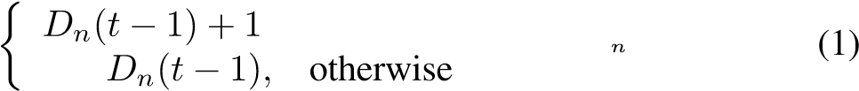*,*

=

From (1), we know that in each slot, *Dn*(*t*) either stays unchanged or increases by 1. Let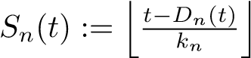, which is the total number of frames that the client plays by time *t*. Then, the buffer length is given by

*,* (2)

where we assume that *Bn*(0) = 0 for every client. If we define

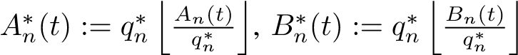 and *qn* := *qn*∗*/kn*,

then (2) can be rearranged as

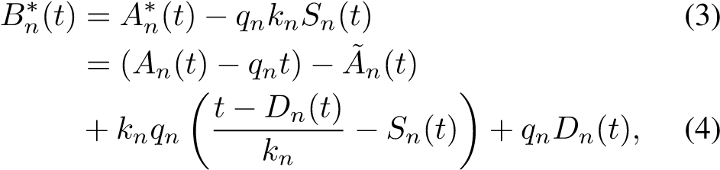

where is non-negative and bounded above by . Here,  and  can be viewed as a quantized version of *An*(*t*) and *Bn*(*t*) for ease of later manipulation, and *qn* is the average number of bits per time slot needed for the video. We further define that

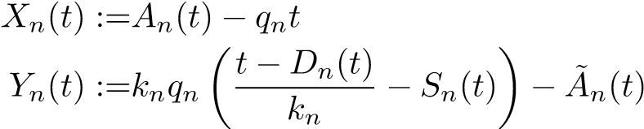(5)

*.* (6)

Since  and , therefore

*Yn*(*t*) is bounded by

 (7)

In each slot, *Dn*(*t*) either stays unchanged or increases by 1. Besides, *Dn*(*t*) increases only when there is no enough data in the buffer upon playing a new frame, i.e. .

Based on the manipulation in (3)–(4), *Bn*∗(*t*) = 0 if and only if. Therefore, we know that *Dn*(*t* + 1) − *Dn*(*t*) equals 1 only when *Bn*∗(*t*) = 0. Now, we can summarize the basic properties as follows.

*Bn*∗(*t*) = *Xn*(*t*) + *Yn*(*t*) + *qnDn*(*t*) ≥ 0*,* (8)

[*Dn*(*t* + 1) − *Dn*(*t*)] ∈ {0*,*1}*, Dn*(0) = 0*,* (9)

*Bn*∗(*t*)[*Dn*(*t* + 1) − *Dn*(*t*)] = 0*.* (10)

In this paper, QoE of each video stream is measured by its total duration of playback interruption. One usual way to assess QoE of a wireless network is through long-term average performance which is formally defined as follows.

*Definition 1:* A video streaming system is said to be *stabilizable* if there exists a scheduling policy *η* such that limsup*t*→∞ *Dnt*(*t*) = 0 for all *n*, almost surely. Moreover, *η* is a *stabilizing* scheduling policy for QoE. *2*

In other words, a wireless video-streaming system is stabilizable if the total duration of video interruption grows sublinearly after some finite time. It can be easily shown that  if and only if the long-term average throughput of each client is at least *qn* [16]. If , then *Xn*(*t*) will go to negative infinity as *t* → ∞, almost surely. By (8), since  is always nonnegative,  implies that *Dn*(*t*) goes to infinity as *t* → ∞, almost surely. Therefore, studying whether a system is stabilizable is equivalent to studying the capacity region of achievable throughput. However, this definition fails to characterize the behavior of the system in the heavy-traffic regime. To fully characterize the growth of playback interruption with time, we study the dynamic behavior by using *diffusion limits* in the following parts of the paper. Moreover, in Section V, we will compare the proposed policy with other popular scheduling policies that are all stabilizing for QoE but are rather different in shortterm performance.

To study the behavior of video interruption in the heavytraffic regime, we consider the diffusion limit of *Dn*(*t*), which is defined as

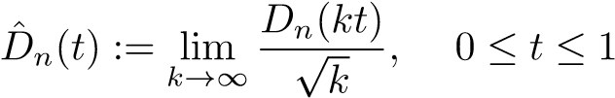 (11)

Similarly, we define

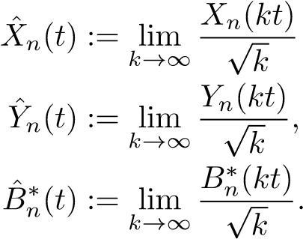 *,* (12)

(13)

(14)

In fact, since *Yn*(*t*) is bounded, *Y*ˆ*n*(*t*) = 0 for all *t*. Given the properties in (5)–(10), we then have the following theorem.

*Theorem 1:* Given *X*ˆ*n*(*t*), there exists a unique pair of

 that satisfies

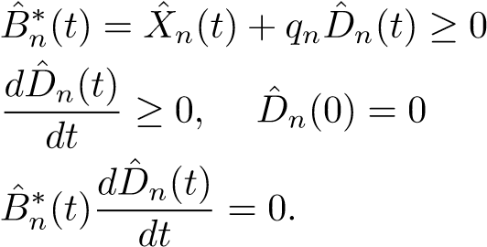(15)

(16)

(17)

Moreover, *D*ˆ*n*(*t*) can be expressed as

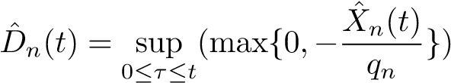 (18)

*Proof:* This is a direct result of Theorem 1 in [16].

Based on Theorem 1, we first characterize *X*ˆ*n*(*t*) and then derive *D*ˆ*n*(*t*) according to (18) in the following sections. Different from [16], this paper studies QoE of video streams over time-varying channels.

In order to distinguish the analysis on and that on *D*ˆ*n*(*t*), we use *stability region* to denote the set of stabilizable systems, and *capacity region* to denote the set of achievable vectors of *D*ˆ*n*(*t*). A more formal definition of capacity region is introduced in Section IV.

# III. STABILITY REGION FOR ON-OFF CHANNELS

We first consider a special case of ON-OFF channels, where transmission rate of each client can only be either zero or a positive value *r*∗, and therefore R = {0*,r*∗}.

The stability region for ON-OFF channels has been shown to be associated with a set of necessary and sufficient conditions [17], [18]. We summarize the results as follows.

*Lemma 1:* [17, Theorem 1] Let *Wn* be the event that client *n* has an ON channel, i.e., *rn*(*t*) = *r*∗. A video streaming system with ON-OFF channels is *stabilizable* if and only if the video playback rates {*qn*} satisfy the following equations:

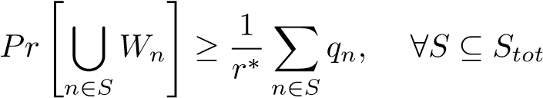 (19)

*2*

The above condition requires checking (19) for all subsets, which can be intractable. However, for the special case where the channel conditions of different clients are independent, we can derive a polynomial-time algorithm to check whether a system is stabilizable. The algorithm is described in the following theorem.

*Theorem 2:* Let *pn* be the probability that client *n* has an ON channel, and *pn >* 0, ∀*n*. Suppose that the clients are sorted based on in descending order, i.e.

. Denote by *Sk* the subset {1*,...,k*} of all clients. Then, the system is stabilizable if and only if

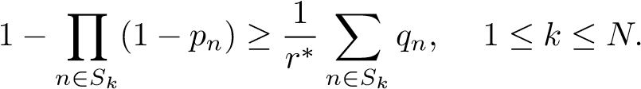 (20)

Moreover, the complexity of checking this condition is *O*(*N* log*N*).

*Proof:* By Lemma 1, we can write down the necessary and sufficient conditions for independent ON-OFF channels as

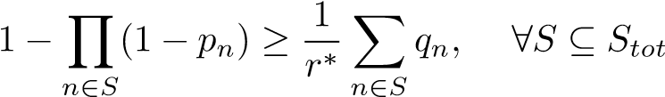*.* (21)

In terms of necessary conditions, (21) certainly implies (20). Now, we prove the sufficient part by contradiction. Suppose that the whole system is not stabilizable. Therefore, there exists at least one smallest unstabilizable subset, say *S*∗. Let *m* be the largest element in *S*∗. If *Sm* = *S*∗, then the proof is complete. Otherwise, suppose that *u* is the largest element in *Sm* \ *S*∗ and *u < m*. Also, we define *S*∗∗ := *S*∗ ∪ {*u*}. First, we want to show that

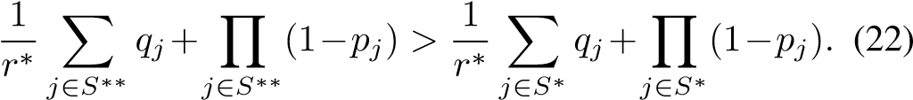

By subtracting the right-hand side of (22) from the left-hand side of (22), we just need to prove that

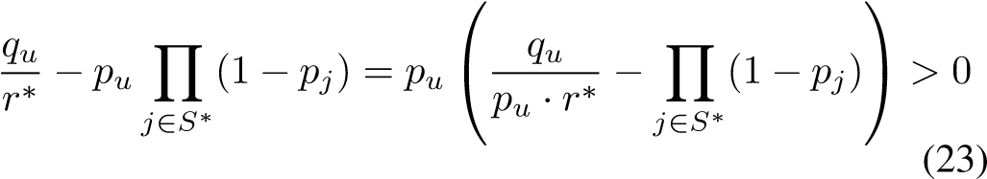

Since *S*∗ is a smallest unstabilizable set, we have

 (24)

By choosing *S*˜ = *S*∗ \ {*m*} in (24), *S*˜ should be stabilizable and hence we have

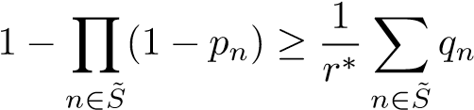*.* (25)

From (24) and (25), we have

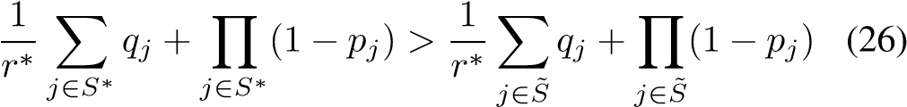

or equivalently,. Since *u < m*, we can obtain that

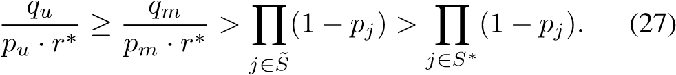

Hence, both (22) and (23) hold. If *Sm* = *S*∗∗, the proof is complete. Otherwise, we continue by finding the largest element in *Sm* \ *S*∗∗ and repeat the same procedure shown in (22)–(27). By induction, finally we have

*r r* ∗

*j*∈*Sm j*∈*Sm j*∈*S j*∈*S*∗

which contradicts the condition given by (20). Since the time complexity of this algorithm is dominated by the pre-sorting of , the overall complexity is *O*(*N* log*N*).

IV. HEAVY-TRAFFIC ANALYSIS FOR ON-OFF CHANNELS

We are particularly interested in the situation where the set of video playback rates {*qn*} is on the boundary of the stability region, that is, under the *heavy-traffic* condition. Recall that *Wn* denotes the event that client *n* has ON channel. In this section, we assume that,

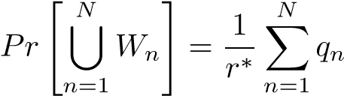*,* (28)

while for any subset *S* ⊂ {1*,...,N*},

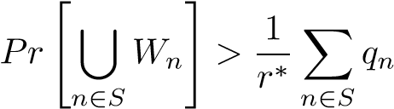*.* (29)

The constraint (29) corresponds to the *complete resource pooling* condition in [19].

*A. A Lower-Bound of Capacity Region for QoE*

We derive fundamental properties of *Dn*(*t*) with ON-OFF channels under the heavy-traffic conditions. Let us define a random process

*N N*

*X*(*t*) := X *Xn*(*t*) = X(*An*(*t*) − *qnt*)*.* (30)

*n*=1 *n*=1

Let ∆*X*(*t* + 1) := *X*(*t* + 1) − *X*(*t*) be the amount of change in *X*(*t*), for all *t* ≥ 0. Regardless of the scheduling policy, the AP can deliver exactly *r*∗ bits to some client *n* if at least one client in *Stot* has an ON channel. Let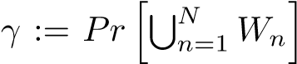.

No matter which client is scheduled at time *t* + 1, we have

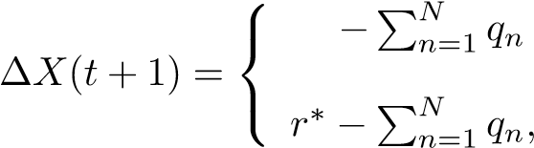 *,* with probability 1 − *γ*

with probability *γ*

(31)

The equations in (31) hold regardless of time and thus ∆*X*(*t*) is i.i.d. across all time slots. Due to the heavy-traffic assumption given by (28), we further have

*N N*

*E*[∆*X*(*t*)] = *γ*(*r*∗ − X *qn*) + (1 − *γ*)(− X *qn*) = 0

*n*=1 *n*=1

Var[∆*X*(*t*)] = *γ*(*r*∗ − *r*∗*γ*)2 + (1 − *γ*)(*r*∗*γ*)2 = (*r*∗)2*γ*(1 − *γ*)*.*

By the *functional central limit theorem* for i.i.d. random variables [20], we have the following important properties regarding the diffusion limit of *X*(*t*).

*Theorem 3:* Let 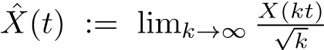. Then *X*ˆ(*t*) is a driftless Brownian motion with variance *σx*2, where *σx* =

*r*∗p(*γ*(1 − *γ*)). Moreover, given *X*ˆ(*τ*), for any *τ,t* ≥ 0 with

is a Gaussian random variable

with zero mean and variance *σx*2*t*. *2*

Similar to (18), we define

*D*ˆ(*t*) := sup (max{0*,*−*X*ˆ(*τ*)}) (32)

0≤*τ*≤*t*

Since *X*ˆ(*t*) is a Brownian motion, we can thereby derive the distribution and important statistics of *D*ˆ(*t*) based on the following lemma.

*Lemma 2:* [21, Section 1.6] Let Φ(*x*) be the cumulative distribution function (CDF) of a standard Gaussian random variable with zero mean and unit variance. The CDF of *D*ˆ(*t*) is given by

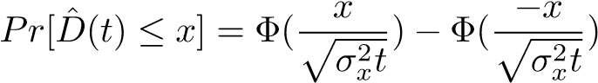

for all *x* ≥ 0, *t* ≥ 0. The expected value of *D*ˆ(*t*) is given by

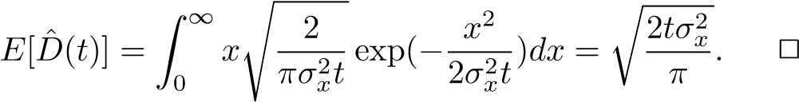

Given the characteristics of *D*ˆ(*t*), we obtain a lower bound for dynamics of video interruption seen by the clients. We first introduce the concept of stochastic ordering as follows [20].

*Definition 2:* Let *D*ˆ*η*1(*t*) and *D*ˆ*η*2(*t*) be two real-valued random processes under policies *η*1 and *η*2, respectively. We say that *D*ˆ*η*1(*t*) ≤*st D*ˆ*η*2(*t*) if

*Pr*[*D*ˆ*η*1(*t*) ≥ *x*] ≤ *Pr*[*D*ˆ*η*2(*t*) ≥ *x*]*,* (33) for all *x* ∈ R and for any *t* ∈ [0*,*1]. *2*

Now, we can formally define the *capacity region* for QoE in terms of the diffusion limits *D*ˆ(*t*) and *D*ˆ*n*(*t*) as follows.

*Definition 3:* A *N*-tuple vector *λ* = [*λ*1*,λ*2*,...,λN*] is said to be *feasible* if there exists a scheduling policy such that

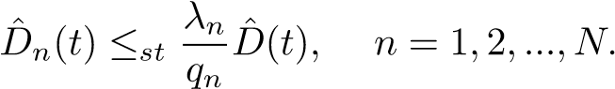 (34)

Then, the *capacity region* for QoE, denoted by Λ, is defined as the set of all feasible vectors *λ*. *2*

By choosing *λ* in the capacity region, we can control the total playback interruption seen by each client. In real applications, *λn* can be determined by a proper pricing scheme given by service providers. To build the relationship between *D*ˆ(*t*) and *D*ˆ*n*(*t*), we make use of *X*ˆ(*t*) and *X*ˆ*n*(*t*):

*D*ˆ(*t*) = sup (max{0*,*−*X*ˆ(*t*)}) (35)

0≤*τ*≤*t*

*N*

= sup (max{0*,*− X *X*ˆ*n*(*τ*)}) (36)

0≤*τ*≤*t n*=1

*N N*

≤*st* X sup (max{0*,*−*X*ˆ*n*(*t*)}) = X *qnD*ˆ*n*(*t*)*.*

0≤*τ*≤*t*

*n*=1 *n*=1

(37)

*Theorem 4:* A feasible vector *λ* = [*λ*1*,λ*2*,...,λN*] with *λn* ≥ 0, for all *n*, must satisfy 

*B. Scheduling Policy for ON-OFF channels*

Now, we introduce a scheduling policy for ON-OFF channels and show that it achieves every point in the interior of the capacity region for QoE.

Joint Channel-Deficit Policy (JCD):

In each time slot, the AP schedules the client *n* with the smallest value of *wnXn*(*t*) among those clients with *rn*(*t*) = *r*∗, where *wn* is a predetermined weight factor. *2*

To prove that JCD policy achieves every point in the interior of the capacity region for QoE, we first establish the *state space collapse* property to characterize the diffusion limit *X*ˆ*n*(*t*) of each individual client.

*Theorem 5:* Let *wn* be the weight for client *n* which is predetermined by the AP. For any pair of clients *n,m* in *Stot*, we have *wnX*ˆ*n*(*t*) = *wmX*ˆ*m*(*t*). Moreover, we can obtain that

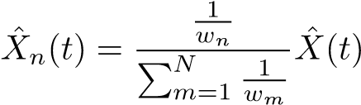*.* (38)

*Proof:* We prove the state space collapse property by introducing a fluid system. First, define

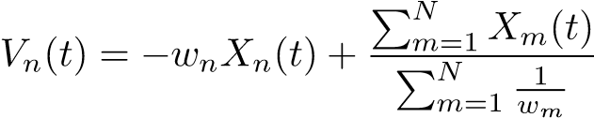*.* (39)

Then, the largest *Vn*(*t*) is associated with the client with the smallest *wnXn*(*t*). By noting that 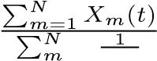 is a weighted average of *wmXm*(*t*), we also have 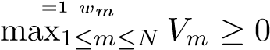 and the equality holds if and only if *wnXn*(*t*) = *wmXm*(*t*), for any pair *n,m* in *Stot*. Next, we consider the *fluid limit* of *Vn*(*t*) defined as

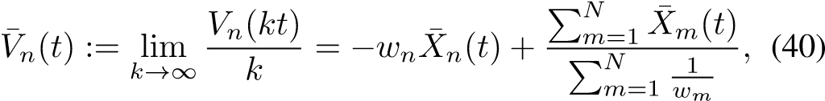

where is the fluid limit for *Xn*(*t*).

Define a Lyapunov function

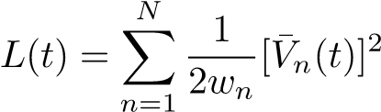*.* (41)

Without loss of generality, we may assume that fluid limits of *Vm*(*t*) are sorted in descending order, i.e. *V*¯1(*t*) ≥ *V*¯2(*t*) ≥ ··· ≥ *V*¯*N*(*t*). Now, we derive the *Lyapunov drift* as

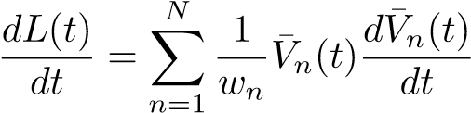 (42)

where

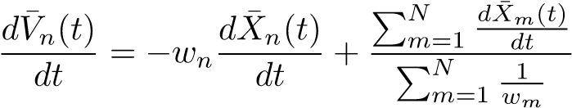*.* (43)

Under JCD policy, client *n* is scheduled when *rn >* 0 and *rm* = 0, for all *m < n*. Let.

Since *Xn*(*t*) = *An*(*t*) − *qnt*, we have

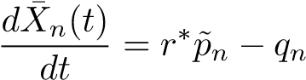*,* (44)

We further define

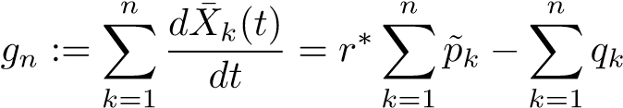 (45)

By using the conditions given by (28) and (29), we have

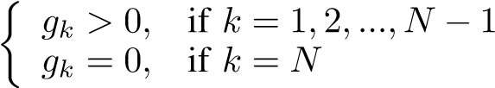 (46)

For convenience, we also let *g*0 = 0. Thus, we can rewrite

. Finally, the Lyapunov drift

in (42) can be computed as

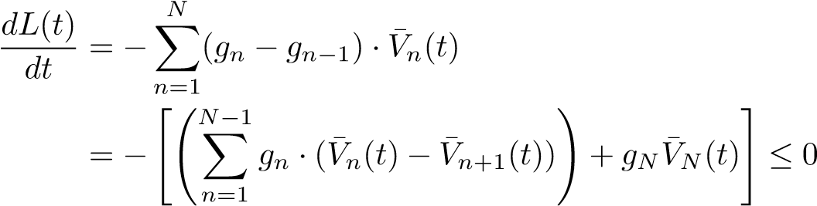

Moreover, the drift is zero only if *V*¯1(*t*) = *V*¯2(*t*) = ··· = *V*¯*N*(*t*) = 0. Therefore, the random process {*Vn*(*t*)} is *positive recurrent*. Thus, we have

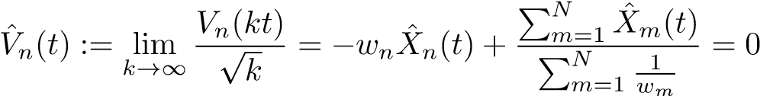*.*

This also implies that *wnX*ˆ*n*(*t*) = *wmX*ˆ*m*(*t*) for any pair of *n,m* and thus completes the proof.

Based on Theorem 5, the JCD policy allows us to achieve every point in the capacity region by choosing proper weight factor {*wn*}. Given any vector *λ* = [*λ*1*,λ*2*,...,λN*] which satisfies *λn >* 0, ∀*n*, and P*Nn*=1 *λn* ≥ 1, we assign for all *n*. By doing this,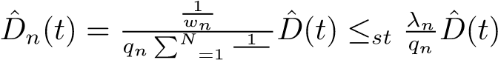,

*m wm* and thus the vector *λ* is feasible. From an engineering point of view, by choosing *wn* for each client, it is possible to differentiate levels of service among all clients. Here, we do not consider the boundary points which have *λn* = 0 for some *n*. In practice, we can get as close as possible to the boundary points by technically assigning extremely large *wn* to our policy. This result also characterizes a sufficient condition for the capacity region.

*Theorem 6:* Given a vector [*λ*1*,λ*2*,...*] with *λn >* 0*,*∀*n*, the vector is feasible if and only if 

# V. HEAVY-TRAFFIC ANALYSIS FOR GENERAL FADING CHANNELS

In this section, we study general fading channels where R can consist of any number of different rates. Unlike the case of ON-OFF channels, the stability region cannot be determined by a simple set of conditions as those in Lemma 1. Instead, we impose the following conditions to simplify the analysis.

Let *R*(*t,S*) := max{*rn*(*t*) : *n* ∈ *S*} and *R*(*t*) be the shorthand for *R*(*t,Stot*). We assume that

*N*

|  |  |  |
| --- | --- | --- |
| and | *E* [*R*(*t*)] = X *qn,*  *n*=1 | (47) |
|  | *E* [*R*(*t*) · I{*R*(*t,S*) = *R*(*t*)}] *>* X *qn,* | (48) |

*n*∈*S*

for all *S* ( *Stot*, where I{·} is an indicator function. It is easy to check these two conditions are sufficient for a system to be stabilizable. Further, it characterizes a portion of the boundary of the stability region, as it is not possible to increase *qn* for any client *n* without making the system unstabilizable. Besides, (48) corresponds to the complete resource pooling condition. We also note that these conditions reduce to (28) and (29) when R = {0*,r*∗}.

*A. A Lower Bound of Capacity Region*

Similar to Section IV, we define  and ∆*X*(*t*) := *X*(*t*)−*X*(*t*−1). Under the heavy-traffic condition given by (47), we have *E*[∆*X*(*t*)] ≤ 0, ∀*t >* 0, regardless of the scheduling policy. To obtain a lower bound of capacity region as in Section IV, we first consider a special class of policies that only schedule clients with the largest *rn*(*t*) at any time *t >* 0. This class of policies still need to determine which client to schedule when there are multiple clients with the same largest *rn*(*t*). Let *X*∗(*t*) be the random process of *X*(*t*) in this special class of policies. Therefore, *X*(*t*) ≤ *X*∗(*t*), ∀*t* ≥ 0, under any scheduling policy. Let ∆*X*∗(*t*+1) := *X*∗(*t*+1)−*X*∗(*t*). Since *R*(*t*) is i.i.d. across all time slots, ∆*X*∗(*t*) is also i.i.d. for all *t >* 0. Moreover,

*N*

*E*[∆*X*∗(*t*)] = *E*[*R*(*t*)] − X *qn* = 0 (49)

*n*=1

2

*N* !

Var[∆*X*∗(*t*)] = Var[*R*(*t*)] = *E*[(*R*(*t*))2] − X *qn* (50)

*n*=1 Then, by the functional central limit theorem for i.i.d. random variables [20], we summarize the fundamental properties of the diffusion limit of *X*∗(*t*) as follows.

*Theorem 7:* Define 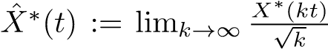 and *σ*2 :=

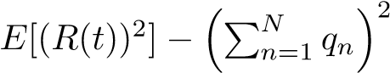. Then, *X*ˆ∗(*t*) is a driftless Brow-

nian motion with variance *σ*2. Furthermore, given *X*ˆ∗(*τ*), for any *τ,t* ≥ 0 with *τ* +*t* ≤ 1, *X*ˆ∗(*τ* +*t*)−*X*ˆ∗(*τ*) is a Gaussian random variable with zero mean and variance *σ*2*t*. *2*

Define *D*ˆ∗(*t*) := sup0≤*τ*≤*t*(max{0*,*−*X*ˆ∗(*τ*)}). Now, we formally define the capacity region for general fading channels.

*Definition 4:* For a system with fading channels, a vector *λ* = [*λ*1*,λ*2*,...,λN*] is said to be *feasible* if there exists a scheduling policy such that

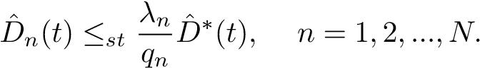 (51)

Then, the *capacity region* for QoE is defined as the set of all feasible vectors *λ*. *2*

Since *X*(*t*) ≤ *X*∗(*t*), ∀*t* ≥ 0, for every sample path, we also have *X*ˆ(*t*) ≤*st X*ˆ∗(*t*), regardless of scheduling policy. Thus, we have *D*ˆ∗(*t*) ≤*st D*ˆ(*t*). By using (35)-(37), we further have . Hence, we obtain a lower bound of capacity region as follows.

*Theorem 8:* For a system with fading channels, a feasible vector *λ* = [*λ*1*,λ*2*,...,λN*] with *λn* ≥ 0, for all *n*, must satisfy P*Nn*=1 *λn* ≥ 1. *2*

*B. Scheduling Policy*

To achieve every point in the interior of capacity region, we consider the following scheduling policy, which is a generalized version of the JCD policy.

Highest Data Rate Policy (HDR):

In each time slot *t*, the AP schedules a client with the largest *rn*(*t*) and break ties by choosing the one with the smallest *wnXn*(*t*), where *wn* is a predetermined weight factor. *2*

Under HDR policy, *X*(*t*) is exactly the same as *X*∗(*t*). Therefore, we have *X*ˆ(*t*) = *X*ˆ∗(*t*) and *D*ˆ(*t*) = *D*ˆ∗(*t*). Now, we show that the HDR policy achieves every interior point in the capacity region under conditions (47) and (48). Similar to Section IV, we first establish the state space collapse property.

*Theorem 9:* Let *wn* be the predetermined weight for client *n*. Under the HDR policy and conditions (47) and (48), we have *wnX*ˆ*n*(*t*) = *wmX*ˆ*m*(*t*), for any pair of clients *n,m*.

*Proof:* We follow the flow of proof in Theorem 5, and the definitions of *Vn*(*t*) and *L*(*t*) are the same as in (39)-(43). Our goal is to show that the random process {*Vn*(*t*)} is positive recurrent for all *n*. We again assume that fluid limits of *Vm*(*t*) are sorted in descending order, i.e. *V*¯1(*t*) ≥ *V*¯2(*t*) ≥ ··· ≥ *V*¯*N*(*t*). Let *Un* be the event that *rn*(*t*) equals *R*(*t*) at some given time *t*. Since *Xn*(*t*) = *An*(*t*) − *qnt*, under the HDR policy we have

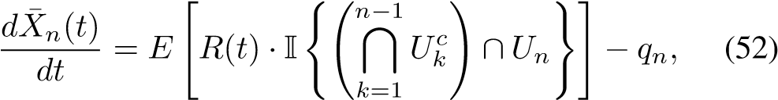

where 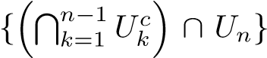 represents the event that client *n* is the only client in {1*,*2*,...,n*} which has the largest transmission rate among all clients. Now, let *r*˜*n* :=

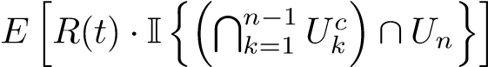. Then, we define *hk* :=

*,* where

 represents the event that at least one client in {1*,*2*,..,k*} has the largest transmission rate among all clients. By using the conditions in (47) and (48), we obtain that

*hk >* 0*,* if *k* = 1*,*2*,...,N* − 1

(53)

*hk* = 0*,* if *k* = *N*

For convenience, we also let *h*0 = 0. Thus, we have

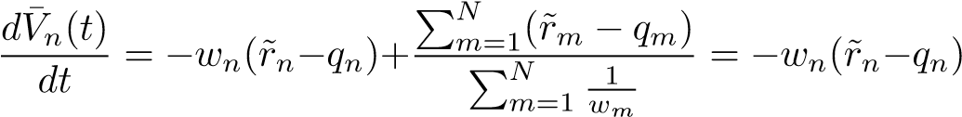*,*

where the last equality holds since and should be zero. Finally, the Lyapunov drift is given by

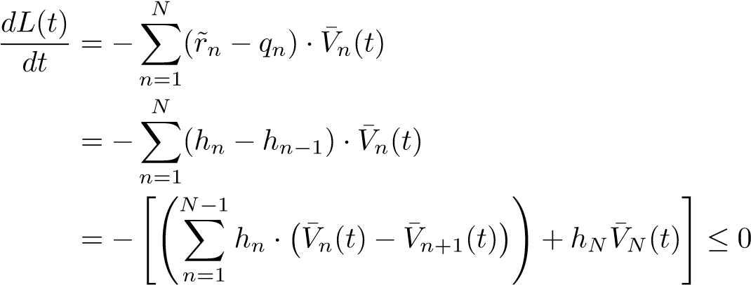

The drift is zero only if *V*¯1(*t*) = *V*¯2(*t*) = ··· = *V*¯*N*(*t*) = 0. Hence, the random process {*Vn*(*t*)} is *positive recurrent*.

Following the same arguments as in Section IV, we know that HDR policy can achieve every point in the interior of capacity region based on Theorem 9. Moreover, we can fully characterize the distribution of *D*ˆ*n*(*t*) for each client. We summarize these results in the following theorem.

*Theorem 10:* Given any vector *λ* = [*λ*1*,λ*2*,...,λN*] which satisfies *λn >* 0, ∀*n*, and , HDR policy can achieve 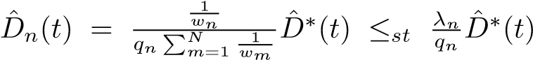 by

assigning for all *n*. Moreover, we have

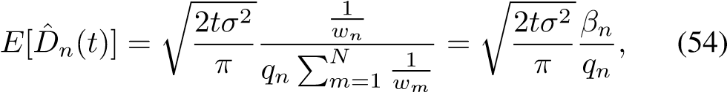

where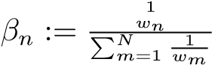 and

Based on Theorems 8 and 10, we can explicitly characterize the capacity region for fading channels.

*Theorem 11:* For a system with fading channels, a vector [*λ*1*,λ*2*,...*] with *λn >* 0, ∀*n* is feasible if and only if P*Nn*=1 *λn* ≥ 1. *2*

VI. NETWORK UTILITY MAXIMIZATION FOR QOE

In this section, we propose a network utility maximization (NUM) problem for QoE, and obtain tractable solutions for several special cases. Given *D*ˆ*n*(*t*) and *T*, we assume that each client *n* suffers from some *penalty fn*(*E*[*D*ˆ*n*(*T*)]), where *fn*(·) is an increasing, differentiable, and convex function. Note that the expectation *E*[*D*ˆ*n*(*T*)] is taken over all sample paths for *t* ∈ [0*,T*]. Here we use *E*[*D*ˆ*n*(*T*)] to approximate the short-term playback interruption *Dn*(*T*). We then aim to minimize the total penalty in the system, which can be expressed as P*n fn*(*E*[*D*ˆ*n*(*T*)]). By Theorems 6 and 11, we have P*n qnE*[*D*ˆ*n*(*T*)] ≥ *E*[*D*ˆ(*T*)] for ON-OFF channels and P *qnE*[*D*ˆ*n*(*T*)] ≥ *E*[*D*ˆ∗(*T*)] for fading channels. Further, if *n*

we have the additional condition of *E*[*D*ˆ*n*(*T*)] *>* 0, the JCD policy and the HDR policy can achieve any set of {*E*[*D*ˆ*n*(*T*)]} by properly assigning the weight {*wn*} to each client. Since the formulation of the NUM problem is the same for ON-OFF channels and fading channels, we take fading channels as an example in the rest of this section. Below, we consider two special types of penalty functions.

First, we study a NUM problem which aims to minimize the sum of polynomial penalty functions.

NUM with Polynomial Penalty Functions:

Given the distribution of **r**(*t*), *T >* 0, *α* ≥ 1, and a vector

[*δ*1*,δ*2*,...*] with *δn >* 0, for all *n*,

*N*

Min. X *δn* · (*E*[*D*ˆ*n*(*T*)])*α*

*n*=1

s.t. *q*1*E*[*D*ˆ1(*T*)] + ··· + *qNE*[*D*ˆ*N*(*T*)] ≥ *E*[*D*ˆ∗(*T*)]*. 2*

To minimize the total penalty, we define a function *L*1 with a Lagrange multiplier *µ*1 as

*L*1 =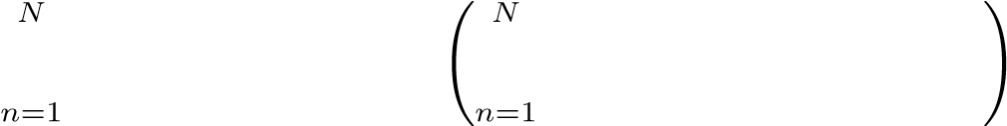 X *δn*(*E*[*D*ˆ*n*(*T*)])*α* − *µ*1 X *qnE*[*D*ˆ*n*(*T*)] − *E*[*D*ˆ∗(*T*)] *.*

Next, we take the partial derivative of *L*1 with respect to each *E*[*D*ˆ*n*(*T*)] and set them to zero, i.e. 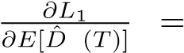

*n*

*δnα*(*E*[*D*ˆ*n*(*T*)])*α*−1 − *µ*1*qn* = 0, ∀*n*. If *α >* 1, an optimal

solution occurs when 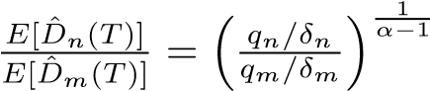, for any pair *n,m*. From (54), it is equivalent to have 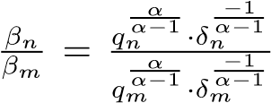.

Then, we can simply assign for each client so that HDR achieves an optimal solution. If *α* = 1, the problem degenerates to a linear program. An optimal solution is obtained by assigning almost all the video interruption time to a client with the smallest. Without loss of generality, we may assume that . Then, we just assign *w*1 = 1 and let *wn* be extremely large for the other clients.

Second, we consider exponential penalty functions.

|  |
| --- |
| NUM with Exponential Penalty Functions:  Given the distribution of **r**(*t*), *T >* 0, and vectors [*δ*1*,δ*2*,...*], [*c*1*,c*2*,...*] with *δn >* 0 and *cn >* 0, for all *n*, s.t.  Again, we define a function *L*2 and the corresponding  Lagrange multiplier *µ*2 as  *.*  (a) Average duration of playback interruption.  By taking the partial derivative of *L*2 with respect to each  *E*[*D*ˆ*n*(*T*)] and let them equal zero, we have *E*[*D*ˆ*n*(*T*)] = **x 104**  , for each *n*. From (54), we can obtain that  q2*Tσ*2 − P*N cnqn* · ln *qn*   (55)  Therefore, an optimal solution can be achieved by assigning to each client that |

Therefore, given the penalty functions, the above two examples demonstrate that HDR policy can achieve an optimal solution to a NUM problem by choosing proper weights {*wn*}.

# VII. SIMULATION RESULTS

We evaluate the proposed policies through ns-2 simulation. Following the IEEE 802.11a standard, we simulate a wireless network that allows data transmission at 54, 48, 36, 18, and 6 Mbit/s. The time to transmit a packet and to receive an ACK is set to be 500 *µ*s, which is short enough so that the channel quality stays almost the same in a time slot. We thereby obtain the corresponding packet size for each data rate: 2340, 2080, 1560, 750, 220 bytes. The frame rate of each video stream is 30 frames per second, and thus each client plays one frame every 66 time slots. All the results presented in this section are the average of 50 simulation trials.

We compare HDR policy against three policies: Max-

Weight policy (MW), weighted Proportional-Fair policy (WPF), and NOVA algorithm. In MW policy, the AP schedules the one with the largest (−*rnXn*(*t*)) and breaks tie by choosing the one with the largest (−*Xn*(*t*)). To further explore the difference between HDR and MW, we also consider the MaxWeight-*α* policy (MW-*α*), which schedules the client with the largest. When *α >* 1, the instantaneous data rate becomes more influential than *Xn*(*t*). In the following simulations, we assign *α* = 10. For WPF policy, the scheduled client at time *t* is the one that maximizes *qn*(*rn*(*t*)*/An*(*t*−1)) [22]. For NOVA, we choose the same objective function as that in [15] with a slight change in the initial condition (*bi*0 in [15]) to fit in our simulation scenario.

(b) Total penalty of the network.

Fig. 1. Comparisons of the five policies in a fully symmetric system.

The simulation results include two parts. First, we consider a fully symmetric system of 20 clients under the heavytraffic condition given by (47) and (48). The channel distribution of each client is the same and evenly distributed, i.e. the probability of each data rate is 0.2. Under this setting, *E*[*R*(*t*)] ≈ 2340. Therefore, *qn* is chosen to be 117 byte/slot for every client. We study a quadratic QoE objective function given by P*n δn*(*E*[*D*ˆ*n*(*T*)])2, where *δn* = 1 for all *n*. Fig. 1 shows the results of the symmetric system. In Fig. 1(a), HDR has the smallest *Dn*(*t*) among all the policies, while MW and NOVA perform rather poorly. As expected, MW-10 policy has a moderate *Dn*(*t*) since MW-10 serves as an intermediate between MW and HDR. Moreover, it is noticeable that WPF has similar performance to HDR. The main reason is that in the symmetric case, *An*(*t*) of each client grows almost at the same speed and thus maximizing *qn*(*rn*(*t*)*/An*(*t*−1)) is equivalent to maximizing *rn*(*t*) in each slot. Moreover, Fig. 1(b) shows the total penalty of MW-10, WPF, and HDR policy to further compare the difference between these three policies.

|  |  |  |  |
| --- | --- | --- | --- |
| |  |  |  | | --- | --- | --- | | **Time (second)**  (a) Average playback interruption: Class 1. | **Time (second)**  (b) Average playback interruption: Class 2. | **Time (second)**  (c) Total penalty of the network. |   Fig. 2. Comparisons of the five policies in a system with the same channel distribution but heterogeneous playback rates. |

Next, we divide the clients equally into two classes. We assign *δn* = 10 to Class 1 and *δn* = 1 to Class 2, with the result that Class 1 dominates the overall QoE performance. In addition, we assume that the two classes have the same evenlydistributed channel but different playback rates. Suppose the clients in Class 1 and Class 2 watch videos with resolution of 480p and 720p, respectively. According to the recommended bitrates for YouTube videos in [23], we choose *qn* = 156 and 78 bytes/slot for 720p and 480p videos, respectively. Simulation results are shown in Fig. 2. Similar to the symmetric case, video interruption of MW and NOVA grow much faster than that of HDR for both classes. Meanwhile, HDR greatly outperforms WPF in total penalty, which is dominated by the *Dn*(*t*) of Class-1 clients. The main reason is that WPF can achieve only one point in the capacity region and this point is far from the optimal point in the asymmetric case.

From simulation, we note that all of the five policies are stabilizing since the duration of video interruption grows sublinearly. However, the short-term performance of these policies are rather different in the heavy-traffic regime. Therefore, diffusion limit indeed provides more detailed information on the playback process.

# VIII. CONCLUSIONS

In this paper, we study dynamic behavior of QoE in heavy traffic by using diffusion approximation. We characterize the capacity region for QoE and propose online scheduling policies to optimize QoE. Simulation results show that the proposed policy outperforms existing popular policies.

# ACKNOWLEDGEMENTS

This material is based upon work supported by, or in part by, the U. S. Army Research Laboratory and the U. S. Army Research Office under contract/grant number W911NF-15-10279.

# REFERENCES

1. Cisco, “Cisco visual networking index: Global mobile data traffic forecast update, 2014-2019,” Feb. 2015.
2. N. Staelens *et al.*, “Assessing quality of experience of IPTV and video on demand services in real-life environments,” *IEEE Transactions on Broadcasting*, vol. 56, no. 4, pp. 458–466, 2010.
3. R. Mok *et al.*, “Measuring the quality of experience of HTTP video streaming,” in *Proc. IFIP/IEEE International Symposium on Integrated Network Management (IM)*, 2011, pp. 485–492.
4. G. Liang and B. Liang, “Effect of delay and buffering on jitterfree streaming over random VBR channels,” *IEEE Transactions on Multimedia*, vol. 10, no. 6, pp. 1128–1141, Oct 2008.
5. A. ParandehGheibi *et al.*, “Avoiding interruptions - a QoE reliability function for streaming media applications,” *IEEE Journal on Selected Areas in Communications*, vol. 29, no. 5, pp. 1064–1074, 2011.
6. Y. Xu *et al.*, “Analysis of buffer starvation with application to objective QoE optimization of streaming services,” *IEEE Transactions on Multimedia*, vol. 16, no. 3, pp. 813–827, 2014.
7. A. Anttonen and A. Mammela, “Interruption probability of wireless video streaming with limited video lengths,” *IEEE Transactions on Multimedia*, vol. 16, no. 4, pp. 1176–1180, June 2014.
8. J. Yang *et al.*, “Online buffer fullness estimation aided adaptive media playout for video streaming,” *IEEE Transactions on Multimedia*, vol. 13, no. 5, pp. 1141–1153, Oct 2011.
9. T. Luan *et al.*, “Impact of network dynamics on user’s video quality: Analytical framework and QoS provision,” *IEEE Transactions on Multimedia*, vol. 12, no. 1, pp. 64–78, Jan 2010.
10. Y. Xu *et al.*, “Impact of flow-level dynamics on QoE of video streaming in wireless networks,” in *Proc. IEEE INFOCOM*, 2013, pp. 2715–2723.
11. D. De Vleeschauwer *et al.*, “Optimization of HTTP adaptive streaming over mobile cellular networks,” in *Proc. IEEE INFOCOM*, April 2013, pp. 898–997.
12. P. Chandur and K. Sivalingam, “Quality of experience aware video scheduling in LTE networks,” in *Proc. National Conference on Communications (NCC)*, Feb 2014, pp. 1–6.
13. R. Bhatia *et al.*, “Improving mobile video streaming with link aware scheduling and client caches,” in *Proc. IEEE INFOCOM*, April 2014, pp. 100–108.
14. K.S. Kim *et al.*, “Scheduling multicast traffic with deadlines in wireless networks,” in *Proc. IEEE INFOCOM*, April 2014, pp. 2193–2201.
15. V. Joseph and G. de Veciana, “NOVA: QoE-driven optimization of DASH-based video delivery in networks,” in *Proc. IEEE INFOCOM*, April 2014, pp. 82–90.
16. I.H. Hou and P.C. Hsieh, “QoE-optimal scheduling for on-demand video streams over unreliable wireless networks,” in *Proc. ACM MobiHoc*, 2015, pp. 207–216.
17. L. Tassiulas and A. Ephremides, “Dynamic server allocation to parallel queues with randomly varying connectivity,” *IEEE Transactions on Information Theory*, vol. 39, no. 2, pp. 466–478, 1993.
18. M. Neely, “Delay analysis for Max Weight opportunistic scheduling in wireless systems,” *IEEE Transactions on Automatic Control*, vol. 54, no. 9, pp. 2137–2150, Sept 2009.
19. J. Harrison and M. Lopez, “Heavy traffic resource pooling in parallelserver systems,” *Queueing Systems*, vol. 33, no. 4, pp. 339–368, 1999.
20. H. Chen and D. Yao, *Fundamentals of Queueing Networks: Performance, Asymptotics and Optimization*. Springer-Verlag, 2001.
21. J.M. Harrison, *Brownian motion and stochastic flow systems*. Wiley New York, 1985.
22. H. Kushner and P. Whiting, “Convergence of proportional-fair sharing algorithms under general conditions,” *IEEE Transactions on Wireless Communications*, vol. 3, no. 4, pp. 1250–1259, July 2004.
23. “Live encoder settings, bitrates and resolutions.” [Online]. Available:

https://support.google.com/youtube/answer/2853702?hl=EN