**SPECIFIC AIMS**

Considerable work over the past several years provided evidence that treatment refractory gait and balance impairments in Persons with Parkinson’s (PwP) are due to deficits in an Attentional-Motor Interface (AMI) linking basal ganglia, thalamus, subcortical cholinergic projection systems, and their cortical targets. The work in humans thus far, however, is correlational. Converging lines of evidence from PET imaging of cholinergic integrity and network-based fMRI have found that patients with falls and gait freezing have deficits in several AMI nodes. These findings and preclinical model work lead to the hypothesis that intact functioning of these nodes plays a compensatory role during the progression of PD until degeneration of cholinergic projections to these AMI nodes unmasks gait dysfunction. A strong causal test of this hypothesis requires manipulating AMI node functions *in vivo* to examine their impact on behavior and network-level brain activity. A transcranial magnetic stimulation (TMS) protocol called theta burst stimulation (TBS) allows for transient (~60 min) focal alteration of neuronal activity, providing a causal manipulation approach. **This proposal uses a multi-modal approach, combining TMS with neuroimaging, to provide causal evidence for the mechanistic role of network interactions between cognitive and motor AMI nodes in PwP motor deficits.**

**Specific Aim 1: Determine the causal mechanistic role of frontal cortical AMI nodes in the motor function of PwP.** Prior work has shown that PwP with falls and/or freezing of gait have dysfunction in cortical cognitive networks of the AMI, including the cingulo-opercular cognitive control network (COCN). We will first assess motor function and COCN integrity via both task-based and resting-state functional magnetic resonance imaging (fMRI) scans. On a subsequent day, we will apply continuous TBS (cTBS) over a COCN node in frontal cortex to transiently disrupt activity in the COCN immediately before undergoing another fMRI session with both cognitive and motor tasks. We hypothesize that disrupting activity in these AMI nodes will “unmask” the effects of dopaminergic degeneration, resulting in increased motor dysfunction. This effect will be most pronounced in dual-task blocks that combine cognitive and motor task performance. Further, the extent of disruption will be proportional to COCN integrity. We expect that patients with relatively strong COCN network strength will display larger behavioral deficits due to COCN disruption. In contrast, if motor dysfunction is due to diminished functioning in these cognitive nodes, patients who display minimal network connectivity will have minimal effects of stimulation due to floor effects. Finally, we expect that stimulation-induced motor dysfunction will coincide with impairments on non-motor measures of attentional/cognitive function. Such a finding would implicate the causal role of the AMI in compensating for motor dysfunction.

**Specific Aim 2: Assess whether increasing excitability in frontal cortical AMI nodes can improve motor function.** In contrast with cTBS, intermittent TBS (iTBS) has been shown to increase excitability under the site of stimulation and also results in increased network communication as measured with fMRI. We will apply iTBS over frontal cortex in the same cohort of patients as Aim 1 to transiently enhance excitability in the COCN immediately before undergoing cognitive and motor testing during neuroimaging. We hypothesize that transient upregulation of activity in these networks via iTBS will enhance performance on both cognitive and motor tasks. Such a finding would provide an exciting avenue for therapeutic intervention (see below).

**Exploratory Aim 1: Assess the safety and feasibility of long-term stimulation of cortical AMI nodes to mitigate falls and freezing of gait.** Repeated iTBS sessions have been an effective treatment for other clinical disorders (such as depression) and have been shown to produce long-lasting (weeks/months) changes in network connectivity and function. After establishing the causal mechanistic role of cortical AMI nodes in Aims 1 and 2, we will bring back a small subset of subjects for a pilot intervention study. These subjects will undergo 5 sessions of iTBS over frontal cortex on consecutive days. We anticipate that this extended treatment duration will be safe and will not exacerbate PD symptoms. This pilot project, if successful, would provide a springboard to a more extensive clinical trial.

**SIGNIFICANCE**

Although dopaminergic replacement therapy (DRT) led to dramatic improvements in function for PwP, disease progression is marked by morbid non-DRT responsive features. These DRT-resistant PD features are identified as major sources of disability by clinicians, caregivers, and PwP. Among the most prominent of these features are cognitive impairments and gait disorders such as freezing and falls. Gait-balance impairments and falls often lead to placement in extended care facilities and are associated with increased mortality1.

Unfortunately, DRT-resistant gait and balance deficits are not the only challenge faced by PwP as the disease progresses. Cognitive function also declines over time, often progressing to dementia. Cognitive impairment and motor dysfunction are not simply advancing in isolation. Control of gait and balance requires extensive integration of cognitive, motor, and sensory functions. Accumulating evidence suggests that these motor deficits in PwP are driven by changes in frontal cortical processing more typically associated with executive functions such as the control of attention. The network-level interactions between these attentional systems and basal ganglia circuits together constitute an Attentional-Motor Interface (AMI)2. Attentional systems can compensate for motor dysfunction due to dopaminergic degeneration until disease progression degrades cognitive AMI nodes and “unmasks” latent motor deficits. This AMI model was developed extensively by researchers at the University of Michigan Udall Center including Dr. Roger Albin, co-investigator on this proposal. There is now extensive evidence from this group and others that several risk factors for falls often reflect deficits in the AMI.

Despite the promise of this work, the evidence from human research linking AMI disruption and motor deficits in PwP is correlational. That is, individuals with cognitive impairments often also display gait and balance deficits. Additionally, neuroimaging studies have shown that reduced step length and freezing of gait have been associated with abnormal connectivity between cortical cognitive control networks and the striatum3. *Though these studies have shed light on potential mechanisms, they cannot provide causal evidence for the importance of AMI nodes in protecting against motor deficits.* Such causal evidence would provide both a deeper mechanistic understanding of the contribution of AMI dysfunction to motor deficits, but would also provide a new avenue for targeted therapeutic interventions.

A strong causal test of the hypothesis that AMI dysfunction directly contributes to motor deficits requires an intervention that specifically perturbs AMI nodes to assess the impact of their disruption on motor control in PwP. Transcranial magnetic stimulation (TMS) is just such a technique. TMS can be used to non-invasively alter neuronal excitability in circumscribed areas of cortex *in vivo*. In addition to providing causal tests of the role of targeted nodes in cognitive processes of interest, TMS shows promise as a therapeutic intervention for several clinical and neurological disorders including PD4. **The goal of this proposal is to provide mechanistic causal evidence that directly implicates AMI dysfunction in motor deficits in PwP. SA1** and **SA2** will use a novel combination of functional neuroimaging and TMS to assess how altering cortical excitability in frontal AMI nodes impacts both motor function and the interaction between cognitive and sensorimotor cortico-striatal loops. Once causality is established, **EA1** will assess the safety and feasibility of using TMS to cortical AMI targets as a therapeutic intervention to mitigate gait and balance deficits in PwP.

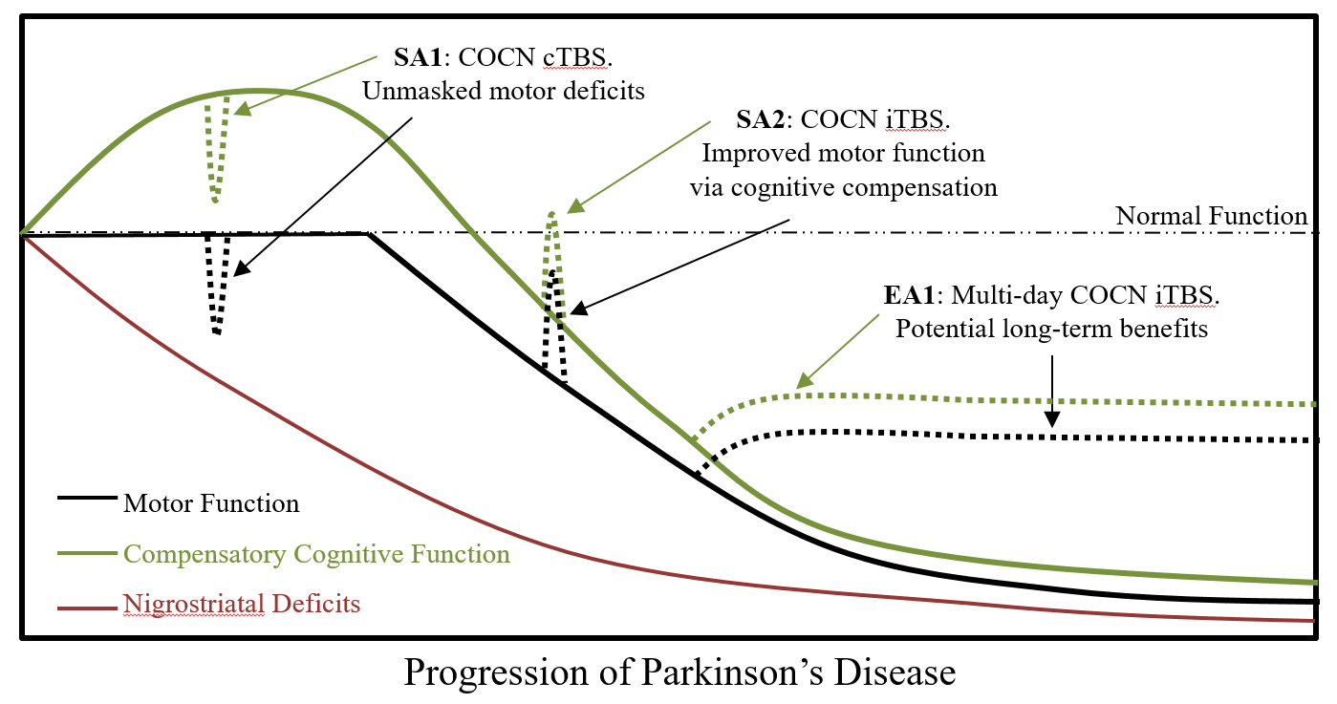

**Figure 1.** Conceptual AMI model and hypothesized effects of stimulation

**INNOVATION**

This proposal is conceptually and technically innovative: Only recently have researchers begun to examine how dysfunction in the AMI affects motor deficits in PwP. We will employ a unique combination of non-invasive brain stimulation and fMRI to provide causal evidence of the role of AMI nodes in both network-level brain activity and behavior. Very few research sites have the facilities and expertise to use both TMS and fMRI.

**APPROACH**

Design Overview. We propose a within-subject design in which participants will undergo multiple (5-8) separate sessions with a combination of behavioral testing, fMRI, and TMS (see Figure 2). All participants will first undergo an initial screening and baseline assessment session. During this session, subjects will be characterized with standard scales: Parkinsonism – MDS-Unified Parkinson Disease Rating Scale (UPDRS); Mood – GDS; Apathy – Lille Apathy Rating Scale; Cognition – a short battery of selected domain-specific tests used previously5. Bradykinesia will be quantified with a tapping task used extensively in prior studies6,7 (see below).Depending on an individual’s face musculature, frontal stimulation can be uncomfortable. During this initial session, we will additionally assess stimulation tolerability by allowing subjects to feel short trains of TMS stimulation to approximate stimulation targets. Once tolerability has been established, we will determine the participant’s individual stimulation intensity for use in subsequent sessions.

Subjects who pass screening will then return for an initial MRI session. This session will be used to obtain structural MRI scans, baseline measurements of resting-state functional connectivity, and both task-based activation and functional connectivity. Frontal cortex stimulation targets will be individually defined based on resting-state and task-based measures from this initial session (see below). While combining neuroimaging with TMS will provide a strong mechanistic understanding of the role of AMI nodes in PD, gait cannot be directly assessed in the neuroimaging environment. Instead, participants will perform a demanding precision force-tracking task (see below). *Prior work has shown that precision grip tasks such as this one and other lab-based motor tasks track well with both disease progression and gait dysfunction in PwP*8,9*.*

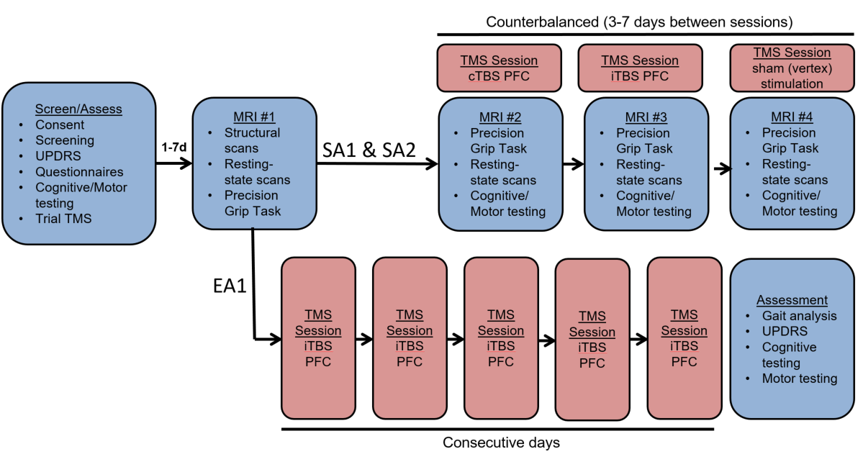

**Figure 2.** Experimental Timeline

*Participant Recruitment.* We will study PD subjects recruited from the Movement Disorders Clinic at the University of Michigan where Dr. Albin, co-investigator on this proposal, serves as the co-director. This clinic sees approximately 1300 PD patients annually and many of these patients have participated in research as the University of Michigan. Subjects must meet Movement Disorder Society (MDS) criteria for PD. Only H&Y2-3 subjects on a stable DRT plan will be enrolled. Exclusion criteria include significant cognitive impairment (Montreal Cognitive Assessment score <24), significant depression (Geriatric Depression Scale [GDS] >5), stimulant use, deep brain stimulation implants, or other confounding neurologic or medical disorders.

*TMS target definition.* Sites for stimulation will be individually defined based on analyses of anatomical, resting state, and task-based data from the first MRI session. Specifically, the BOLD timecourse for dorsal anterior cingulate cortex and the right anterior thalamus extracted from 6mm regions-of-interests (ROIs) will be averaged and entered as a regressor in a GLM. This approach has been used to reliably reveal other COCN nodes including in frontal cortex10,11. We will then create a univariate task-based activation map for each individual contrasting task vs. baseline. By overlapping this connectivity map and activation map, we will reveal an individualized target in right inferior frontal cortex for each subject. As in prior work, we will actively stimulate the vertex (‘active sham control’) by finding the mid­point between the nasion and the inion on the midline of the skull12.

*TMS protocol.* TMS will be delivered through a MagPro X100 magnetic stimulator and a 90 mm figure-8 coil (MC-B70, MagVenture Inc.). Motor evoked potentials (MEP) elicited using biphasic posterior-anterior stimulation and coil oriented 45 degrees to the coronal plane will be recorded from the right first dorsal interosseous (FDI) using surface electromyography (Rogue Research, Montreal). Active motor threshold (AMT) will be obtained as the percentage of stimulator output that elicits an MEP of ≥ 200 μV peak-to-peak on five out of ten trials while the participant is contracting the FDI muscle at 20% of maximum. We will deliver theta-burst stimulation (TBS) with standard parameters: 3 pulses of stimulation at 50 Hz, repeated every 200 ms (TBS). Continuous TBS (cTBS) will be applied uninterrupted for a total of 600 pulses in 40 seconds13. Intermittent TBS (iTBS) will be applied in 2s trains repeated every 10 s for a total of 600 pulses (190s). Stimulation will be delivered at 80% of AMT, within consensus recommendations for safety14. In numerous studies, cTBS leads to decreased cortical excitability and iTBS increased cortical excitability for up to 60 minutes post-stimulation. We have successfully stimulated the right inferior frontal cortex in several prior studies using TBS protocols12,15–17.

*MRI acquisition.* All neuroimaging data will be collected using a 3T GE MR 750 scanner at the University of Michigan’s Functional Magnetic Resonance Imaging Laboratory. A standard 32-channel head coil will be used, and participant movement will be minimized by stabilizing the head with cushions and Velcro straps. Each imaging session will include acquisition of T1-weighted anatomical images, high-resolution anatomical images using an MP-RAGE sequence, and T2*-weighted functional images. Functional images will be acquired using a multi-band EPI sequence (acceleration factor of 3) that will allow us to collect whole brain data at a voxel size of 2 mm isotropic at a repetition time (TR) of 1.2 s. We will collect six functional runs of 5 minutes each.

*MRI preprocessing.* Anatomical, functional and resting-state data will be preprocessed using fMRIPrep 20.1.118. The anatomical preprocessing pipeline performs brain-tissue segmentation and reconstruction of cortical surfaces. The functional preprocessing pipeline comprises susceptibility distortion correction, slice-timing correction, motion correction, coregistration with the subject’s T1-weighted image, and nonlinear transformation to MNI152 space. Resting-state data will undergo additional preprocessing steps including interpolation across high-motion time-points (>0.5 mm FD), application of a bandpass filter to extract frequencies between 0.009 and 0.08 Hz, mean ‘grayordinate’ signal regression (MGSR), and censoring of high-motion time-points19,20.

**Figure 3.** Precision Force-Tracking Task. Participants will use a grip-force sensor to keep a cursor within a target circle that moves up and down the screen. In dual-task blocks, participants will need to simultane­ously count the number of times the target flashes white.

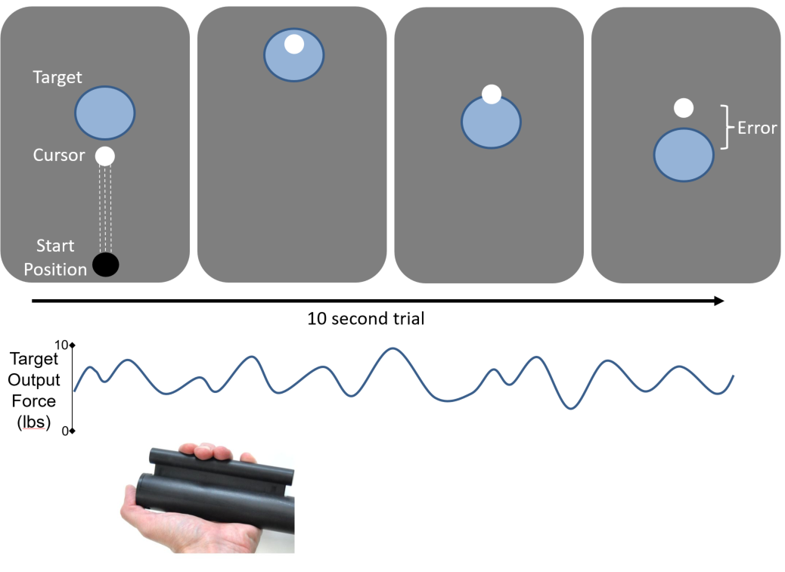

*Precision force-tracking task.* To measure dynamic motor function in the scanner, we will use a precision force-tracking task (FTT). In this task (**Fig. 3**), participants must use a scanner-compatible force transducer (Current Designs, Inc., Philadelphia, PA) to continuously modulate their grip force to match a target force output. This task has already been implemented in Dr. Lee’s lab. Each trial consists of a 15 second pattern of grip modulation during which participants attempt to keep the cursor (white circle) inside the bounds of a moving target (blue circle). The target will follow a trajectory generated by the linear combination of multiple different waveforms. At each frame refresh, we will calculate squared distance (error) from the cursor to the target which will allow us to calculate a root mean squared error (RMSE) for each trial as a dependent variable. During dual-task trials, participants will be required to simultaneously count the number of times the target circle flashes. This requires both tonic attentional vigilance as well as working memory maintenance, two executive functions previously implicated as important in the AMI23,24. At the end of the trial, participants will report the number of target flashes they observed by responding to an on-screen prompt using the same grip force device.

*Tapping task.* As a measure of bradykinesia, we will use the well-validated tapping task7 (eg., **Figure 1**). With the hand most affected by PD, subjects are instructed to alternately tap 2 manual counters spaced 20 cm apart as rapidly as possible for 30 s. Subjects will practice several times in the initial screening session until they feel comfortable with the task. They will perform 3 trials spaced ~1 minutes apart with the initial trial discarded to reduce variation secondary to anxiety. Results of the remaining 2 trials will be averaged to generate a tapping speed (taps/min) for each subject.

*Spatial N-back working memory task.* As a measure of cognitive control and executive function, we will use the ‘n-back’ task, a widely studied and highly robust activator of cognitive control networks22. The task has multiple components, including attentional vigilance, short-term storage, information manipulation and recognition. Subjects will see a ring of 8 unfilled circles evenly spaced apart. Individual circles will ‘light up’ for 0.5 sec, every 2 sec. The target condition will test for 2-back recall, in which subjects respond with a button press to a target that matches the location from 2 presentations before. Accuracy rate will be used as the dependent variable of interest.

*General Analysis plan.* All dependent variables in **SA1** and **SA2** (tapping speed, n-back performance, FTT performance, fMRI measures) will be analyzed using within-subject linear mixed effects models. TMS session (cTBS, iTBS, sham) and time (day 1, 2, 3) will be entered as factors with fixed effects.

*Task-based and resting-state fMRI analysis.* We will use a standard univariate analysis in a GLM framework to assess task based activations versus baseline and to compare single- and dual-task FTT blocks. We will use the psychophysical interaction (PPI) approach21 to assess task-based functional connectivity differences between single- and dual-tasking using the stimulation site as a seed. For assessing COCN resting integrity, we will calculate the average time-series correlation across all COCN nodes using coordinate based ROIs in standard space.

*Power analysis.* The analyses proposed here will test the main effect of stimulation location on both behavioral and fMRI measures. Previous work by Dr. Lee, PI of this proposal, used a very similar TMS procedure to examine the effects of prefrontal stimulation on cognitive performance15. In that study, the effect of TMS location was associated with an effect size of ηp2 = 0.21. Other studies that have applied cTBS to cortical sites using within-subject designs have reported effects in a similar range (ηp2 = 0.22-0.44). Because publication bias can inflate published estimates of effect size, we selected the lower end of this range (ηp2 = 0.20) to calculate power for the current studies. Using G*Power 3.1.9.4 (www.gpower.hhu.de), we calculated the *a priori* required sample size to detect a significant effect at α < 0.05 with a power of 0.8, resulting in a required sample size of 17 participants. To account for subject attrition, we will aim to recruit 25 participants.

**SA 1: Determine the causal mechanistic role of frontal cortical AMI nodes in the motor function of PwP.**

**SA 2: Assess whether increasing excitability in frontal cortical AMI nodes can improve motor function.**

*Rationale.* Prior studies, including those by our research team, have shown that cTBS can disrupt network connectivity and lead to impairments on attention and cognitive control tasks12,15. Similarly, iTBS enhances network connectivity and can lead to performance improvements on these same attentional tasks25. If frontal AMI nodes play a compensatory role in maintaining motor function in PwP, disrupting activity at these sites should lead to deficits in FTT performance. Similarly, temporarily enhancing function in these nodes could lead to motor performance improvements, especially in PwP with relatively poor baseline performance.

*Procedure.* Following the initial fMRI session, participants will return for three subsequent combined fMRI-TMS sessions (see **Fig. 2**). Just prior to entering the scanner, participants will receive either 1) cTBS over frontal cortex, 2) iTBS over frontal cortex, or 3) “sham” TBS over the vertex of the scalp. The order of stimulation sites will be counterbalanced across participants. Just following stimulation, participants will perform the tapping task outside of the scanner and then immediately go into the scanning bay. N-back performance will be assessed while in the scanner while collecting anatomical localizers for functional scanning. Rest, single- and dual-task FTT trials will alternate within each functional run. All participants will be tested in the DRT ‘ON’ state.

*Prediction.* cTBS will lead to poorer n-back performance, FTT performance, and diminished functional connectivity between cortical and subcortical COCN nodes relative to sham stimulation. In contrast, iTBS will enhance both n-back and FTT performance, along with increased functional connectivity within the COCN. Participants who display minimal COCN connectivity at baseline likely already have AMI deficits. We expect that cTBS effects will be relatively small in this sub-group, but that they may show the largest improvement following iTBS if COCN connectivity can be restored to a compensatory role.

**Exploratory Aim 3: Assess the safety and feasibility of long-term stimulation of cortical AMI nodes in mitigating falls and freezing of gait.**

*Rationale.* If the cognitive nodes of the AMI serve a compensatory role in maintaining motor function as PD progresses, it is possible that enhancing or otherwise upregulating AMI function will lead to

*Procedure.* For **SA3,** a small subset of participants will return for 5 consecutive days of iTBS stimulation over frontal cortex. Immediately following stimulation on the 5th day, participates will complete a battery of cognitive and motor testing including tapping speed, n-back working memory, and UPDRS part III.

*Prediction.* All subjects will tolerate repeated doses of stimulation. No participants will experience a worsening of PD symptoms. We will observe some evidence of cognitive and motor improvements relative to baseline.

**BUDGET JUSTIFICATION**

*Personnel ($161,855).* All salaries below are based on current salary with 3% inflation/yr and the College standard fringe benefits rate of 30% (exception: 27% for the GRSA).

Taraz Lee (PI, 1 summer months per year, 33%).

Michael Vesia (Co-I, 0.5 summer month per year, 16.7%). Dr. Vesia has over a decade of experience in motor control and with the TMS protocols used in this proposal.

Roger Albin (Co-I, 0.3 calendar month per year, 2.5%). Dr. Albin is among the world leaders in PD research and is the co-director of the Movement Disorders Clinic where subject recruitment will take place. Dr. Albin’s effort allocation is divided between the University of Michigan and the Department of Veteran’s Affairs. An MOU governing his effort allocation is on file at the Department of Neurology and the VAAAHS. The effort for this project will come from Dr. Albin’s University of Michigan effort.

Research Coordinator (Kacee Pavelka, TBA, ~4 calendar months per year, 45.8%). The research coordinator will manage subject scheduling, team management, and all testing sessions.

GRSA (TBA, 2 calendar months per year). A graduate student will aid in fMRI and other analyses.

*fMRI costs ($77,138).* 125 hours of scans (32 hrs in yr 1, 68 hrs in yr 2, 25 hrs in yr 3) at $600/hr (3% inflation)

*Subject payment ($15,000).* $500/subject for 30 subjects. These funds will cover 5+ sessions, travel compensation, and a completion bonus.

*TMS coil ($7,700).* TMS coils can only effectively administer a certain number of pulses before degradation. We anticipate we will need to replace the coil during the course of the proposed projects.

*Computing costs ($5,000).* fMRI data will be analyzed using UM’s high performance computing cluster and stored in secure cloud storage.

*Publication costs ($6,000).* We anticipate publishing two manuscripts in year 3 of the project ($3000 each)