

**Version 1.0**

**Developer’s Guide**

**CS3215 Team9: 0110**

**Gu Yang**

**Li Yi**

**Li Zichen**

**Lu WenHao**

**Tso Shuk Yi**

**Yu Qiqi**

Table of Contents

1. CleanSync 3

1.1 Introduction 3

1.2 Functionality features 3

1.3 Glossary of terms 4

2. Components 4

2.1 GUI 5

2.1.1 GUI 5

2.1.2 USBDetection 5

2.1.3 Balloon / Balloon Decorator 6

2.1.3 IconExtractor 6

2.2.8 DifferenceToTreeConvertor 6

2.2 Logic Components 7

2.2.1 MainLogic 7

2.2.2 JobLogic 7

2.2.3 CompareLogic 8

2.2.4 SyncLogic 8

2.2.5 ReadAndWrite 10

2.2.6 LogFile 11

2.2.7 ConflictHandler 11

2.3 Metadata 12

2.3.1 ComponentMeta 12

2.3.2 FileMeta 13

2.3.3 FolderMeta 14

2.3.4 JobDefinition 14

2.3.5 PCJob 15

2.3.6 USBJob 16

2.3.7 Differences 16

2.2.8 Conflict 17

2.2.9 ComparisonResult 18

2.2.10 JobConfig 18

2.3 External Components 18

3 Technical Details 19

3.1 Sequence Diagrams 19

3.1.1 Create a job 19

3.1.2 Accept a job 19

3.1.3 Accept & Sync 20

3.1.4 First Setup 21

3.1.5 Normal Sync 22

3.2 Implementation Details 23

3.2.1 Normal Clean Synchronization 23

3.2.2 Re - Synchronization 23

3.2.3 Renaming of Files and Folders in the USB 23

3.2.4 Determining folders to store meta data 24

3.2.5 Loading and unloading meta data to and from the hard disk. 24

4 Known Issues 25

# 1. CleanSync

## 1.1 Introduction

CleanSync is a one stop user-friendly and file synchronization software that facilitates the daily back-up and synchronization needs of Users who have to bring home the files from the office to continue their work at home and thus have to ensure that the two sets of files at both locations are synchronized. Other than conventional synchronization between 2 folders, CleanSync utilizes our new technology, Clean Synchronization, which allows users to sync two computers using a third removable device, while keeping disk space usage on the removable device, to a minimum. With Clean Synchronization, users can synchronize between workstations using a removable device without keeping track of two separate synchronization jobs of the external drive to eachof the computers separately.

## 1.2 Functionality features

Below are some of the main features that is implemented by CleanSync:

**Clean Synchronization**

Clean Synchronization is the method through which CleanSync does synchronization. It is especially designed to synchronize folders in 2 different computers through an external drive. There are 2 distinct forms of Clean Synchronization: normal clean synchronization and re-synchronization.

**Safe Synchronization**

If a synchronization process is interrupted, CleanSync will attempt to restore the folders and files to their original state. CleanSync will also backup deleted and overwritten files and folders on folders.

**Preview feature**

CleanSync can preview a list to changes made to each computer before synchronization so that users can see what will be changed before allowing synchronization to take place.

**Conflict Handling**

CleanSync can handle conflicts and allow users to choose from 3 options: Using the one on the removable device, using the one on the computer or choosing to update both, in which case files will be copied in both directions, and will be renamed.

**External drive Plug-in Plug-out detection**

CleanSync will detect whenever an external drive is plugged in or plugged out and load or unload any synchronization job found on the external drive respectively.

**Automation**

CleanSync allows the user to select the option of synchronizing a job on the removable device whenever the device is plugged in.

## 1.3 Glossary of terms

**Removable Device**

A removable device refers to an external hard drive through which folders in 2 computers can be synchronized.

**FileMeta / FolderMeta**

FileMeta and FolderMeta are serializable classes used to store information about files and folders respectively. Using FileMeta and FolderMeta, a directory structure can be represented.

**Job**

A job stores the information of the directory on both computers and the removable device. When the user wants to synchronize folders in 2 different computers, users create a job. In implementation, a job consists of 2 serializable PCJob classes which is stored in the computers and a serializable USBJob which is stored in the removable device.

# 

# 2. Components

CleanSync consists of 3 main components: GUI, Logics and MetaData. Below are their description, the class they consist of and description of some of the more notable methods found in the classes.

# 

|  |
| --- |
|  |

## 2.1 GUI

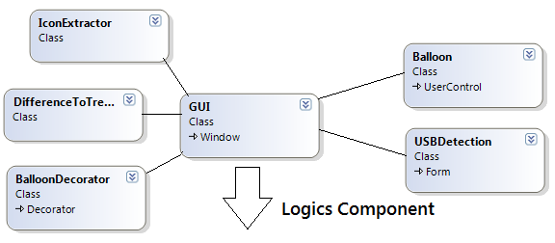

GUI is implemented using WPF. It consists of the main class GUI, which is the main window for CleanSync, and several GUI helper classes.

### 2.1.1 GUI

The GUI class is the main window for the user interface.

### 2.1.2 USBDetection

This class is in charge of detecting whenever a removable device has been plugged in or plugged out.

### 2.1.3 Balloon / Balloon Decorator

The balloon class is used to create information balloons displayed on the system tray. The balloon decorator is used to define the balloon.

### 2.1.3 IconExtractor

The IconExtractor is used to load icons from the system registry. It is mainly used to load the new, modified and deleted icons at the analysis results screen.

### 2.1. DifferenceToTreeConvertor

DifferenceToTreeConvertor converts a difference into tree form for display purposes. Note that difference to tree convertor is also called by SyncLogic and CompareLogic.

**Methods**

**Public**

**FolderMeta ConvertDifferencesToTreeStructure(Differences difference)**

**Private**

**bool ConvertFolderListToTree(FolderMeta root, bool haveDifference, List<FolderMeta> folders)**

* + Adds a list of FolderMeta into a given root. Parent folders are created if it does not exist yet.

**bool ConvertFileListToTree(FolderMeta root, bool haveDifference, List<FileMeta> files)**

* + Adds a list of FileMeta into a given root. Parent folders are created if it does not exist yet.

## 2.2 Logic Components

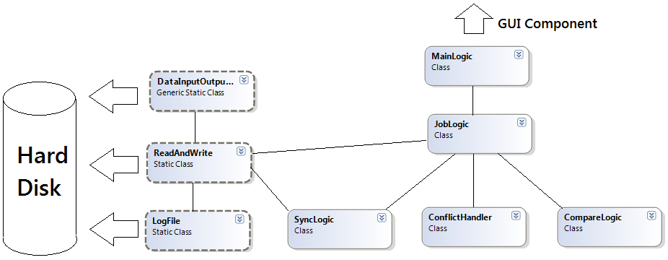

### 2.2.1 MainLogic

MainLogic handles request from the GUI and distributes the work to the various classes in the logic component.

**bool FirstTimeSync(PCJob pcJob, System.ComponentModel.BackgroundWorker worker)**

**List<USBJob> AcceptJob(List<string> drives)**

This method searches all USB drives connected to the computer for incomplete jobs. If there is an incomplete job, check if this computer is the computer that created the job. If it is not, it will return it as an incomplete USB job available to be accepted by this computer.

**PCJob CreateJob(USBJob jobUSB, string PCPath)**

**string GetPCID()**

Get the identification string of the current computer. The identification string is created at the first time when CleanSync runs on a computer using the System.Environment.TickCount, the string is then stored inside the data folder and following GetPCID() will just read the string from this file.

### 2.2.2 JobLogic

JobLogic handles all requests for job-related work. It manages the jobs in the system and delegates the work further to CompareLogic and SyncLogic.

**void InitializePCJobInfo()**

Loads all pcJob found on the PC

**void InitializeUSBJobInfo(string usbRoot,string pcID)**

Searches and Loads all usbJob found on the USB drives and mount them to the respective pcJobs.

### 2.2.3 CompareLogic

CompareLogic handle comparison between two folders, given two root folders, it is able to tell what are the changes: "modified", "deleted" or "created". And return a comprehensive result to callers.

CompareLogic currently handles two different jobs: Checking for differences between folders and checking for conflicts between 2 differences.

### 2.2.4 SyncLogic

Sync Logic handles synchronization between two folders. After comparing differences of the component metas, the results are brought here to execute synchronization and the copying of files and folders between the PC and the USB.

Files and Folders stored in the USB are renamed and their renaming is also handled by Sync Logic.

In SyncLogic there are two methods called by external classes.

**void CleanSync(ComparisonResult comparisonResult, PCJob pcJob, System.ComponentModel.BackgroundWorker worker)**

This method checks whether this PC is the last PC to do a synchronization with the USB by matching the PCID with the usbJob's MostRecentPCID. If it is not the last PC to synchronization with the USB, a normal synchronization is performed. Else, it will do a re-synchronization. The worker object is used to update the progress of synchronization.

**public void InitializationSynchronize(Differences PCToUSB, PCJob pcJob, System.ComponentModel.BackgroundWorker worker,System.ComponentModel.DoWorkEventArgs e)**

This method is called when synchronizing for the first time.

**Private methods**

Private methods are divided into three groups.

**Calculate Size**

These methods are called to calculate the total size of data needed to be copied for this job.

**void initializeTotalSize(ComparisonResult comparisonResult)**

**void updateFolderSize(List<FolderMeta> folders)**

**void updateFileSize(List<FileMeta> files)**

**Normal Synchronization**

These methods are called to do a normal synchronization, based on the tree structure of the differences.

**void NormalCleanSync(ComparisonResult comparisonResult, PCJob pcJob)**

**void NormalCleanSyncFolderPcToUsb(FolderMeta pcToUsb, string originDirectoryRoot, string destinationDirectoryRoot, Differences pcToUsbDone)**

**void NormalCleanSyncFolderUsbToPC(FolderMeta usbToPC, string originDirectoryRoot, string destinationDirectoryRoot, Differences usbToPCDone)**

**Resynchronization**

These methods are called to do a resynchronization. Updates of files and folders in the PC will be updated on the USB. The renaming of these files and folders are also handled here. The pair of differences in the comparisonResult, instead of being treated as in a normal synchronization, are now viewed as old and new differences. Old differences are the differences in the USB that is to be synchronized with the other PC, new differences are the differences in the PC that are now to be copied to the USB.

**void CleanSyncReSync(ComparisonResult comparisonResult, PCJob pcJob)**

**void ReSynchronizeFolders(FolderMeta oldDifferencesRoot, FolderMeta newDifferencesRoot, string sourceDirectory, string destinationDirectory, Differences pcToUSBDone)**

**void ReSynchronizeFiles(FolderMeta oldDifferencesRoot, FolderMeta newDifferencesRoot, string sourceRoot, string destinationRoot)**

* The previous two methods are called to resync a modified folder to a previously modified folder.

**void CompareNewDeletedWithOldModifiedFolders(FolderMeta folderNew, FolderMeta folderOld)**

**void CompareNewDeletedWithOldModifiedFiles(FolderMeta folderNew, FolderMeta folderOld)**

* These two methods are called to resynchronize a modified folder with a deleted folder.

**void ReSynchronizeToNewFolder(FolderMeta oldDifferencesRoot, FolderMeta newDifferencesRoot, string sourceRoot, string destinationRoot)**

**void ReSynchronizeToNewFolderFiles(FolderMeta folderOld, FolderMeta folderNew, string sourceRoot, string destinationRoot)**

* These two methods are called to resynchronize a previously new folder with a modified folder

**Restoration**

**void RestoreIncompletePCChanges(FolderMeta changes, string pcPath)**

* This method is called during normal synchronization if the job if an exception is thrown, to restore the folder to its previous state.

### **2.2.5 ReadAndWrite**

Other than for logging, ReadAndWrite performs all copy and delete operations on files and folders. It is also called to fetch data from the hard disk.

**static FolderMeta BuildTree(string rootDir)**

* + This is the main method invoked to construct a directory’s metadata. It calls a private method of the same name which is recursive, and returns the root folder’s foldermeta.

**static void DeleteFolder(string path)**

* + This method will delete the specified folder and all its contents.

**static void DeleteFolderContent(string path)**

* + This method will not delete the specified folder, only all its contents.

**static void EmptyFolder(string path)**

* + This method will only delete the subfiles within the specified folder

**static void MoveFolderContents(string source, string target)**

* + This method will move the contents inside the source to the target. Files and folders will not be overwritten.

**static void MoveFolderContentWithReplace(string source, string target)**

* + This method will move the contents inside the source to the target. Files and folders will explicitly be overwritten.

### 2.2.6 LogFile

LogFile is in charge of logging. The path to the file is specified and every subsequent log is written to that file.

### 2.2.7 ConflictHandler

This method handles any conflicts found. Based on the job setting, different conflicts will be handled differently.

### 2.2.8 JobsRestoreLogic

**static void RestoreInterruptedPCJobPCChanges(PCJob pcJob)**

* + This method is invoked to restore a PCJob from a previous synchronization crash due to some PC related failure (e.g. unexpected power off).

**static void RestoreInterruptedUSB(PCJob pcJob)**

* + This method is invoked to restore a USBJob from a previous normal synchronization crash due to some removable device related failure (e.g. plug-out removable device during synchronization).

**static void RestoreReSyncUSB(PCJob pcJob)**

* + This method is invoked to restore a USBJob from a previous re-synchronization crash due to some removable device related failure (e.g. plug-out removable device during synchronization).

## 2.3 Metadata

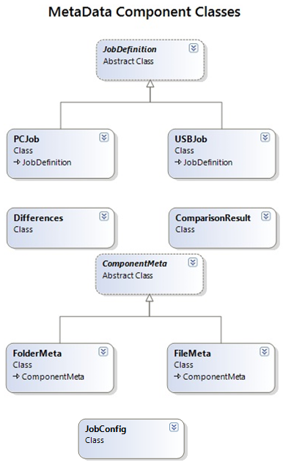

### 2.3.1 ComponentMeta

This is the basic file and folder metadata definition extends form the basic metadata definition "**ComponentMeta**". It provides the basic information about each files, also, give the structure of the folders using tree structure.

**Attributes**

**Public**

* **enum Type{ New,Modified,Deleted,NotTouched }**
  + Defines the type (or status) of one file(folder).
    - New: first created
    - Modified: being modified by other side
    - Deleted: Deleted by other side
    - NotTouched: No change on both sides
* **string Name**
  + Name of the file/folder metadata
* **string Path**
  + Relative path based on the root folder selected. Eg:"D:\temp\temp1\a.txt", if we selected

"D:\temp" as the root, then path will be "temp1\a.txt".

* **string AbsolutePath**
  + Stores the absolutePath of the file/folder metadata
* **string rootDir** 
  + Give the root folder selected by user

**Methods**

**Private**

* **static bool operator >(ComponentMeta first, ComponentMeta second)**
* **static bool operator <(ComponentMeta first, ComponentMeta second)** 
  + The above 2 methods compare 2 ComponentMetas using their name.

.

### 2.3.2 FileMeta

An instance extending from ComponentMeta describes a given file.

**Attributes**

**Public**

* **Type FileType**
  + Type of the file: using the Type in the ComponentMeta enum.
* **public DateTime LastModifiedTime**
  + Get the last modified time for the file.
* **public DateTime CreationTime**
  + Get the creation time of the file.
* **public long Size**
  + Get the size of the file.

**Constructor**

* **FileMeta(string path, string rootDir) : base(path, rootDir)**
  + Inheritated from the ComponentMata.
* **FileMeta(FileMeta file) : base(file.AbsolutePath,file.rootDir)**
  + Using the given FileMeta to construct new FileMeta object.

**Methods**

**Public**

* **static int ConvertToKiloByte(FileInfo fileInfo)**
  + Return file size in Kbytes.
* **string getString()**
  + Provide a string representation of the file metadata.

### 2.3.3 FolderMeta

An instance extending from ComponentMeta which describes a given folder.

**Attributes**

**Public**

* **Type FolderType**
  + Type of the folder: using the Type in the ComponentMeta enum.
* **List<FolderMeta> folders**
  + List of folders inside one folder.
* **List<FileMeta> files**
  + List of files inside one folder.
* **long Size**
  + Size of the folder.

**Constructor**

* **FolderMeta(string path, string rootDir)**
  + Inheritated from the ComponentMata.
* **FolderMeta(FolderMeta root):base(root.AbsolutePath,root.rootDir)**
  + Given one folder metadata to generate its own metadata.

**Methods**

**Public**

* **void AddFile(FileMeta file)**
  + Add one file to the file list.
* **void AddFolder(FolderMeta folder)**
  + Add one folder to the folder list.
* **IEnumerator<FolderMeta> GetFolders()**
  + Get all the folders in the folder metadata.
* **IEnumerator<FileMeta> GetFiles()**
  + Get all the files in the folder metadata.
* **String getString()**
  + Return a string representation of the folder metadata.

### **2.3.4 JobDefinition**

JobDefinition is a serializable abstract class used to describe the meta data for jobs. PCJob and USBJob inherit from JobDefinition

**Attributes**

**Public**

* **enum JobStatus { Complete, Incomplete, NotReady**
  + Complete indicates that both PCs synchronized in this Job have already been identified.
  + Incomplete indicates that
  + NotReady
* **string JobName**
* **JobStatus JobState**
* **string RelativeUSBPath**

**Methods**

**Public**

* **void ToggleStatus(JobStatus state)**
  + Toggles the state of the job, based on a given state.

### 2.3.5 PCJob

USBJob stores the metadata of the job information that is stored on the PC.

**Attributes**

**Public**

* **string PCPath**
* **FolderMeta FolderInfo**
  + Stores the last known metadata of the root folder in the PC.
* **string PCID**

**Private**

* **USBJob usbJob**
  + Whenever a removable device is plugged in, if the USBJob corresponding to a PCJob is found it will set this attribute to the USBJob and consider this job ‘mounted’.

**Methods**

**Public**

* **USBJob GetUsbJob()**
* **void SetUsbJob(USBJob usb)**

### 

### 2.3.6 USBJob

USBJob stores the metadata of the job information that is stored on the USB.

**Attributes**

**Public**

* **string PCOnePath**
* **string PCTwoPath**
* **Differences diff**
* **string PCOneID**
* **string PCTwoID**
* **string MostRecentPCID**
  + The ID of the most recent PC which did a synchronization.
* **bool PCOneDeleted**
  + Checks if PCOne has deleted this job.
* **bool PCTwoDeleted**
  + Checks if PCtwo has deleted this job.

### 2.3.7 Differences

CleanSync handles five different types of differences:

**Attributes**

**Private**

* **List<FolderMeta> deletedFolderDifference =new List<FolderMeta>();**
  + Contains differences of type folder deleted.
* **List<FolderMeta> newFolderDifference = new List<FolderMeta>();**
  + Contains differences of type folder created.
* **List<FileMeta> deletedFileDifference = new List<FileMeta>();**
  + Contains differences of type file deleted.
* **List<FileMeta> newFileDifference = new List<FileMeta>();**
  + Contains differences of type file created.
* **List<FileMeta> modifiedFileDifference = new List<FileMeta>();**
  + Contains differences of type file modified.

### **2.2.8 Conflict**

Each conflict object represents one conflict found during synchronization analysis.

**Attributes**

**Public**

* **enum FolderFileType**
  + FileConflict
  + FolderVSFileConflict
  + FileVSFolderConflict
  + FolderVSSubFolderConflict
  + SubFolderVSFolderConflict
    - 3 different kinds of conflicts are identified by CleanSync. The first one is when two files are modified in both the PC and the USB. The second one is when a folder is modified on one side while a sub-file in that folder is modified in the other side. The third kind of conflict happens when a folder is modified in one side and a sub-folder is modified on the other side.
* **enum UserChoice**
  + KeepPCUpdates
  + KeepUSBUpdates
  + Untouched
    - Users are given 3 choices to handle conflicts: Keep the update on the PC, keep the update on the USB and keep both updates and do not synchronize the conflict.
* **enum ConflictType**
  + New
  + Modified
  + Deleted
* **FolderMeta CurrentPCFolder**
* **FolderMeta USBFolder**
* **FileMeta CurrentPCFile**
* **FileMeta USBFile**
* **FolderFileType FolderOrFileConflictType**
* **ConflictType PCFolderFileType**
* **ConflictType USBFolderFileType**
* **string Name**
* **bool USBSelected**
* **bool PCSelected**
  + The above 2 booleans represents the user’s choice of resolving this conflict.

### 2.2.9 ComparisonResult

Comparison Result contains the result through compare logic, which maintains three different results: Differences on PC, difference on removable devices and lastly the conflict between the two above.

**Attributes**

**Public**

* **public Differences USBDifferences**
  + This is the difference on USB relative to PC, of type Differences.
* **public Differences PCDifferences**
  + This is the difference on PC relative to USB, of type Differences.
* **public List<Conflicts> conflictList**
  + This contains conflicts of PC and USB, which maintained inside a list of Conflicts.

## **2.2.10 JobConfig**

JobConfig is stored in every PCJob, and stores the configurations of the job on this PC. 2 configurations are currently handled: automation and auto-conflict resolving. Automation enables the job to be synchronized automatically whenever it’s removable device is plugged in or whenever CleanSync starts up with the removable device plugged in. Conflict resolving allows user to specify the job to always copy either the computer or the removable device’s files and folders to the other.

## 2.3 External Components

CleanSync uses <http://www.hardcodet.net/projects/wpf-notifyicon> for balloon notification.

# 3 Technical Details

## 3.1 Sequence Diagrams

### 3.1.1 Create a job

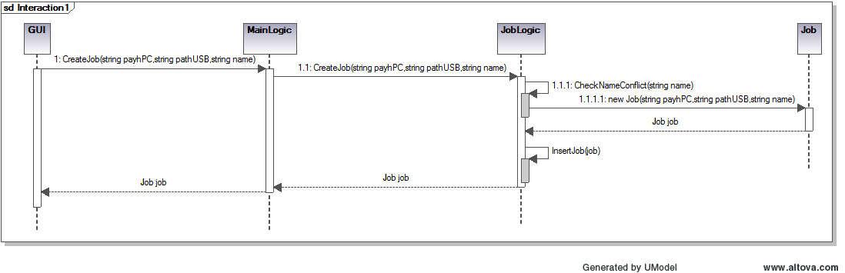

### 3.1.2 Accept a job

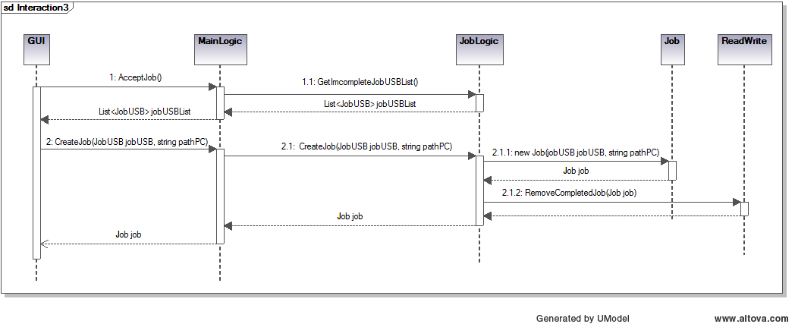

### 3.1.3 Accept & Sync

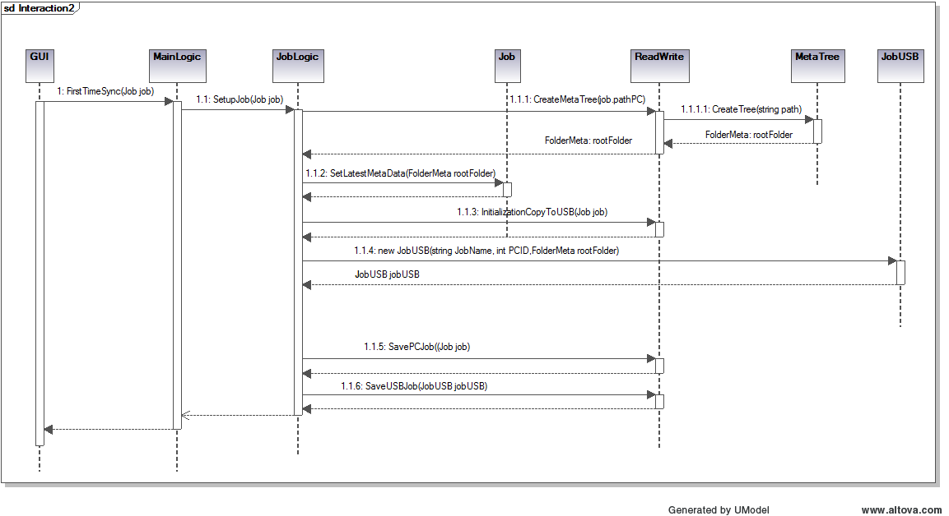

### 3.1.4 First Setup

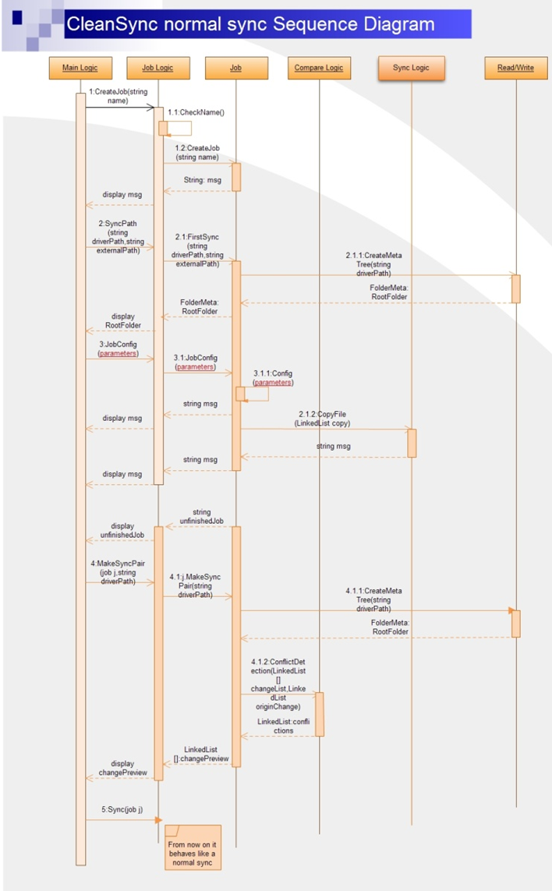

### 3.1.5 Normal Sync

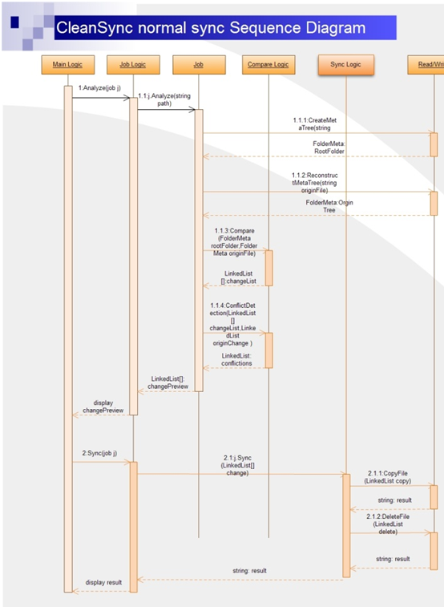

## 3.2 Implementation Details

### 3.2.1 Comparison

### 3.2.2 Conflict Handling

### 3.2.2 Clean Synchronization

Clean Synchronization does synchronization in SyncLogic based on trees. Calling methods provide a ComprisonResult object, and SyncLogic takes the 2 differences in the comparison result and converts them to tree form. After that, synchronization is performed based on the trees generated from the differences. SyncLogic does synchronization differently for normal synchronization and re-synchronization.

#### 3.2.2.1 Normal Synchronization

Normal Synchronization is invoked when the previous synchronization happened on the other computer. SyncLogic will then propagate the required updates to both the PC and the removable device. To allow for restoration of previous state and backing up of deleted files and folders, normal synchronization works as follows:

1. Extract changes from the PC to a temporary USB folder.
2. Copy changes from the USB to a temporary PC folder.
3. Propagate the changes from the temporary PC folder to the folder in the PC. During this time, any files and folders deleted from the PC will be moved to the backup folder.
4. Move the old changes from the main USB folder to another temporary USB folder.
5. Move the new changes from the temporary USB folder to the main USB folder.

After the correct changes are in place, the temporary folders’ contents will be cleared.

If during the synchronization, the USB is plugged out or the user cancels the process, An exception will be thrown and SyncLogic will move the folders back to the correct locations, depending on where the exception was thrown.

#### 3.2.2.2 Re - Synchronization

Re-Synchronization is invoked when synchronizing the computer to the USB successively. Instead of a normal synchronization where updates on both sides are updated, re-synchronization only checks what updates from the computer are to be copied over to the USB. SyncLogic defines the differences on the USB as the old differences from this computer, and the differences on the USB as the new differences. SyncLogic will compare each file and folder between the old and new differences and make changes to the old differences accordingly:

Comparing contents between 2 folders which are modified:

If a folder exists in both differences:

1. The old folder is **deleted**, the new folder is **new**
   1. This means the folder is previously deleted, and now a new folder with the same name is created. The folder’s difference will then be set to modified, and the sub folders and files will be compared recursively.
2. The old folder is **new**, the new folder is **deleted**
   1. The folder new folder will be removed, and no changes need to be made to the other computer, so the difference will be removed.
3. The old folder is **new**, the new folder is **modified**
   1. In this case, a special method will be called to check accordingly the subfiles and subfolders. If a subfile or subfolder is now deleted, it will be deleted from the differences. Else, any changes will be updated
4. The old folder is **modified**, the new folder is **deleted**
   1. A special method will also be called, to check if the there are any new files that will also be deleted from the differences. Also, previously deleted files and folders will also be added back to the differences.
5. Both folders are **modified**
   1. The folders will be checked recursively again.

If a file exists in both differences:

1. The old file is **deleted**, the new file is **new**
   1. A previously deleted file has been created again, thus, the difference will be set to modified.
2. The old file is **new**, the new file is **deleted**
   1. The file will be removed from the differences.
3. The old file is **new**, the new file is **modified**
   1. The new file will be set as new again.
4. The old file is **modified**, the new file is **modified**
   1. The file will still be modified
5. The old file is **modified**, the new file is **deleted**
   1. The difference will be set to deleted

To allow for restoration of previous state and backing up of deleted files and folders, normal synchronization works as follows:

1. Copy all the changes from the USB to a temporary folder
2. Extract the changes from the PC to a temporary folder on the USB
3. Do the resynchronization to the main USB folder.
4. Delete the temporary USB folder.

If the synchronization is interrupted or cancelled, the temporary folders will be flushed except for the data on the temporary folder containing the original differences which will be set back as the original differences.

### 3.2.3 Determining folders to store meta data

There are two types of meta data. One is meta data for folder on computer (PC), we’ll refer to this type as PCJob. The other is meta data for folder on removable device, we’ll refer to this type as USBJob.

The root folder to store PCJobs is the path the Clean Sync executable resides in. All meta data are stored in a folder named “_cs_job_data” and the property of the folder is set to System Hidden.

The root folder to store USBJobs is the path of the root drive of the USBJob. All meta data are stored in folder named “_cs_job_data” and the property of the folder is set to System Hidden.

### 3.2.4 Loading and unloading meta data to and from the hard disk.

We define two different types of job, one stores the job information for computer(we'll refer to this type of job as PCJob), and one stores the job information for removable device(we'll refer to this type of job as USBJob).

PCJob:

A PCJob is created when a new job is successfully created or when a job is successfully accepted. PCJobs are stored in the root\_cs_job_data\JobsList where root is the current path the CleanSync.exe resides.

PCJobs are initialized and loaded by the program when the program starts up.

USBJob:

An incomplete USBJob is created when a new job is successfully created. The incomplete USBJob will be stored in the root:\_CleanSync_Data_\_cs_job_data\incompleteJobs where root is the root drive of the removable device which user chooses to store the intermediary file. An incompete USBJob will be used to notify CleanSync that there is not fully connected job on this removable device.

When an incomplete job is accepted, the incomplete USBJob will be removed and a new USBJob will be created in the path root:\_CleanSync_Data_\_cs_job_data\usbJobsList where root is the root drive of the removable device.

The USBDetection Class is used to handle removable device plug in. When a removable device is detected, the program will check whether the device contains "_CleanSync_Data_" folder. If yes, the program will then search for the incomplete USBJobs to display, and for USBJobs, the program will try to load the USBJob to the corresponding PCJob on this computer. For PCJobs that can be connected with a USBJob, they can proceed with Analyse or Sync functions.

# 4. Known issues

CleanSync version 2.0 currently has the following known issues:

* Restoration of interrupted synchronization on the PC’s folder.

If a synchronization was stopped due do the program being exited (i.e power shortage, etc), CleanSync will attempt to restore the folder the next time users synchronize the folder again. However, while modified and deleted files can be restored to the PC, new files and folders that were already copied to the folder will not be removed from the folder. They will be detected as new files the next time synchronization occurs.