EBS Http library release notes.

Building:

A Visual ‘C’ 2010 project is provided in the folder:

.\httpserverandclient\http\v0.2.6\project\msvs.net2010\win32\serverdemo

A Linux project needs to be developed and debugged. The source code already supports Linux, Make file need to be created and the code needs to be tested.

About the demo - The demo demonstrates using the HTTP client in concert with the http server and web pages to create dynamic applications.

Main Menu – The main menu allows several options.

The default selections for most client operations is to access the server at localhost.

The main menu allows you to spawn a server in the background select option 4, (option 3 is available for a simple disk based only server with no dynamic content support ). Then continue on to run client code in the foreground from the console.

***Note: If you run the server in the background and you wish to restart, you must to kill the application named serverdemo.exe in the task manager.***

You may also run separate instances of the server and client both in the foreground. If you run this way you will be able to see server messages printed to the console. To do this you must run the executable twice. In the first case select option 2, (option 1 is available for a simple disk based only server with no dynamic content support ) in one window and select option 0 in the other windows on to run client code

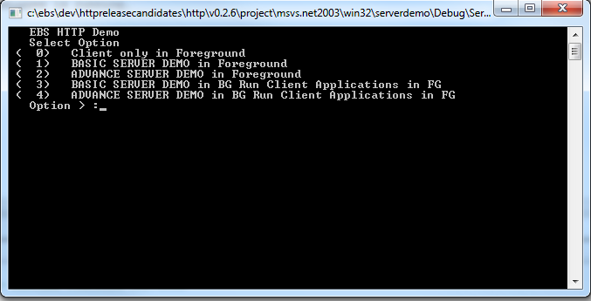

Client menu from the client menu you may select an app to run. Several options and the results are displayed below.

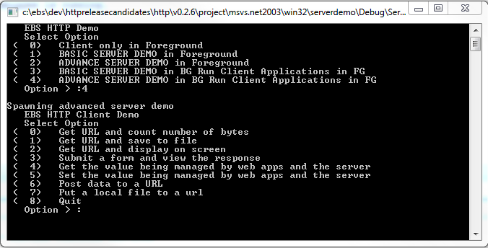

This is the result of running of choosing option 0 from the client menu and choosing default selections.

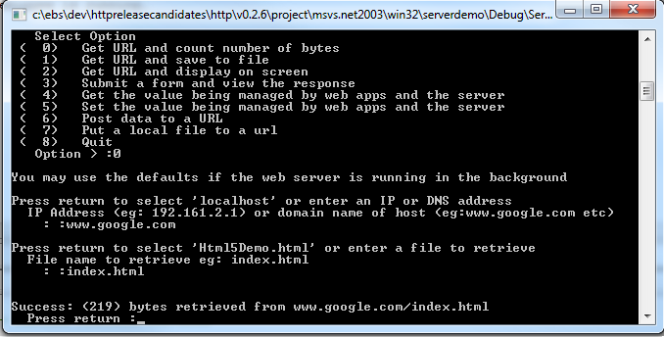

This is the result of running of choosing option 3 from the client menu and choosing default selections.

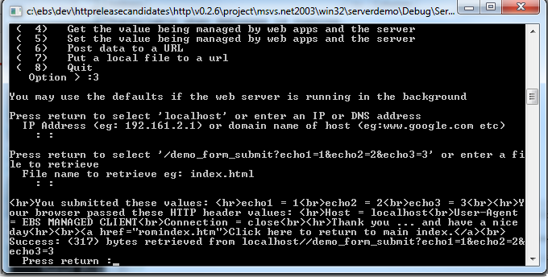

This is the Web Page displayed when running the advanced server in either foreground mode or background mode and accessing the server’s compiled in index page at <http://localhost/romindex.html>.

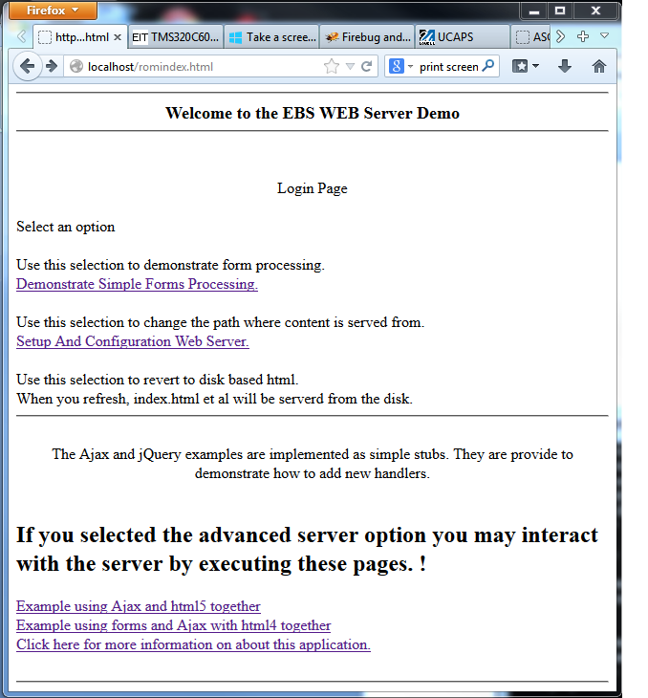

This is the Web Page when running the advanced server in either foreground mode or background mode and accessing the server’s compiled in index page at the <http://localhost/Html4Demo.html>. This page is also accessible as a link from <http://localhost/romindex.html>.

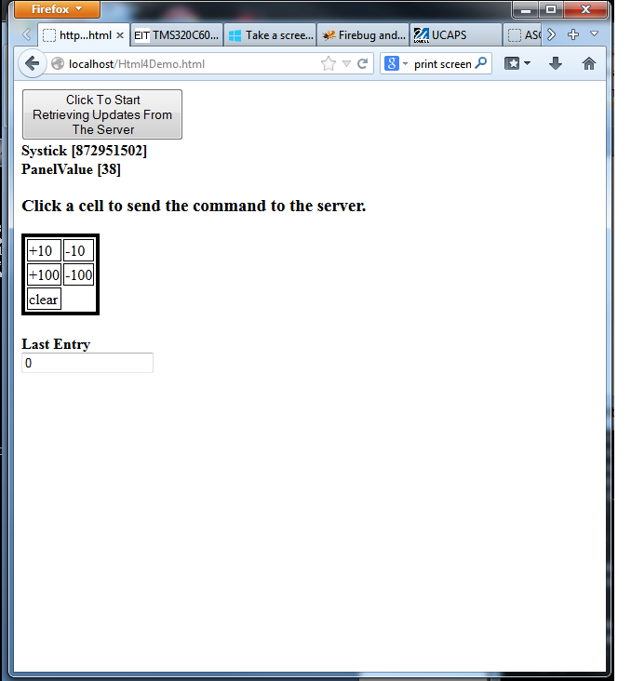

This is the the Web Page when running the advanced server in either foreground mode or background mode and accessing the server’s compiled in index page at the <http://localhost/Html5Demo.html>. This page is also accessible as a link from <http://localhost/romindex.html>.

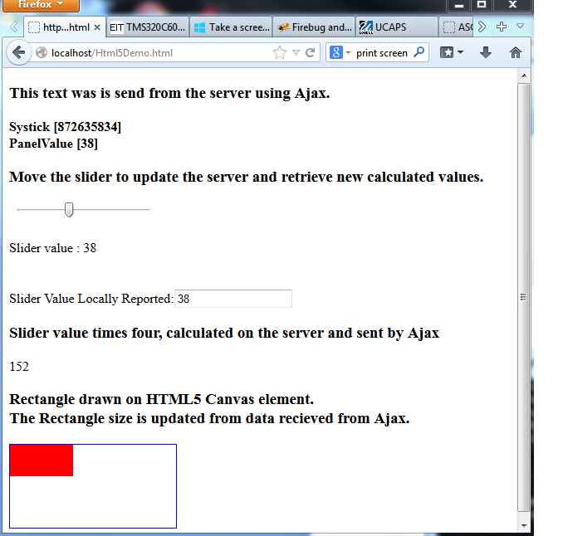

This is the the Web Page when running the advanced server in either foreground mode or background mode and accessing the server’s compiled in index page at the <http://localhost/demo_form.html>. This page is also accessible as a link from <http://localhost/romindex.html>.

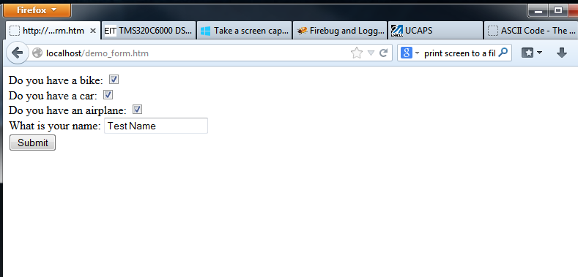

This is the the Web Page displayed when running the advanced server in either foreground mode or background mode and Submitting the page at the <http://localhost/demo_form.html>.

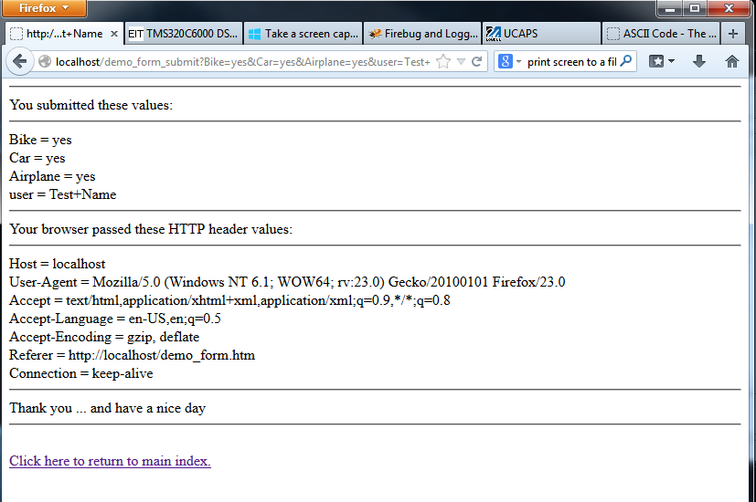

The console values displayed when running the advanced server in background mode selecting option 4 from the client menu. Note that the value labeled as “Panel Value” in the console has the same value as the being display in the web browser displaying <http://localhost/Html4Demo.html>.

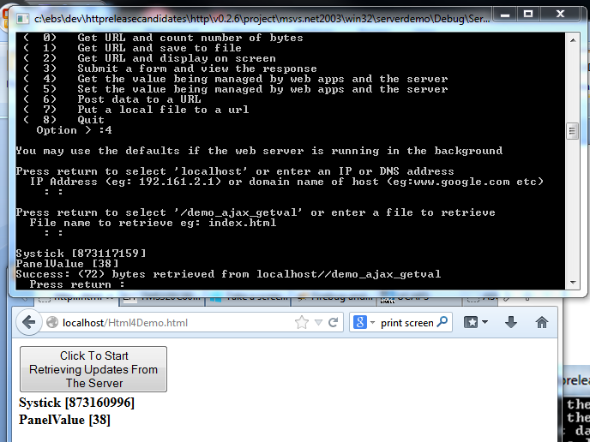

The console values displayed when running the advanced server in background mode selecting option 5 from the client menu. Note that the Value was changed to 95 in the console window and that value is the same value being display in the web browser displaying <http://localhost/Html4Demo.html>.

