Active Defense Syslog

Introduce Active Defense Syslog
This Active Defense application is an Internet traffic forced syslog system. It was built based on the Palo Alto firewall and it mainly looks at traffic coming from the internet and finds out any IP / port scanning and vulnerability attack attempt activities and instructs the firewall to perform an explicit block action.
An example of how policy configuration makes use of this Active Defense system. The top policy to block IP addresses that match the Blacklist address object which is provided by Active Defense system. The bottom policy will feed all un-matched / implicit blocked traffic, plus all other public facing policies’ logs to the system for data analysing where a Blacklist-IP will be produced.
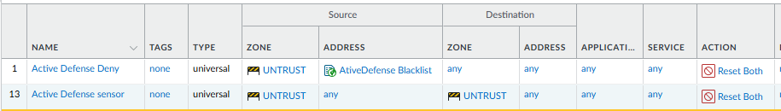
An example of list of bad guys. And the detail of why they got blacklisted. Firewall will block these public IPs by rule 1 above.
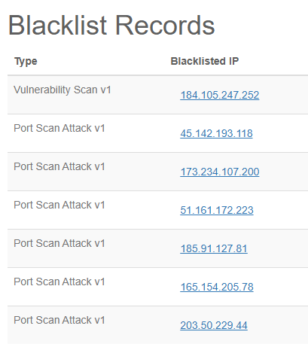
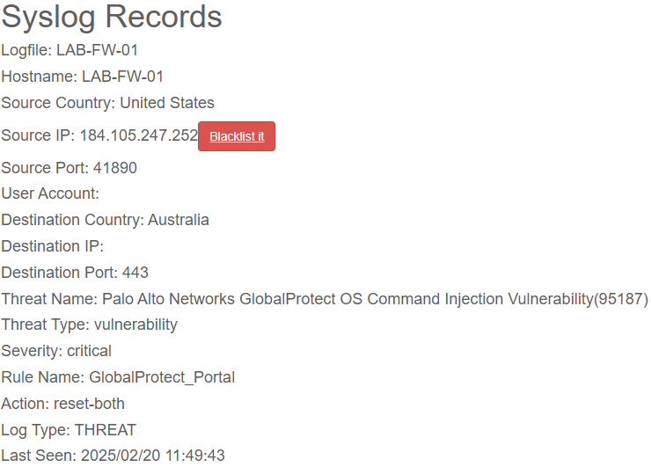
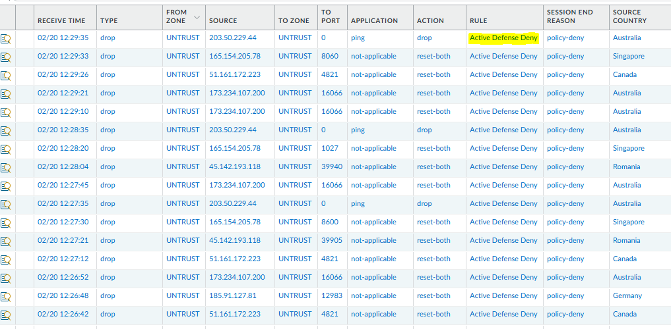
Finally, users can tune the settings of how the Defense engine runs. Such as the number of ports per certain mins to be defined as port scan activity. Blacklist public IP that triggered Critical-level or High-level vulnerability attempts. Keeping firewall logs for a number of months and remove blacklist IP after number of months without being detected with any bad activity.
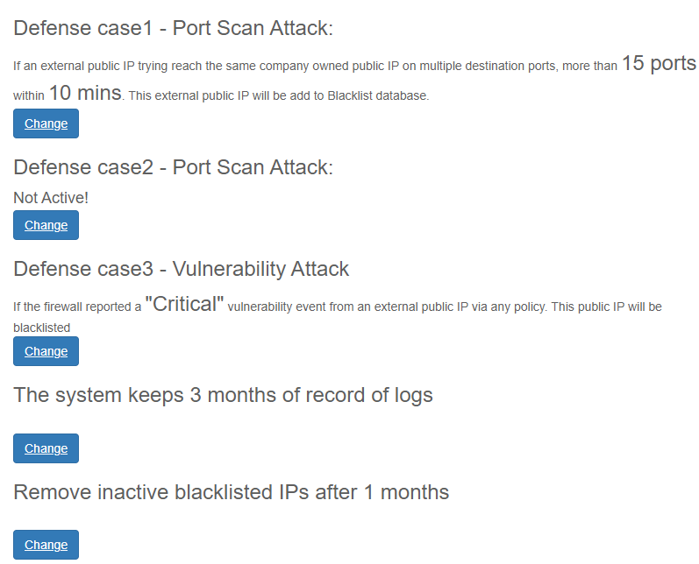

Install Active Defense Syslog System

Assume you have an Ubuntu server installed and enabled SSH with full access
- Ubuntu server. 24.04.02

To make sure your server can utilize all disk space
sudo lvextend -l +100%FREE /dev/ubuntu-vg/ubuntu-lv
sudo resize2fs /dev/mapper/ubuntu--vg-ubuntu--lv

Rsyslog application which is available out-of-box with Ubuntu server.
- Edit file ”sudo nano /etc/rsyslog.conf”
  - Find and un-hash below two line:
module(load="imudp")
input(type="imudp" port="514")
  - Add below 3 lines to the end of the file
$template firewall,"/var/log/Firewall/%HOSTNAME%.log"
if $fromhost != 'Whatever-the-server-hostname-is' then ?firewall
& stop
- Create a folder for storing logs and give full access permission to all users
sudo mkdir /var/log/Firewall
sudo chmod 777 /var/log/Firewall
- Give the application the ability to restart the Rsyslog service
  - Edit file “sudo nano /etc/sudoers” add below line to the end of the file
ALL ALL=(ALL) NOPASSWD: /usr/bin/systemctl restart rsyslog.service
- Restart and verify Rsyslog service.
sudo systemctl restart rsyslog.service
systemctl status rsyslog.service

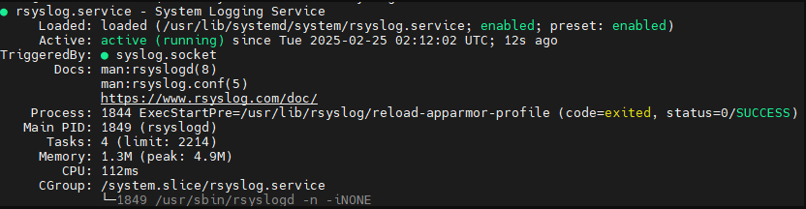

Install Django Framework
sudo apt-get update
sudo apt-get install python3-django
sudo apt-get install python3-pip python3-venv

Create virtual environment and install Django
cd /
sudo mkdir Automation
sudo chmod 777 Automation
python3 -m venv Automation
cd Automation
source bin/activate
pip3 install Django
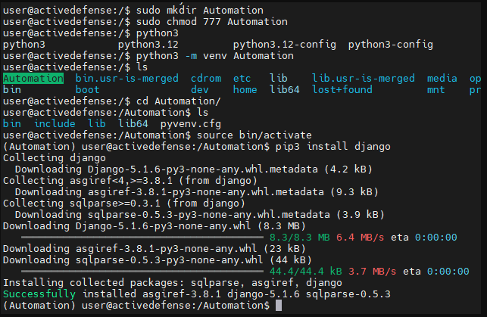

Create web applications and install dependent libraries
- Perform below commands under directory /Automation within the virtual environment
django-admin startproject ActiveDefense .
python3 manage.py startapp Login
python3 manage.py startapp Syslog
pip3 install pathlib netifaces datetime apscheduler sqlalchemy
pip3 install python-dateutil gunicorn

Copy the source code files and install the system
We will use sftp to copy the source files into created directories from above
If you are using a Windows computer you can use MoxaXterm free application to do this. Linux users can perform this task natively using Terminal.
- Start from the directory where you have downloaded source files. SFTP to the server. Copy and override everything into the remote server with below command
cd /<the directory on your local computer where you downloaded the source code>
sftp user@<server IP>
cd /Automation
put -R *
exit
- Install / create PostgreSQL database engine with below command
sudo apt install postgresql postgresql-contrib libpq-dev
source /Automation/bin/activate
pip3 install psycopg2-binary
  - create Database
sudo -u postgres psql
SQL commands below:
CREATE DATABASE activedefense;
CREATE USER activedefenseuser WITH PASSWORD 'activedefensepassword;
ALTER ROLE activedefenseuser SET client_encoding TO 'utf8';
ALTER ROLE activedefenseuser SET default_transaction_isolation TO 'read committed';
ALTER ROLE activedefenseuser SET timezone TO 'Australia/Sydney';
ALTER ROLE activedefenseuser WITH CREATEDB;
GRANT ALL PRIVILEGES ON DATABASE activedefense TO activedefenseuser;
ALTER DEFAULT PRIVILEGES IN SCHEMA public
GRANT ALL PRIVILEGES ON TABLES TO activedefenseuser;
\q
  - Temporary rename the app.py file to avoid error during the database initial setup
cd /Automation/Syslog
mv apps.py apps.py.tmp
cd ..
  - create Database
python3 manage.py makemigrations
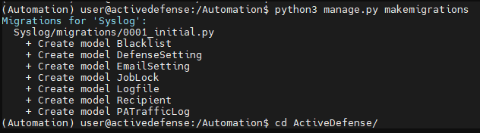
python3 manage.py migrate
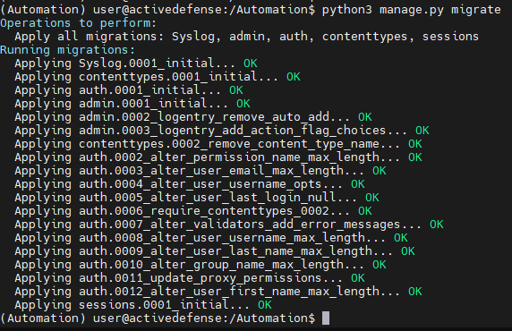
  - Create superuser
python3 manage.py createsuperuser
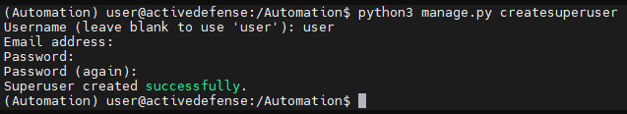
  - Rename the apps.py.tmp back to apps.py
cd /Automation/Syslog/
mv apps.py.tmp apps.py
cd ..

Start the application
- Apply executable permissions to startup scripts
chmod +x /Automation/run.sh*
- Setup auto start @reboot
sudo nano /etc/crontab
  - add below line to the bottom and save / exit
@reboot user /bin/bash -c "/Automation/run.sh"

Setup and configure the web server
- Setup Nginx (Engine X) as front-end web server
  - Install Nginx
sudo apt-get install nginx
  - Setup web site in nginx by creating file “django” in /etc/nginx/sites-available/
sudo nano /etc/nginx/sites-available/django
    - Copy below to the file, save and exit
server {
listen 443 ssl;
server_name <server FQDN or IP Address>;

ssl_certificate /Automation/Cert/server.crt;
ssl_certificate_key /Automation/Cert/server.key;

location / {
proxy_pass http://127.0.0.1:8000;
proxy_set_header Host $host;
proxy_set_header X-Real-IP $remote_addr;
proxy_set_header X-Forwarded-For $proxy_add_x_forwarded_for;
proxy_set_header X-Forwarded-Proto $scheme;
}
location /static/ {
alias /Automation/static/;
}
}
server {
listen 80;
server_name your.domain.or.ip;
return 301 https://$host$request_uri;
}

  - Start Nginx
sudo ln -s /etc/nginx/sites-available/django /etc/nginx/sites-enabled/
sudo nginx -t
sudo systemctl restart nginx

- Set the correct timezone before Rebooting the server.
sudo timedatectl set-timezone <local timezone such as Australia/Sydney>
sudo reboot now
- The system will startup automatically. Access the application using:
https://server-ip-address
username password has been created as superuser above

Setup Palo Firewall and forward the logs

Setup syslog at Palo firewall
Device 🡪 Server Profiles 🡪 Syslog 🡪 Add new
Add the IP address of the Defense system as syslog server. Copy below log format string to both Thread and Traffic log type
SrcLocation=$srcloc; SrcIP=$src; SrcPort=$sport; SrcUser=$srcuser; DstLocation=$dstloc; DstIP=$dst; DstPort=$dport; Action=$action; RuleName=$rule; RuleID=$rule_uuid; TimeReceived=$time_received; ThreatName=$threat_name; ThreatID=$threatid; Severity=$severity; Subtype=$subtype; Type= $type;
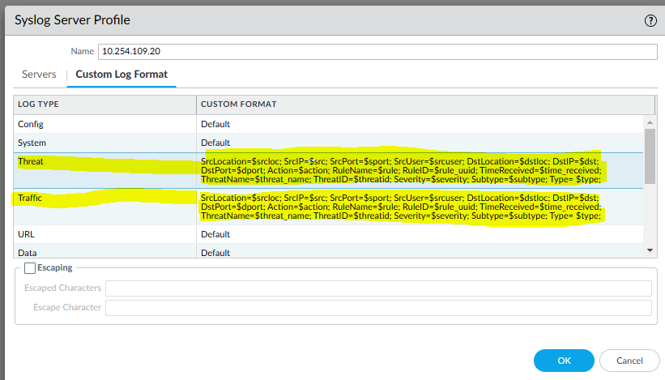
Objects 🡪 Log Forwarding 🡪 Add new
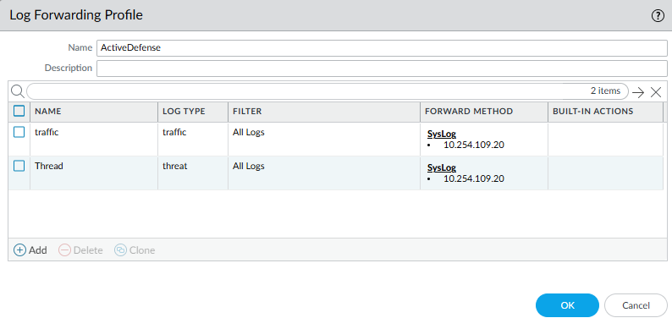

Create blacklist address object
Objects 🡪 External Dynamic Lists 🡪 Add new
Type: IP List
Source: https://<server-IP>/files/blacklist.txt
Check for update: Every 5 mins
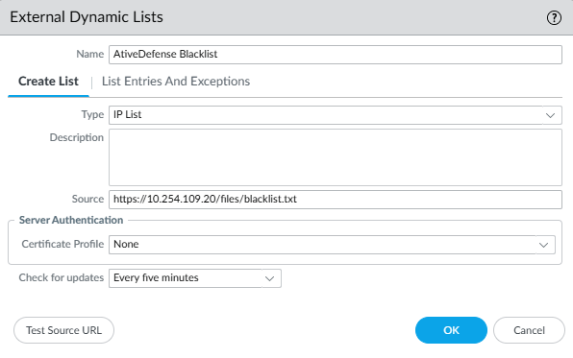

Create the Active Defense policies

The Fist policy needs to be at the top position
Source Zone: Internet/Untrust
Source: address: <ActiveDefense Blacklist created at above>
Destination Zone: any
Destination Address: any
Action: Deny
Log forward: <ActiveDefense Syslog>
Note: best practice is to forward the blocked logs. System will know if any known blacklisted IPs are still attacking you. System will reset its time within the block-window (default 1 month). Otherwise, system will remove it after block-window regardless. Eventually it will get block again as a new IP
- The Second policy needs to be at the bottom position.
This policy needs to be at the bottom whenever a new policy is added in the future. Basically, it captures all un-matched traffic and forwards the logs to the syslog.
Source Zone: Internet / Untrust
Source Address: any
Destination Zone: any
Action: Deny or reset
Log forward: <ActiveDefense Syslog>
Note: We need to forward all un-matched traffic that ActiveDefense can tell if anyone trying to do port scanning on you. If you don’t have this catch-all rule. ActiveDefense can only block vulnerability detected IP.

Apply the ActiveDefense syslog to all other Internet facing policy such as the Globalprotect one as below
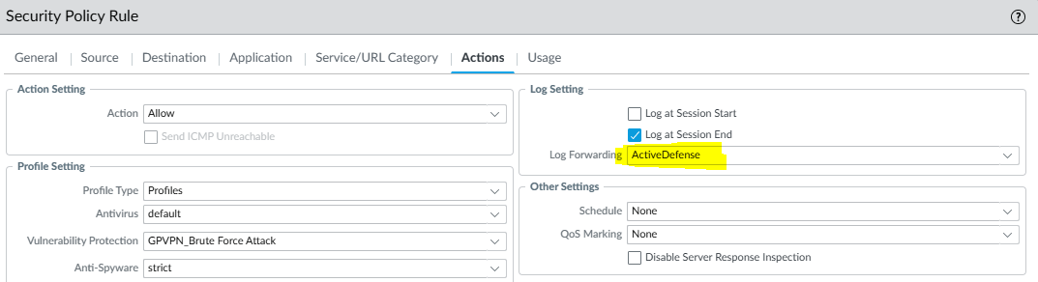
Note: ActiveDefense will find out if anyone tries to do vulnerability attacks on you and blacklist them. This type of policy usually has security Profile attached such as Vulnerability Protection etc.
Commit all above changes and the firewall is completed.

Setup Active Defense Syslog

Login to GUI and change password or create your own account
https://<server-ip>/admin
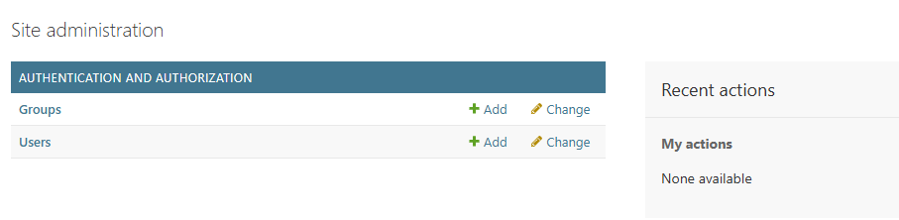

Setup SMTP server and recipients for notification. System will email recipients if new IP address added to blacklist (optional)

Find and add the syslog file location
New log data will be saved at /var/log/Firewall/ directory before converting into Database records. The log file name is the hostname of the firewall with extension “.log”
You can SSH to the server provided (above) and find out the log files.
Command: ls /var/log/Firewall/
Register the log file and path to the system
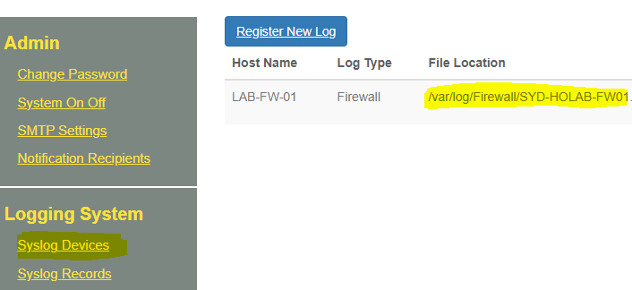

Tune the Active Defense settings to meet your need under mane “ActiveDefense Settings”
- Defense case 1 – port scanning (multiple ports)
Default setting. It is targeting a single public IP being tried with more than 10 ports in the last 10mins window. You can relax it by increasing the number of ports or lowering the time. Such as 20+ ports or in 8 mins. Be aware that the defence engineer runs every 5 mins. If the time is set to lower than 5 mins. It will skip logs
- Defense case 2 – Port scanning (multiple IPs)
Default setting: system will find out if someone tries to find out open ports on all of your public IPs. Such as targeting https port (443) on all your public IPs. It is set to 10 of your public IP being tried on a single port in the last 10 mins. You can relax it by increasing the number of public IPs or reducing time. If you don’t own multiple public IPs. You can disable this by setting the time to 0.
- Defense case 3 – Vulnerability detection
By default. It blacklists any external public IP who had triggered “Critical” vulnerability alerts. You can make it more aggressive to set the value to 2. It will also blacklist someone who triggered a “High” vulnerability alert. Set to 0 to disable this function if you don’t have Threat protection on your firewall.
- The other two settings are Database keeping.
By default, it is set to keep 3 month’s log records and release the blacklisted IP if it has been doing bad things in a month.

Start the system and verify running
“System On Off” is to start or restart the scheduled jobs when needed. If you can see any new traffic logs in “Syslog Records”. Do a “Reset” and “start”. It will restart the defense engine. The logs will always be received even if the engine is not running. It will keep in /var/log/Firewall. the log file will grow until the engine runs again. Logs will convert into DB and the log file size gets reduced.
The engine will not auto start when you restart the server. You will need to login to the GUI and start the defense system manually or “reset / start” it every time you reboot the server.
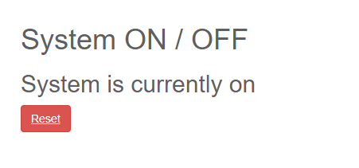
To verify it’s running. You can simply look at the last 24 hours logs. confirm by the time of the record
Or SSH to the server and look at the log file size. A .tmp file will be created when the system converts the logs into Database. Then the log file will get reduced and the .tmp file should be gone after the scheduled job is completed. It runs every 5 mins.
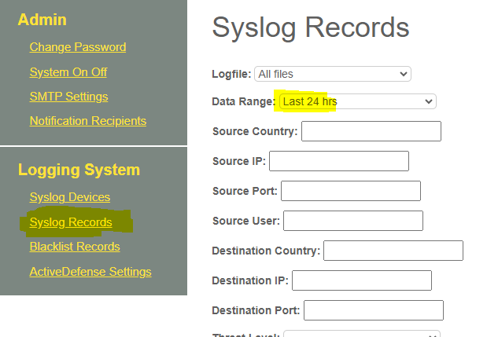
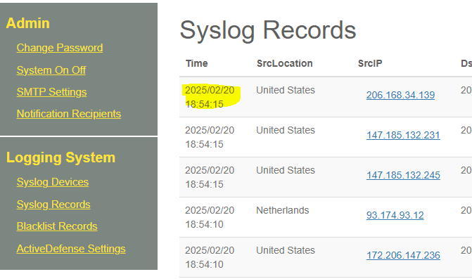

Limitation
If you have a large amount of logs and the server can not process it within 5 mins. Then you need a faster system to keep up with the log growing. Spread to multiple servers for multiple firewalls. Or external the scheduling time to every 10mins for example. It will require edit to the source code:
/Automation/Syslog/scheduler.py
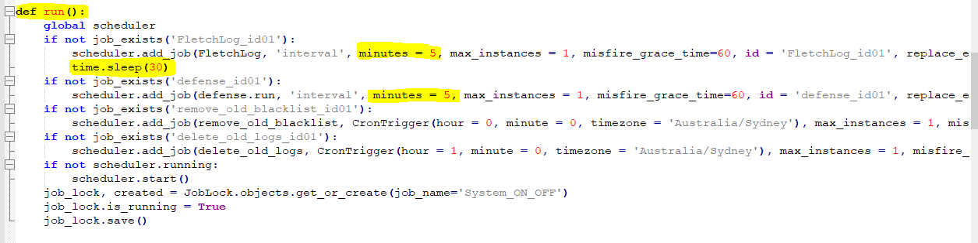
Note: the “sleep time” is the gap between two jobs. Database gets locked every action. Job gets delayed automatically when DB gets locked. Graceful period of 1 mins before the job gives up and waits for the next run.

